# CSV2HTML Users Guide

## Introduction:

CSV2HTML is a CSV (columns separated by a semicolon) to HTML conversion tool.

It translates a CSV into a header (fixed and only if desired)) and scrollable table.

The tool is based on TXT2HTML (V2.5) written by Lionel B. Dyck.

From

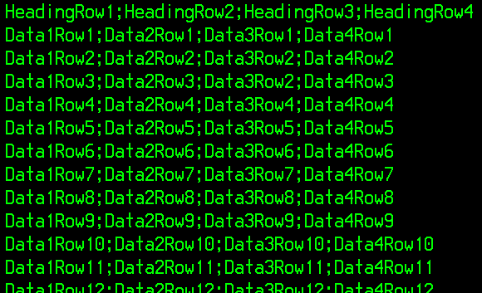

To

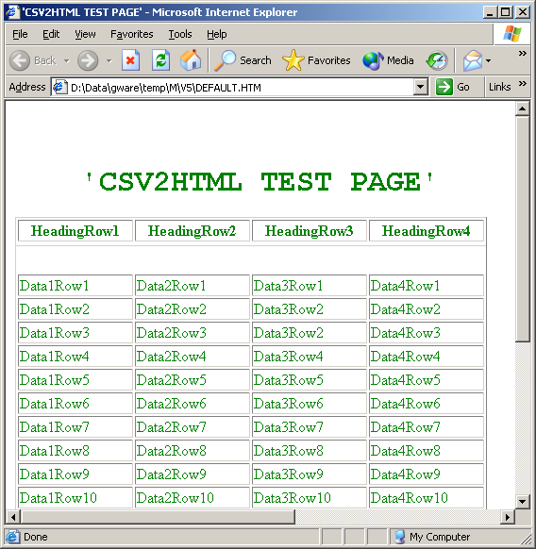

Syntax:

%CSV2HTML options

Valid Options:

**IN** input-dataset or **IN** DD:input-dd

**OUT** output-dataset or **OUT** DD:output-dd

**COLOR** color (see options)

**FONT** font-size (from 1 to 7)

**CC** Yes or No (indicates if the input dataset has carriage control)

**NOCONFIRM** (turns off all non-critical informative messages)

**BROWSE** (browse the report if under ISPF)

**TABLE (**to translate csv in table format)

**NOHEADER (**if no header row desired for TABLE)

**WRAP (**columns are wrapped to the largest word in the column)

**BANNER** Yes or No (to print title as a banner)

**TITLE** title text (must be the **last** keyword used)

## Options:

COLOR: the font color. Fullname or abbreviation can be used

|  |  |  |  |
| --- | --- | --- | --- |
| **Color** | **Abbreviation** | **Color** | **Abbreviation** |
| **Aqua** | A | **Navy** | N |
| **Black** | Bla | **Olive** | O |
| **Blue** | Blu | **Purple** | P |
| **Fuchsia** | F | **Red** | R |
| **Gray** | Gra | **Silver** | S |
| **Green** | Gre | **Teal** | T |
| **Lime** | L | **White** | W |
| **Maroon** | M | **Yellow** | Y |

FONT: relative font size from 1 (small) up to 7 (big)

TABLE: translates a comma delimited file (; in between different columns) to a HTML table. By default a header (first line) is added and “NoWrap” (column level) is assumed.

NOHEADER: overrules the default “HEADER” of the table. CSV is interpreted as a list of data without header.

WRAP: overrules the default “NoWrap” of the table. Column data is wrapped to the longest word in the column (header and footer).

BANNER: puts the ‘TITLE’ on top of the document

TITLE: MUST be (if mentioned) the last keyword. Only visible on top of the document if keyword BANNER is specified.