CSV2HTML Users Guide

Introduction:
CSV2HTML is a CSV (columns separated by a semicolon) to HTML conversion tool.
It translates a CSV into a header (fixed and only if desired)) and scrollable table.
The tool is based on TXT2HTML (V2.5) written by Lionel B. Dyck.

From

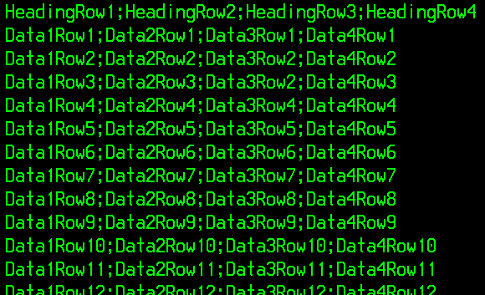

To
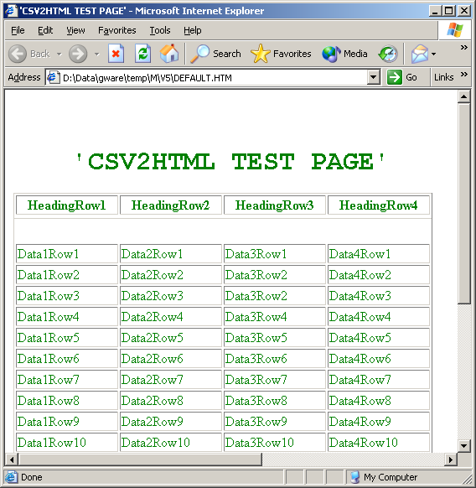
Syntax:

%CSV2HTML options

Valid Options:

IN input-dataset or IN DD:input-dd
OUT output-dataset or OUT DD:output-dd
COLOR color (see options)
FONT font-size (from 1 to 7)
CC Yes or No (indicates if the input dataset has carriage control)
NOCONFIRM (turns off all non-critical informative messages)
BROWSE (browse the report if under ISPF)
TABLE (to translate csv in table format)
NOHEADER (if no header row desired for TABLE)
WRAP (columns are wrapped to the largest word in the column)
BANNER Yes or No (to print title as a banner)
TITLE title text (must be the last keyword used)

Options:
COLOR: the font color. Fullname or abbreviation can be used

Color | Abbreviation | Color | Abbreviation
Aqua | A | Navy | N
Black | Bla | Olive | O
Blue | Blu | Purple | P
Fuchsia | F | Red | R
Gray | Gra | Silver | S
Green | Gre | Teal | T
Lime | L | White | W
Maroon | M | Yellow | Y

FONT: relative font size from 1 (small) up to 7 (big)

TABLE: translates a comma delimited file (; in between different columns) to a HTML table. By default a header (first line) is added and “NoWrap” (column level) is assumed.

NOHEADER: overrules the default “HEADER” of the table. CSV is interpreted as a list of data without header.

WRAP: overrules the default “NoWrap” of the table. Column data is wrapped to the longest word in the column (header and footer).

BANNER: puts the ‘TITLE’ on top of the document

TITLE: MUST be (if mentioned) the last keyword. Only visible on top of the document if keyword BANNER is specified.

