Lee Beadle

CS 455 Software Engineering

Tomcat Assignment

Step 1:

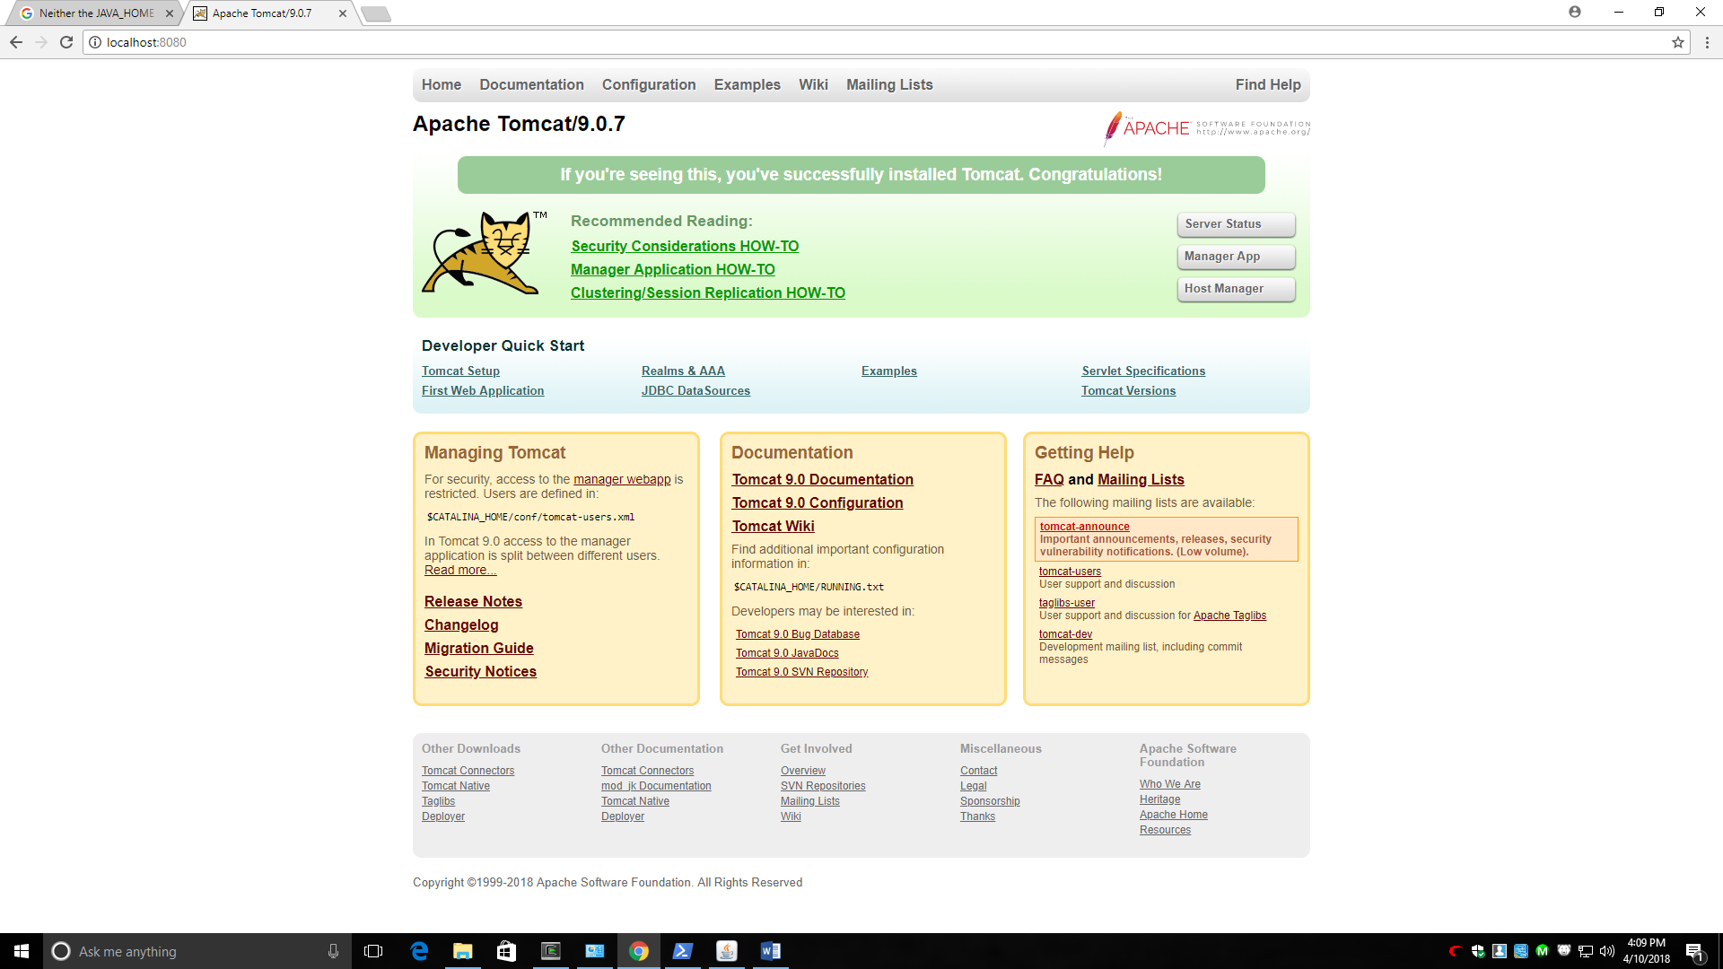

Step 2:

Catalina.log

10-Apr-2018 17:07:20.312 SEVERE [main] org.apache.tomcat.util.net.SSLUtilBase.getStore Failed to load keystore type [JKS] with path [c:\tmp\.keystore] due to [Illegal character in opaque part at index 2: c:\tmp\.keystore]

java.lang.IllegalArgumentException: Illegal character in opaque part at index 2: c:\tmp\.keystore

at java.net.URI.create(URI.java:852)

at java.net.URI.resolve(URI.java:1036)

at org.apache.tomcat.util.file.ConfigFileLoader.getInputStream(ConfigFileLoader.java:88)

at org.apache.tomcat.util.net.SSLUtilBase.getStore(SSLUtilBase.java:132)

at org.apache.tomcat.util.net.SSLHostConfigCertificate.getCertificateKeystore(SSLHostConfigCertificate.java:204)

at org.apache.tomcat.util.net.jsse.JSSEUtil.getKeyManagers(JSSEUtil.java:184)

at org.apache.tomcat.util.net.openssl.OpenSSLUtil.getKeyManagers(OpenSSLUtil.java:79)

at org.apache.tomcat.util.net.AbstractJsseEndpoint.createSSLContext(AbstractJsseEndpoint.java:112)

at org.apache.tomcat.util.net.AbstractJsseEndpoint.initialiseSsl(AbstractJsseEndpoint.java:85)

at org.apache.tomcat.util.net.NioEndpoint.bind(NioEndpoint.java:216)

at org.apache.tomcat.util.net.AbstractEndpoint.init(AbstractEndpoint.java:1043)

at org.apache.coyote.AbstractProtocol.init(AbstractProtocol.java:540)

at org.apache.coyote.http11.AbstractHttp11Protocol.init(AbstractHttp11Protocol.java:74)

at org.apache.catalina.connector.Connector.initInternal(Connector.java:932)

at org.apache.catalina.util.LifecycleBase.init(LifecycleBase.java:136)

at org.apache.catalina.core.StandardService.initInternal(StandardService.java:530)

at org.apache.catalina.util.LifecycleBase.init(LifecycleBase.java:136)

at org.apache.catalina.core.StandardServer.initInternal(StandardServer.java:852)

at org.apache.catalina.util.LifecycleBase.init(LifecycleBase.java:136)

at org.apache.catalina.startup.Catalina.load(Catalina.java:633)

at org.apache.catalina.startup.Catalina.load(Catalina.java:656)

at sun.reflect.NativeMethodAccessorImpl.invoke0(Native Method)

at sun.reflect.NativeMethodAccessorImpl.invoke(NativeMethodAccessorImpl.java:62)

at sun.reflect.DelegatingMethodAccessorImpl.invoke(DelegatingMethodAccessorImpl.java:43)

at java.lang.reflect.Method.invoke(Method.java:498)

at org.apache.catalina.startup.Bootstrap.load(Bootstrap.java:306)

at org.apache.catalina.startup.Bootstrap.main(Bootstrap.java:491)

Caused by: java.net.URISyntaxException: Illegal character in opaque part at index 2: c:\tmp\.keystore

at java.net.URI$Parser.fail(URI.java:2848)

at java.net.URI$Parser.checkChars(URI.java:3021)

at java.net.URI$Parser.parse(URI.java:3058)

at java.net.URI.<init>(URI.java:588)

at java.net.URI.create(URI.java:850)

... 26 more

10-Apr-2018 17:07:20.314 SEVERE [main] org.apache.catalina.util.LifecycleBase.handleSubClassException Failed to initialize component [Connector[HTTP/1.1-8443]]

org.apache.catalina.LifecycleException: Protocol handler initialization failed

at org.apache.catalina.connector.Connector.initInternal(Connector.java:935)

at org.apache.catalina.util.LifecycleBase.init(LifecycleBase.java:136)

at org.apache.catalina.core.StandardService.initInternal(StandardService.java:530)

at org.apache.catalina.util.LifecycleBase.init(LifecycleBase.java:136)

at org.apache.catalina.core.StandardServer.initInternal(StandardServer.java:852)

at org.apache.catalina.util.LifecycleBase.init(LifecycleBase.java:136)

at org.apache.catalina.startup.Catalina.load(Catalina.java:633)

at org.apache.catalina.startup.Catalina.load(Catalina.java:656)

at sun.reflect.NativeMethodAccessorImpl.invoke0(Native Method)

at sun.reflect.NativeMethodAccessorImpl.invoke(NativeMethodAccessorImpl.java:62)

at sun.reflect.DelegatingMethodAccessorImpl.invoke(DelegatingMethodAccessorImpl.java:43)

at java.lang.reflect.Method.invoke(Method.java:498)

at org.apache.catalina.startup.Bootstrap.load(Bootstrap.java:306)

at org.apache.catalina.startup.Bootstrap.main(Bootstrap.java:491)

Caused by: java.lang.IllegalArgumentException: Failed to load keystore type [JKS] with path [c:\tmp\.keystore] due to [Illegal character in opaque part at index 2: c:\tmp\.keystore]

at org.apache.tomcat.util.net.AbstractJsseEndpoint.createSSLContext(AbstractJsseEndpoint.java:114)

at org.apache.tomcat.util.net.AbstractJsseEndpoint.initialiseSsl(AbstractJsseEndpoint.java:85)

at org.apache.tomcat.util.net.NioEndpoint.bind(NioEndpoint.java:216)

at org.apache.tomcat.util.net.AbstractEndpoint.init(AbstractEndpoint.java:1043)

at org.apache.coyote.AbstractProtocol.init(AbstractProtocol.java:540)

at org.apache.coyote.http11.AbstractHttp11Protocol.init(AbstractHttp11Protocol.java:74)

at org.apache.catalina.connector.Connector.initInternal(Connector.java:932)

... 13 more

Caused by: java.io.IOException: Failed to load keystore type [JKS] with path [c:\tmp\.keystore] due to [Illegal character in opaque part at index 2: c:\tmp\.keystore]

at org.apache.tomcat.util.net.SSLUtilBase.getStore(SSLUtilBase.java:150)

at org.apache.tomcat.util.net.SSLHostConfigCertificate.getCertificateKeystore(SSLHostConfigCertificate.java:204)

at org.apache.tomcat.util.net.jsse.JSSEUtil.getKeyManagers(JSSEUtil.java:184)

at org.apache.tomcat.util.net.openssl.OpenSSLUtil.getKeyManagers(OpenSSLUtil.java:79)

at org.apache.tomcat.util.net.AbstractJsseEndpoint.createSSLContext(AbstractJsseEndpoint.java:112)

... 19 more

Step 3:

Clean:

10-Apr-2018 17:57:06.518 INFO [main] org.apache.catalina.startup.VersionLoggerListener.log Server version: Apache Tomcat/9.0.7

10-Apr-2018 17:57:06.520 INFO [main] org.apache.catalina.startup.VersionLoggerListener.log Server built: Apr 3 2018 19:53:05 UTC

10-Apr-2018 17:57:06.520 INFO [main] org.apache.catalina.startup.VersionLoggerListener.log Server number: 9.0.7.0

10-Apr-2018 17:57:06.521 INFO [main] org.apache.catalina.startup.VersionLoggerListener.log OS Name: Windows 10

10-Apr-2018 17:57:06.521 INFO [main] org.apache.catalina.startup.VersionLoggerListener.log OS Version: 10.0

10-Apr-2018 17:57:06.521 INFO [main] org.apache.catalina.startup.VersionLoggerListener.log Architecture: amd64

10-Apr-2018 17:57:06.521 INFO [main] org.apache.catalina.startup.VersionLoggerListener.log Java Home: C:\Program Files\Java\jdk1.8.0_131\jre

10-Apr-2018 17:57:06.521 INFO [main] org.apache.catalina.startup.VersionLoggerListener.log JVM Version: 1.8.0_131-b11

10-Apr-2018 17:57:06.521 INFO [main] org.apache.catalina.startup.VersionLoggerListener.log JVM Vendor: Oracle Corporation

10-Apr-2018 17:57:06.521 INFO [main] org.apache.catalina.startup.VersionLoggerListener.log CATALINA_BASE: C:\tomcat

10-Apr-2018 17:57:06.521 INFO [main] org.apache.catalina.startup.VersionLoggerListener.log CATALINA_HOME: C:\tomcat

10-Apr-2018 17:57:06.522 INFO [main] org.apache.catalina.startup.VersionLoggerListener.log Command line argument: -Djava.util.logging.config.file=C:\tomcat\conf\logging.properties

10-Apr-2018 17:57:06.522 INFO [main] org.apache.catalina.startup.VersionLoggerListener.log Command line argument: -Djava.util.logging.manager=org.apache.juli.ClassLoaderLogManager

10-Apr-2018 17:57:06.522 INFO [main] org.apache.catalina.startup.VersionLoggerListener.log Command line argument: -Djdk.tls.ephemeralDHKeySize=2048

10-Apr-2018 17:57:06.522 INFO [main] org.apache.catalina.startup.VersionLoggerListener.log Command line argument: -Djava.protocol.handler.pkgs=org.apache.catalina.webresources

10-Apr-2018 17:57:06.522 INFO [main] org.apache.catalina.startup.VersionLoggerListener.log Command line argument: -Dignore.endorsed.dirs=

10-Apr-2018 17:57:06.522 INFO [main] org.apache.catalina.startup.VersionLoggerListener.log Command line argument: -Dcatalina.base=C:\tomcat

10-Apr-2018 17:57:06.523 INFO [main] org.apache.catalina.startup.VersionLoggerListener.log Command line argument: -Dcatalina.home=C:\tomcat

10-Apr-2018 17:57:06.523 INFO [main] org.apache.catalina.startup.VersionLoggerListener.log Command line argument: -Djava.io.tmpdir=C:\tomcat\temp

10-Apr-2018 17:57:06.524 INFO [main] org.apache.catalina.core.AprLifecycleListener.lifecycleEvent Loaded APR based Apache Tomcat Native library [1.2.16] using APR version [1.6.3].

10-Apr-2018 17:57:06.524 INFO [main] org.apache.catalina.core.AprLifecycleListener.lifecycleEvent APR capabilities: IPv6 [true], sendfile [true], accept filters [false], random [true].

10-Apr-2018 17:57:06.524 INFO [main] org.apache.catalina.core.AprLifecycleListener.lifecycleEvent APR/OpenSSL configuration: useAprConnector [false], useOpenSSL [true]

10-Apr-2018 17:57:07.260 INFO [main] org.apache.catalina.core.AprLifecycleListener.initializeSSL OpenSSL successfully initialized [OpenSSL 1.0.2m 2 Nov 2017]

10-Apr-2018 17:57:07.369 INFO [main] org.apache.coyote.AbstractProtocol.init Initializing ProtocolHandler ["http-nio-8080"]

10-Apr-2018 17:57:07.404 INFO [main] org.apache.tomcat.util.net.NioSelectorPool.getSharedSelector Using a shared selector for servlet write/read

10-Apr-2018 17:57:07.410 INFO [main] org.apache.coyote.AbstractProtocol.init Initializing ProtocolHandler ["ajp-nio-8009"]

10-Apr-2018 17:57:07.412 INFO [main] org.apache.tomcat.util.net.NioSelectorPool.getSharedSelector Using a shared selector for servlet write/read

10-Apr-2018 17:57:07.413 INFO [main] org.apache.coyote.AbstractProtocol.init Initializing ProtocolHandler ["https-openssl-nio-8443"]

10-Apr-2018 17:57:07.569 INFO [main] org.apache.tomcat.util.net.NioSelectorPool.getSharedSelector Using a shared selector for servlet write/read

10-Apr-2018 17:57:07.571 INFO [main] org.apache.catalina.startup.Catalina.load Initialization processed in 1384 ms

10-Apr-2018 17:57:07.589 INFO [main] org.apache.catalina.core.StandardService.startInternal Starting service [Catalina]

10-Apr-2018 17:57:07.590 INFO [main] org.apache.catalina.core.StandardEngine.startInternal Starting Servlet Engine: Apache Tomcat/9.0.7

10-Apr-2018 17:57:07.597 INFO [main] org.apache.catalina.startup.HostConfig.deployDirectory Deploying web application directory [C:\tomcat\webapps\docs]

10-Apr-2018 17:57:07.832 INFO [main] org.apache.catalina.startup.HostConfig.deployDirectory Deployment of web application directory [C:\tomcat\webapps\docs] has finished in [234] ms

10-Apr-2018 17:57:07.832 INFO [main] org.apache.catalina.startup.HostConfig.deployDirectory Deploying web application directory [C:\tomcat\webapps\examples]

10-Apr-2018 17:57:08.082 INFO [main] org.apache.catalina.startup.HostConfig.deployDirectory Deployment of web application directory [C:\tomcat\webapps\examples] has finished in [249] ms

10-Apr-2018 17:57:08.082 INFO [main] org.apache.catalina.startup.HostConfig.deployDirectory Deploying web application directory [C:\tomcat\webapps\host-manager]

10-Apr-2018 17:57:08.110 INFO [main] org.apache.catalina.startup.HostConfig.deployDirectory Deployment of web application directory [C:\tomcat\webapps\host-manager] has finished in [28] ms

10-Apr-2018 17:57:08.112 INFO [main] org.apache.catalina.startup.HostConfig.deployDirectory Deploying web application directory [C:\tomcat\webapps\manager]

10-Apr-2018 17:57:08.136 INFO [main] org.apache.catalina.startup.HostConfig.deployDirectory Deployment of web application directory [C:\tomcat\webapps\manager] has finished in [25] ms

10-Apr-2018 17:57:08.138 INFO [main] org.apache.catalina.startup.HostConfig.deployDirectory Deploying web application directory [C:\tomcat\webapps\ROOT]

10-Apr-2018 17:57:08.158 INFO [main] org.apache.catalina.startup.HostConfig.deployDirectory Deployment of web application directory [C:\tomcat\webapps\ROOT] has finished in [20] ms

10-Apr-2018 17:57:08.164 INFO [main] org.apache.coyote.AbstractProtocol.start Starting ProtocolHandler ["http-nio-8080"]

10-Apr-2018 17:57:08.174 INFO [main] org.apache.coyote.AbstractProtocol.start Starting ProtocolHandler ["ajp-nio-8009"]

10-Apr-2018 17:57:08.177 INFO [main] org.apache.coyote.AbstractProtocol.start Starting ProtocolHandler ["https-openssl-nio-8443"]

10-Apr-2018 17:57:08.180 INFO [main] org.apache.catalina.startup.Catalina.start Server startup in 608 ms

Step 4:

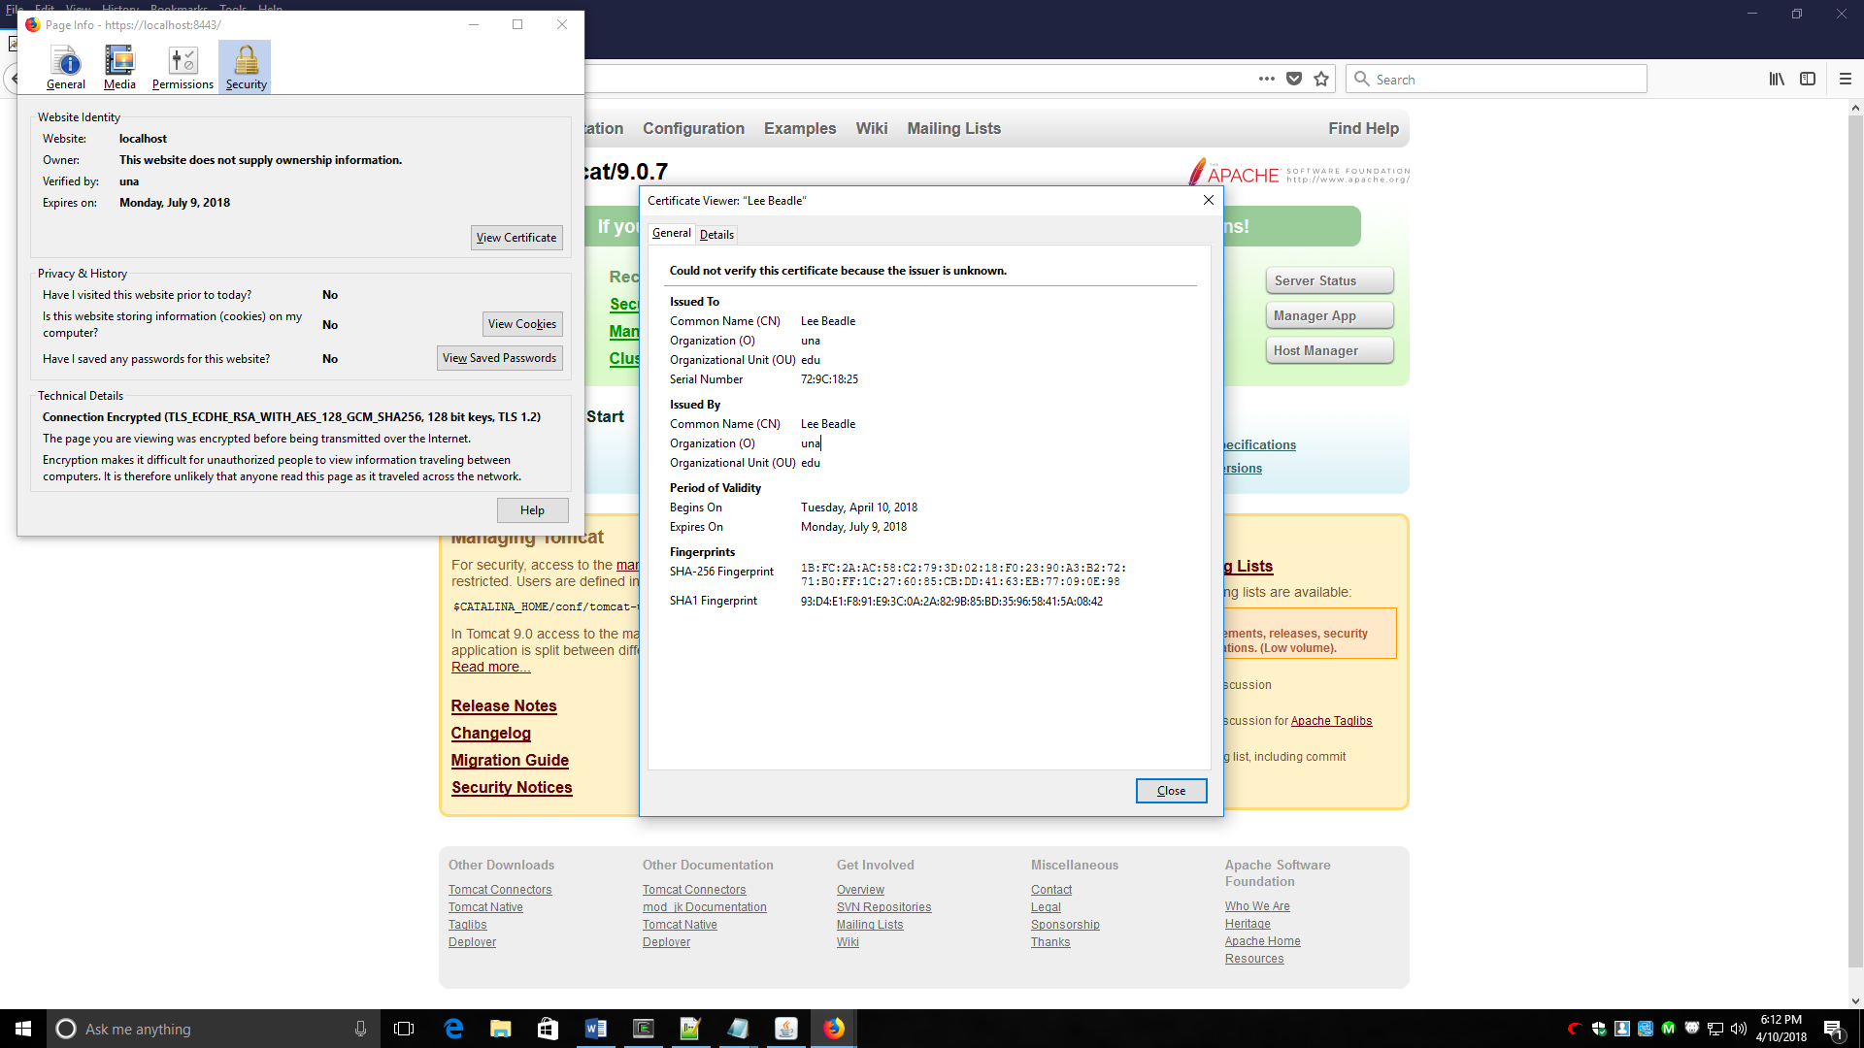

Step 5:

