**Supplemental Figure**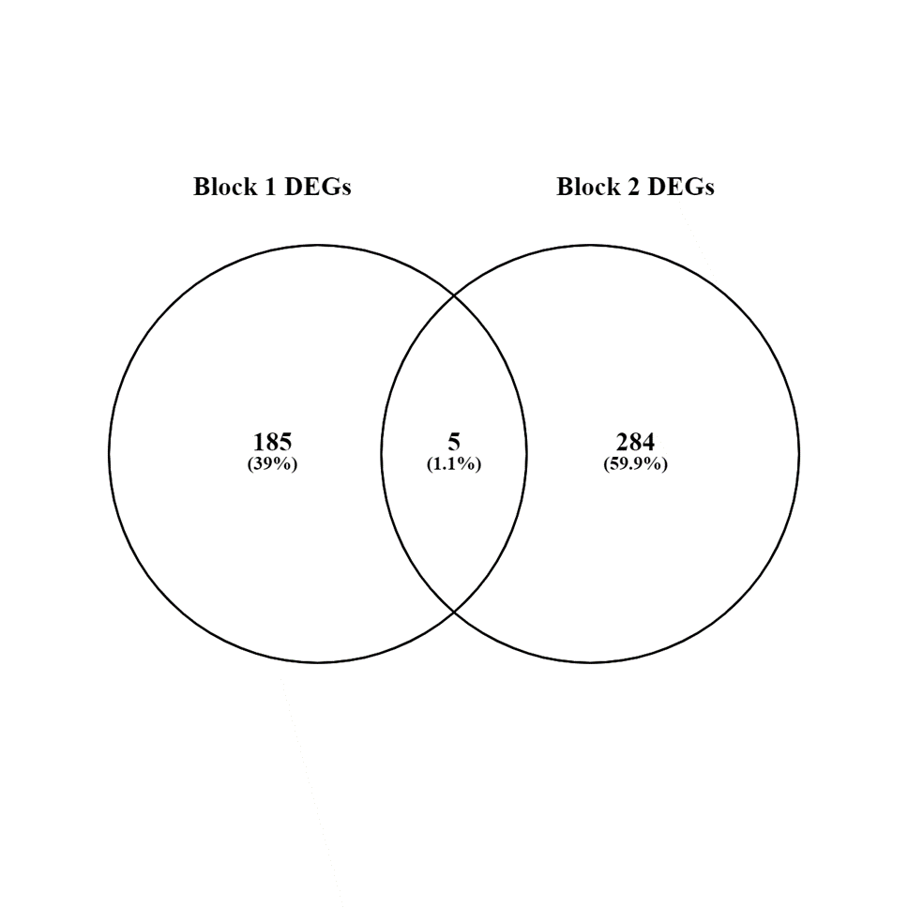

**Figure S1:** **Venn Diagram of the Differentially Expressed Genes (DEGs) between Block 1 and Block 2**. Each block had 3 cows’ paired end reads for postruminal lysine treatments of 0 g/d and 63 g/d. Block 1 had a total of 190 DEGs and Block 2 had 289 DEGs. There were only 5 DEGs that were shared across Block 1 and Block 2. These 5 genes were bi-directionally expressed. Thus, causing no shared trends between genes between the blocks of cows and the support for averaging read-counts across the blocks.