QXmlEdit
User Manual
Editing and exploring XML data with QXmlEdit.

Version 0.9.17

Contents
2 Contents
5 Welcome to QXmlEdit
5 View and Navigate XML Data in Unusual Modes
5 Information About QXmlEdit
5 Before You Begin
5 What You Will Learn
6 Finding Out More
6 What's New in This Version
7 Overview of QXmlEdit User Interface
8 Operation with XML
9 Startup
11 Main Functionality
11 Working with XML Files
11 Opening Files
11 Opening Files in New or Same Window
12 Using only One Window or One Window per File
12 Saving files
12 Creating a File From Clipboard Contents
12 Creating specialized files
12 Reloading last saved version
13 Loading a sample of a document
13 Exporting the XML
13 Avoiding modifications
13 Loading the Last Edited Files
13 Working With Preferred Directories
14 Viewing Elements and Attributes
17 Filtering Attributes
19 Working with name spaces and prefixes
19 Prefix operations
19 Assigning a prefix
19 Removing a prefix
20 Replacing a prefix
20 Namespace operations
21 Assigning a namespace
21 Removing a namespace
22 Replacing a namespace
22 Normalizing a namespace
24 Choosing an Editing Mode
26 Using XSLT Edit Mode
26 Specific display style
26 Specific edit panels
27 A specific context menu
28 Navigate templates and functions
29 Using SCXML Edit Mode
29 Specific display style
29 Specific edit panels
29 Navigate states
31 XML Schema management
32 Inserting XML Schema References
32 Using the XSD Edit Mode
32 Editing or inserting a type, attribute or element
33 Edit an annotation
34 Single annotation panel
36 Annotation list edit panel
37 Editing Enumeration or Facets
37 Edit facet panel
37 This panel edits a single facet item.
38 Editing XML Schema Attributes
38 Inserting the Schema Instance “nil” Attribute
38 Removing the Schema Instance “nil” Attribute
38 Inserting the Schema Instance “type” Attribute
38 Removing the Schema Instance “type” Attribute
39 XML From XSD and Vice-Versa
39 One-time Configuration
40 Help and information
40 Show keyboard shortcuts
41 Tasks
41 Adjust Display Detail
42 Preferences
43 General
44 Style
45 Editor colors
46 Validation
47 Sessions
48 Edit Modes
49 XML
51 Customization
51 Choosing a Display Style
53 Operations
53 Editing Elements
53 Navigating Elements
54 Editing Elements and Attributes
56 Searching text
56 Deleting siblings
56 Copying Selected Text Into the Clipboard
57 Namespaces
59 Using the Bookmarks
61 Viewing and editing info and DTD
62 Working with Base64 Coded Content
62 Working With Inner XML Content
62 Inserting an XML prolog on document creation
62 Formatting a document
63 Formatting Presets
63 Validating an XML Document
63 Counting Children Elements and Measuring Their Size
63 Finding Text
65 Search results
66 XPath syntax
67 Search results
67 Browsing the search results
68 Replacing text
68 Replace panel
68 Comparing Files
71 Loading data sample
71 Limitations
71 Anonymizing data
71 Data and business rules
72 Options
74 Configuring the anonymization
75 Format of the CSV for importing and exporting the exceptions
77 Anonymizing a file
78 Filling data
79 Cloning Elements
79 This picture shows the result of the clone operation with the insert of an index using the “id” attribute:
80 Working with Snippets
82 Executing XSL style sheet
82 XSLT Execution panel
84 Metadata
84 Introduction
84 Metadata types
84 Updatable Metadata
84 Static metadata
84 Metadata implementation
84 Operation
84 Creating a document
84 Reading a document
85 Saving a document
85 Editing metadata
85 Metadata summary
85 Updatable Metadata
85 Static Metadata
85 Editing metadata
87 Working With XML Schema Files (XSD)
88 Visualization Types
88 Changing the background color and pattern.
88 Exporting XSD Graphical view
90 Working With Big XML Files
90 Searching in Files and counting elements
92 Split an XML file
92 Decide if you want to extract information or browse it
92 Choose the file and how to fragment it
93 Limit the extracted fragments number
93 Decide the output folder and the naming
93 Advanced Options
95 Go and examine data
96 Flex Code Generation From Balsamiq Source
97 Life With Sessions
98 The session user interface
98 Sessions Management Dialog
99 Session Properties
100 Managing sessions data
100 Sessions configuration
101 Viewing data
102 User Interface
103 3D Visualization
103 Measurement types
103 Size
103 Payload size
104 Attributes count
104 Children Elements count
104 Structure
104 Commands available in the contextual menu of the map
104 Visualize Relationship
106 Attributes summary
106 Testing XML Files
106 Base 64 Explorer
107 Encoding tools
107 Explore how a string will be coded in a specific encoding
108 Explore how binary values are recognized by different encoding
109 Explore how a string will be translated when written in some encoding and read in another one
110 Get information about a character
111 Code Pages explorer
112 Visually Comparing XML Schema files
113 Binary files viewer
114 Command Line arguments
115 Appendix
115 Note on “Single Application” Mode
115 Style file format
115 Root Tag:
115 Element “styles”
115 Element “default”
115 Element “style”
116 Element “keywords”
116 Element “keyword”
116 Element “ruleSet”
116 Element “rule” (inner)
117 Element “ids”
117 Element “id”
118 Installation of new styles

Welcome to QXmlEdit

View and Navigate XML Data in Unusual Modes
QXmlEdit offers you the possibility to view, navigate and edit XML data as few other editors. It is like a Swiss army knife. It is multi platform and, more, it is Libre Software; that means that it gives to the user the freedom to adapt it to its needs and it comes with complete source code.

Information About QXmlEdit
QXmlEdit is an XML editor and its main features are:
- Hierarchical customizable view of XML elements.
- Fast XML hierarchy navigation.
- Handling of base 64 coded text and XML inserted as data.
- Powerful search.
- XML snippets.
- XML compare utility.
- XML Schema viewer.
- Visual compare of XML schema.
- Flex code generation from Balsamiq source.
- Session handling.
- XSL specialized mode.
- Split of big XML files.
- Data anonymizer.

Before You Begin
QXmlEdit is an XML editor. To use it with proficiency you need to be accustomed with XML. It is a technical tool oriented toward software developers.

What You Will Learn
Following this manual you will learn to:
- Examine XML data in details.
- Applying different views to XML data to examining them under different points of view.
- Customize QXmlEdit to ease your work.
- Navigate and inspect XML data.

Finding Out More
On the QXmlEdit Internet site you will find the up to date documentation and tutorials. The site address is: http://qxmledit.org. The link for the source code is: https://github.com/lbellonda/qxmledit.
To get help while using the program you can use the menu Help > Help on QXmlEdit.

What's New in This Version
Generation of XML from XSD and vice-versa provided that Apache XMLBeans is installed. New options in the tray menu.

Overview of QXmlEdit User Interface
The user interface is very simple and consists of a main panel where all the functions of the program can be controlled.
Copy selected data into the clipboard
Show keyboard shortcuts
Search commands

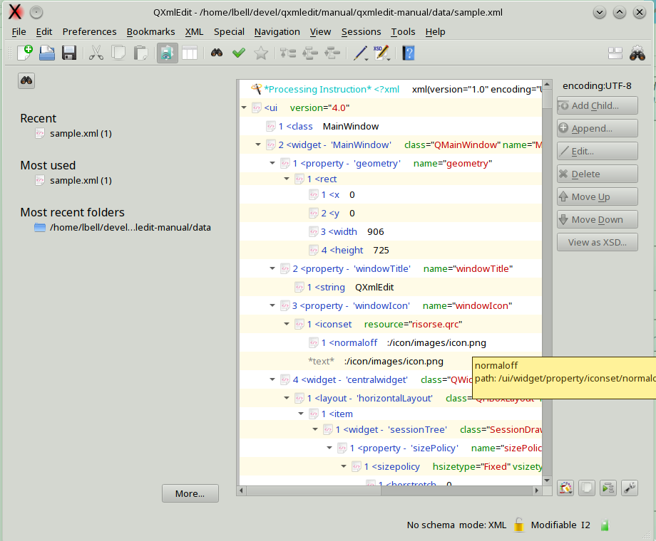
Main edit functions
XSD viewer
Sessions data panel
Styles selector
Indentation
View settings
Data modification indicator
Working mode indicator
Read only status
Session status

Operation with XML

This is a small abstract of the common operations grouped by purpose:
- Navigation:
  - Go to parent element (menu Navigation, shortcut F12).
  - Go to next sibling (Navigation, F10).
  - Go to previous sibling (Navigation, F9).
- Data modification:
  - Insert or append an element.
  - Insert or append a comment.
  - Insert or append a processing instruction.
  - Change the position of a node.
  - Paste a node as child or sibling.
  - Copy or paste a set of attributes.
  - Operation on containers:
    - Insert a parent
    - Insert a child container that enclose all the current children
    - Remove the parent of a node.
  - Transform a node into a comment and vice versa.
  - Insert prolog and namespace declarations.
  - Edit base 64 coded text blocks.
  - Edit base 64 coded attributes.
  - Transform files into base 64 text blocks.
- View Data:
  - Hide all the siblings of a node.
  - Hide all the children of all the sibling of a node.
  - Filter the visible attributes.
  - Hide all the elements that have no children.
  - Show the children count and the size of a node.
  - Close all the siblings of a node.
For a complete description of each operation go to the specific section of this document. Here you will find a small reminder of the commands.

Startup
The first time QXmlEdit is started, it asks the user if a simplified user interface should be activated. Through a panel it is possible to access the main features but there are no restrictions about what QXmlEdit can perform. At any time, using the Preferences menu, the choice can be reverted.
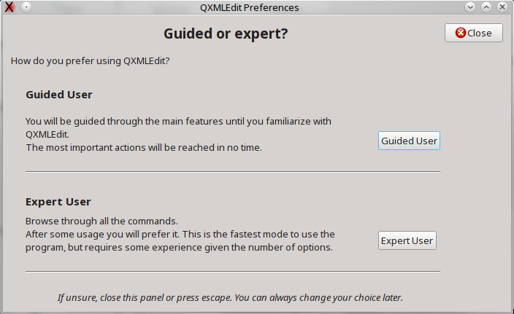
If the choice is “guided user”, the following panel is open:

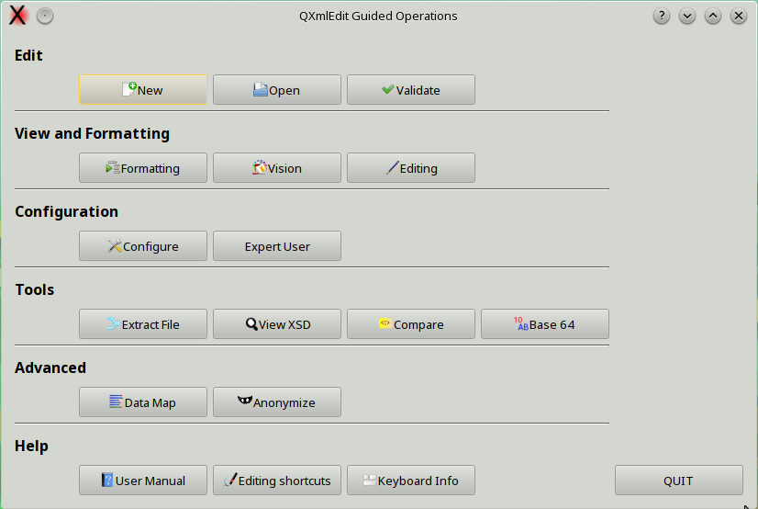
From above panel the following operations can be started:

Item | Description
New | Open a new editor.
Open | Load an XML file.
Validate | Validate XML using XSD.
Formatting | Formatting and indentation options.
Vision | View Options.
Editing | Editing options.
Configure | Open the main preferences panel.
Expert User | Switch to “Expert User” mode.
Extract File | Extract fragments from an XML.
View XSD | View an XSD file as a diagram.
Compare | Compare XML files.
Base 64 | Open the Base64 operations panel.
View Data Map | View XML file statistics.
Anonymize | Anonymize a file using previously created profiles.
User Manual | Open the user manual.
Editing Shortcuts | Show the editing shortcuts.
Keyboard Info | Show the panel that list keyboard shortcuts.

Main Functionality
Menus are divided in main functional groups; the most used commands are kept visible in main dialog as a button on the right.
The menus are described here:
Menu | Functionality
File | XML document creation and saving
Edit | clipboard handling; find command and configuration options
Tasks | common tasks, grouping other menu commands
Bookmarks | all about bookmarks
XML | XML tree manipulation (insertion, deletion, etc)
Special | special XML operations
Navigation | XML tree navigation
View | view commands and options
Sessions | Session related commands
Tools | plugins and tools
Help | help

Working with XML Files
The QXmlEdit goal is to view and edit small XML files. It is not intended to handle data of hundred of megabytes, since it works completely in memory.

Opening Files
- Open files using the File > Open menu.
- In the Open Files dialog choose the file type you are looking for.

Opening Files in New or Same Window
This feature lets you override the settings by opening a file in a new window, if open new files in same window is selected as a global option. If the configured behavior is to open files using new windows, the option lets you reuse the current editor window.
- Use the menu File > Open in New Window if behavior is to open files reusing same window.
- Use the menu File > Open in Same Window if behavior is to open files using new windows.

Using only One Window or One Window per File
This setting can be configured in the preferences dialog.
- Menu Edit > Configure
- Select General tab
- Check “Open in new window” option.

Saving files
You can save the file using this menu commands:
To save the file with the same name:
- Save the file using the File > Save menu.
To save the file with another name
- Save the file using the File > Save As... menu.
To save a copy of the file with another name, but continue to work in the original file:
- Open files using the File > Save a Copy As... menu.
Note: using this last option you make a copy of the file as it is in its current state. The original file is not modified and the editor retains the current state.

Creating a File From Clipboard Contents
Sometimes you can create a new file by pasting an XML text from the clipboard. For example you can cut a block from a database client or a PDF or HTML page.
Use the menu File > New From Clipboard.

Creating specialized files
Using the File > New Specialized item, you can create new documents of a particular kind.
- XSL-FO
- XML Schema
- XSLT
- Maven POM.xml
- SCXML
The documents are created with the predefined namespaces and declarations.
Creating Documents from Snippets
Using the File > New Specialized > New from Snippet item, you can create new documents from a previously saved snippet.

Reloading last saved version
Using the menu File > Reload the last saved version. The modifications to the current file will be lost.

Loading a sample of a document
Using the menu File > Load Sample. A sample of each tag and attribute will be loaded in a new document.

Exporting the XML
The following export methods are available from the File > Export menu:
- Export Element to File
- Copy all to the clipboard
- Export as Java/JavaScript
- Export as C/C++

Avoiding modifications
The document can be put in read only mode using the menu Edit > Read Only

Loading the Last Edited Files
Using the menu File > Recent Files you can load the last edited files.

Working With Preferred Directories
Usually, working with files, there are some directories that are accessed often. QXmlEdit gives you the possibility to remember these places and to quick recall them when opening files.
To add the directory of the current open file to the preferred ones:
- Use the menu File > Preferred Directories > Add Current Directory to Preferred Ones
To edit the directory list in a separate window:
- Use the menu File > Preferred Directories > Edit Preferred Directories...
A dialog will open

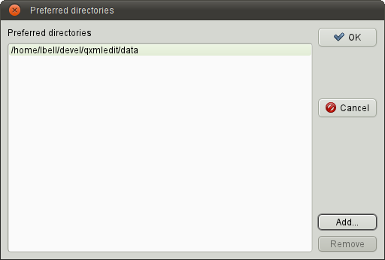
Preferred directories
Insert a new link to directory
Remove a link

To add a new link to a preferred directory
- Push the Add... button.
To remove a link to a directory
- Push the Remove button.
To confirm the directory list press OK.

To open a file into a preferred directory:
Use the menu File > Preferred Directories, then select the directory.

Viewing Elements and Attributes
After having loaded XML data, there are many modes to view elements and attributes. The main view uses a tree representation, mapped on XML data, however you can highlight some data aspect:
To view one element attribute on a separate line (very readable if you are looking for attribute values):
- Select the menu View > Show One Attribute per Line
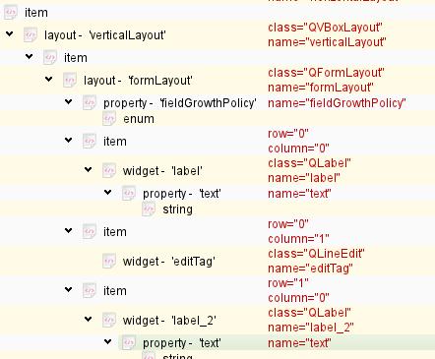
To show the ordinal position of each child relative to their parent:
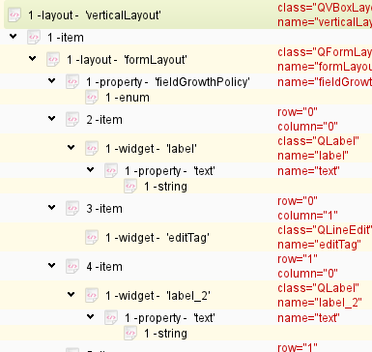
- Select the menu View > Show Child Index
To show a more compact view:
- select the menu View > Compact View
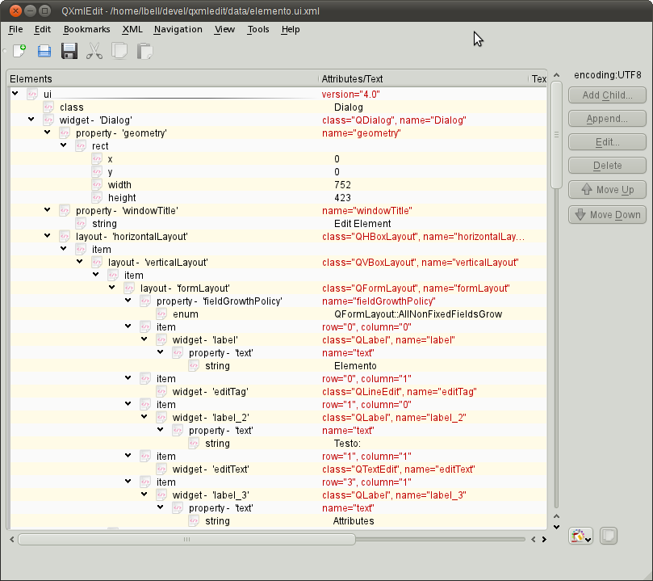
To show the attribute length near to their name:
- Select the menu View > Show Attributes Length.
To show attribute contents using a fixed size font, to better discover the presence of spaces:
- Select the menu View > Show Attributes Length.
To show in a separate column the text length of the elements:
- Select the menu View > Show Text Length.
To show the number and size of the children of each element:
- Select the menu View > Show Element Size.
To show the text contained into elements as base 64 encoded:
- Select the menu View > Show Text as Base 64 Coded.
Note: this option can have an impact on visualization speed.
To expand all the closed branches of the XML tree:
- Select the menu View > Expand
To enlarge or reduce the size of the character used to display the data:
- Select the menu View > Zoom In or View > Zoom Out.
or
- Use the Control key while scrolling with the mouse wheel.

To view only the structural components of the XML (the elements that have other elements as children):
- Select the menu View > Hide All the Leaf Children
To undo the effect of the previous command:
- Select the menu View > Show All the Leaf Children.
To show or hide on the basis of individual node, first select the node, then, to hide:
- Select the menu View > Hide Leaf Children.
To show:
- Select the menu View > Show Leaf Children.

Filtering Attributes
It is possible to filter the display of the attributes. A profile can show only a set of attributes or hide a given list of attributes. When an element has some hidden attributes, a filter icon appears.
It is possible to manage the attributes that can be shown or hidden in each element using the menu View > Filter attributes > Manage Profiles...
In the management section it is possible to create delete or apply profiles.
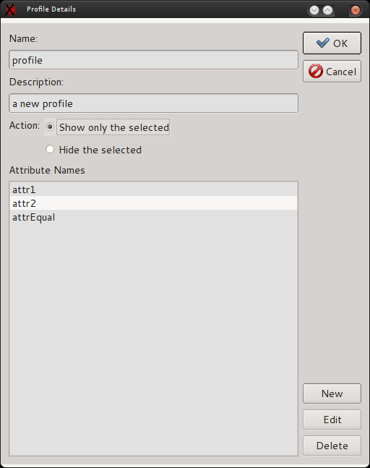

To apply a temporary profile, based on the current element:
- Select an element.
- Use the menu View > Filter attributes > Apply a Temporary Profile.

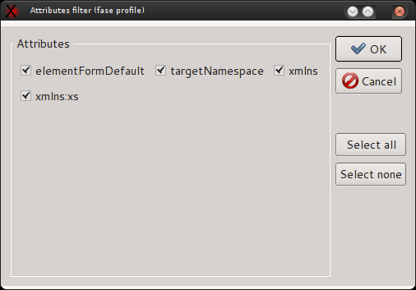
It is possible to transform the temporary profile into a regular one using the menu Use the menu View > Filter attributes > Save the current Profile.

Working with name spaces and prefixes
Namespaces and prefixes commands can be accessed from the XML > Namespaces menu item. Both offer prefix manipulation, but only namespaces commands are aware of namespace concepts. Prefix related items do not know about namespaces at all, they simply manipulate prefixes.

Prefix operations
The operations that can be performed on prefixes are:
- Assign a prefix.
- Remove a prefix.
- Replace a prefix.

Assigning a prefix
This operation sets the same prefix to all the elements on which it is applied. No considerations about namespace declarations are made.
Panel:
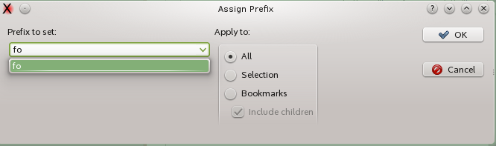
Items:

Item | Description
Prefix to set | The prefix to apply
Apply to | Elements involved.

Removing a prefix
The remove option removes the selected prefix from all the items, only from the selected item or from the selected item and all its descendants, from tags and attributes. If there is a selection, the prefixes found recursively in the selection are shown in the prefixes combo. No attention is payed to the namespaces in this operation.
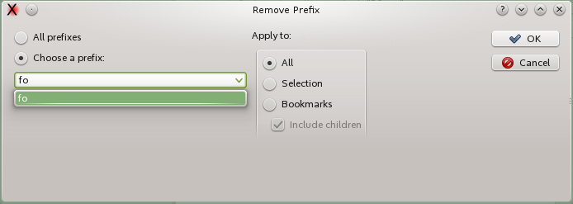
Items:

Item | Description
All prefixes | Choose to remove all the prefixes.
Choose a prefix | Removes a single prefix.
Apply to | Elements involved.

Replacing a prefix
This operation replaces one or all the prefixes with another one.
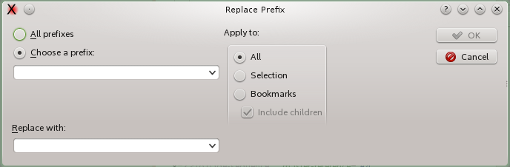
Items:

Item | Description
All prefixes | Choose to replace all the prefixes.
Choose a prefix | Replace a single prefix.
Replace with | The prefix that will be inserted.
Apply to | Elements involved.

Namespace operations
The operations that can be performed on namespaces are:
- Assign a namespace.
- Remove a namespace.
- Replace a namespace.
- Normalize a namespace.

Assigning a namespace
This operation assigns a namespace to a tree or to all the document. The selected namespace will be declared if not existent.

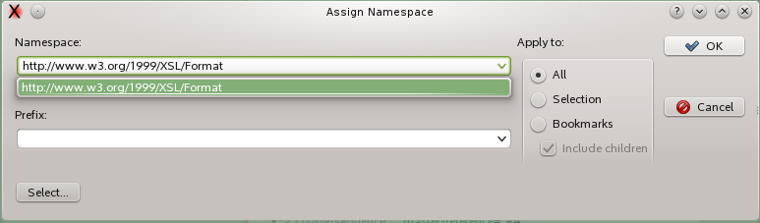
Items:

Item | Description
Namespace | The namespace to set.
Prefix | The prefix to set.
Apply to | Elements involved.

Removing a namespace
Remove one or all the namepaces. The declarations of the removed namespace can be optionally removed.
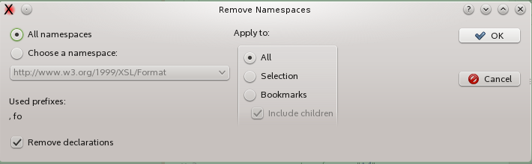
Items:

Item | Description
All namespaces | If chosen, all the namespaces will be removed.
Choose a namespace | Select only one namespace to remove.
Remove declarations | With this option even the namespace declaration will be removed.
Apply to | Elements involved.

Replacing a namespace
This operation replaces a selected namespace with another one. All the namespace elements will be translated, even if declared with different prefixes.
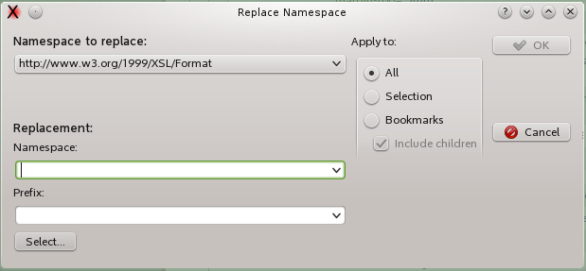
Items:

Item | Description
Namespace to replace | The namespace to be replaced.
Namespace | The namespace that will be assigned.
Prefix | Prefix of the new namespace.
Select | Recalls the namespace selection panel.

Normalizing a namespace
This operation sets the same prefix on all the elements and attributes belonging to a namespace. The prefixes of the namespace other than the selected one are lost and their declarations removed.
The normalization operation assumes that the XML is well formed and valid, so the chosen namespace must be legally declared. This said, it will not be declared anew on the children if the option “Declare namespace on root” is selected.
This option removes all the declaration from the inner of the selection tree and forces a declaration on root of the selection tree. If the apply zone is only a part of the tree, only this part will be checked. If there is no namespace declared, a declaration on root will be created if the option is enabled.
Using this option it is possible to manage a namespace in only a branch of the XML tree.
Panel:
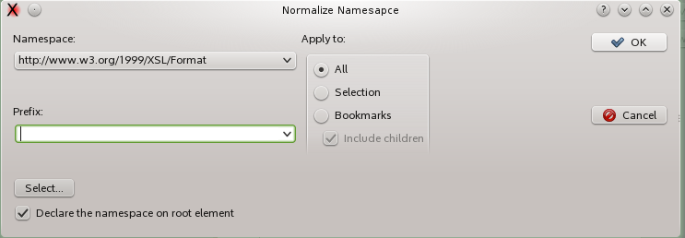
Items:

Item | Description
Namespace | The namespace to normalize.
Prefix | The prefix to apply to normalized namespace.
Select | Opens a namespace selection panel.
Apply to | Elements involved.
Declare namespace on root | The declaration of the namespace is moved to the root element only, any other inner declaration will be removed.

Choosing an Editing Mode
Using the XML > XSLT Edit Mode menu item you can switch to XSLT edit mode. When loading a file with "xsl" extension or containing a reference to XSLT namespace a panel will open.
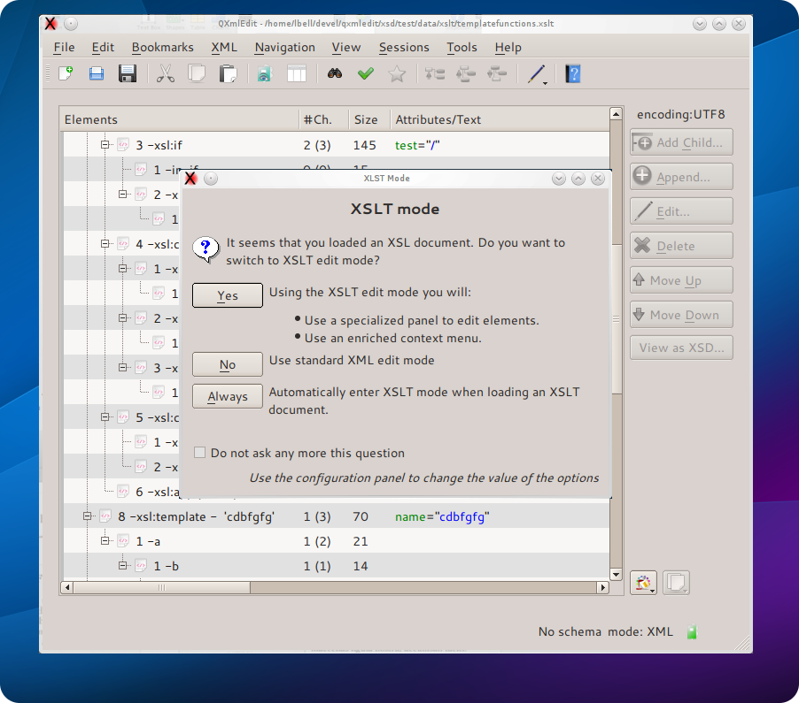
- To activate the XSLT mode simply answer "Yes" or use the return key.
- To have the mode always activated without answering the panel any more, select "Auto".
The settings can be also changed using the preferences.
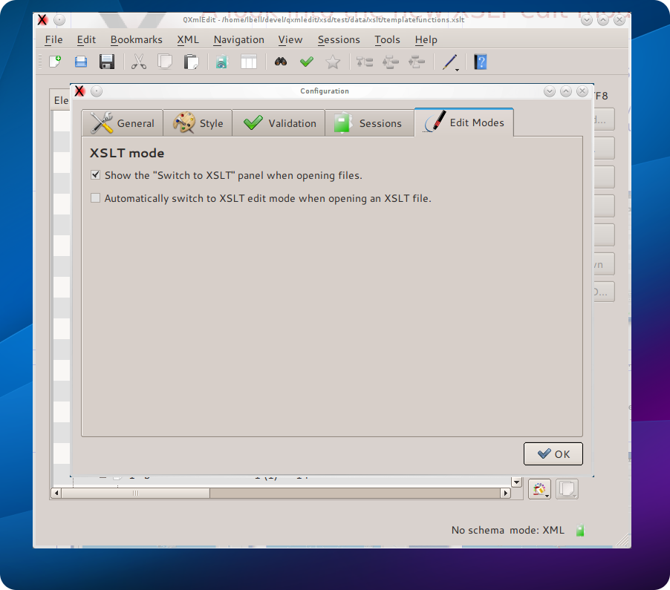
- From the Edit menu choose "Configure", then "Edit modes".
- Set if the XSLT edit mode should automatically engage.
- You can hide the panel if you do not care to enter this mode.

Using XSLT Edit Mode

Specific display style
A specific display style will be applied only to XSLT elements. The intermixed non XSLT elements will not be touched, to reveal the XSL structure at a glance.
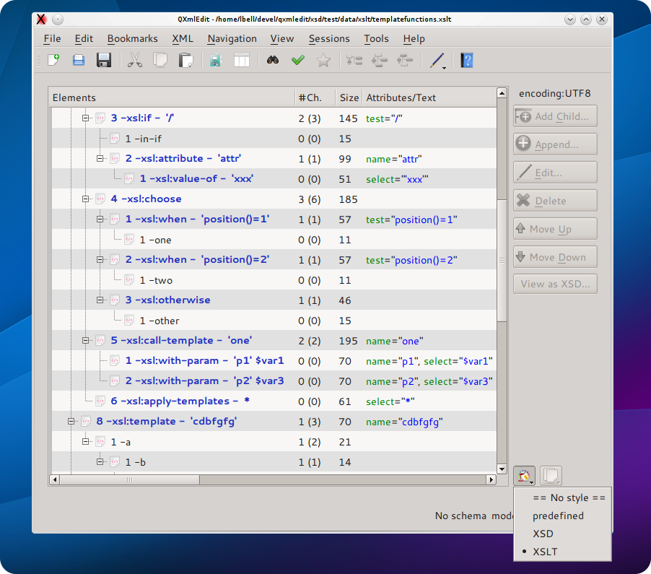

Specific edit panels
1- Double click an XSL element in the editor.
2- A special panel will open.
3- When you edit the "select" attribute, the auto-completion function will list the relevant variables.
4- When invoking templates or parameters, you will see their names in the combo.
5- To return to the usual property panel use CTRL-double click.
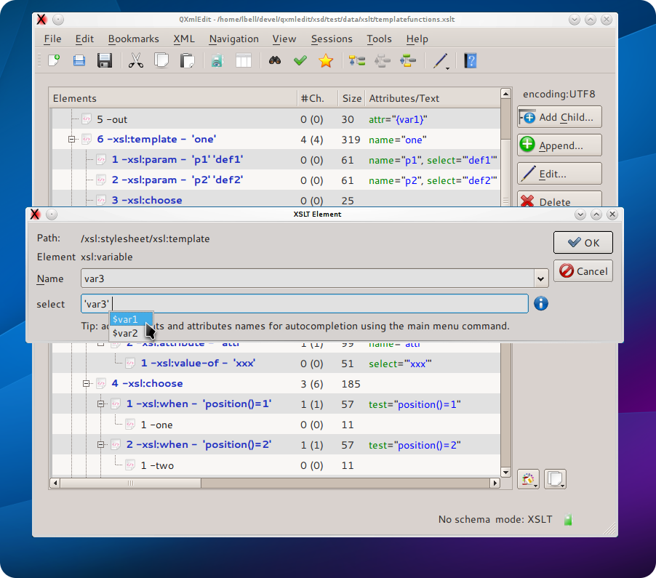

A specific context menu
A new context menu appears on the editor elements. The menu propose to you the most used XSL elements giving you the choice to append them to the current element as sibling, or to insert them
as a child.
The proposed elements are sync with the context, that is in a "call-template", the only "with-
parameter" element is proposed as a child.
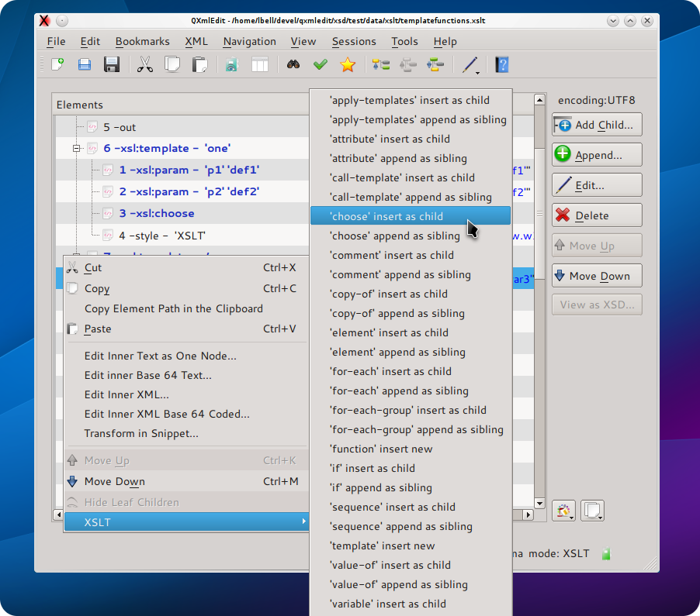
Using names for auto-completion
When XSTL mode is acting, you can scan the target XML file to extract names to be used with the auto-completion feature of the edit panel.
Use the menu XML > Target XML
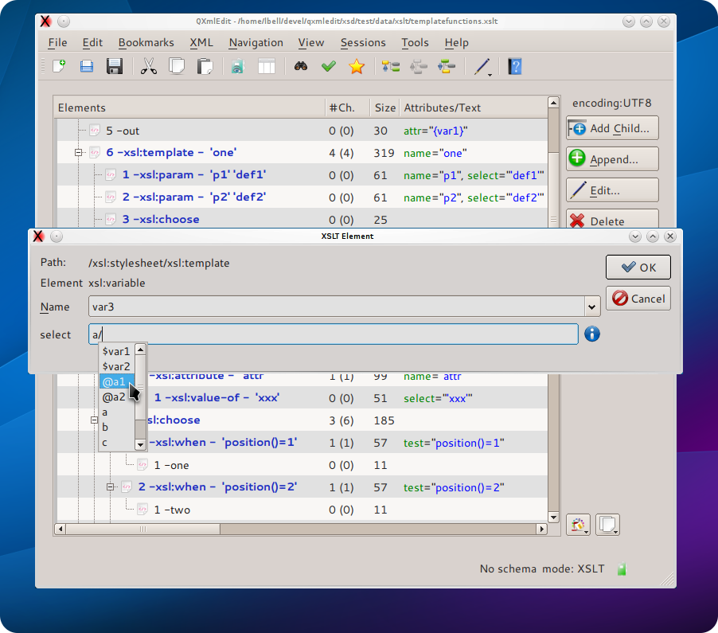

Navigate templates and functions
A XSL navigator for functions and templates will open automatically in the editor when choosing XSL edit mode. The navigator can be shown or hidden using the menu Navigation > Show XSL Navigator. A double click will lead you to the template or function definition in the editor.

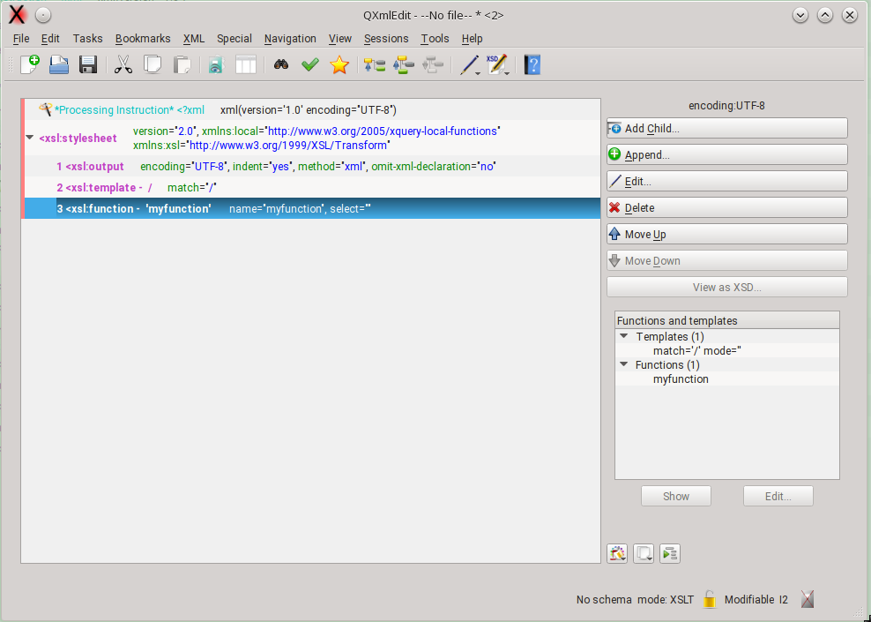

Using SCXML Edit Mode

Specific display style
A specific display style will be applied only to SCXML elements. The intermixed non SCXML elements will not be touched, to reveal the SCXML structure at a glance.

Specific edit panels
With SCXML edit mode enabled:
1- Double click an SCXML element in the editor.
2- A special panel will open.
3- When selecting a state name, a combo will reveal the list of states defined in the file..
5- To use to the usual element edit panel use CTRL or ALT while double clicking.
If the SCXML edit mode is not enabled, the double click modifiers are reversed.

Navigate states
A SCXML navigator for states will open automatically in the editor when choosing SCXML edit mode. The navigator can be shown or hidden using the menu Navigation > Show SCXML Navigator. A click will lead you to the state definition in the editor, a double click will open the edit properties window.
The list of states can be flat or hierarchical.
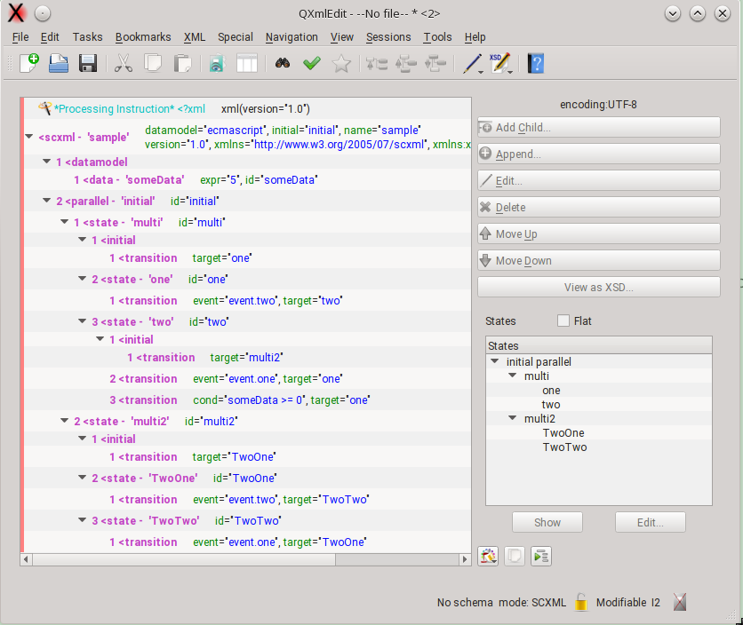

XML Schema management

Inserting XML Schema References
It is possible insert references to an XML Schema set of files. Using the menu XML > Schema Instance > XML Schema References the “Insert Xml Schema References” dialog will appear.
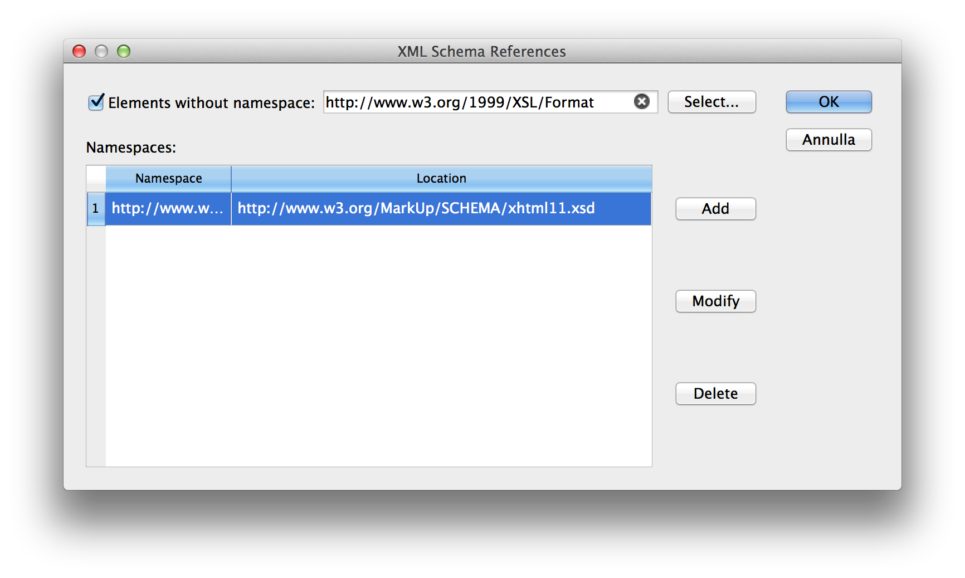
In this dialog you can insert
- a schema reference for elements without namespace
- for each namespace, a schema reference
The references will be inserted in the root element using the xsi namespace defined as http://www.w3.org/2001/XMLSchema-instance namespace. If the namespace is already declared in the root element, it will be used, else the namespace declaration will be inserted. If the prefix xsi is already used, a new prefix will be created.

Using the XSD Edit Mode
There is a facility for edit XML Schema documents in the editor a set of menu commands:
XML Schema > Insert No Namespace Schema Reference Attributes : insert a no namespace attribute for the target schema to complete.
XML Schema > Insert Schema Reference Attributes : insert a namespace attribute for the target schema to complete.

Editing or inserting a type, attribute or element
Using the XML Schema menu items it is possible to edit or insert XSD types.

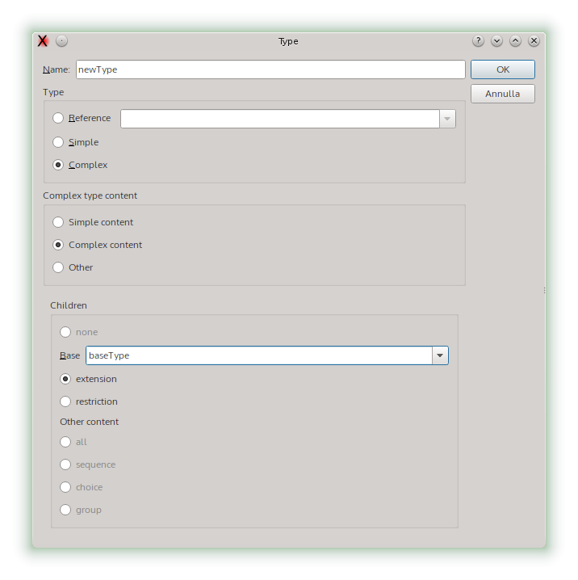
Operations in the dialog:
Choosing the type
- Reference: will set a reference to a type.
- Simple: inner simple type.
- Complex: inner complex type.
When choosing a complex type, it is possible to choose the content type.
If it is an update of existing data, the existent children that are not compatible with the selected type will be deleted, but the children that are compatible will be preserved.

Edit an annotation
The annotation of XSD objects can be edited using the menu:
XML > XML Schema > Edit XSD Annotation
If the element has no annotation one annotation is automatically created and the edit panel is open. From this panel is it possible open the complete edit annotations panel where more than one annotation can be inserted for the given element. If the element has already more than one annotation item, the full annotation panel is open.

Single annotation panel
This panel configures a single annotation item.
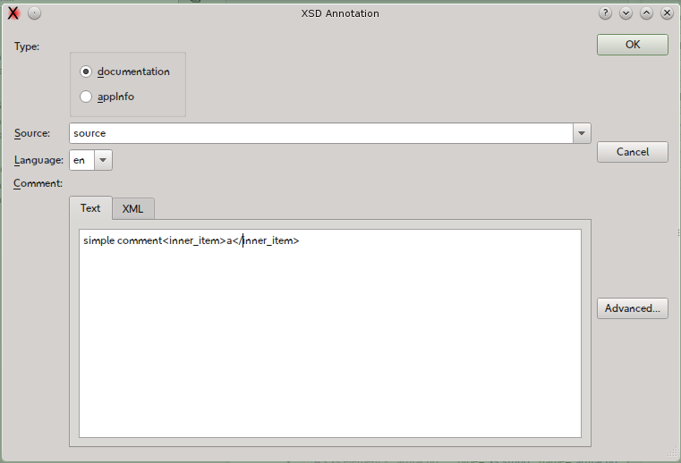
The panel can show the inner contents of the annotation when containing XML mixed to text.
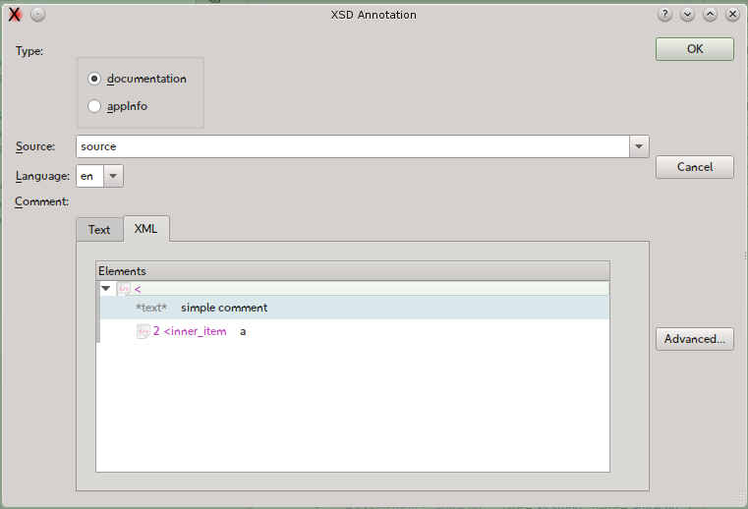

Available options:

Command | Functionality
Type | Switch the type of the annotation item between documentation and appinfo.
Source | Set the source of the item.
Language | Valid only for documentation type.
Comment/text | Edit field for the annotation item
Comment/XML | XML view of the annotation item. This view is read only.
Advanced | When the panel opens and the parent element has no items or only one, this button opens the advanced edit panel.

Annotation list edit panel
This panel shows a list of annotation items. Form here the items can be created, edited and deleted.
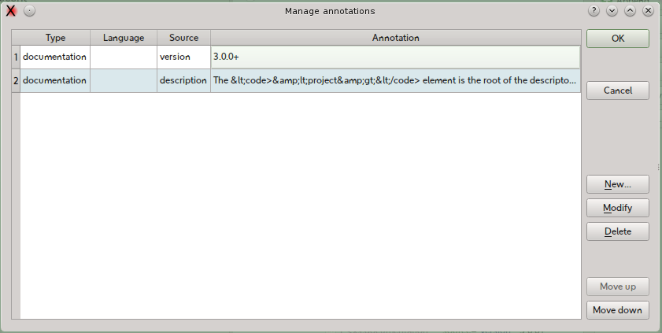
Available options:

Command | Functionality
New | Create a new item.
Modify | Edit the selected item. This option can be triggered also by a double click on the list.
Delete | Delete the selected item.
Move Up | Move the item one position up in the list.
Move Down | Move the item one position down in the list.

Editing Enumeration or Facets
The factes can be edited selecting the restriction element ad using the menu item:
XML > XML Schema > Edit Enumeration or Facet
The panel list all the facets. The items can be reorder, edited and annotated. Not legal elements are discarded.
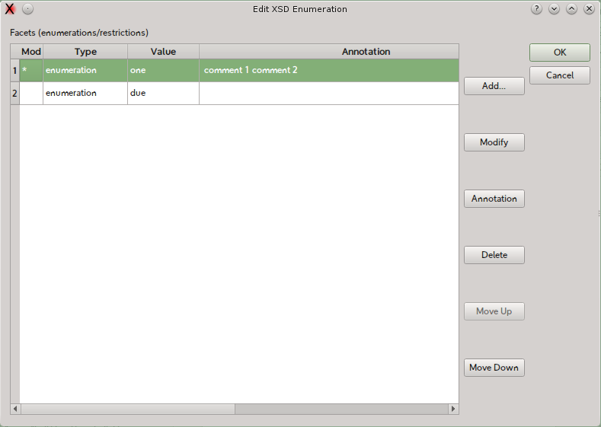

Edit facet panel

This panel edits a single facet item.
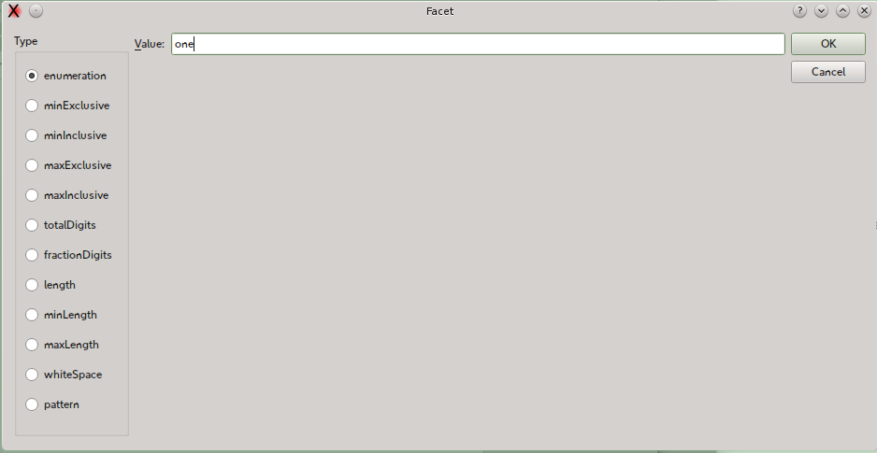

Editing XML Schema Attributes

Inserting the Schema Instance “nil” Attribute
Select an element and use the menu “XML>Schema Instance>Insert “nil” Attribute” to insert the Schema Instance (XSI) “nil” attribute. If the namespace “xsi” is not present, it will be inserted in the element, changing the prefix if the same prefix is already used; after that the attribute is inserted.

Removing the Schema Instance “nil” Attribute
Select an element containing the Schema Instance “nil” attribute and use the menu “XML>Schema Instance>Remove “nil” Attribute” to remove the XSI “nil” attribute. If the XSI namespace is declared in the elements and it is not used in the same element or its children, the namespace is removed too.

Inserting the Schema Instance “type” Attribute
Select an element and use the menu “XML>Schema Instance>Insert “type” Attribute” to insert the Schema Instance (XSI) “type” attribute. If the namespace “xsi” does not exist, it will be inserted in the element, changing the prefix if the same prefix is already used; after that the attribute is inserted. The type can be chosen by using a dialog.

Removing the Schema Instance “type” Attribute
Select an element containing the Schema Instance “nil” attribute and use the menu “XML>Schema Instance>Remove “type” Attribute” to remove the XSI “type” attribute. If the XSI namespace is declared in the elements and it is not used in the same element or its children, the namespace is removed too.

XML From XSD and Vice-Versa
It is possible to generate a sample XML from a XSD or to create the XSD from XML. To enable this feature Apache XMLBeans is required. This feature will only work if the tool is installed.

One-time Configuration
Open the Configuration panel, navigate to Validation panel and set the path of inst2xsd (part of XMLBeans) and xsd2inst into the fields in the XSD Manipulation section.

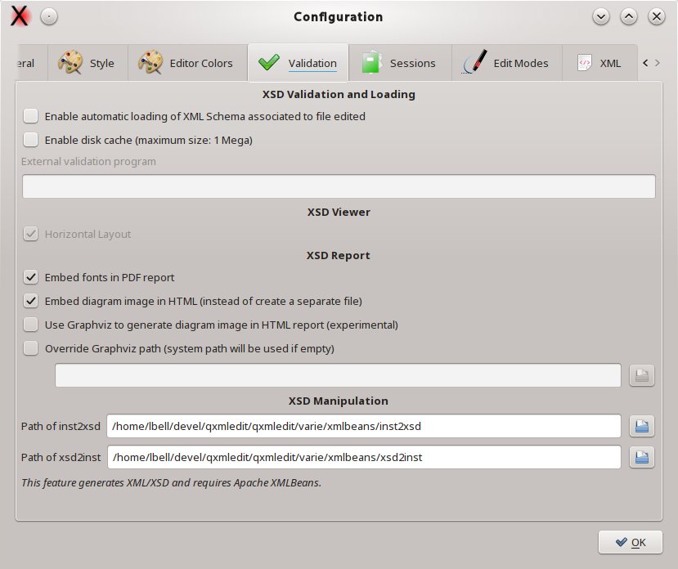
From now on it is possible to generate an XSD from data using the menu Special>Generate XSD From Data. A new editor window will open with the generated XSD.
To generate XML from XSD, load an XSD file in the editor, then use the menu Special>Generate XML from XSD. If the XSD contains more than one element that can be used as root, a panel will open asking which element use as root.
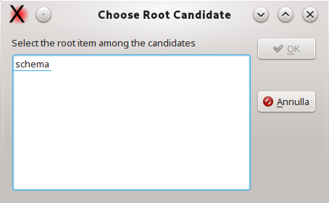

Help and information
There are some facilities to discover and search commands

Show keyboard shortcuts
With the toolbar button or the menu Help>Show Keyboard Shortcuts the shortcuts bound to the current editor window can be visible listed by ket qualifier.
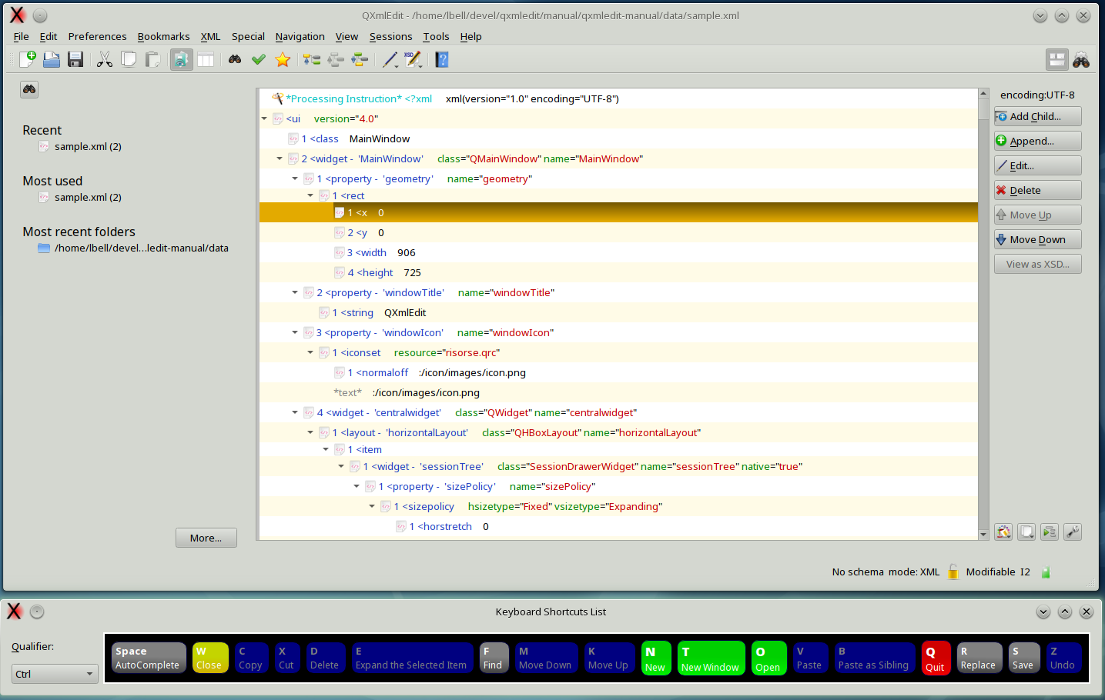
Changing the qualifier key in the combo the shortcuts introduced by that qualified are reported. The buttons can be pressed using the mouse.

Tasks
Tasks are operations than can be accomplished using different commands. They are a sort of macro, The following tasks are predefined:

Task | Description
Adjust Display Detail | Set the editor view options.

Adjust Display Detail
With this task the level of detail of the editor is set. You can choose between some predefined settings and have a preview of each one.
Options:
Command | Description
Use Predefined | Use the predefined settings.
Use (value) | Use the style shown in the selected tab.
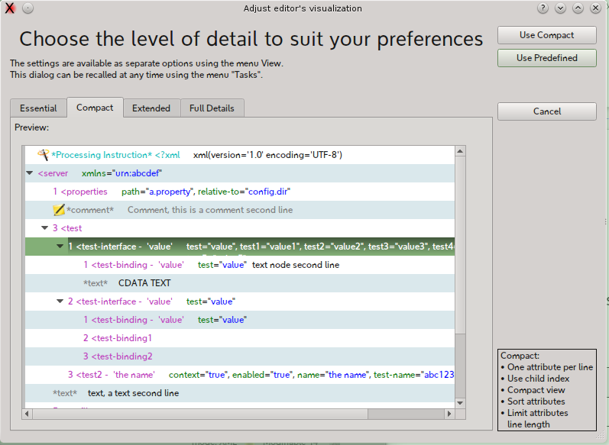

Preferences
The preferences panel can be opened using the menu Edit > Configuration.
The panel allows the configuration of the following categories:

Information | Description
General | General options.
Style | Management of display style in the editor.
Editor Colors | The name says all.
Validation | Option related to XML and XML Schema validation.
Sessions | Management of sessions data.
Edit Modes | Activation of special modes in the editor (e.g. XSLT).
XML | XML management.

Here a detailed explanation of the options:

General

Option | Description
Show welcome page | Shows the welcome page at program start up.
Enable experimental features for test purpose | Enables experimental feature in development editions.
Default font bold | Use bold font weight for elements.
Override the font for elements display | Use a user chosen family in the editor.
Override the font for fixed spacing attributes | Use a custom font when rendering attributes with mono spaced font.
Enable Logs | Enable logging.
Automatically expand editor tree when loading data | Expands (open) the whole tree after loafing a new file.
Autoscroll in the elements tree | Enable autoscroll when dragging items
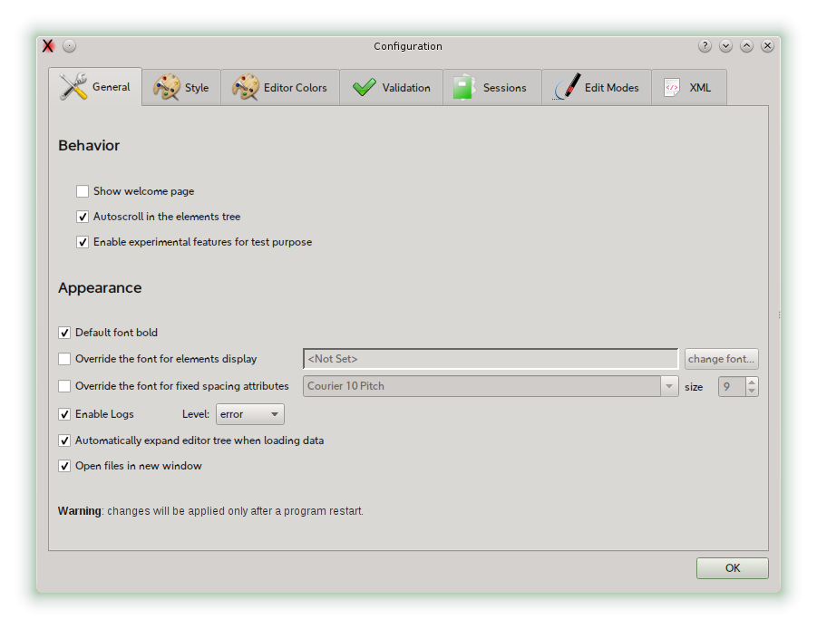  Open files in new window | A new window is used each time a file is loaded.
Limit attributes length | The maximum length of the attributes lines in XML visualization.

Style
This panel lets you choose the location for user defined styles files.
Option | Description
Use the program directory | Use the installation folder
Use the standard Operating System location | Use the default location for data.
Use the following directory | Use a user defined folder.

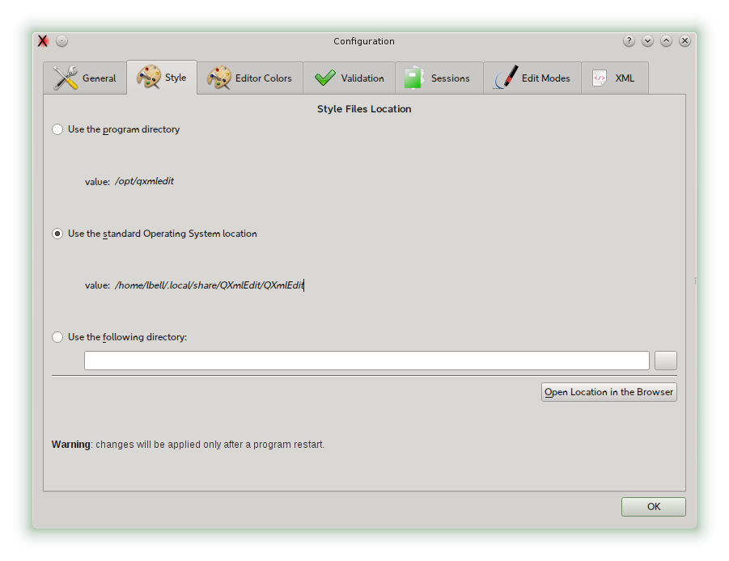

Editor colors
This dialog is described in details in the Style section. You can customize the colors of the editor.
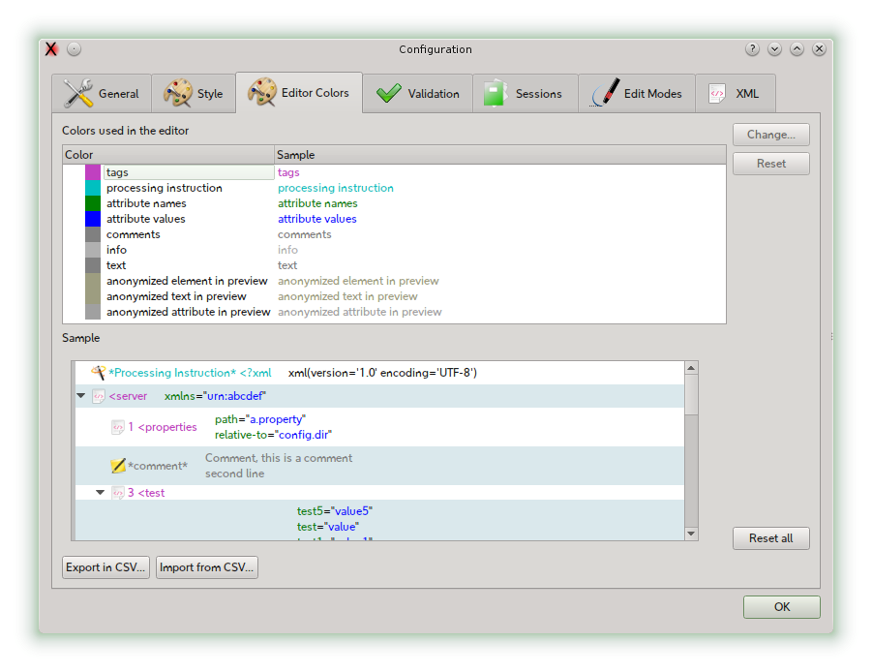

Validation

Option | Description
Enable automatic loading of XML Schema associated to file edited | Automatically loads referenced XML schema files in the background at the XML file loading.
Enable disk cache (maximum size: 1 Mega) | Enable cache for XML schema files to avoid unnecessary network traffic.
Embed fonts in PDF report | Option to embed fonts in PDF report
Embed diagram image in HTML | If the diagram image in HTML report should be inlined or generated as external file.
Use Graphviz to generate diagrams in HTML | Use GraphViz (not included in QXmlEdit) to generate the diagram image. This option is experimental
Override GraphViz path | Custom path to dot executable.

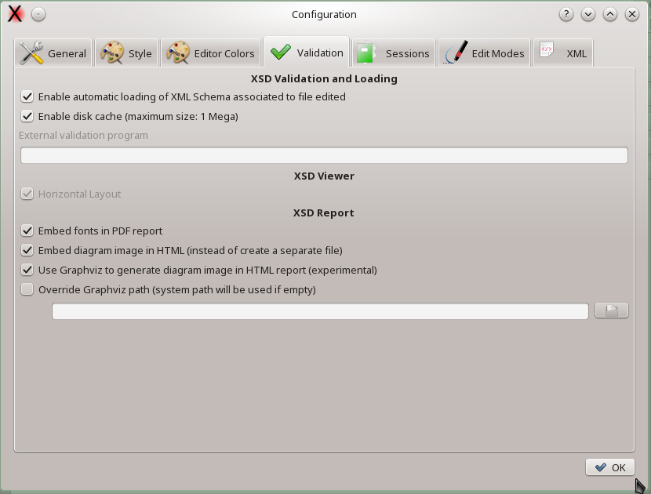

Sessions
Session options described in the Session section.
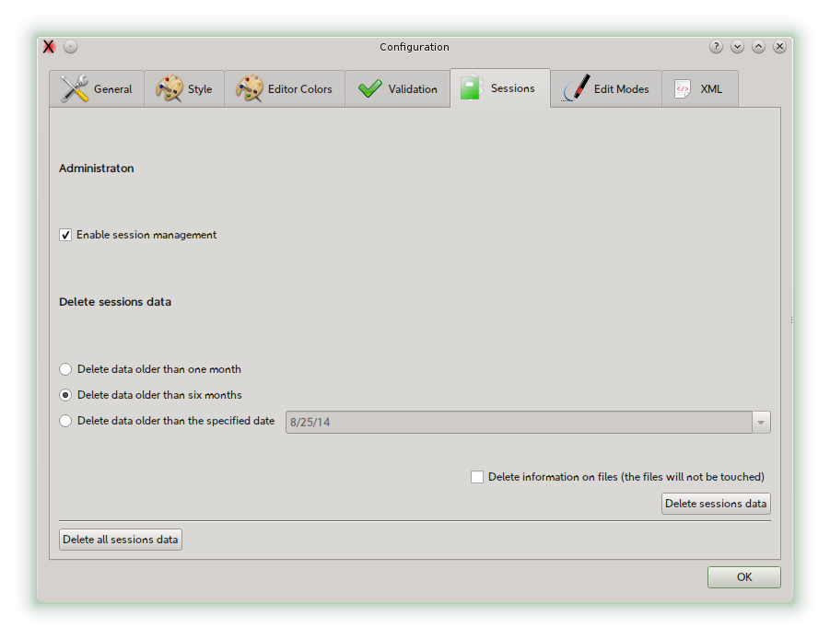

Edit Modes
This panel for the options related to specialized edit modes.
Option | Description
Automatically switch to XSLT edit mode when opening an XSLT file. | When loading a new file, if it is recognized as a XSLT documents, XSLT edit mode is automatically enabled.
Show the "Switch to XSLT" panel when opening files. | When loading a new file, if it is recognized as a XSLT documents, open the XSLT edit mode panel.
Use external Java engine with Saxon command line syntax | If you want to use an external XSLT Java engine having the same command line interface as Saxon, insert here the path of the jar.
Automatically switch to SCXML edit mode when opening a SCXML file. | When loading a new file, if it is recognized as a SCXML documents, SCXML edit mode is automatically enabled.
Show the "Switch to SCXML" panel when opening files. | When loading a new file, if it is recognized as a SCXML documents, open the SCXML edit mode panel.

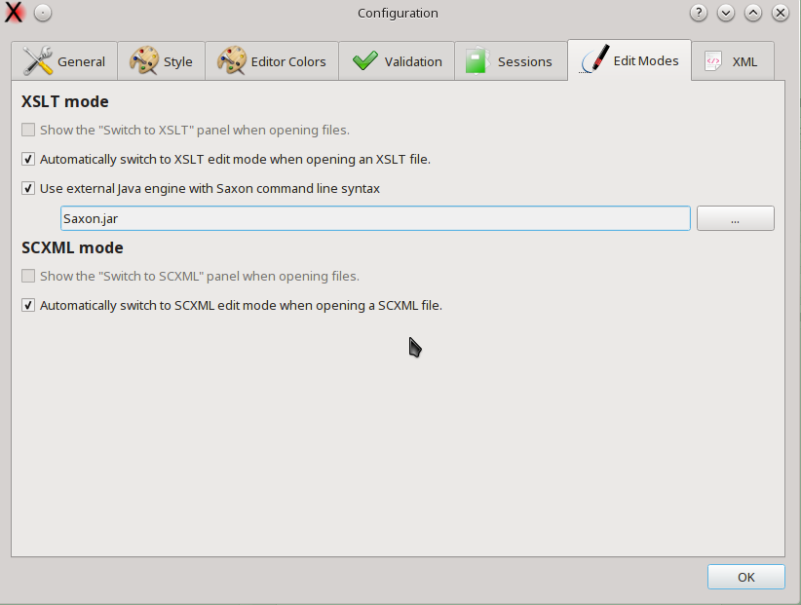

XML
XML management options

Option | Description
Automatically insert prolog with encoding | When creating new files, insert XML prolog with optional encoding specification.
Automatically update metadata as processing instruction if found when saving data | Enable the update of QXmlEdit specific metadata in the file when saving.
Automatically insert formatting metadata process instruction | When creating a new XML document insert a processing instruction that holds formatting settings (indentation, ...)
XML indentation on save | Enable or disable XML indentation when saving. A value of 0 still saves on element per row. You have to disable it explicitly if you want only one output text line.
Save using stream instead of DOM | Enabled by default. Allow a finer control on input and output. DTD declarations are not handled if this option is unchecked.
Sort alphabetically the attributes | On saving the attributes will be sorted alphabetically on their name.
Attributes line length | It limits the start column of the attributes. If a limit is set, if the attribute start at a column that is greater than the distance from the tag end than the limit, a new line is started.
Limit attribute length to X columns | Limits the length of the attribute zone when saving the file.
Process formatting metadata | When reading a document, if formatting metadata are fouund, they will be applied.
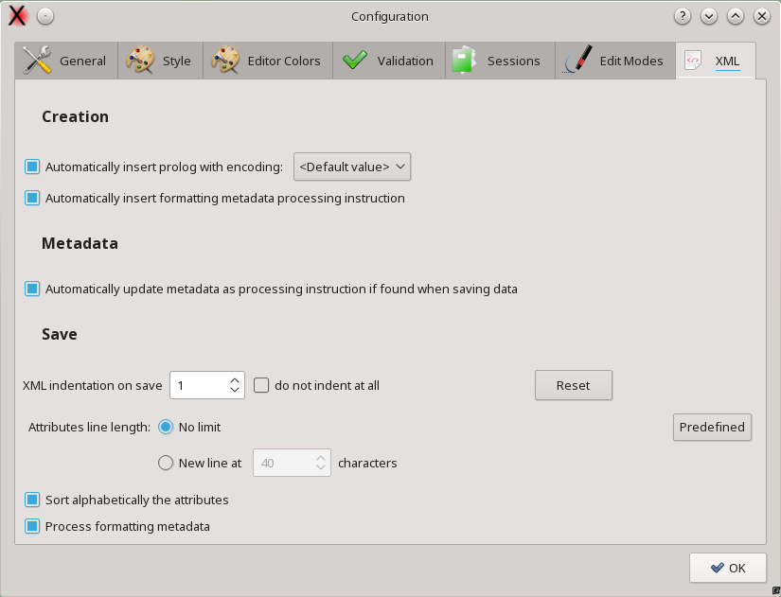

Customization

Choosing a Display Style

QXmlEdit can use a different display style, the font used, its dimensions and the color, to represent different XML structures. The style description can be created by the user and applied on demand. QXmlEdit comes with some predefined styles.
The style can display the value of some attribute near to the element tag to highlight the element type.
To apply a style:
- In the main window, click the styles popup ( ), then choose the desired style.
To remove a style:
- In the main window, click the styles popup ( ), then choose the ”== No Style ==“ item

The style files location can be configured using the menu item Edit > Configure.
In the appendix there is the complete style reference.
An example of style applied to an XML Schema file is represented in the following screenshot:
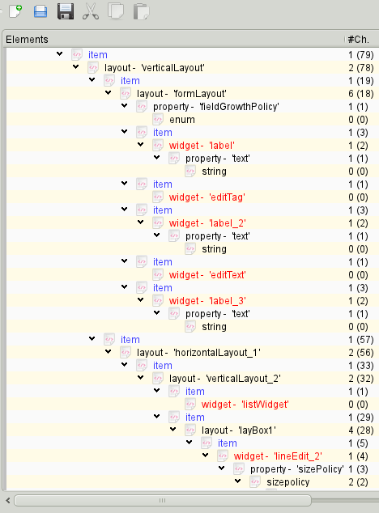
The style can be used to highlight the elements.
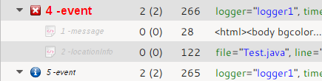
The Style can be based on rules, in the appendix there is the full detail.

Operations

Editing Elements
Basically you can use the tree view to insert child nodes or append nodes as brothers of the current one. There is a separate input panel for each node type you can manipulate: elements, comments, processing instructions.
To insert an element as a child of some other node:
- Select the XML > Add a Child Element menu.
or
- Click the button Add Child... on the main window.
To append a node as brother of the current selection:
- Select the XML > Append a Brother Element menu.
or
- Click the button Append... on the main window.
To work with attributes:
- open the element edit panel and start editing
To insert a processing instruction as a child of some other node:
- select the XML > Add Processing Instruction as a Child menu
To append a processing instruction as a brother of some other node:
- select the XML > Add Processing Instruction as Brother menu
To remove a node of any type (element, attribute, comment, processing instruction):
- click the button Delete on the main view

Navigating Elements
There are some shortcuts to move from one element to another one using the relationship between the two. These shortcut are handful especially when the data tree is very tall, and avoid you the necessity to continually scroll the window while examining data.
To rise from an element to its parent:
- select the element, then press F11
To jump to the next element at the same level of the current one:
- select the element, then press F10
To jump to the previous element at the same level of the current one:
- select the element, then press F9
To close all the children of an element and all the children of their brothers (it gives you a compact view of the tree level in one operation):
- select the element, then press F12

Editing Elements and Attributes
To edit the selected object:
- double click on the selected element
or
- press the Edit... button in the main window
When editing elements a panel will open. In the panel the current element path is shown; it is possible to manage namespaces by recalling a library of user defined data. It is possible to manage base 64 coded attributes.

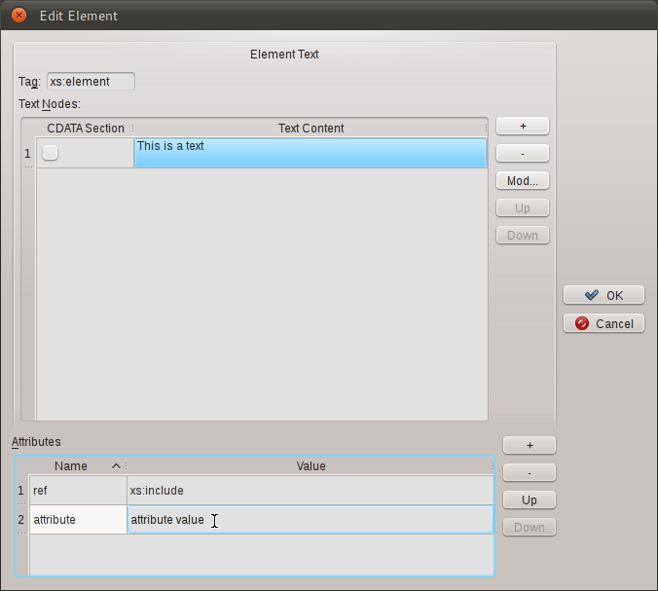
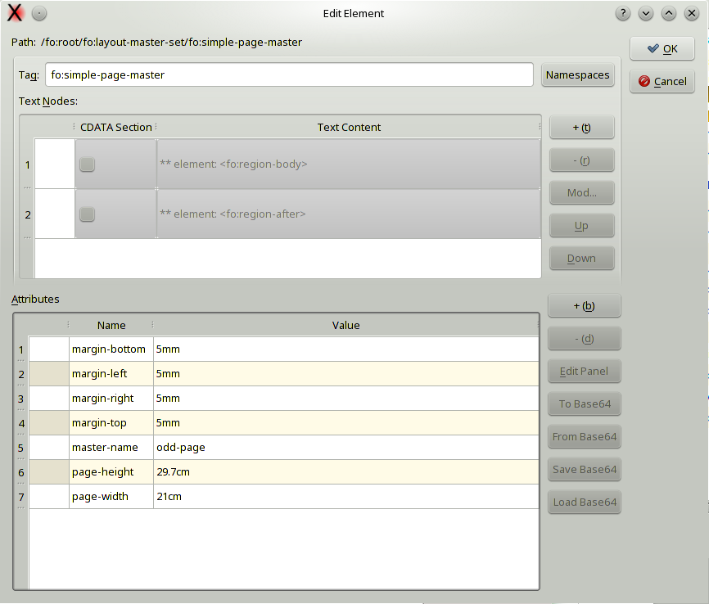
In the panel you can insert the following information:
Name | Information
Tag | The tag of the element
Text Nodes | You can insert or remove text nodes as element children
Attributes | You can edit the element attributes

To insert a text node:
- press the + button in the text nodes section
To insert a CDATA text node:
- press the + button in the text nodes section then activate the CDATA check box on the text nodes table
To modify text node content:
- Select the text node, then press the Mod... button. A panel will open.
Note: you cannot edit child element nodes in this panel, only text nodes.
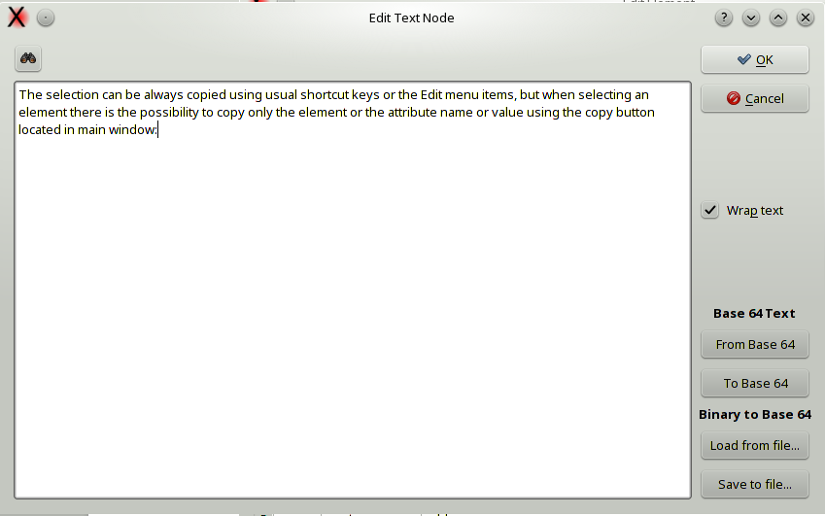
To insert a base 64 coded text:
- Insert the text, then press To Base 64 button, then save the text.
To modify a base 64 coded text:
- Press the From Base 64 button, the text will be decoded, modify the text, then press To Base 64 button, then save the text.
To view the text on more lines even it is a single line:
- Activate the Wrap text check box.
To load a binary file as base 64 coded text:
- Press the Load from file... button, then browse to the file in the file dialog.
To save current base 64 coded text into a binary file, decoding the values:
- Press the Save to file... button.

Searching text
In text panel there is a tool button at the top just over the text box; when pressed the search panel appears.
The option for text search are:
- Search only whole words.
- Search with case sensitivity.

Deleting siblings
The menu XML>Siblings lets you
- Delete the siblings before the selected element.
- Delete the siblings after the selected element.
- Delete all the siblings of the selected element.

Copying Selected Text Into the Clipboard
The selection can be always copied using usual shortcut keys or the Edit menu items, but when selecting an element there is the possibility to copy only the element or the attribute name or value using the copy button located in main window:

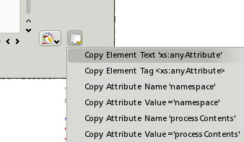

to copy the selected element tag:
- click the Copy Element Tag item
to copy the selected element content:
- click the Copy Element Text item
For each attribute of the selected element:
to copy the attribute name:
- click the Copy Attribute Name item
to copy the selected attribute value:
- click the Copy Attribute Value item

Namespaces
In the edit element window it is possible to recall the namespaces management dialog.
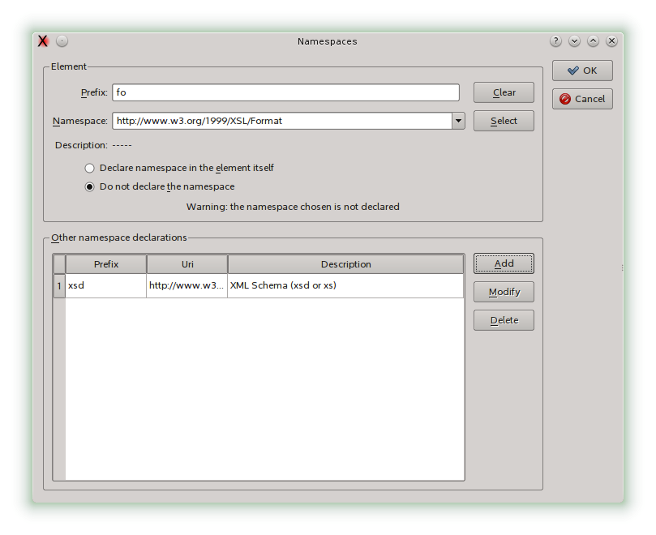Namespace management dialog
In this dialog it is possible insert namespace references recalling the namespace selection dialog.
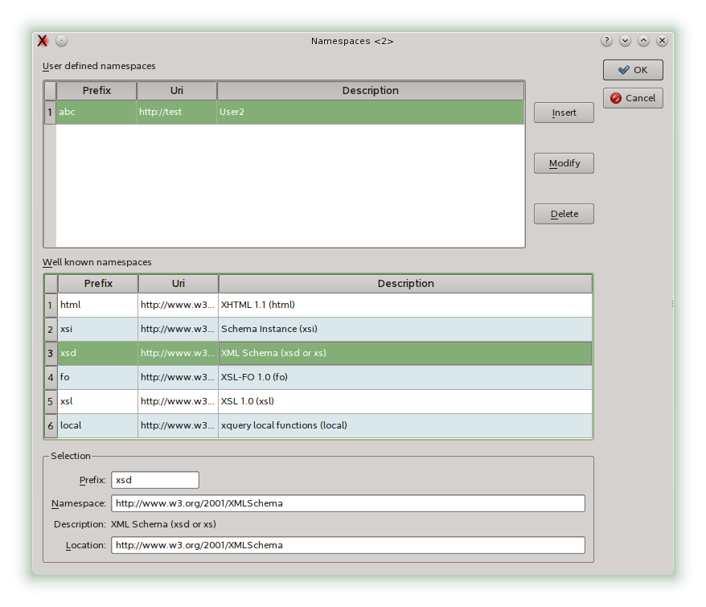Namespace list dialog
I n this panel it is possible to select a system defined namespace or choose a user defined namespace. The user defined namespaces are managed in a separate dialog, stored permanently and are available to successive sessions of QXmlEdit.
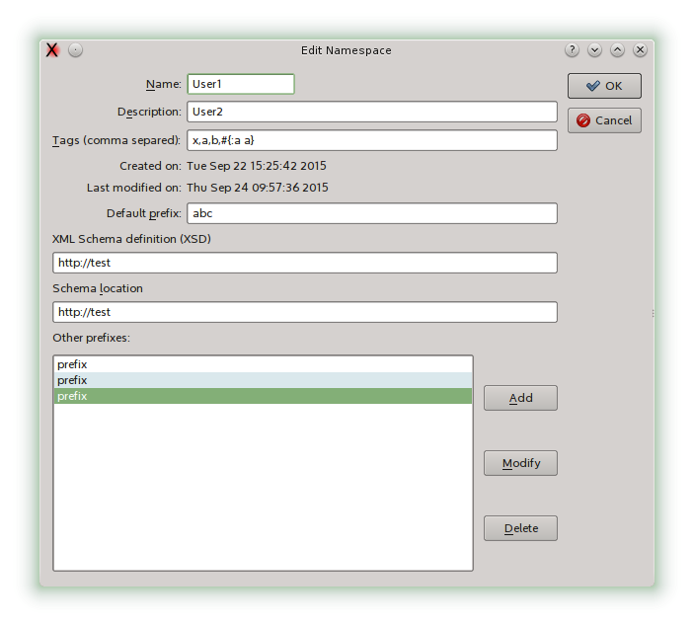

Using the Bookmarks
You can mark the elements with bookmarks for easy retrieval and navigation.
To set a bookmark:
- select an element, then use the menu Bookmarks > Toggle Bookmark (CTRL-F2)
To remove a bookmark:
- navigate to the bookmark, then use the menu Bookmarks > Toggle Bookmark (CTRL-F2)
To remove all the bookmarks:
- use the menu Bookmarks > Remove All Bookmarks
To move to the next bookmark:
- Press F2
or
- use the menu Bookmarks > Go to Next Bookmark
To move to the previous bookmark:
- Press Shift-F2
or
- use the menu Bookmarks > Go to Previous Bookmark

Viewing and editing info and DTD
Basic information about the file can be shown using the menu Edit > Info
The information is relative to:
- Encoding.
- XML Schema references embedded into the file.
- Declared name spaces.
- DTD.
- File information.
Here an “Info” panel:
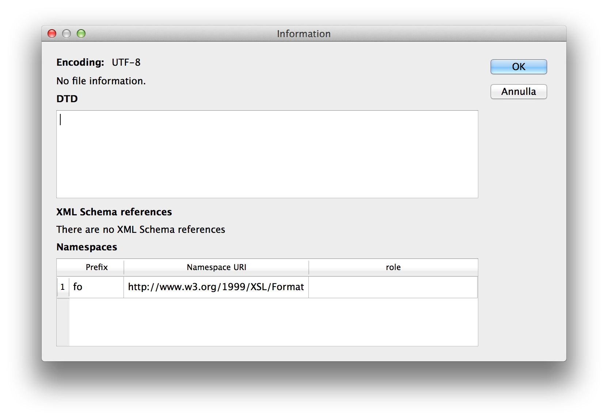

Please note that some namespace prefix can be used in more than one place with different references.
The “role” column will list well known namespaces.
The DTD of the document can be edited in this panel if the file is not read only. The manually edited DTD is not checked against syntax errors.

Working with Base64 Coded Content
Sometimes the data of an element are text nodes or binary data base 64 coded. QXmlEdit can display decoded base 64 coded text near to the literal content in the main window, and permit you to edit directly the content.
To edit directly the base 64 coded text of an element:
- select the element, then right click to make the context menu appear and select Edit Inner base 64 Text.
- Write directly the text into the edit box of the panel that appears.
The text will be automatically encoded and decoded as needed.

Working With Inner XML Content
Sometimes the data of an element is an XML payload registered as text, or a base 64 coded XML. QXmlEdit can edit directly both the types of contents.
To edit directly the XML data stored as payload of an element:
- select the element, then right click to make the context menu appear and select Edit Inner XML.
- Another QXmlEdit Window will appear; you can use it to edit the inner XML.
The XML will be automatically encoded and decoded as needed.
To edit directly a base 64 coded XML used as element payload:
- select the element, then right click to make the context menu appear and select Edit Inner XML Base 64 Coded.
- Another QXmlEdit Window will appear; you can use it to edit the inner XML.
The XML will be automatically encoded and decoded as needed.

Inserting an XML prolog on document creation
You can insert an XML prolog XML using the menu XML > Insert prolog. You can insert automatically a prolog on document creation using an option in the configuration panel. In the panel you can also select the encoding to be used.

Formatting a document
QXmlEdit can use a processing instruction to store and retrieve formatting settings for indentation, attributes display and so on.
If the processing of the instruction is enabled, the settings are read and applied at the next saving. If some formatting options is changed and the instruction exists in data, the instruction is automatically updated before saving.
The instruction processing can be enabled in preferences, XML section.
To insert a formatting processing instruction use the menu item Edit>Formatting>Add Formatting Info. To remove it us the same menu, and the Remove Formatting Info item.
To enable or disable the management for a single document, use the formatting panel with the toolbar or the menu item Formatting>Formatting…
The preferences panel has an option to automatically insert the instruction at each document creation.
The processing instruction is transparent to XML management, however should you want to avoid it, you can disable it in preferences panel.

Formatting Presets
In the menu Edit>Formatting there are some common (hopefully) presets. The name of the items gives a clue about its settings.

Validating an XML Document
An XML Schema validation option is available, but it uses the Qt XML validation facility, that is rather limited at the moment. The validation is made by default using schema references contained in the XML document, if any. You can use an external XML Schema file; after this assignment the validation is performed using the assigned file until an explicit command to use the document references is given.
If an external schema file is used, its path is visible In the tool tip of the toolbar “Validate” command.
To validate using the last assigned schema:
- select the menu XML > Validate
To validate a document using self referenced XSD, if any:
- select the menu XML > Validate Using Document References
To use a different an XML Schema file:
- select the menu XML > Validate Using New Schema File

NB: the validation option is available only if compiling at least with the Qt 4.4. It uses the Qt XML validation facility, that is rather limited at the moment.

Counting Children Elements and Measuring Their Size
It is possible to display the sum of the number of elements children and the element total size, calculated on the canonical element form (i. e. counting stating and ending tags). The size calculated is only an approximation of the real value, given that there are many modes to write the same XML data.
To activate the option:
- select the menu View > Show Element Size

Finding Text
It is possible to execute searches in the editor. To open the search panel:
- use the Edit > Find menu
or
- press Control+F
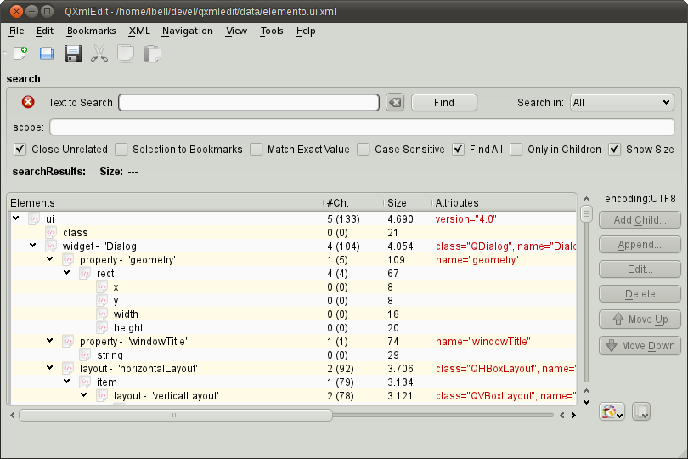
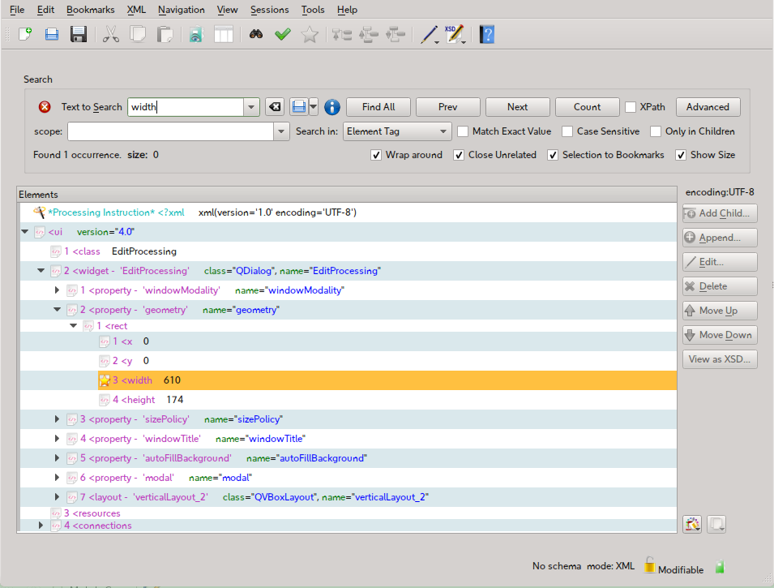
In the panel you can do the following operations:
To start a search:
- insert the text in the edit box and press Enter key or press the Find button
To limit the search to a particular kind of XML components, use the Search In option box:
- All the types of components
- Element tags only
- Attribute names only
- Attribute values only
- Text nodes
- Base 64 coded text
The elements that match the search rules will be highlighted, but you can act on the display in the following manners:
Name of the Option | Information
close unrelated | close all the branches that does not contain any occurrence of the search text.
selection to bookmarks | adds all occurrences found to the bookmarks collection.
match exact value | executes the search of the exact value of text (opposed to regard the text as a substring)
case sensitive | the search will be case sensitive
find all | mark all the occurrences of the search pattern with a background pattern to ease the reading, elsewhere the search will stop to first match.
only in children | the search can be limited only to children of the selected item or to the whole tree.
scope | can limit the search to a set of elements or attributes. This field can contain a path in XPath like syntax. For example to search a value in the “id” elements children of “resource”, the field must contains “resource/id”. If the search has to be performed only on “name” attribute of the “window” element, write “window/@name”. To include any elements between “window” and “widget” tags, simply omit it as in “window//widget”
XPath | Activates the XPath syntax (see below for details). If unchecked the text entered in the search box is used as pure text.

The number of matches is reported in a box at the bottom of the search panel.
It is possible to find the next occurrence starting the search from the selected item. You can use the command buttons in the panel or activate it using the following command:
- use the Edit > Find Next menu
or
- Use the key F3

Search results
The matching items are highlighted and, in combination with other options, non matching items are closed.

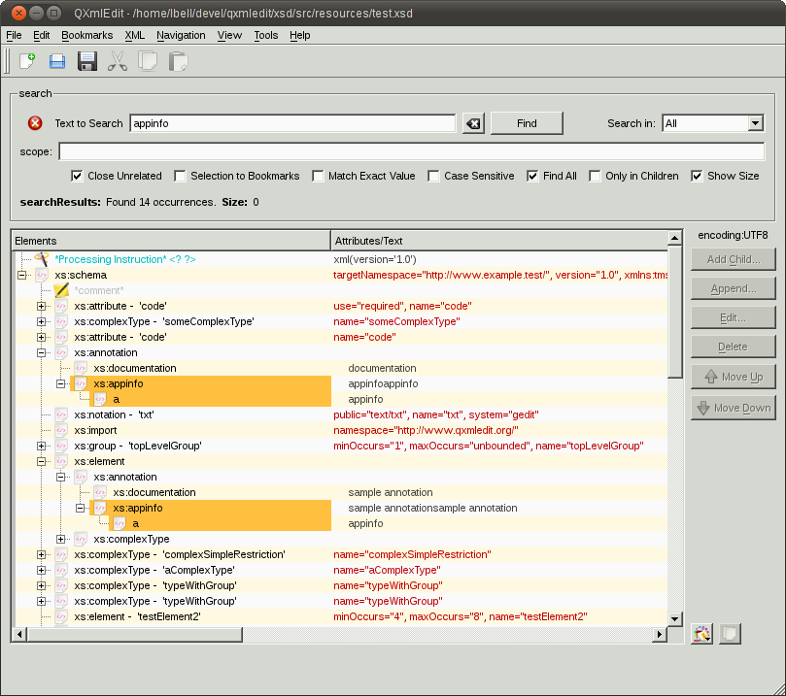
Matched items

XPath syntax
In the panel you can do the following operations:
To start a search:
- select the “XPath” check box
- insert the text in the edit box using XPath syntax and press Enter key or press the Find button
A small note will indicate the XPath mode activation.
If “Only in Children” check box is selected the root of the search is the current element, if not the search starts at the document root.
Some of the options available to the text search are hidden because their operation can be carried on using XQuery and XPath.
The elements that match the search rules will be highlighted, but you can act on the display in the following manners:
Name of the Option | Information
close unrelated | closes all the branches that does not contain any occurrence of the search text.
selection to bookmarks | adds all occurrences found to the bookmarks collection.
only in children | the search can be limited only to children of the selected item or to the whole tree.
scope | can limit the search to a set of elements or attributes. This field can contain a path in XPath like syntax. For example to search a value in the “id” elements children of “resource”, the field must contains “resource/id”. If the search has to be performed only on “name” attribute of the “window” element, write “window/@name”. To include any elements between “window” and “widget” tags, simply omit it as in “window//widget”

The number of matches is reported in a box at the bottom of the search panel.

Search results
The matching items are highlighted and, in combination with other options, non matching items are closed.
The following screen shot shows a search using XPath:
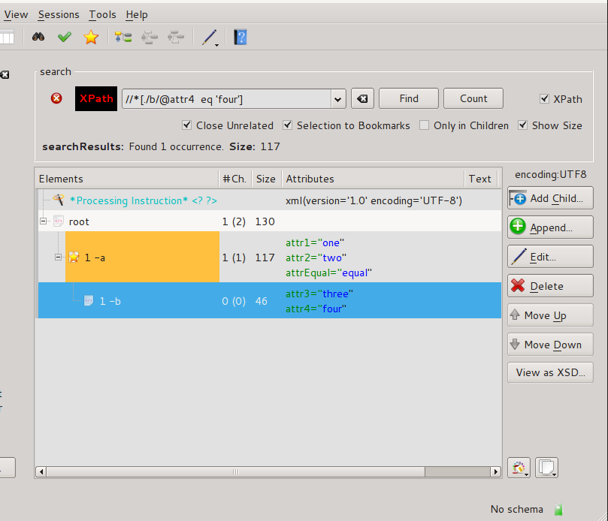

Browsing the search results
You can open a search results panel using the button “Open panel” in the find panel.
The new panel will show only the search results, giving the possibility to browse directly the XPath queries elements or the text search results.

Replacing text
Replace uses the search feature to find text that can match and replace it all at once or one at time. Replace is triggered by the menu Edit > Replace.

Replace panel
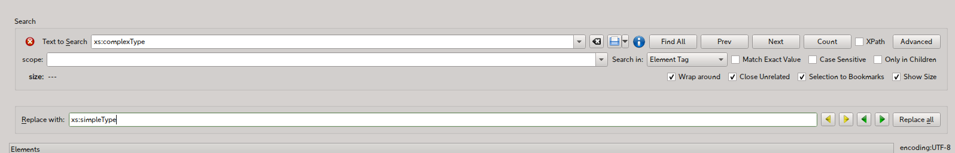
The following commands are available:
Command | Behavior
Replace All | Replaces all the occurrences of the search pattern.
Replace and find next | If there is a selection, a replacement is applied if there is a match; then the next element that matches is selected. If no selection was existing, the next match is selected.
Replace and find previous | If there is a selection, a replacement is applied if there is a match; then the previous element that matches is selected. If no selection was existing, the previous match is selected.
Skip and find next | If there is a selection then the next element that matches is selected. If no selection was existing, the next match is selected.
Skip and find previous | If there is a selection then the next element that matches is selected. If no selection was existing, the previous match is selected.
Note: replace operation cannot use XQuery search.

Comparing Files
The purpose of the comparison as implemented is to give a compact view of changes, comparing the current editor content with another file. The sense of the comparison is to show what transformations are needed to the chosen file to become the current loaded one.
To compare a file against the current:
- select the menu File > Compare with...
- choose a file
In the panel that opens you have the following information:
- The current file in XML format with elements and attributes that are different between the files with highlighted colors (Synthetic View).
- A structure comparison side by side of the two files (Analytical view).
- The list of the differences with the path of elements (Difference list).
The following options can be set:
Option | Meaning
Compare text | Compare even the text nodes
Compare comments | Take into account the comments
Denormalize EOL | In CDATA nodes do not transform the CR LF sequences into LF as stated by specs.

In the panel that opens you have the following options:
- Compare only elements or comments and mixed content too.
- Copy the comparison result to the clipboard.
- Retry the comparison, after changing some option.
To start a comparison, load a recent file from the relative combo box or select another one using the browse button.

User interface

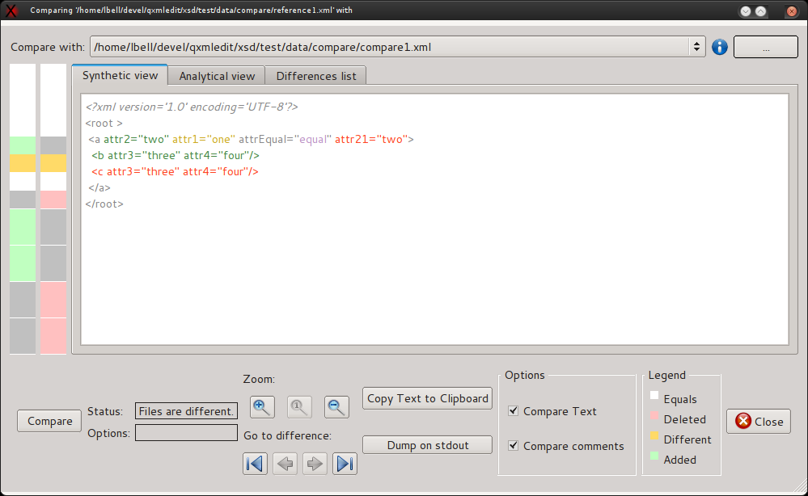
Encoding indicator
Recent files
Browse file
Compare options
Status

Analytical view
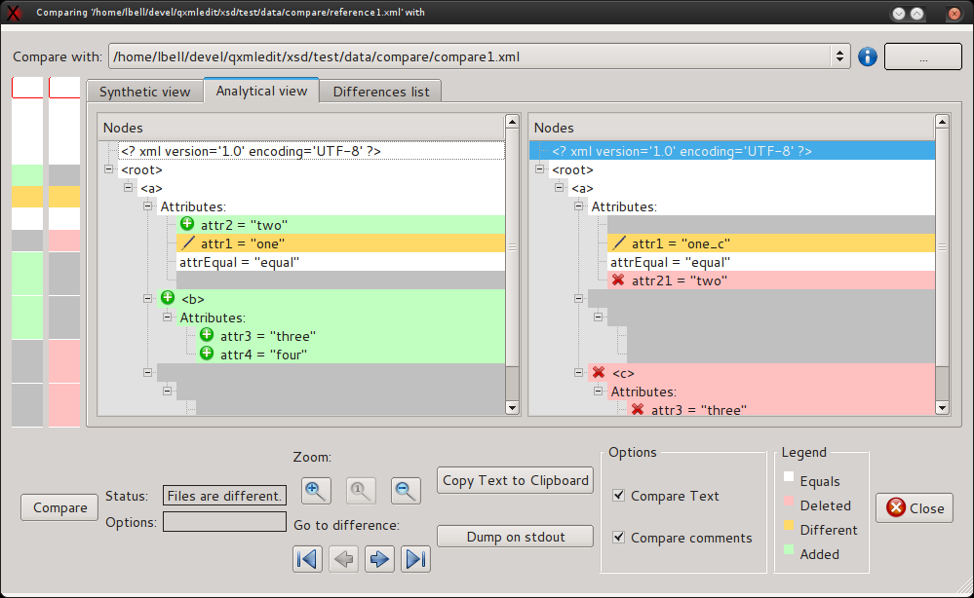

Differences list
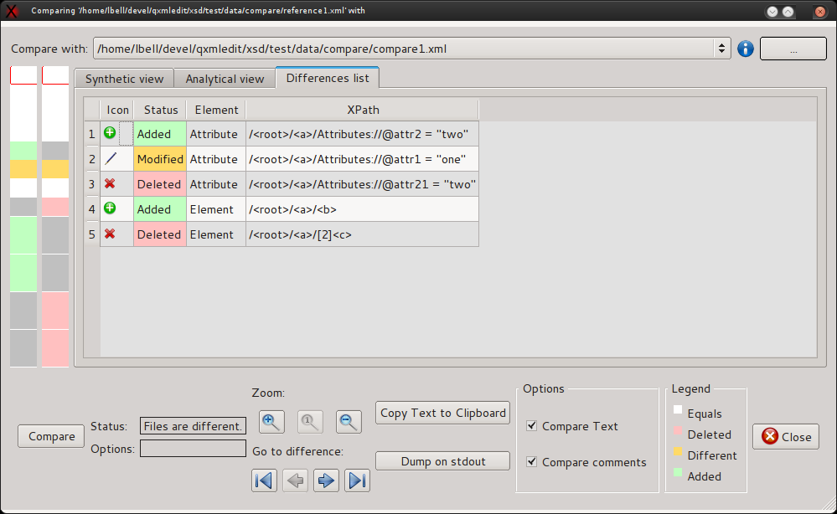

Loading data sample
The menu File > Load Sample allows to load only one copy of each tag and attribute of a file in a new document. This feature is useful to set the rules for anonymization of a huge file or simply to look into a file. Each tag, identified by its path is loaded only one time even if is is repeated. The attributes of an element are collected over all the instances of the element; only the first occurrence of the attribute is retained unless the attribute is empty, in this case the first following instance that is not empty will replace the original one.
Note: there are some limitations, be sure to read the “Limitations” paragraph.

Limitations
Occasionally the XML generated may be not valid if namespace declarations are different on different instances of the same tag and have the same prefix; it is up to the user to manage this case.

Anonymizing data
The menu Special > Anonymize recalls a dialog to anonymize the data contained in attributes and text of the XML.
This feature can be useful if the XML file should be sent to technical staff for debugging purposes avoiding the disclosure of personal information.
Using this feature the text and the attributes can be altered using a fixed character or using a different letter for each input character by preserving the case of the original letters.
The original data structure is preserved replacing only letters and digits with altered text, preserving the case of the letters and the reserved XML attributes. The tags and attribute names are not changed.
Note: in order to set rules on a huge file, you can load only a sample of the file using the File > Load Sample menu. Details on the specific paragraph.

Data and business rules
Often the files contain not only personal information, but also data for business rules. Modifying all the contained text or attributes will end in a useless file transporting no information at all.
To avoid that result, manipulating the parameters that belong to the business rules, two features can be used:
- A filter to avoid the anonymization of values consisting of less than 4 characters (the length of many codes).
- The use of exceptions.
The exceptions can be bound to any element, attribute or text node and force the subject to be anonymized or not; if anonymized, a user defined value can be used to replace the original one.
The exceptions can be hierarchical and extended to the children of the subject. It is possible to isolate data from business rules from personal data. When applying more expressions, the more specific wins; for example if an element has been forced to be anonymized with children, and one of its children has another exception of reverse meaning, the child exception is applied.
Each time an exception is modified, the anonymization operation results are shown in a preview pane. The original values can be seen in the tooltips of the elements of the preview.
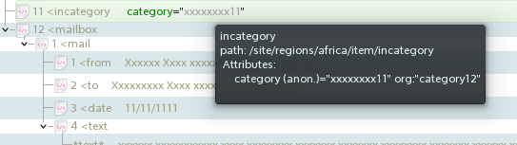
Since creating rules and exceptions is a time expensive process, it is possible to save them using a profile and recall them later in other anonymization processes.

Options
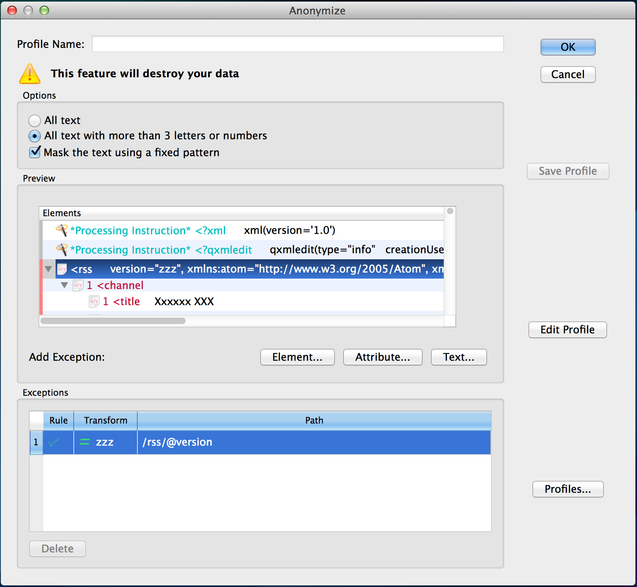

The options are:
- All text: all the text will be changed.
- Text with more than 3 letters or digit: only the text that is composed by more than 3 letters or digits will be changed. This to skip codes that usually have a limited length.
The check box “fixed pattern” determines how the text is transformed.
- If checked: letters are replaced by 'x' and numbers by '1'.
- If unchecked: the letters and the numbers are replaced by a succession of letters or numbers in alphabetical order.
The exceptions can be entered selecting the element and using the contextual menu.
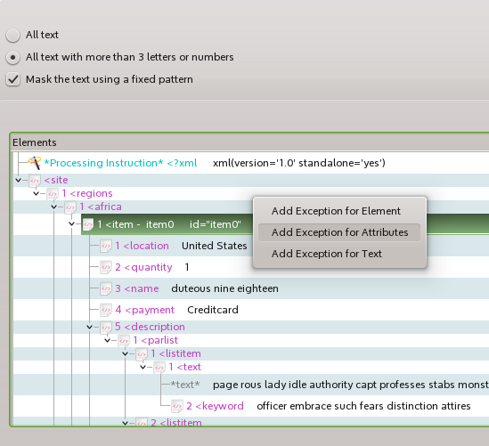

Information in the panel:
Name | Information
Profile Name | Name of the profile (read only)
Options | Options to anonymize data:  - anonymize all the text  - anonymize only the text with more than 3 letters or numbers  As an option it is possible to use a fixed pattern to replace the text.
Preview | It shows the final result of the operation on the current data
Add Exception | You can add exceptions when an element is selected in the preview.
Exceptions | The list of the exceptions
Save Profile | Saves the current profile data. If the profile has not been created, a creation panel will appear.
Edit Profile | Edits the profile data.
Profiles | Manages the profiles.
Import | Import a list of exception in CSV format (see below for details)
Export | Export the exception list to the clipboard in CSV format

To insert an exception:
- Select an element in the preview pane
- Use one of the buttons in the “Add exception” row
To remove an exception:
- Select an exception in the exception list
- Press “Delete” in the exception group.
To save the exception list in a profile:
- Press “Save profile”
If the profile has not be created, a profile creation panel will appear.
To mange profiles:
- press “Profiles...”
A list of profiles, grouped by tags will appear. Selecting a profile and exiting with “Ok” will load the profile in the caller dialog. It is possible also creating and deleting profiles.

Configuring the anonymization
The colors of anonymized items can be configured using the “Editor Colors” panel.
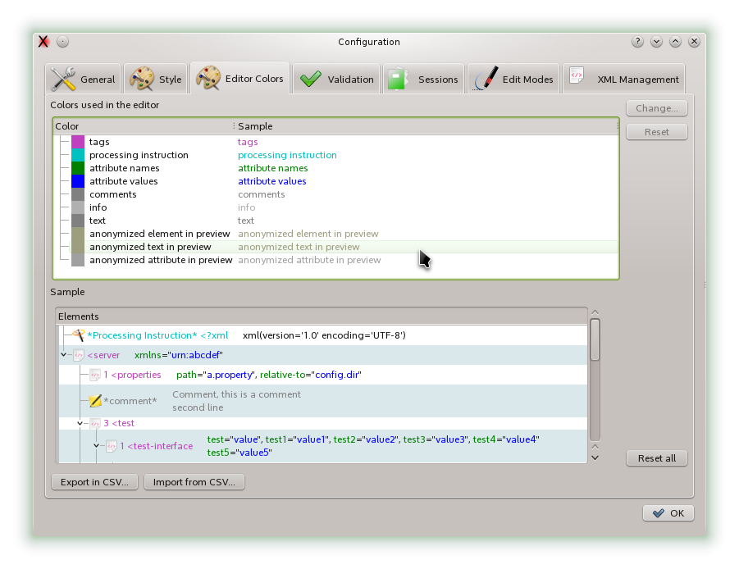

Format of the CSV for importing and exporting the exceptions
The CSV fields used to exchange the exception list are:
- The XPath of the exception.
- The inclusion criteria as integer:
  - 0: exclude (default)
  - 1: exclude with children
  - 2: include
  - 3: include with children
- Type of data mask used:
  - Use default.
  - Use a fixed value.
- A string value if the fixed value replacement is chosen.
- A numeric flag for processing namespaces.
  - 0: do not process namespaces
  - 1: process namespaces

Anonymizing a file
When a profile has been created in the interactive anonymized dialog the profile can be used to process a file without loading it into the editor.
To activate the function use the menu Tools > Anonymize File...

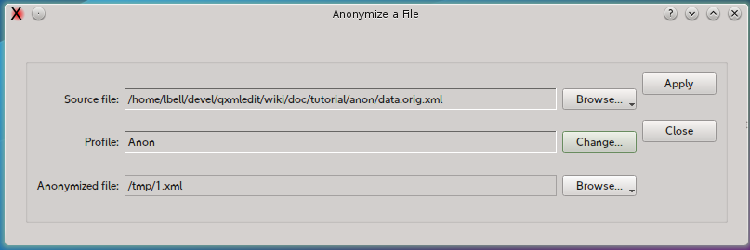

In the anonymize panel you have the following options:

Name | Option
Source file | Name of the source file to anonymize. Use the “Browse...” button to select it
Profile | The name of the anonymizing profile. Use the “Change...” button to select it among the previuosly saved profiles.
Anonymized file | Name of the anonymized file. Use the “Browse...” button to select it.  Note that this function will overwrite the file.

At the end of the operation the destination folder can be opened by the panel.
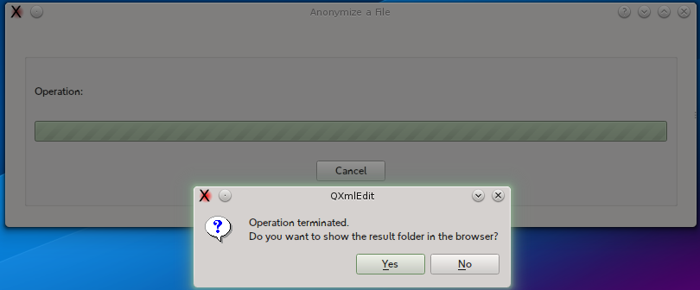

Filling data
It is possible to insert a progressive number or alphabetic sequence selecting an element and triggering the menu “Tools > Fill Serie...”. A dialog box will allow to choose the attribute name that will contain the progression index.
This is the dialog and below each option is explained:
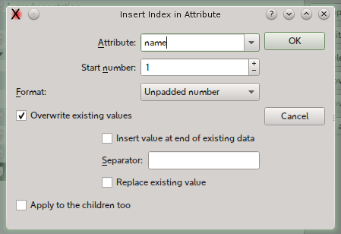
Options:
Name | Information
Attribute Name | Name of the attribute that will contain the progression index. If the attribute does no exists in the element, it will be created.
Start number | The index of the series fill. For the alphabetic enumeration '0' is equivalent to 'A'.
Format | The format of the index. The possible predefined formats are:  Unpadded number (1,2,3)  Padded number ( 01, 02, 03)  Padded alpha (AA, AB, AC)  Unpadded Alpha (A, B, C)
Overwrite existing values | This option allow the modification of an existing attribute. Without this authorization, the existing attributes are left untouched.
Insert values at the end of existing data | If the attribute for the index is existing and overwrite is enabled, the index will be written before or after the current data.
Replace existing value | Replaces an existing value of the attribute.
Separator | This separator is used when inserting the index into existing data.
Apply to the children too. | Apply recursively the index. Each series restarts from 0.

Cloning Elements
Cloning or replicating elements in the editor using an existing sample is activated by using the menu Tools > Clone Elements in the 0.9.2 version. Any element can be used as a sample except the root one.
The only options available to this feature is if to clone only the selected element or even its children recursively, the number of cloned objects and the use of a counter.
The counter that can be insert in an attribute, existing or created while cloning, is the same that can be recalled by the “Fill Serie” dialog,
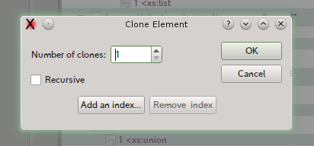

This picture shows the result of the clone operation with the insert of an index using the “id” attribute:
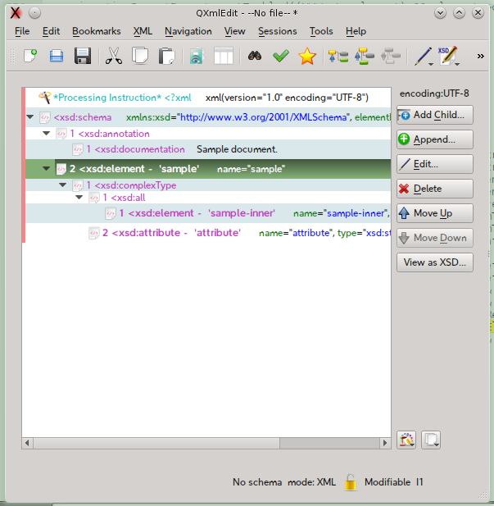 | 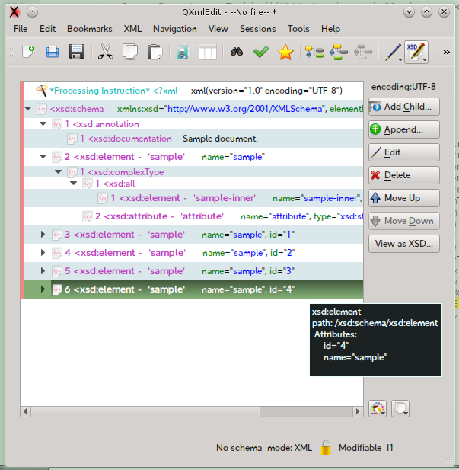

Working with Snippets
Snippets are pre-configured XML fragments that can be categorized and inserted in the main XML text. A snippet example can be a resource reference in a J2EE component.
To create a snippet:
select an XML element, then:
- select Transform in Snippet from the context menu
or
- select the XML > Transform in Snippet menu
To insert a snippet in the XML you are editing:
select an XML element that will be the father of the snippet, then:
select the menu XML > Insert Snippet.
in the panel that will appear chose the snippet category from the left, then choose the snippet to insert.
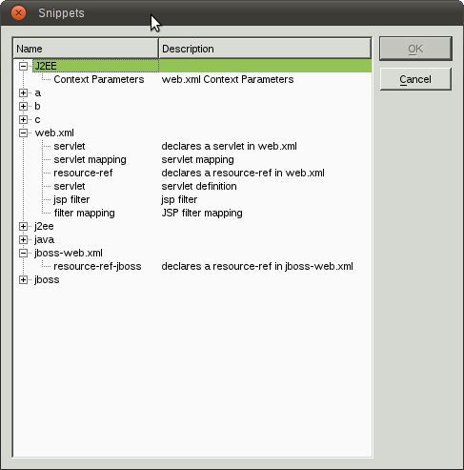
Snippet to insert
Snippet category

To edit the snippets and their categories:
- Select the menu Edit > Configure Snippets
- In the panel that will open, insert, modify or delete a snippet at time.
To assign snippets values:
In the edit snippet panel you can supply the following informations:
Name | Information
Name | The name of the snippet
Description | The description that will be shown when choosing a snippet
Tags | Set of comma separated values that will be used as snippet categories. A snippet can have more than one category

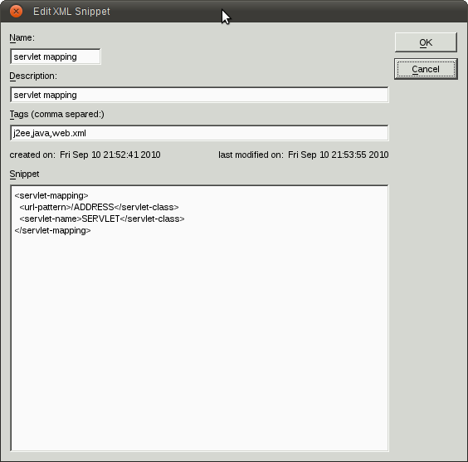

Executing XSL style sheet
You have three options:
- Executing a XSLT using the current editor content as source.
  - Use the menu Special > XSLT > Execute XSLT using this as source.
- Executing a XSLT using the current editor content as Style Sheet.
  - Use the menu Special > XSLT > Execute XSLT using this as source.
- Using a panel to specify the source, the style sheet and the output.
  - Use the menu Tools > XSL Executor.

XSLT Execution panel
Using the menu Tools > XSL Executor brings a panel from which you can specify all the details of the XSL execution.

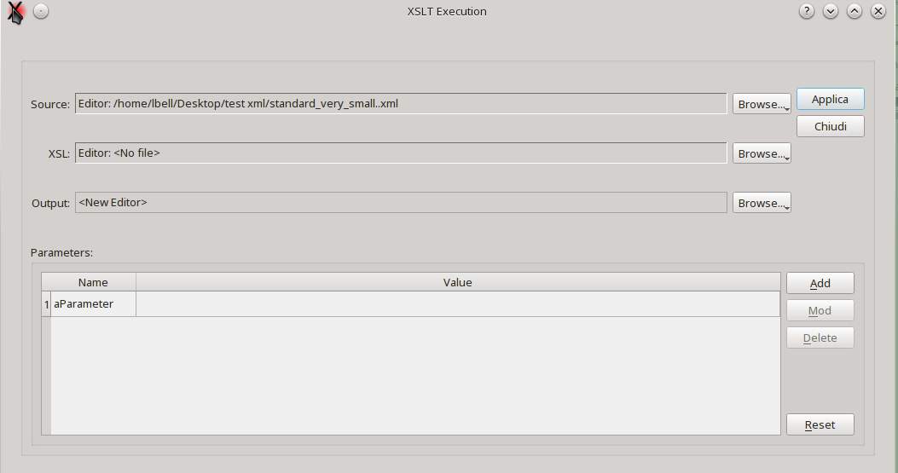
In this panel you can specify:
- The source XML.
- The XSL template.
- The output.
When selecting the XSL template, the parameters, if any, are shown in the list.
If the internal engine has been selected as the XSL engine, you can choose the editors as source, if the external engine has been configured, only files are allowed.
Note: the support to XSL-T 2.0 in Qt is currently not complete.
You can use SAXON or another Java jar with same command line syntax (not part of QXmlEdit) if you configure it in preferences.

Metadata

Introduction
The metadata records carry information about the data in which it is located without modify the data itself. QXmlEdit supports descriptive metadata implementing it using an XML processing instruction whose target is “qxmledit”.

Metadata types
There are two types of metadata: updatable and static.

Updatable Metadata
This kind of metadata carries information about the current state of the document and it can be automatically updated at each document modification if the relative option is enabled. The data that can be automatically updated consists of: document creation user and date and the document revision.

Static metadata
The values contain semantic information and cannot be automatically updated without explicit user intervention. Some data are predefined, others can be inserted by the user when needed.

Metadata implementation
The metadata lives on the root level of the XML document. Each metadata record consists of a Processing Instruction composed by pseudo attributes. The first attribute is always “type”and denotes the metadata role. The updatable metadata is composed by pseudo attributes that live all together in a single “info” type. Other metadata uses a single processing instruction having the attribute “value” for the real data. No entities will be resolved in a metadata pseudo-attribute except the characters “double quote”, “single quote”, “greater than” and “minor than”, that are escaped using usual XML entities notation.

Operation

Creating a document
The updatable metadata record is inserted manually via menu command. The editable ones are inserted using a command that insert the updatables ones too.

Reading a document
No metadata is automatically inserted on read.

Saving a document
When saving, if the option is active, the updatable data are modified. If the metadata record does not exist in the XML document, it will be inserted if the user gives permission. If only partial compiled metadata exists, QXmlEdit will complete it. Other unknown metadata information in the same processing instruction will be preserved for future compatibility. If no creation data exists, the data will be taken from the file data if available, else they will be created anew.

Editing metadata
The metadata can be inserted in an XML document using a menu command or by using a dialog. The user defined metadata can be handled using the dialog user interface. Malformed data inserted by hand will be overwritten.

Metadata summary

Updatable Metadata
Name | Value
creationUser | The login name of the user
creationDate | The date of the creation
updateUser | The login name of the user
updateDate | The date of the modification
revision | A progressive value incremented at each writing operation

Static Metadata
The values have no special meaning respect to the user defined metadata, however they can be presented to the user in a configuration dialog.
Predefined data:
Name | Value
project
name
copyright
domain
version

Editing metadata
Using the menu Edit > Edit Metadata you can open the metadata edit panel. Only updatable metadata whose check box is selected will be written into the document.
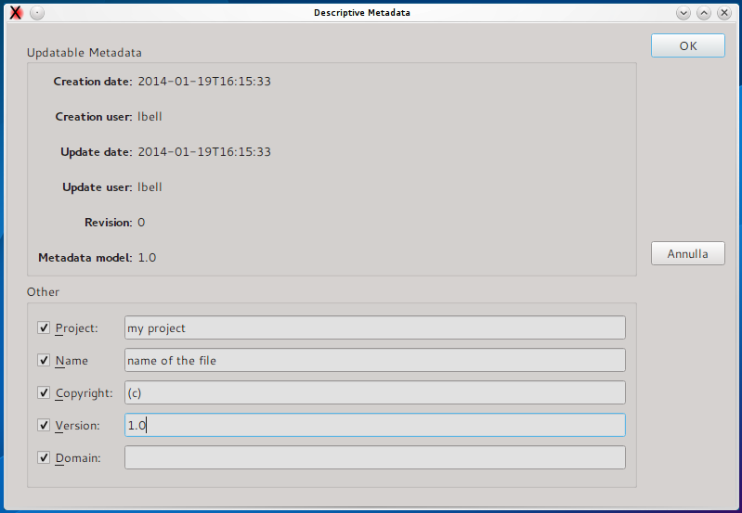

Working With XML Schema Files (XSD)
When the file in editing declares itself as a XML Schema (XSD) through the root element and its namespace, the button View as XSD in the main window is enabled. This button leads to a window that display a graphic view of the file contents.
Alternatively you can display the current XSD file in this manner:
- Load the XSD file as a normal XML file.
- Use the menu Tools > Plugins > XsdPlugin
A window will open with the graphical representation of the data:
Search box
Navigation bar
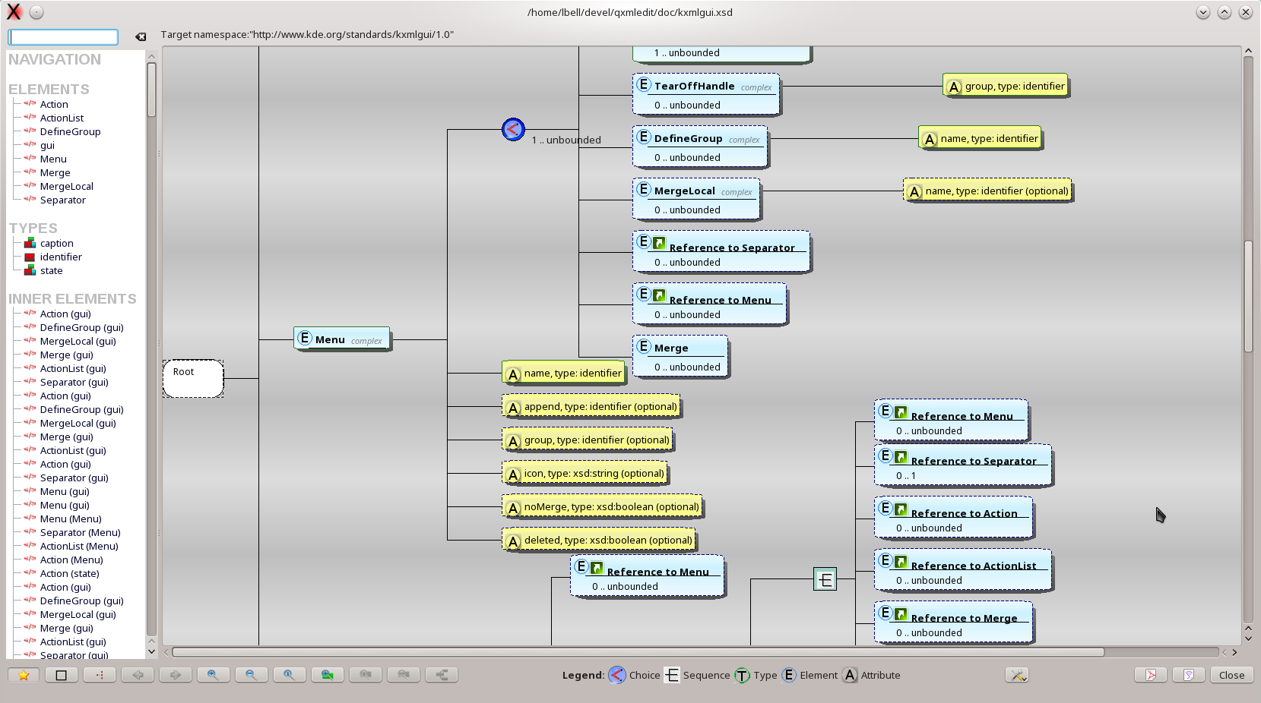
Shows or hides the navigation bar
Graphical view of XSD types and elements

The symbols denote:
- E: element
- T: type
- A: attribute
The icons in the elements represent:
Icon | Description
 | There are annotations relative to the element that will be shown in the tooltip.
 | The object is a reference to another one.

Visualization Types
The visualization modes are two:
- regular: allows to view all the schema entities (low level view)
- outline: allows to view the resulting structure hiding details like restrictions and extensions
The selection of the view mode is done using the “Ouline” button.

Changing the background color and pattern.
In the tools button there is the menu command to open the diagram background inspector. The settings are immediately applied and saved.
To open the inspector:
Tools button > Configure aspect...
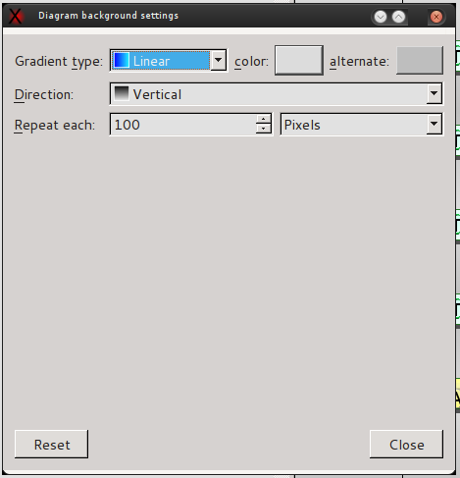

Exporting XSD Graphical view
In the window there are buttons that permit to export the view as PDF, HTML or SVG file. The reports can be:
- physical: the children of the entities that refer to other entities are expanded inline,
- logical: (default) the references to other objects are kept.

Command | Description
HTML Report | Open a panel where a report of the XSD diagram is shown.
Save as HTML | A HTML report of the XSD, with the diagram image, is saved to a file.
Save as PDF | A PDF report of the XSD, with the diagram image, is saved to a file.
Export as SVG | A SVG image of diagram is exported.

The preferences panel in the “Validation” tab has some option to customize the report generation.

Working With Big XML Files
QXmlEdit is targeted to files with dimensions not too big (< 100 MB). If you need to explore files very big files, you can enter “Explore Mode” where only the element structure is loaded, without data and attributes. In this mode, denoted by this icon in the status bar: . You cannot edit the XML document, but you can search in it as usual.
To activate Explore Mode:
- Select the menu File > Explore Structure...
To exit from Explore Mode:
- Load another XML file or start a new document.

Searching in Files and counting elements
It is possible to search in external files the occurrences of a given pattern using a fast parser or group and count elements.
The occurrence count will simply count how many of the elements stated in the search pattern exist in the file. The grouping show the aggregation occurrences of the elements.
Let's do an example; if the input XML file is like that:
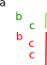
the number of elements 'a' will be 1, 'b' 2 and 'c' 3, but if we look at the groups they form, we will have 1 group composed of one 'a' element (the root one), one group of 'b' elements (the children of a ) and two groups of 'c' elements: one composed by one item (indicated by the green color), and the other one composed by two items (red color).

To search in files:
- Select the menu Tools > Search in Files...
The search window will open:
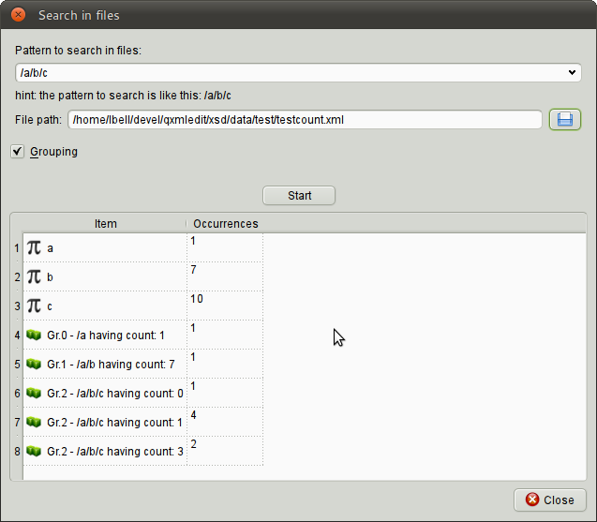
Pattern to search
File to look into
Start the search
Aggregation
Results

In this window you can insert the following informations:
Information | Description
Pattern to search | The pattern as XPath (elements only) for example: /a/b/c
File Path | Path of the file to search into.
Grouping | The scan operation will calculate element groups too.
Start | Starts the search operation.

The icons in the result grid have these meanings:

Icon | Description
 | The item is an occurrence count.
 | The item is an aggregation report.

Split an XML file
There is the possibility to split an XML file in smaller fragments and/or to examine the fragments directly in the editor. This feature is handy mainly to explore very big files that does not even fit in memory.

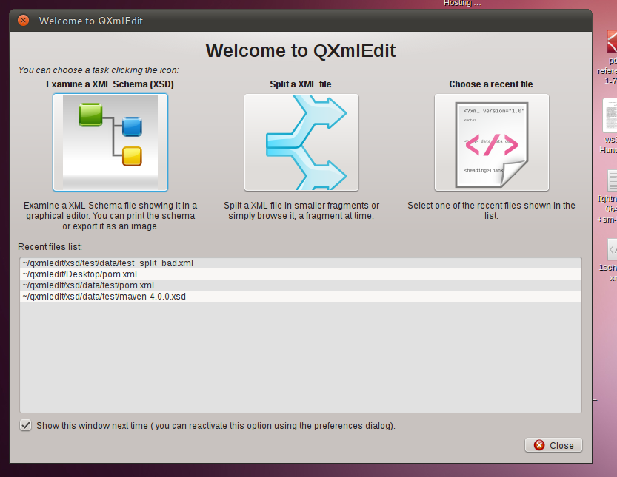
When starting, the program will open a welcome dialog leading to the most common operations. Choose “Split a file”. If you choose to hide the dialog next time the program restart and change your mind, you can reactivate it in the configuration panel. You can access this feature also from the menu Tools.

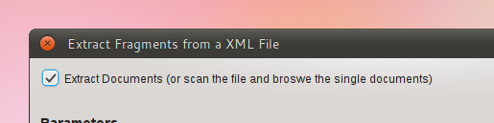
Decide if you want to extract information or browse it
If you want only navigate the data without creating any file, do not check 'Extract Documents'. Even if you don't extract the XML fragments into smaller file, QXmlEdit scans the file and records the information for an interactive review.

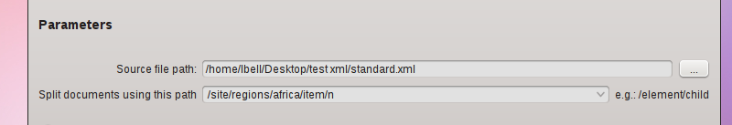
Choose the file and how to fragment it
Browse to the file to examine, the insert the XPath that identifies a fragment. Insert a string of the form /ROOT/DATA and so on.
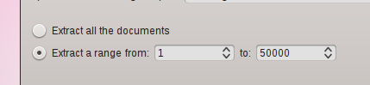

Limit the extracted fragments number
Selecting a range permits to extract only a small subset of the original file. You are not obliged to waste space on your disk if you want only a single fragment.
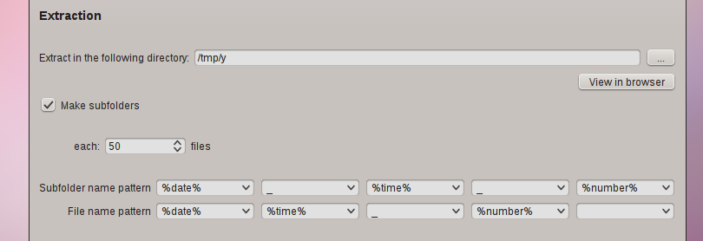

Decide the output folder and the naming
Enter the location where write the extracted fragments and decide if you want to create a folder each N files. Decide also how to name the files and the folders. The combo boxes have some predefined values to ease the task, like a timestamp, or a progressive counter.

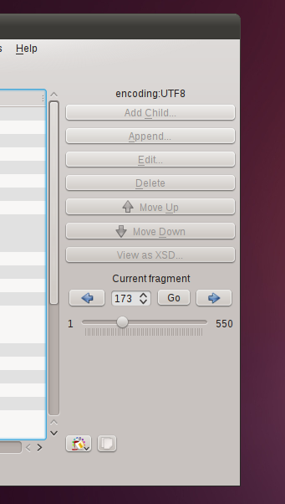

Advanced Options
Clicking Advanced the advanced options dialog opens. In the dialog the following items can be selected:
- Use namespaces (it is the default behavior) when reading and creating files.
- Transform the input data using the following process:
  - Trim attributes
    - all the attributes will be trimmed at the end
  - Remove empty attributes
    - all the attributes that evaluate to empty string will be excluded form the resulting file
The transformations can be chosen independently one from another.
Advanced options dialog:
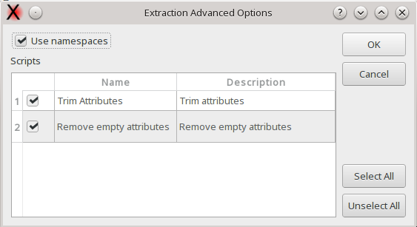

Information in this panel:
Information | Description
Use namespaces | Default choice is ON. Manage namespaces.
Scripts | List of scripts that can be executed.
Select All | Select all the scripts.
Unselect All | Unselect all the scripts

Go and examine data
After the start of the operation, in the main window a navigation box appears. The fragments found in the input file are accessible directly with a random access using the information collected in the previous phases. If you choose to split the file in fragments, you can examine them in the extraction directory.
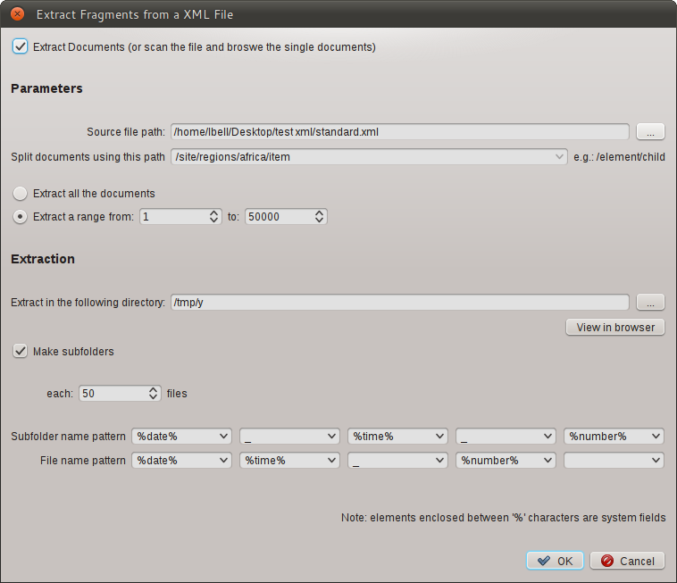Illustration 2: The complete extraction panel.
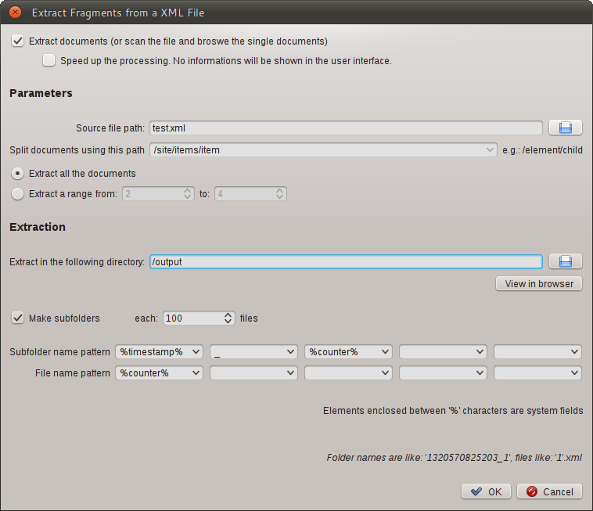Illustration 1: The Extraction Panel
Information in this panel:
Information | Description
Extract documents (or scan the file and browse the single documents) | If selected the fragments found in the input file will be written to files as XML documents, one per fragment
Speed up the processing. No information will be shown in the user interface. | If selected, the extraction process will be faster, but after the extraction, it will not possible to browse the input file fragments in real time using the user interface.  Use it if you need the output files only.
Source file path | The path of the input file
Split documents using this path | The XPath used to find the XML fragments in the input file. The path must be entered using a syntax like this: /root/element/element
Split using the depth | Use the depth of the element as criterion. Root element has depth one. Note: the elements will be extracted independently from their tag.
Extract all the documents | If selected causes the extraction of all the documents found in the input file.
Extract a range | If selected, only the documents that fall in the specified range will be extracted.
Extract in the following directory | The destination directory for the fragments.
Make subfolders | With this option the extracted files are created in a subdirectory when their number exceeds the configured threshold. Use it when the input file contains thousand of fragments that will make impossible the browse of the destination directory if all the files are in a single place.
Subfolder name pattern | The naming to assign to the subdirectories created in the extraction process.  You can use a predefined token that will be expanded at run time or any other thing you like.
File name pattern | The naming to assign to the files created in the extraction process. The files will have a '.xml' suffix automatically apposed.  You can use a predefined token that will be expanded at run time or any other thing you like.
Advanced | Open the advanced options dialog.

Token that can be used in the name pattern section:
Information | Description | Example Output
%counter% | The counter of the object created. This is an unique number that can be used to identify the object | 1
"%date%" | The current date in the YYYY_MM_DD format | 2011_10_07
"%time%" | The current time in HH_MM_SS_millis format | 10_43_30_560
"%timestamp%" | The current date and time in a numeric format | 123456789
"%space%" | A blank space used a separator  Since 0.6 version. | “ ”

Flex Code Generation From Balsamiq Source
There is a plugin to generate Flex code from Balsamiq mockup program source. You can choose a set of source files that will be transformed to a Flex application in the output directory.
Only a subset of Balsamiq controls are supported, controls not supported are converted to mx:Label

List of supported controls:
- Button
- Label
- LinkBar
- DataGrid
- List
- TabBar
- Vrule
- Hrule
- TextInput
- ComboBox
- TextArea
- Paragraph
- CheckBox
- RadioButton
- Tree

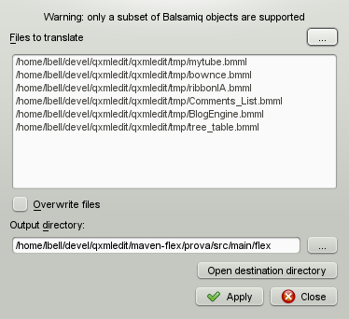

Life With Sessions
Sessions are information about a set of files and access dates, related to a work or an activity than can be recalled if needed. A file can be shared among different sessions, with different accesses. The sessions can automatically collect information of the files that the program access. Only one session can be active at time and there is no need to have a session active for QXmlEdit to work.
A session can be active (collecting information), paused or closed.
When sessions are active, there is the possibility to view the most used or recent files or folders in a list in the main view.
In the main menu the following commands are available:
Command | Information
New | Creates a new session. The current one, if existing, is closed.
Pause | Pauses the current session when active. Paused sessions does not collect information.
Resume | Resumes a paused session.
Close | Closes the current session. No session is active, then.
Details | Opens a dialog with information on the current session.
Manage | Opens a dialog where have information about all the sessions.

The session user interface
The session panel can be shown or hidden using the toolbar button or the command in the View menu.
The following lists are shown:
- Recent: the most recent files accessed in the session. Double clicking a file opens it in the editor.
- Most used: the most used files of the session. Double clicking a file opens it in the editor.
- Most recent folders: the most recently used folders containing session related files. Double clicking a folder entry shows the open file dialog on that folder.

Sessions Management Dialog

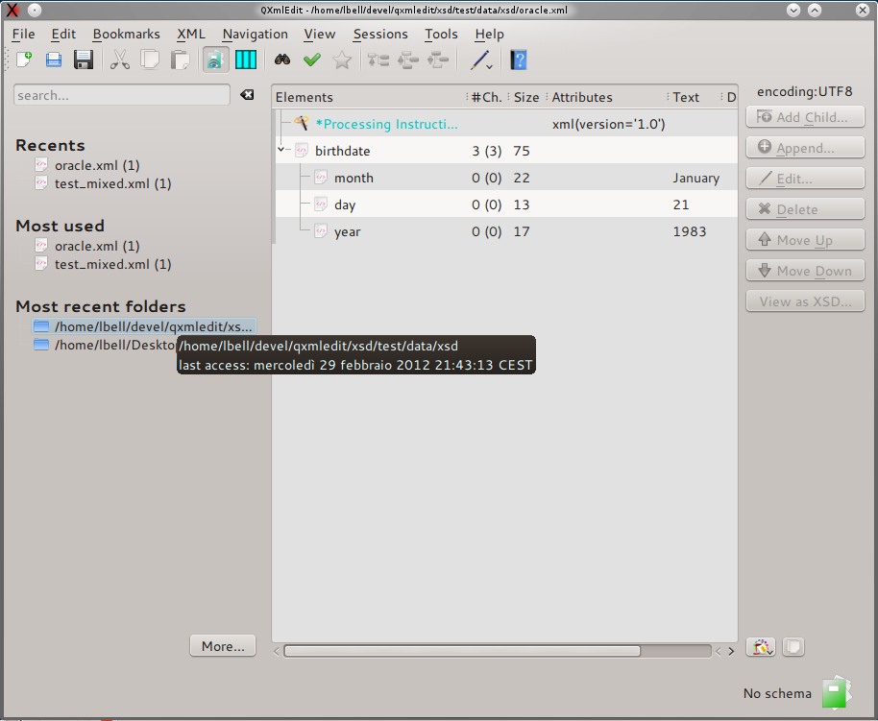
Show or hide
the browser

Clicking on the files
opens them in the editor

Session data
browser
Clicking on the folder,
opens it in the open file dialog

In this dialog you can view the sessions list. From here you can activate a session or manage sessions, creating, deleting or editing them. When a session is selected, its accesses and files are shown in the lower half of the dialog. The list of files can be copied in the clipboard. Double clicking on a file loads it in the editor.
The following commands are available:
Command | Information
Activate | Activates the selected session, closing automatically the current one, if any.
New | Creates a new session.
Edit | Opens the session detail dialog of the currently selected session.
Delete | Delete the currently selected session.
Edit file | Loads in the editor the file selected in the lower pane.
Export file data | Put in the clipboard the path of the files.
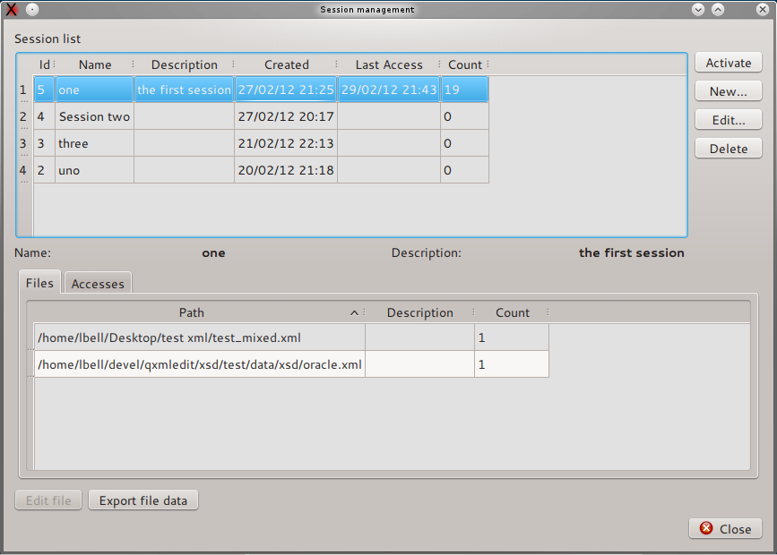

Session Properties
In this dialog you can set the session properties and examine its accesses to files. The name and the description of a session can be changed and saved.
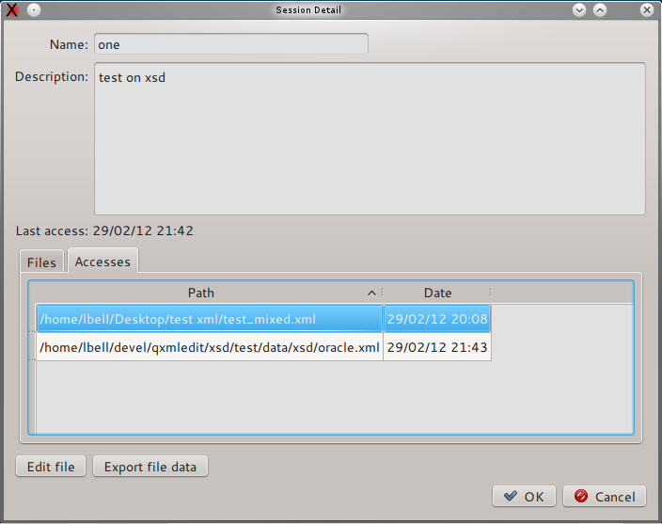
You can set or change the session name and description. The list of files can be copied in the clipboard. Double clicking on a file loads it in the editor.

Managing sessions data
Sessions data are stored in the user data folder as indicated by the operating system using a sqlite database file. To reduce sessions data file dimensions use the configuration dialog. The cleaning procedure operates as follows:
- Completely erase the data.
- Erase sessions data on date criteria.

The following table explains in detail the options:
Option | Operation
Delete all sessions data | Completely erase the sessions data.
Delete data older than... | Delete the data older than the specified date. The data are deleted as follows:  - all the accesses to a file registration older than the specified date.  - all the sessions that have last access date older than the specified date and have no access data.  If the delete files information is selected, the files information without access data are deleted. The file themselves are not altered, the operation is done only on session registration inside QXmlEdit.

Sessions configuration
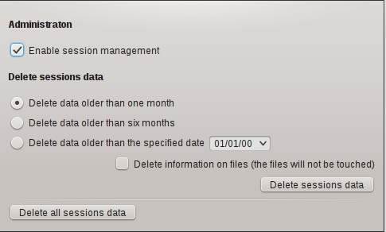
The session configuration panel allows to enable or disable session handling. There is the possibility to clean session data as explained in details in the paragraph “Managing sessions data”.

Viewing data
Use the Visualization feature to graphically visualize the composition or the structure of an XML file. The file can be view as a map; only the summary data are loaded in the program main memory, so the consumed memory is of the order of magnitude of the data itself.
The data that can be shown are:
- Size: size of the elements, attributes and text nodes.
- Elements: number of children elements.
- Attributes: number of attributes.
- Structure: the data can be split on their depth from the root.
- Payload: the size of the text nodes children of the elements.
The data values can be cumulative or relative. The cumulative measuring shows the sum of the quantity associated with a given element and all its children. This kind of measurement gives an idea of how the hierarchy is structured. The non cumulative measurement spots what elements have the most relevant values.
The data relevance is underlined using a color map, shown in the dialog itself.

User Interface
Options for Calucation
Load XML file
Measure type

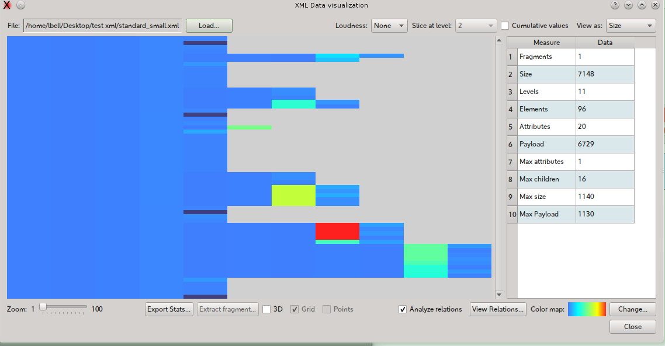
Data Map
Zoom
Color Map
Numeric values

To access to the Visualization use:
- The welcome dialog.
- The Tools > View Data menu.
The operation sequence is as follows:
- Load a file using the Load file... button.
- Choose the measurement type from the View as combo box.
- Select the Cumulative values if you want to display cumulative values.
- The data are now show.
- Select the zoom level.
- Explore data hovering with the mouse on the interest points, a tool tip will appear.
- Use the context menu (right mouse button) to export data.
Checking the “Analyze relations“ button will give access to the relations explorer dialog.

3D Visualization
If QXmlEdit is compiled with 3D support, a 3D view can be enabled using “3D” check box.
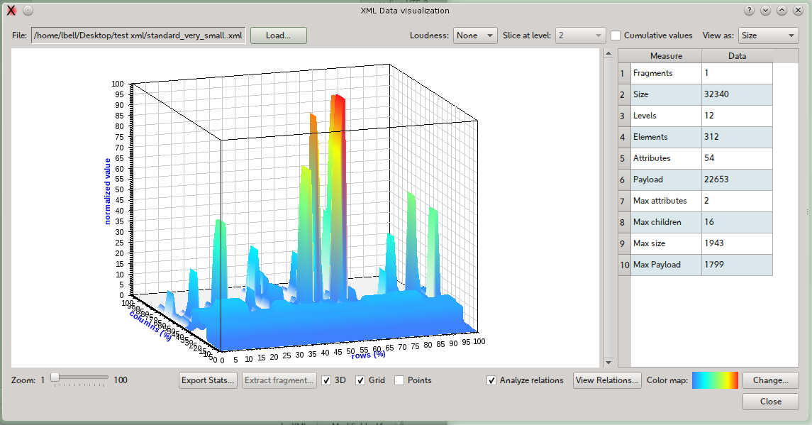
The available options are:

Command | Information
Grid | Show a grid in the back walls.
Points | Show only points, do not draw surfaces.

Measurement types
The following measurement types are available:

Size
The size is the size in bytes of the element, its attributes and its text nodes. The cumulative measurement is the sum of the size of the element and all its children. The root element in the cumulative mode has the maximum size of all the tree.
To activate the size measurement select Size in the View As combo box.
Note: the calculated size can differ from the physical file because when the data are loaded, the formatting is discarded.

Payload size
The payload size is the size in bytes of the text nodes children of an element. The cumulative measurement is the sum of the payload size of the element and all its children. The root element in the cumulative mode has the maximum size of all the tree.
To activate the size measurement select Payload in the View As combo box.

Attributes count
The attributes counting is the number of the attributes of each element. The cumulative measurement is the sum of the number of the attributes of the element and all its children. The root element in the cumulative mode has the maximum total of all the tree.
To activate the attributes count measurement select Attributes in the View As combo box.

Children Elements count
The children element counting is the number of the children of each element. The cumulative measurement is the sum of the number of the children of the element and all its children. The root element in the cumulative mode has the maximum total of all the tree.
To activate the elements count measurement select Elements in the View As combo box.

Structure
The structure view shows how the elements are divided in blocks using the depth from the root information independently from the element tag. It shows the relative width of each element at a given level. There is no cumulative option.
To activate the structure measurement select Structure in the View As combo box.
To change the depth level, use Slice At Level combo box.

Commands available in the contextual menu of the map
The map exposes the following features in the contextual menu or with mouse hovering.

Command | Information
Copy Data to Clipboard | Copies the current measurement data, relative to the portion of the visible map to the clipboard. The data consist of an header and the values ordered by row.
Extract this fragment | Opens the extraction dialog with depth and fragment numbers information relative to the current point.
Copy Path to the Clipboard | Inserts into the clipboard the current element XML path.
Show current element information | Implemented as a tool tip that appears hovering with the mouse on a point of the map.

Visualize Relationship
The relations panel shows in graphical form and using a table, the relationship between the nodes.
Graphic view: show the elements existing in the file and their relationships. The elements that are in relation father-child are connected by a line.
The elements are disposed on the canvas in random position at each invocation. The nodes are subject to a repulsive force and tend to be distribute evenly in the view.

Data view: show a table of nodes and the number and the type of connected elements.
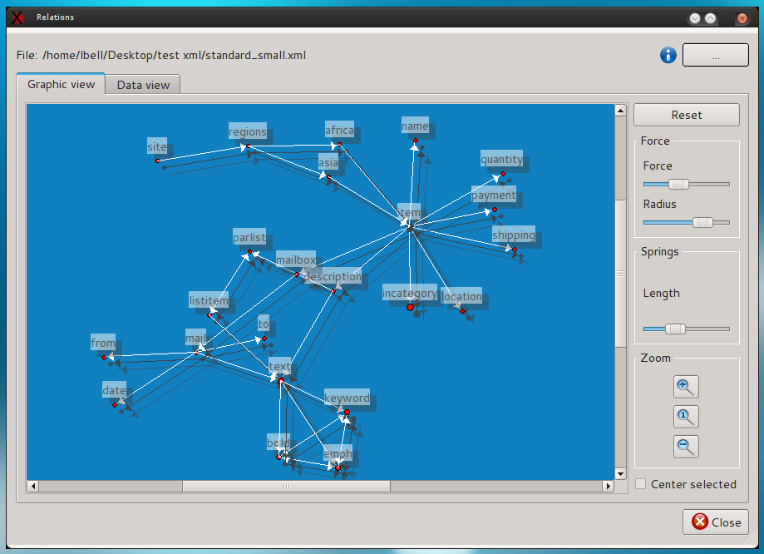

Options:

Panel | Option | Description
Force | Force | The value of the repulsive force between the nodes.
Force | Radius | The effective radius of the force.
Spring | Length | The length of the spring.
 | Reset | Reset the position of the nodes.
Zoom | Zoom in | Execute a zoom in
Zoom | Zoom 1:1 | Restore the view to the default size.
Zoom | Zoom out | Executes a zoom out

The relation panel can be accessed in the following modes:
- To show the data relative to the file loaded in the editor: View->View Relations...
- To show the data relative to a file: Tools->Relations...
- To show the data in the map view: check “Analyze relations”, load a file then “View relations”

Attributes summary
In the same panel in the “Attributes View” tab a detail of the attributes is shown. The allowed options are:

Option | Description
Load Whitelist | Load a whitelist of attributes XPATH.
Load Blacklist | Load a blacklist of attributes XPATH.
Reset Lists | Clear whitelist and blacklist.

The behavior is as follows:
- if there is no whitelist and no blacklist all the attributes are included in the same summary,
- if there is a whitelist only, the attributes in the whitelist are grouped together and the remaining form another group,
- if there is a blacklist only, the attributes non in the blacklist are grouped,
- if there is a blacklist and a whitelist, the attributes in the whitelist form a group, then all the other attributes non in the blacklist are added to the group.

Testing XML Files
This operation allows to test an XML file without opening it in the editor and can be used to test for XML syntax errors in huge files.
To access this operation:
Menu > Tools > Test XML
A file choosing panel will let you select the file to be tested. At the end of the operation a report will be shown.

Base 64 Explorer
This dialog permits to encode and decode text from and to base 64 coding, using one of the common character encodings.
To access Base 64 Explorer:
Menu > Tools > Base 64 Tools...
- To encode text in base 64:
  - Write text into the “text” panel. The base 64 coding will appear in the base 64 panel.
- To decode from base 64:
  - Choose an encoding using the “encoding” combo box.
  - Write or paste the base 64 coded text in the “Base 64” panel. The text will automatically appear using the selected encoding.

Encoding tools
This dialog will permit to see how the text is transformed from unicode to different encodings.
To access the dialog:
Menu > Tools > Encoding Tools...

Explore how a string will be coded in a specific encoding
To explore how a string will be coded in different encodings:
- Select the tab “String Explorer”.
- Write the text into the Source Text box.
The encoded text will be displayed in the grid, character by character along its Unicode value.
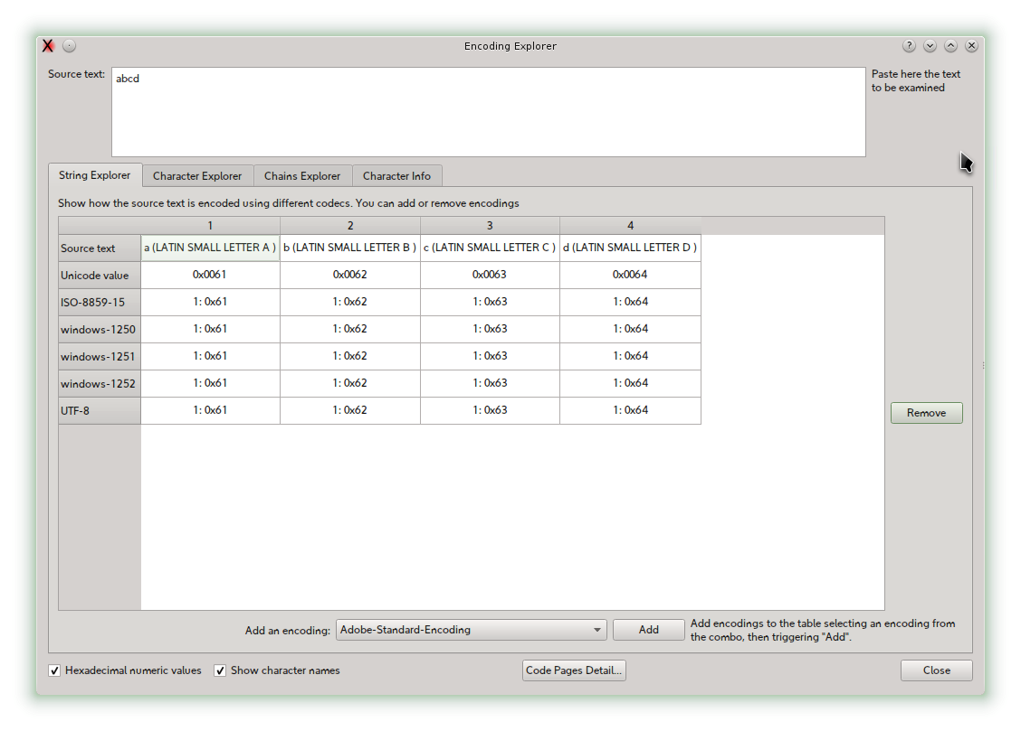
To add an encoding to the grid:
- Select an encoding in the encoding combo box, then trigger add button.
To remove an encoding:
- Select the encoding row, then press Remove button.

Explore how binary values are recognized by different encoding
You can insert numeric values and examine how they are interpreted by different encoding.
To access this feature:
- Select the “Character Explorer” tab.
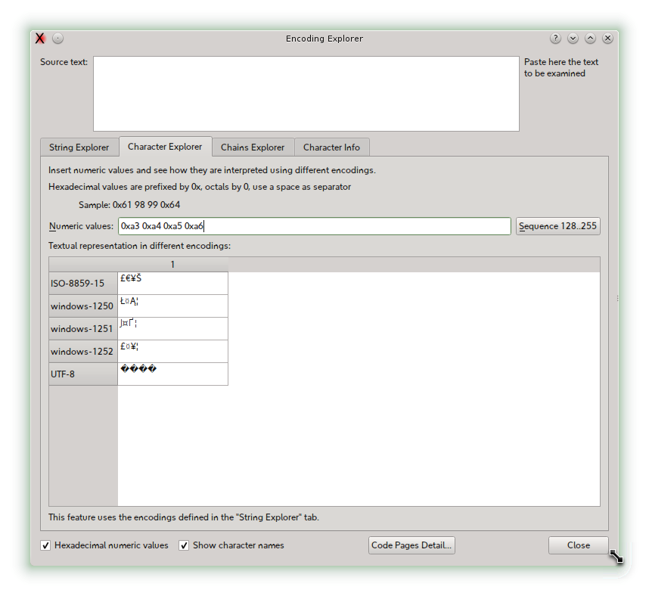
Insert the numeric values in the input box, using the prefix “0x” for hexadecimal numbers, “0” for octal.
To add or remove encodings, use the “String Explorer” tab.
Use “Sequence” button to insert a sequence of 128-255 characters; if you press the Control key with the “Sequence” button, the characters from range 32-127 will be inserted.

Explore how a string will be translated when written in some encoding and read in another one
Select the Chains Explorer tab, select an encoding (up to three are available), then write the string into source text box.
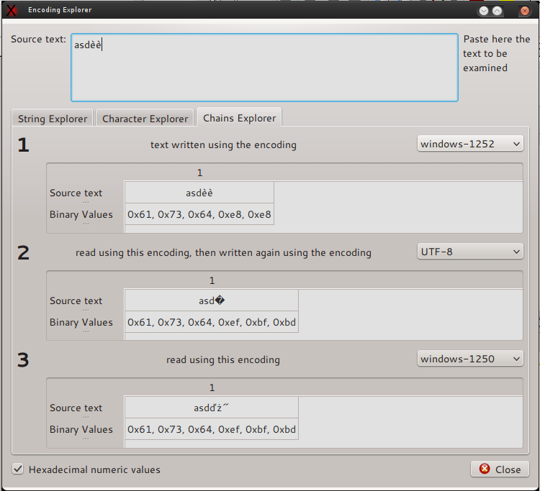
The grid will show the string transformation up to three steps.

Get information about a character
Select the Character Info tab, select a character using one of the methods:
- Literal character typed in a box.
- Unicode code point written in decimal or hexadecimal.
- A value of a given encoding.
You can change the character display using the “Change Font” button.
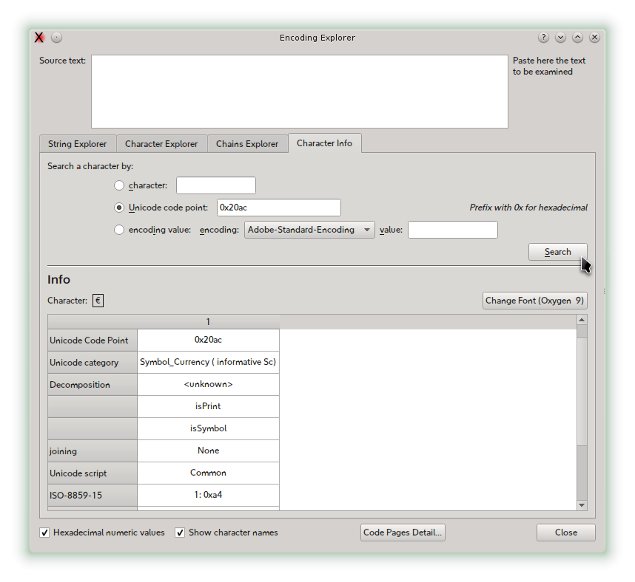

Code Pages explorer
Using the menu “Tools” > “Code Pages” you can open the code page explorer where you can examine the code pages supported by QXmlEdit.
The possible operations are:
Change the encoding using the “Encoding” combo box.
Search a character using:
- The literal value.
- The Unicode code point.
The search result will be highlighted in the table and reported in a box.
Option for display of the characters:
Show the UTF-8 encoding.
Show the Unicode name of the character.
Show the value of the character.
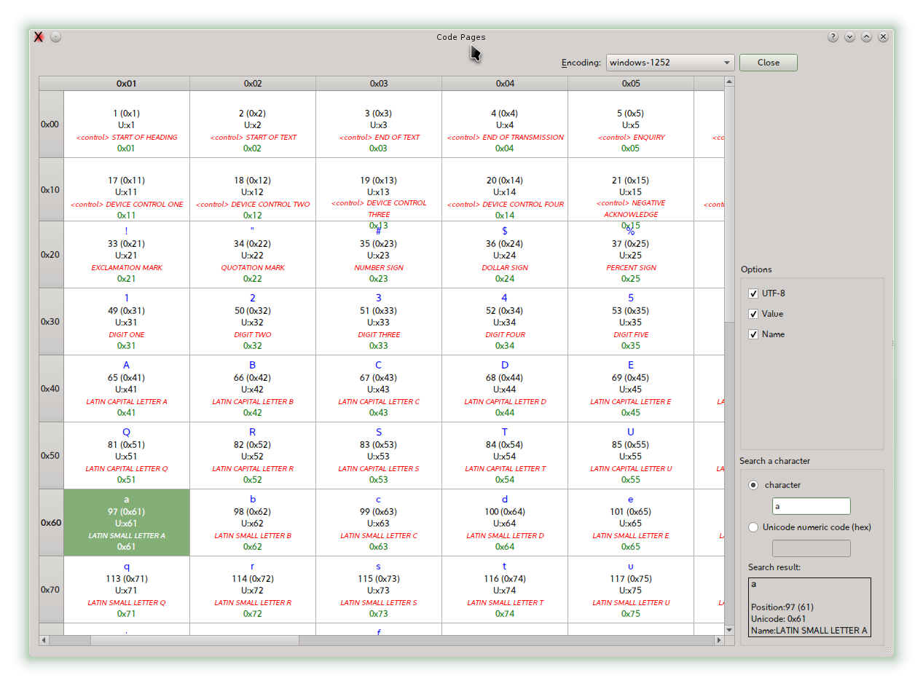

Visually Comparing XML Schema files
The compare operation is started loading a XML Schema file, then selecting the menu operation. After the compare a window will open, showing the elements with different colors depending on their state. The comparison can be done taking into account the annotations or not. Even the single items of restriction enumerators values are shown.
To start the compare operation:
Menu > File > Compare XSD...
Options available: exchange source and reference and compare annotations or not.
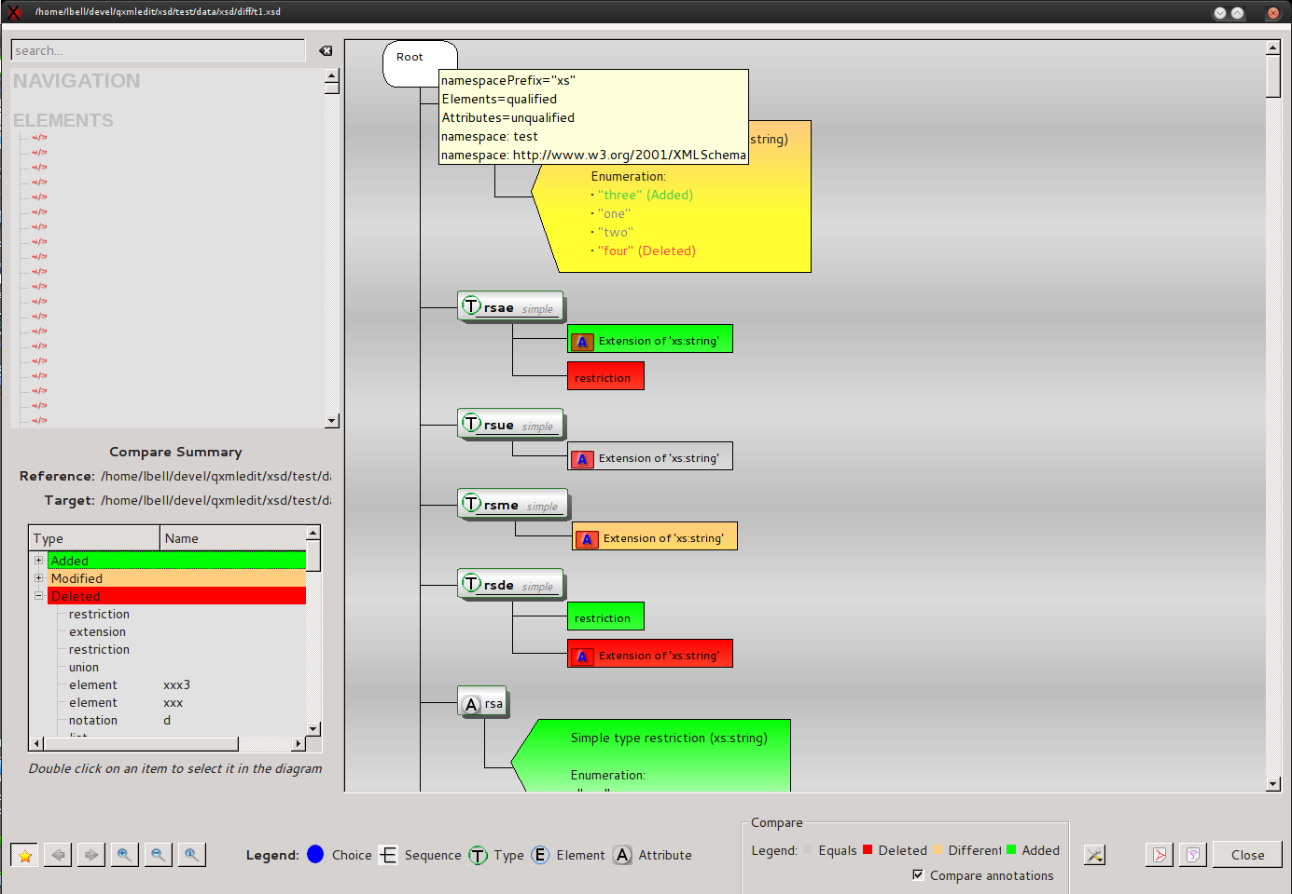
Differences report
Items, with different colors depending on state
Tools menu

Binary files viewer
Using the menu Tools > Binary files viewer you can view the raw data of a file. The data can be decoded in text using one of the supported encoding, but each row of 16 bites is decoded separately. The input file is divided in pages to not overloading the memory. In this panel you can:
- View the raw data using a text encoding.
- Search text using the selected encoding .
- Go to an offset into the file.
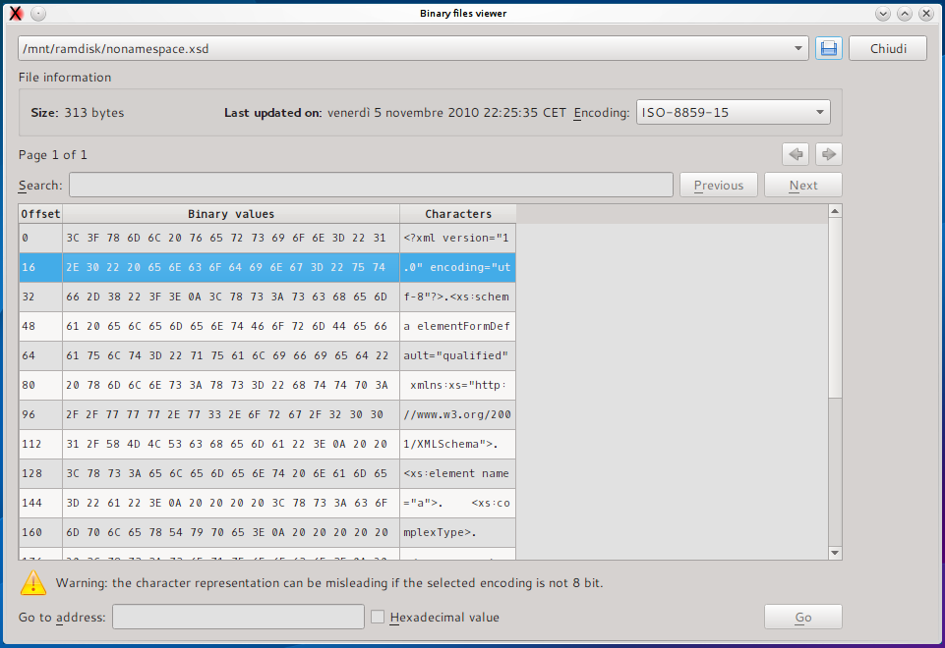
Select encoding
Search box
Raw value
Jump to offset

Command Line arguments
QXmlEdit can be started with the following arguments:

Option | Operation
-vis <file> | Opens the data visualization panel
-anonymize <inputfile> <profile> <outputfile> | Anonymizes a file and exit
-xslt [-saxon] -xsl=<xslFile> -output=<outputfile>  {-p<name>=<value>}* <inputfile> | Executes XSL transformation and exit.  Parameters can be supplied using the ‘-p’ options.

any other argument is used as a file to open.

Appendix

Note on “Single Application” Mode
The single application mode is enabled by default, but can be disabled using an option in the Options panel.
It consists in opening a local server when starting, After that, if a command line argument is used by the shell (e.g. the “Open With” in Windows Exlporer), the arguments are sent to the existing instance via the local socket.

Style file format
This section describes the structure of a style file.
A style file is an XML file with the following structure:

Root Tag:
Tag name | Attributes | Child elements
style: | - “name” style name as shown in the user interface  - “description”: a description  - “namespace”: an optional namespace | - “keywords”  - “styles”  - “ids”

Element “styles”
This element is simply a collection of “style” elements plus one optional “default” that will be used as default style, if existing.

Element “default”
It contains one “style” element.

Element “style”

Tag name | Attributes | Child elements
style | - “id” unique identifier of the style. It is a string  - “color”: hexadecimal representation of a color used to paint the text. Example: “FF0000”  - “backColor”: optional, the background color in hexadecimal format with optional alpha at the end.  Example: FF0000 or FF000080  - “family”: font family if different from default.  - “size”: font size if different from default.  - “bold” set to 'true' or a numeric value different from zero to force bold style on font  - “italic”: same of bold, but for italic style  The only mandatory attribute is id, the others are activated if set.

Element “keywords”
This element is simply a collection of “keyword” and “rule” elements

Element “keyword”
A keyword, with associated style. Each element tag in the data file that is enrolled in this section will be printed with the indicated style

Tag name | Attributes | Child elements
keyword | - “keyword” the name of the element to mark  - “idStyle”: the identifier of the associated style

Element “ruleSet”
Contains a set of “rule” and “ruleSet” using implicit AND connector
Tag name | attributes | Child elements
ruleSet | - “connector” the connector of the children  - and (default)  - or  - “idStyle”: for a top level rule identify the style to be used | “rule”, “ruleSet”

Element “rule” (inner)

Tag name | attributes | Child elements
rule | - “entity”: denotes and attribute or an element, default: attribute  - attribute  - element  - “name”: if attribute, the name of the attribute or element  - “op”: denotes the comparison operator  - EQ: equals  - NE: not equals  - EX: value exists  - NX: value non existent  - GT: greater than  - LT: less than  - GE: greater or equal  - LE: less or equal  - SS: substring (string only)  - ST: starts with (string only)  - “type”: type of comparison, optional, default: string  - s: string  - n: number  - p: position  - “value”: the comparison value. If position, the value should be:  - numeric  - first (literal)  - last (literal)  - “case”: if the comparisons take the case of the strings into account, default: true  - true: case sensitive  - false: not case sensitive | none

Element “ids”
This element is simply a collection of “id” elements

Element “id”
This element contains the name of attributes whose content will be printed next to element tag

Tag name | attributes | Child elements
id | - “id” name of the attribute that is considered as an identifier.  - “alpha”: if true, force the enclosing of the value between quotes.

This is a complete sample style file:

<?xml version="1.0" encoding="UTF-8"?>
<!-- this is a sample QXmlEdit style file -->
<style name="Log" description="log test style">

<keywords>
<keyword keyword="resource" idStyle="1"/>
<ruleSet idStyle="2">
<ruleSet connector="and">
<rule entity="element" op="eq" type="s" value="event"/>
<rule entity="attribute" name="level" op="eq" type="s" value="fatal" case="false" />
</ruleSet>
</ruleSet>
<ruleSet idStyle="3">
<ruleSet connector="or">
<rule name="level" op="eq" type="s" value="ERROR" />
<ruleSet connector="and">
<rule entity="attribute" name="level" op="eq" type="s" value="INFO" case="true" />
<rule name="pri" op="gt" type="n" value="12"/>
</ruleSet>
</ruleSet>
</ruleSet>
<ruleSet idStyle="4">
<rule name="level" op="eq" value="WARNING" case="true" />
</ruleSet>
<ruleSet idStyle="5">
<rule name="level" op="eq" type="s" value="INFO" case="true" />
</ruleSet>
</keywords>

<styles>
<style id="1" color="2080FF" />
<!-- fatal -->
<style id="2" color="FF0000" size="12" family="Arial" bold="true" italic="false" icon=":E:" />
<!-- error -->
<style id="3" color="FF4080" size="10" family="Arial" bold="true" italic="false" icon=":E:"/>
<!-- warning -->
<style id="4" color="C0C080" size="10" family="Arial" bold="false" italic="false" icon=":W:"/>
<!-- info -->
<style id="5" color="000000" size="8" family="Arial" bold="false" italic="true" icon=":I:"/>
<default>
<style id="default" color="C0C0C0" size="8" family="Arial" bold="false" italic="true"/>
</default>
</styles>

<ids>
<id id="name" alpha="true"/>
<id id="id" alpha=""/>
</ids>

</style>

Installation of new styles
Given that styles are so simple, they can be created by the user with a simple text editor. Styles are searched in a directory configured via 'Configure...' menu.

