Scenario event driven architecture – transactional

1. START MONGO DB
2. START ZOOKEEPER
3. START KAFKA
5. SHOW LISTENER ON THE QUEUE
6. PENDING
7. OK
8. KO
9. CONNECTTO DATABASE WITH MYSQL WORKBENCH
   1. Connect to bookabattery_db_event localhost;
   2. Select id, bokingstate from booking;
10. LAUNCH CHROME 01_EVENT (LIST MONGODB - CLEANER MONGODB)
11. START APPLICATION 01

SHOW NO DATA IN TABLE

1. SHOW LISTENER ON THE QUEUE
2. PENDING
3. OK
4. KO

mysql> connect bookABattery_db_event localhost

1. MYSQL COMMAND LINE

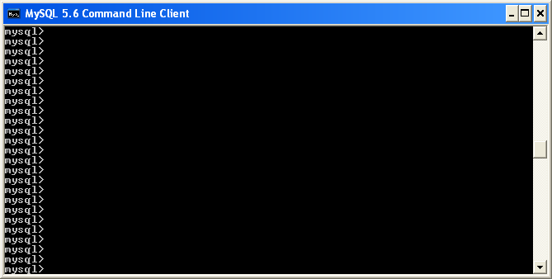

1. LOAD FILE WITH DEMO DATA

mysql>

source C:/development/microS_code2016_serviceRegistryDiscovery/

01_bookABattery_SERVICE/demoLoadBooking.sql;

1. SHOW DATA LOADED

mysql>

select id, bookingstate from booking;

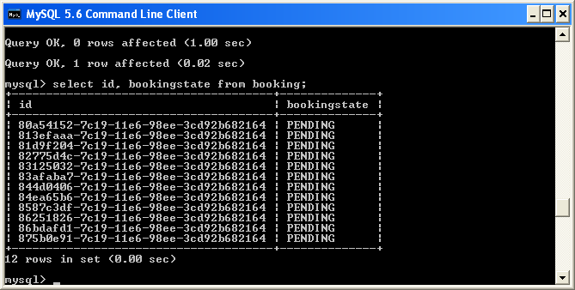

1. All in state PENDING
2. After Batch:

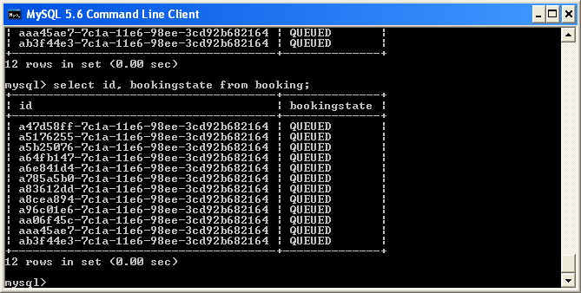

1. SHOW TOPIC PENDING

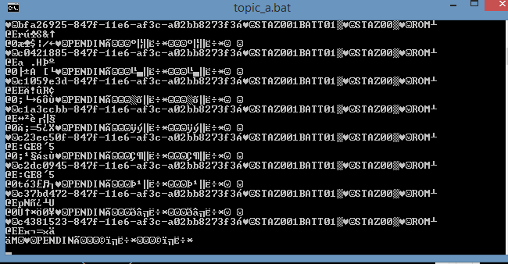

1. RELOLOAD FILE WITH DEMO DATA

mysql>

source C:/development/microS_code2016_serviceRegistryDiscovery/

01_bookABattery_SERVICE/demoLoadBooking.sql;

1. START MATERIALIZED VIEW
2. CALL MONGO DB REST

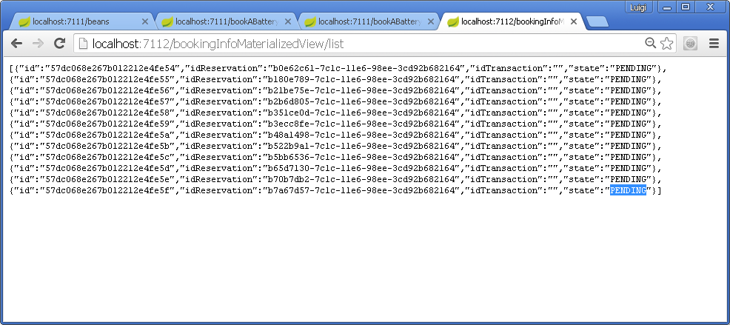

1. RELOLOAD FILE WITH DEMO DATA

mysql>

source C:/development/microS_code2016_serviceRegistryDiscovery/

01_bookABattery_SERVICE/demoLoadBooking.sql;

1. [TRUNCATE DATA MONGO DB]

<http://localhost:7112/bookingInfoMaterializedView/deleteForDemoOnly>

1. RELOLOAD FILE WITH DEMO DATA

mysql>

source C:/development/microS_code2016_serviceRegistryDiscovery/

01_bookABattery_SERVICE/demoLoadBooking.sql;

1. START BATTERY MANAGER
2. START PUBLISHING AND CONSUMING QUEUE

