06_PWS EUREKA DISCOVERY LOAD BALANCING

# PREREQUISITES

1. LAUNCH AND LOGIN PIVOTAL
2. START APP EUREKA SERVER
3. START APP SERVICE
4. START APP CONSUMER

# DEMO

1. SHOW CONSOLE EUREKA
   1. LIST APPLICATION
   2. LAST 100 0 SINCE STARTUP (REGISTERED LEASE AND CANCELLED LEASE)
2. SHOW LIST DISCOVERY HOW MANI INSTANCE OF SERVICE ARE REGISTERED

<http://06-bookabatteryclient_discovery_service.cfapps.io/listDiscovery>

1. SHOW LOAD BALANCER BOOKING (TREREIS ONLY ONE SERVICES THAT IS WHAT IS ANSWERING TO THIS REQUEST)

<http://06-bookabatteryclient_discovery_service.cfapps.io/loadBalancerBooking>

1. SHOW METRICS

<https://metrics.run.pivotal.io/apps/844e210d-5f5f-4b5f-9194-83786ca6489f>

1. SCLAE OUT INSTANCE
2. TAKES 40 SECONDY –
   1. SHOW LIST DISCOVERY THE INSTANCE AVAILABLE
   2. SHOW THE CONTINUING OF WOKIING OF LISTLOADBALANCER
   3. SHOW METRICS

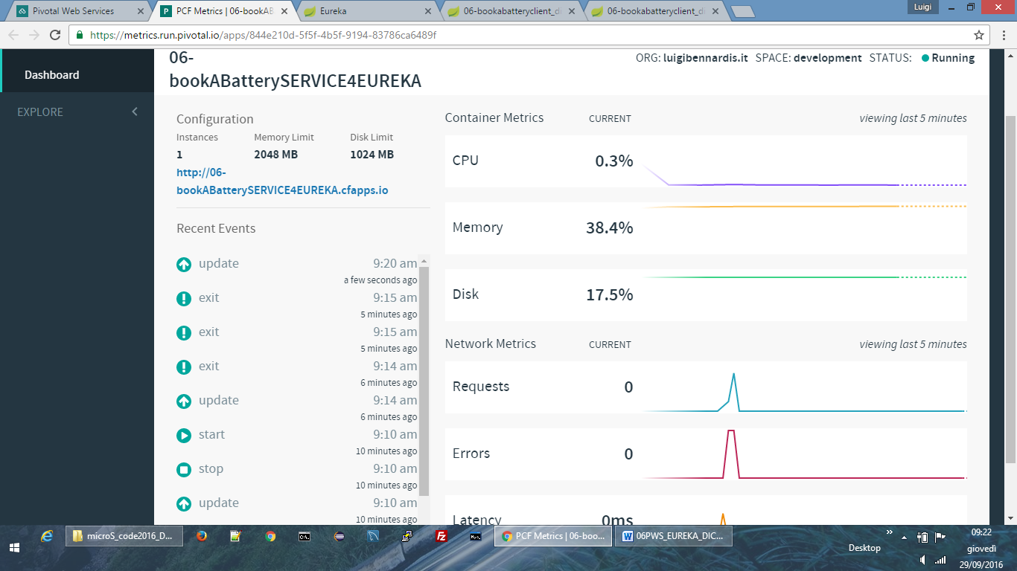

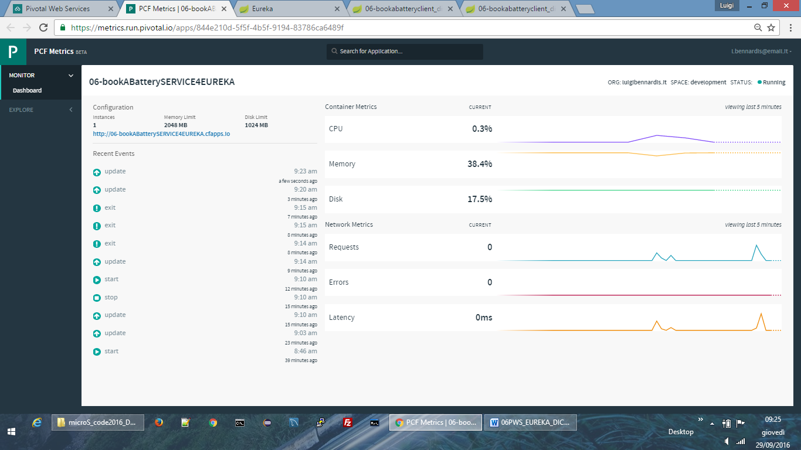

* 1. SHOW CPU OF EACH INSTANCE
  2. CPU GOES DOWN TO 0 (THEN IS REGISTRED WITH EUREKA)
     1. BEFORE GOES TO ZERO CPU IS TAKING RESOURCES TO REGISTER UNDER EUREKA
  3. GOES TO LIST DISCOVERY THEN 2 INSTANCE AVAILABLE
  4. SHOW THE CONTINUING OF WOKIING OF LISTLOADBALANCER
  5. SHOW THE LOG WHERE THE TWO INSTANCE TRACE THE ADDRESSED REQUESTS
  6. SHOW THE RENEWAL LEASE FROM CONSOLE

1. SCALE DOWN SCENARIO
   1. REDUCE TO ONE INSTANCE
   2. GO TO EUREKA CONSOLE THAT REDUCE THAT SUDDENLY REDUCED TO ONE INSTANCE
   3. THEN GO TO LISTDISCOVERY THE LIST IS REDUCED TO ONE

SOTP THE SERVICE4EUREKA

CHCK EUREKA DEREGISTER THE LAST INSTANCE

WAIT AND SHO THAT TREARE ARE NOT LISTDISCOVERY INSTANCE