EUREKA LOCAL

**[SET UP]**

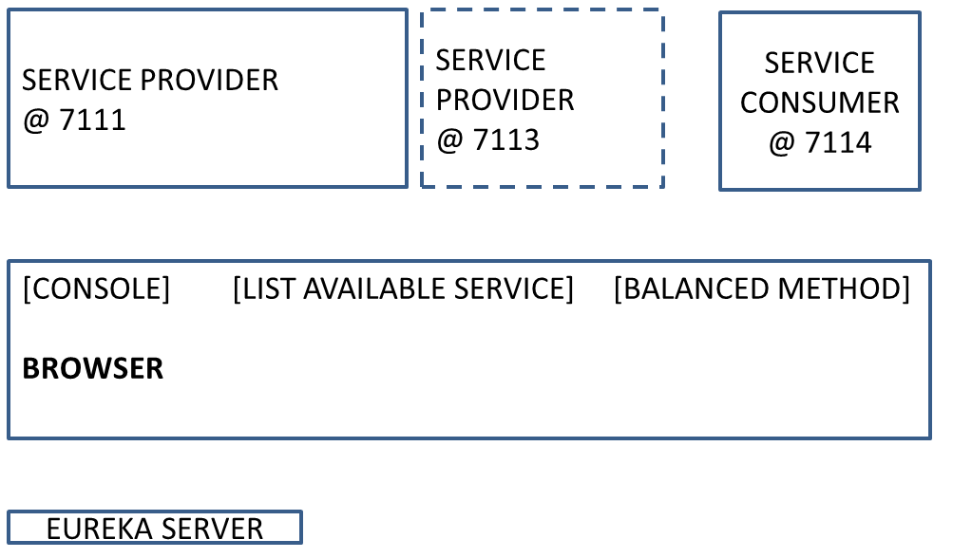

**[DESCRIPTION]**

**So a brief description of these windows**

1. **The Top left one represents the service provider instance listening to the http port number 7111**
2. **The Top Right represents the service consumer instance listening to the http port number 7114**

**[DESCRIPTION]**

1. **The eureka console shows the registered consumer and provide services**
2. **Then I start a new instance on the provider service**
3. **[LIST AVAILABLE SERVICES] Meanwhile the consumer address all its requests towards the single available service instance**
4. **[SLOW!]Calling the balanced Rest method we can see the corresponding log evidences**
5. **Browsing the Eureka console we can see when the new instance TURNS available**
6. **Then we can check the updated available instances**
7. **[SLOW!]Calling the balanced Rest method we can see the corresponding log evidences distributed among the service instances**