**DEMO**:

-1H PRERUN PWS 00 ON THE CLOUD AND TEST IT

-1H PRERUN PWS 02 06 EUREKA ON THE CLOUD AND TEST IT

-1H PRERUN LOCALLY

Scenario docker container - stop

scenario base transaction - stop

scenario eureka

13/09/2016 TODO HOME

1. ~~Check project 00 first demo – please align logic to 00PWS~~
2. Check deployment 00PWS and run it OK
3. ~~Prepare a fake deployment project PWS su pivotal~~
4. Launch fake deployment
5. PWS:DEPLOYMENT EUREKA-SERVER-SERVICE-CONSUMER OK
6. ~~PWS:CHECK ERRORS ON DEPLOYMENT EUREKA- SERVER- SERVICE – COMUSUMER~~
   1. Ok web 06 consumenr
   2. ~~Fix starter version 02 06 service4eureka~~
   3. ~~https://github.com/spring-guides/gs-service-registration-and-discovery/blob/master/complete/eureka-service/src/main/resources/application.properties~~
   4. ~~Check new deploy on 06 service check booking class 000077.999~~
   5. Bind database pws on tool
7. CHECK DEMO TRANSACTIONAL BEHAVIOUR on pc ram consumption
8. CHECK DEMO TRANSACTIONAL BEHAVIOUR on pc ram consumption
9. Detailed how eureka server works (notes on home’s table)

Complete:

1. Scenario local
2. Scenario docker
3. Scenario docker Hub
4. Scenario PWS
5. Scenario Transactional
6. Scenario Eureka LOCAL
7. Scenario Eureka PWS

**[PRESENTATION OF THE WORK]**

As form the title the aim of this work is try to show a possible process of development of a microservices ecosystem from the very first phase of design to delivery.

**[ABSTRACT]**

**[BUSINESS CONTEXT]**

So let us see in brief the business context that originated the need of this application development

[FIRST IMAGE rome center]

this is historical district of Rome the city where I live since I was born. The story of this district goes back in the past from the romans.

[SECOND IMAGE limited traffic zone]

The blue line surround the motorvehicle limited traffic zone. It is an area of about 10 square kilometers caracterized by a strong concentration of historical monuments, tourism facilities and national institutions (government and parliament) with important needs of moving goods.

As you can see from scale the In such area mobility is a challenge for the reduced spaces. Besides also pollution is an issues not only for the quality of the air but also for the architectonical values.

A possible solution for daily goods delivery that realize both an efficient mobility and respect of environment could be led by smart electrical vehicle.

For a more sustainable for the environment and efficient mobility in such a context the daily delivery of goods could be done by means of (through) “smart” electrical vehicles.

[IMMAGINE DEL VEICOLO]

Small so that they can easily move among the small street with no pollution emission. And safe at the same time for the environment.

~~A partial solution of these issues could be addressed by means of smart electric vehicles for daily goods delivery.~~

~~In tye same time an issue as good deliveries should be addressed, in fact in this area beside A partial solution of these issues could be addressed by means of smart electric vehicles for daily goods delivery.~~

To overcome the limited life of the batteries these vehicles has been enginnered with special battery pack that could be easily and rapidly changed in dedicated service station.

[IMMAGINE DEL VEICOLO CAMBIO BATTERIA]

In this way these vehicle will not need to stop for charging their batteries and so could guarantee a continous ideal 24/7service in comparison with those vehicles not engineered in such a way.

[THIRD IMAGE PIT-STATION]

So here reprensented the map of the pit station that will deliver the fresh charged battery for the delivery fleet.

I do not know if this is a realizable scenario but if so it is necessary a software solution by witch manage these service of smart delivery. So let me list the requirements in a very summarized way.

## [REQUISITI 1 – FUNZIONALI ]

## [REQUISITI 2– non FUNZIONALI ]

## [REQUISITI 3– project management ]

## [technology stacks]

A possible solution of these requirements could be led by the following technology stack coming by the stìpring project abd Netflix

In this chart i have tried to summarize the technology stacks that I have used to realize the design patterns defined ~~for choose for the development~~.

In this chart I have tried to summarize the technology stacks that realize the design patterns choosed for the architecture of this system

SPRING BOOT RUNNABLE FROM COMMANDLINE EXAMPLE

## Lifecycle vs service vs environment specifity

In this chart I have arranged that will accomplish the lifecycle steps imagined for this project and the corresponding realizing services both in a local and in a cloud environment.

In this chart i have arraged the    that accomplish the lifecycle steps imagined for this project and the corrispondending realizing services   
both in a local and in a cloud environment.

## [MICROSERVICES database per service : DESIGN PATTERN]

## Microservice and Database per service will fulfill the non functional requirements

So a Microservices architecture will be the design pattern that accomplish the listed requirements (face the choose of a database design pattern)

What is the database design pattern that best fit a microservice architecture?

Description of database per service pattern for developing Micorservices

Face the design of one of the microservice of the system that which record the booking information

* Show picture (db/logic/api)

# Demo

## [DEVELOPMENT / UNIT TEST ]

### LOCAL H2

00 pws – show details on ppt

1. ~~Pom frgments~~
2. ~~Application.class~~
3. Data assess by hibernate
4. ~~Web package~~
5. ~~Configuration file~~ 
   1. ~~Application~~
   2. ~~yml~~
6. ~~Show highligts at strautup~~
7. Web exposed
   1. /h2 console
   2. All rest services
8. ~~Migration~~
9. ~~Startup db resolution show~~

### LOCAl MYSQL

## [SCENARIO QUALITY ASSURANCE/INTEGRATION TEST –DOCKER LOCAL]

**00DLoc_bookabattery_local_docker.docx**

**So let’s go ahead in the develipong process facing the phase of integration test**

**The commit master will have the duty of conduct the integration test against all development done on one or more sevices modified for the new system release or for bug fixing coming from the QA or production environments.**

**THE INTEGRATION TEST WILL BE CONDUCTED IN AN EVIRONMENT WHERE THERE WILL BE AVAILABLE ALL THE SERVICES needed for the system to be consistent.**

**In a simple scenario two or more developers each responsible for the development of a part of a microservice finish with success the unit test**

**Beside the skill of the qa team must be enough to get the application and run it, it is stated in the requirements that in this team there will be no need of technical slìkill that will manage the deployment or other technical tasks.**

**So the commit master in a dedicated branch deliver the work of the developers merging all the contributes and build the microservice**

Docker definition

-I have provided an empty database image that will be load by flyway at start up

Show Dockerfile

Show dockerfile template

Show maven implementation and plug in

Create a local docker image

Run the container + database

Show bindings

## [SCENARIO QUALITY ASSURANCE TEST –DOCKERHUB – JENKINS@OPENSHIFT]

**00D_ScenarioQulityASS_dockHub-GITHUB.docx**

Among the requirements it has been stated that the project’s teams

The progect management requirements shoud accomplish teams geographically distributed.

In such a context the delivery of the application as a docker machine could be realized by means of Docker Hub as a project’s images registry.

## PWS on COlud foundry

Database as service pattern will enforce database per service pattern.  Dedicated instance , dedicated schema and horizontal scale up

Show definition of application .cloudfoundry and its link to application.yml

YML

Db resolution show (?)

# Microservice Transactional scenario with event driven architecture

1. DESCRIPTION
2. Start ZOOKEEPER
3. Start KAFKA
4. Start MongoDB
5. START LISTENER TO TOPIC
   1. confirmBookingTopic
   2. notConfirmBookingTopic
   3. pendingBookingTopic
6. project **01-batteryBookingInformation_SERVICE**
   1. DETAILS: TOPIC IMPLEMENTATION
   2. DETAILS: PROCESS DB INQUIRY
   3. DETAILS: POM
      1. spring-cloud-stream
      2. spring-cloud-starter-stream-kafka
      3. spring-boot-starter-data-mongodb
   4. RUN FROM .BAT
   5. LIST BOOKING INFOS

<http://localhost:7112//bookingInfoMaterializedView/list> NULL

1. project **01-batteryManagement_SERVICE**
   1. DETAILS: TOPIC IMPLEMENTATION
   2. DETAILS:
   3. RUN 01_**batteryManagement** _SERVICE
      1. Show log output
      2. Show database load
   4. Show topic subscriber **EMPTY**
   5. RUN FROM .BAT
2. project 01_bookAbattery_SERVICE
   1. DETAILS: TOPIC IMPLEMENTATION
   2. DETAILS: PROCESS DB INQUIRY
   3. DETAILS: POM
      1. spring-cloud-stream
      2. spring-cloud-starter-stream-kafka
   4. RUN 01_bookAbattery_SERVICE –profile localmysql FROM .BAT
      1. Show log output
      2. Show database load

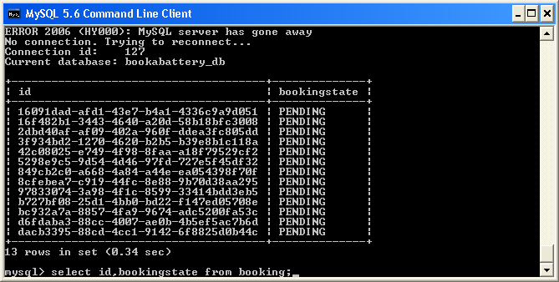

* + 1. Show log file with executing jobs

DbPollingPendingCleaner Job -> 09/06/2016 16:29:13

DbPollingPending Job -> 09/06/2016 16:29:13

DbPollingPending Job -> 09/06/2016 16:29:23

DbPollingPending Job -> 09/06/2016 16:29:33

DbPollingPendingCleaner Job -> 09/06/2016 16:29:38

DbPollingPending Job -> 09/06/2016 16:29:43

DbPollingPending Job -> 09/06/2016 16:29:53

DbPollingPending Job -> 09/06/2016 16:30:03

DbPollingPendingCleaner Job -> 09/06/2016 16:30:03

DbPollingPending Job -> 09/06/2016 16:30:13

DbPollingPending Job -> 09/06/2016 16:30:23

DbPollingPendingCleaner Job -> 09/06/2016 16:30:28

* + 1. Show Topic subscriber

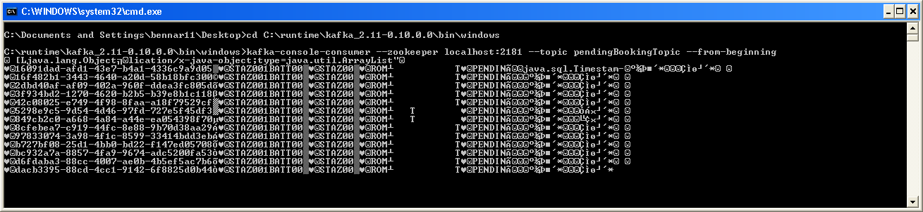

* + 1. Show database update

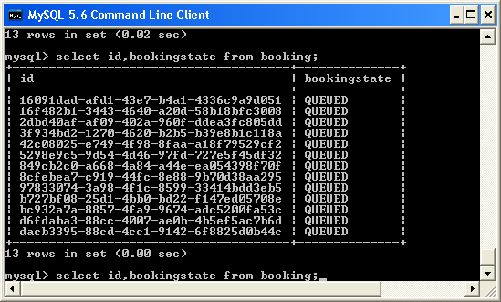

* + 1. Blah

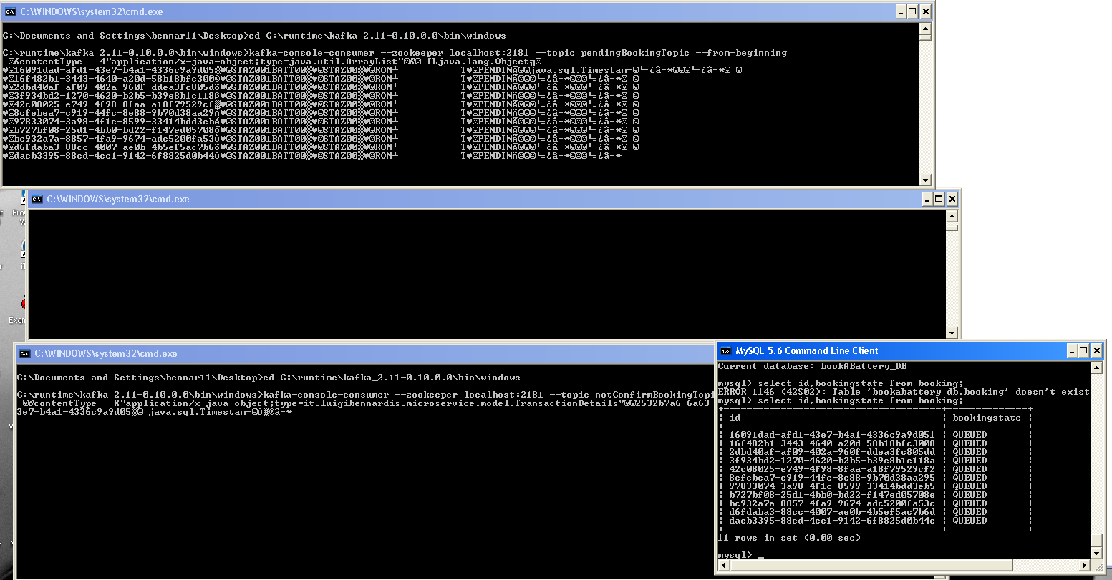

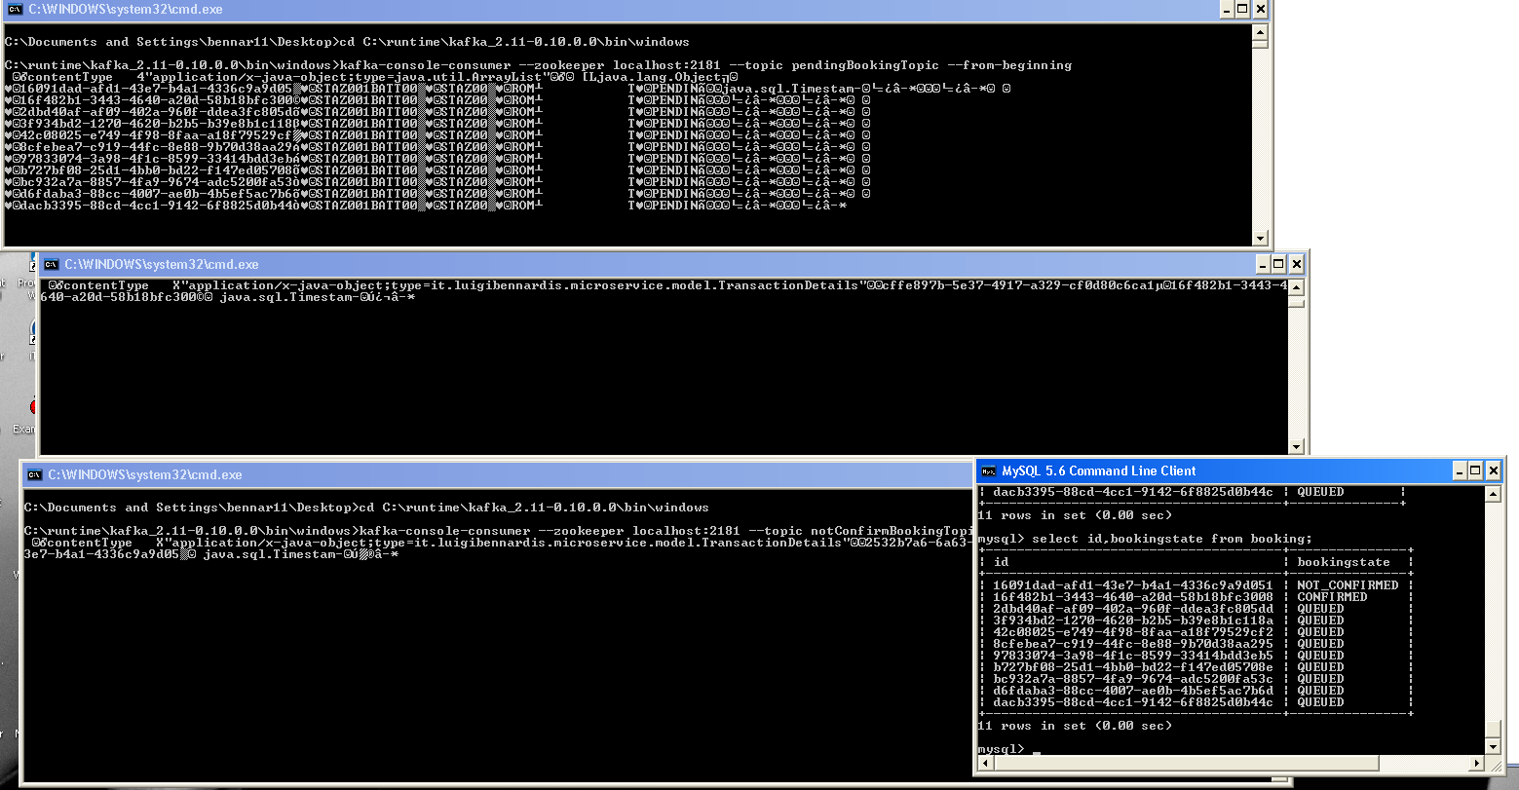

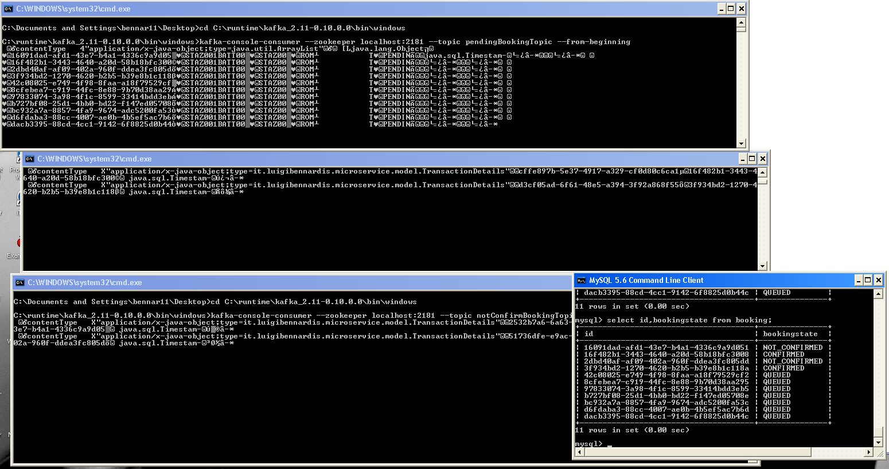

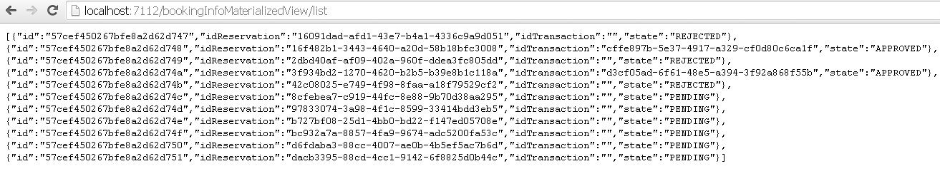

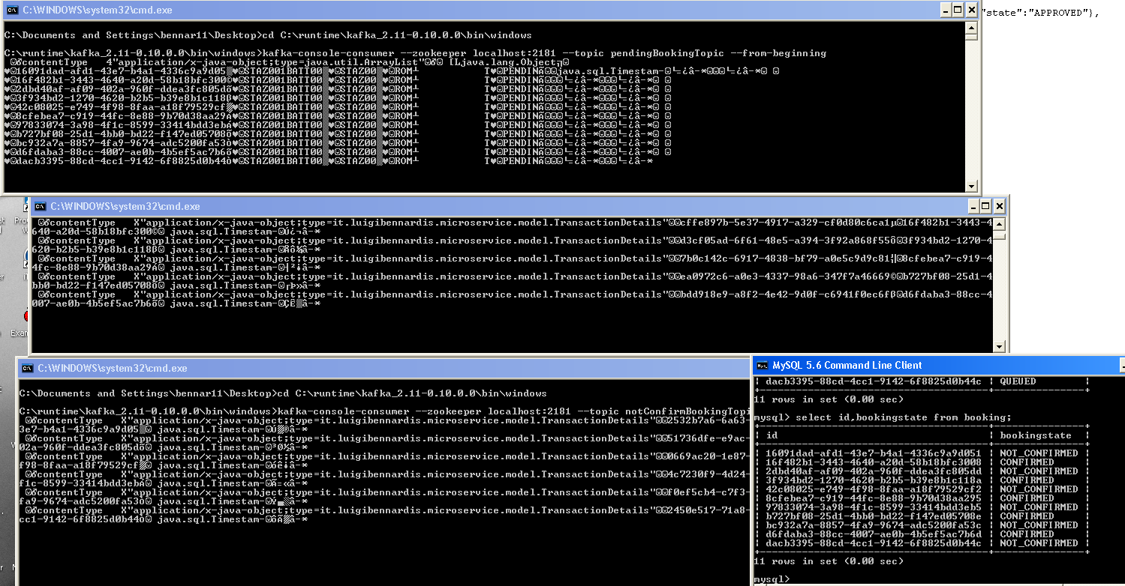

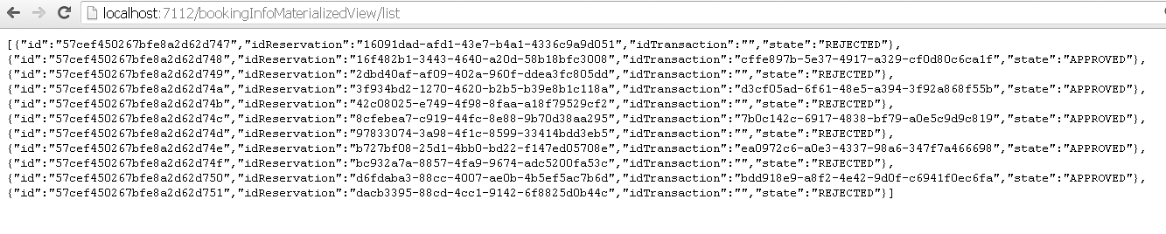

1. Stop core services and check information services still running

# Wiring microservices - Service Discovery

In sun an architecture microservices can cooperate for a computing system ecosystem shoud wire each other

Wiring by resftfull call baut to achieve decouplig it is necessary that service shoud be discocered.

Eureka server is on its turna microservice (run as a spring boot application)

1. START 02 EUREKA SERVER
2. SHOW CONSOLE EUREKA
3. START 06 7111
4. SHOW REGISTRATION
5. START 06 SERVICE CONSUMER
6. SHOW /LIST SERVICES
7. SHOW /

### 02-eureka-server

Overview of the project

File yml etc

Configurations of Eureka

Run project from command line .bat

Show console

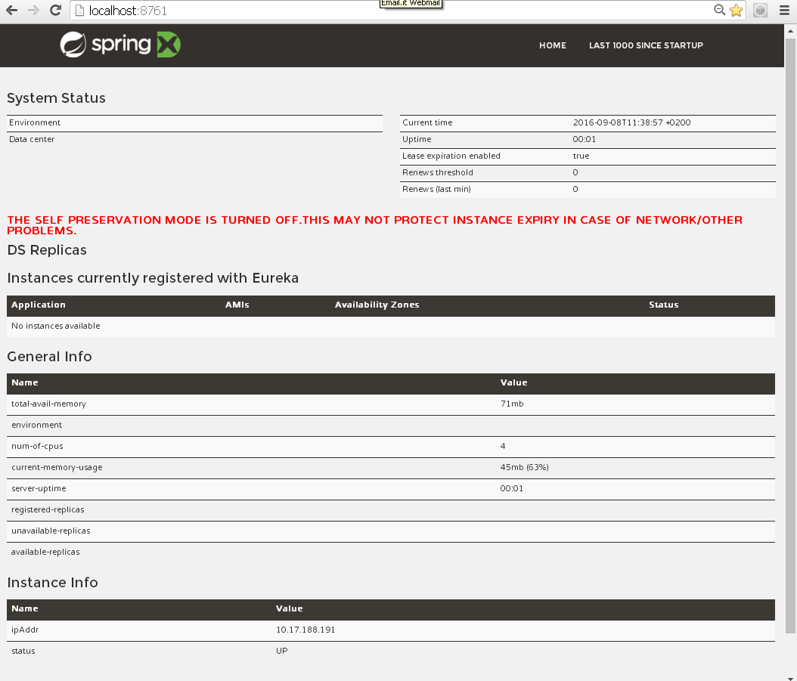

#### Detail the message “THE SELF PRESERVATION MODE IS TURNED OFF.THIS MAY NOT PROTECT INSTANCE EXPIRY IN CASE OF NETWORK/OTHER PROBLEMS”

2016-09-08 14:52:35.431 WARN 8232 --- [a-EvictionTimer] c.n.eureka.PeerAwareInstanceRegistry : The self preservation mode is disabled!. Hence allowing the

instances to expire.

<https://github.com/ExampleDriven/spring-cloud-eureka-example/blob/master/eureka-server/src/main/resources/application.yml>

http://stackoverflow.com/questions/33921557/understanding-spring-cloud-eureka-server-self-preservation-and-renew-threshold

### 06_bookABatterySERVICE4EUREKA

Overview of the project

Eureka directives on application .class

File yml etc

Run project from command line .bat

Check registration

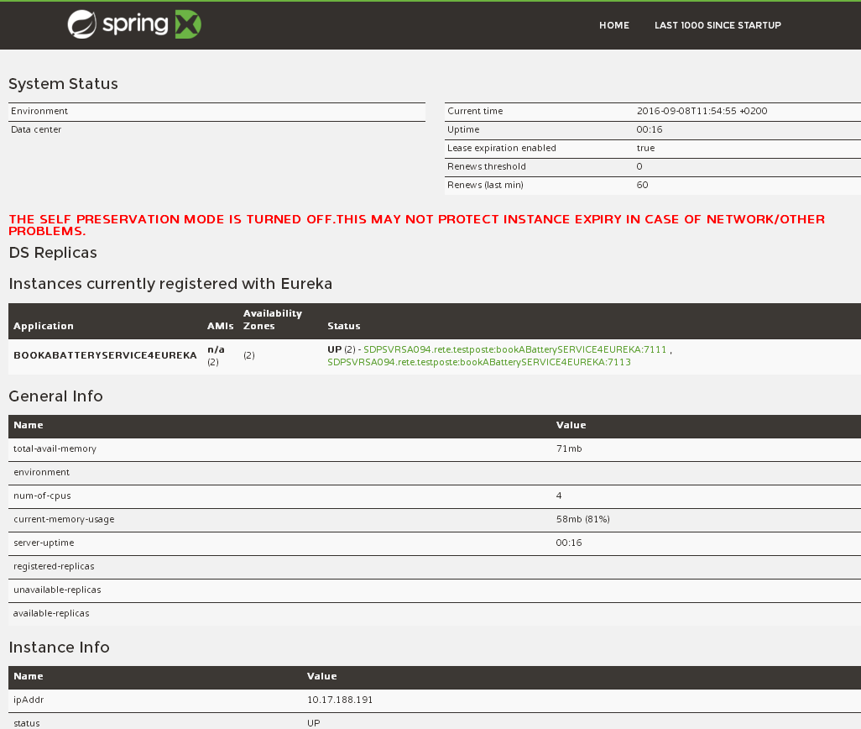

#### 06_bookABatterySERVICE4EUREKA 7113-7115

Overview of the project

Eureka directives on application .class

File yml etc

Run project from command line .bat

Check registration

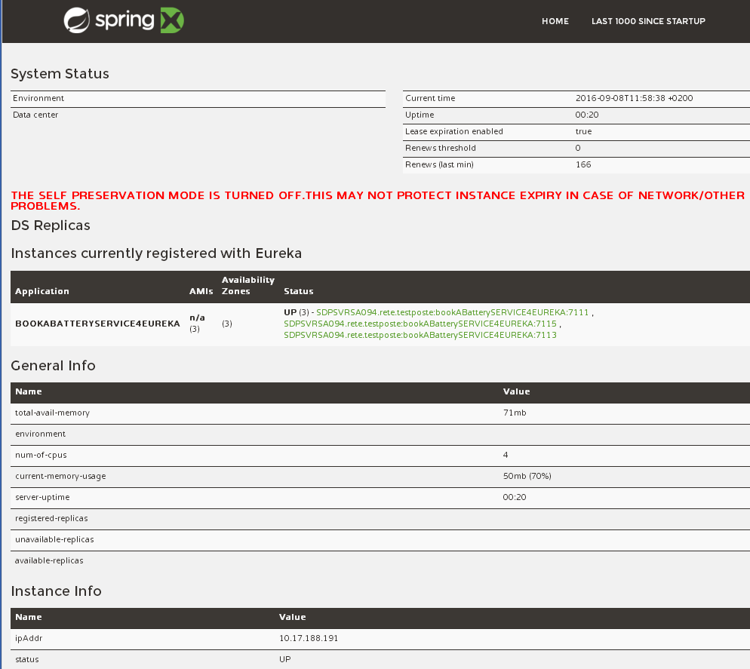

### Discovery

### 06_bookABatteryCLIENT_DISCOVERY_SERVICE

Code description

Run from .bat

Call:

## Load balancing with ribbon

### 06_bookABatteryCLIENT_FEIGN_SERVICE

Show implementation

<http://sdpsvrsa094:7112/>

show requested on the tree instance

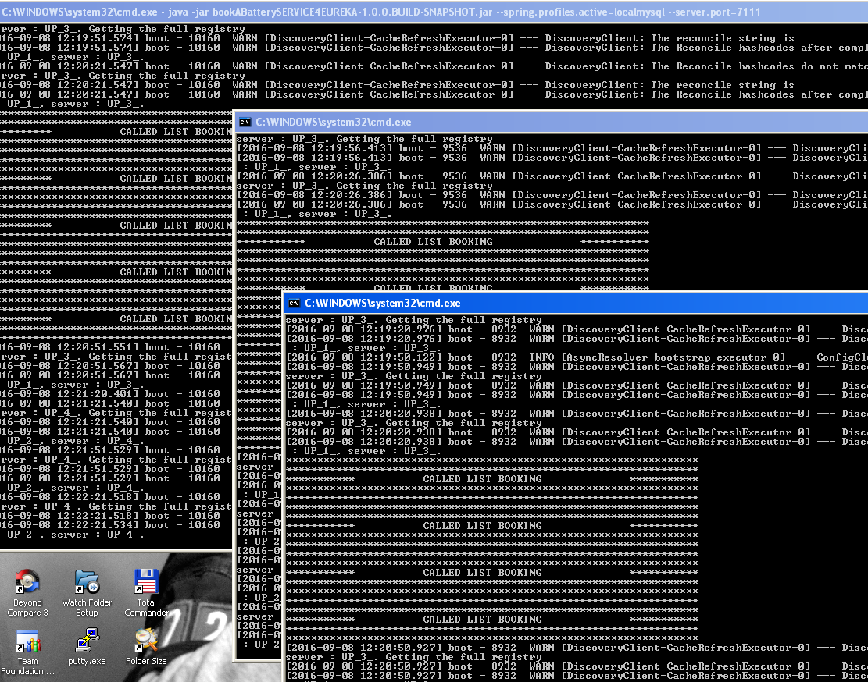

Stop two and how requested on the one running

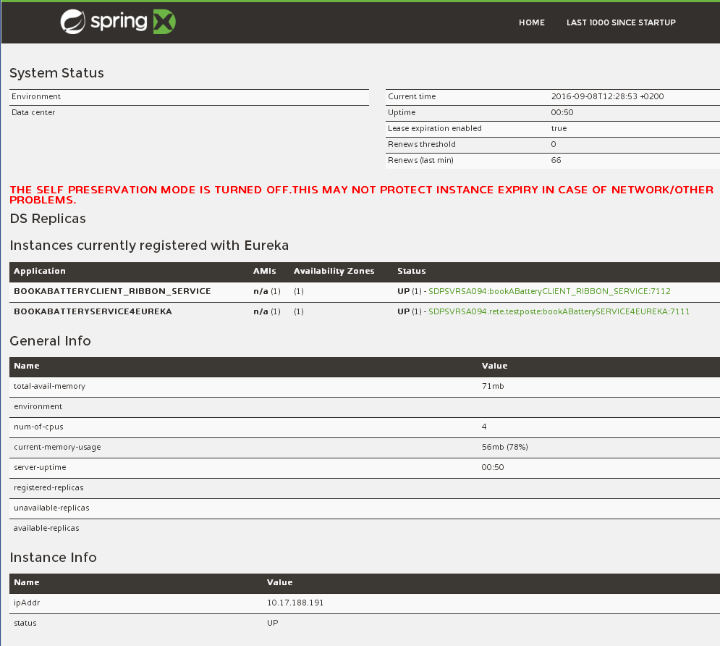

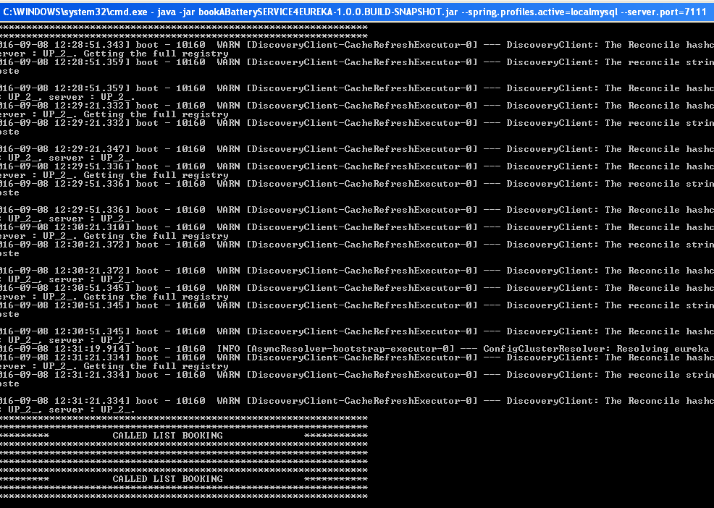

Suppress warn and info on services display

## Load Balancing

## Load Balancing

To cover in such a short time all these aspect each technology and process aspects are been described at a very high level,and need to be detailed in deep

**[PWS DISCOVERY AND BALANCING]**

Predeployed application only one service

Describe eureka

Launch test of balancing

LIVE: Scale instance of service then

http://06-bookabatteryclient_discovery_service.cfapps.io/listDiscovery

Launch test of balancing

**[EUREKA ALSO DEFINITION]**

07 June 2016 on [netflix](https://luizkowalski.net/tag/netflix/), [oss](https://luizkowalski.net/tag/oss/), [eureka](https://luizkowalski.net/tag/eureka/)

In this series of posts, I'll try to get you inside the Netflix stack: understand how it works and get your feet wet in the microservices world.

So, to begin, we need to know the first component of the Netflix stack: Eureka

The Eureka is described by Netflix as

a REST based service that is primarily used in the AWS cloud for locating services for the purpose of load balancing and failover of middle-tier servers. We call this service, the Eureka Server. Eureka also comes with a Java-based client component,the Eureka Client, which makes interactions with the service much easier. The client also has a built-in load balancer that does basic round-robin load balancing.

So basically, Eureka is a register, that will know where which one of our services lives, how many instances of they are up (or down) and how to access them.

Thanks to Spring, all the complexity to get a Eureka server up and running was wrapped inside useful libraries that we'll be using in this series.

So, enough with chit chat, let's get to work.

#### Creating an Eureka Server using Spring

Get a Eureka Server to run is unbelievable easy. First, visit [http://start.spring.io](http://start.spring.io/) and fill the form as follow:

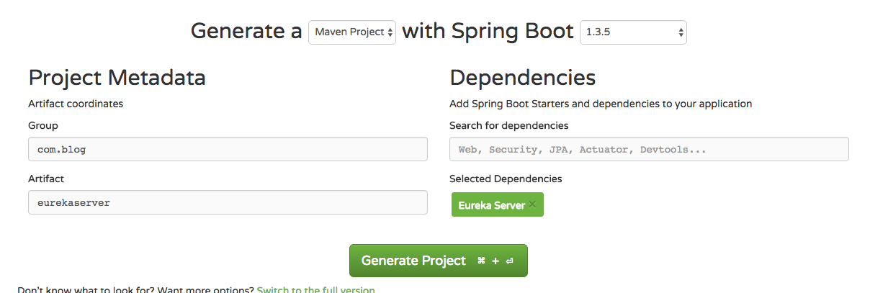

Pay attention to "Eureka Server" dependency listed.   
Now, download the project clicking "Generate Project" and import it to your IDE (if you are using Eclipse, you can "mavenize" it running mvn eclipse:eclipse on root).

Now, if you open it, you'll see an empty Spring Boot project, then, go to your application.yml (or application.properties if you prefer) and change as follow:

server:

port: 8761

eureka:

numberRegistrySyncRetries: 1

instance:

hostname: localhost

client:

registerWithEureka: false

fetchRegistry: false

serviceUrl:

defaultZone: http://${eureka.instance.hostname}:${server.port}/eureka/

server:

enable-self-preservation: true

Explaining the most important lines:

server:

port: 8761

Here, we are configuring the Eureka Server to run on port 8761. This is the default port and you can change, but you need to give this port to the clients later on.

eureka:

numberRegistrySyncRetries: 1

If you are running locally, there is a 2 to 3 minutes wait until fulling boot up. This happens because Eureka will be looking for peers. To disable this, set to 0 (although you should never do this in production)

client:

registerWithEureka: false

As this is the Eureka Server, we do not want it to register itself. Will always be set to false on server and true on the clients.

serviceUrl:

defaultZone: http://${eureka.instance.hostname}:${server.port}/eureka/

the defaultZone is the fallback URL for every client that doesn't specify a preference for a server.

Now, the only thing we should do is enable the Eureka Server.   
To do so, go to the main class (at this point, you should only have one class in the project, though) and annotate it with @EnableEurekaServer, as follow

@EnableAutoConfiguration

@EnableEurekaServer

public class EurekaServerApplication {

public static void main(String[] args) {

SpringApplication.run(EurekaServerApplication.class, args);

}

}

and start the server with mvn spring-boot:run

the latest log lines would be something like this

2016-06-07 21:34:38.624 INFO 723 --- [ main] o.s.c.support.DefaultLifecycleProcessor : Starting beans in phase 0

2016-06-07 21:34:38.627 INFO 723 --- [ main] .p.EurekaConfigBasedInstanceInfoProvider : Setting initial instance status as: STARTING

2016-06-07 21:34:39.120 INFO 723 --- [ main] com.netflix.discovery.DiscoveryClient : Not registering with Eureka server per configuration

2016-06-07 21:34:39.127 INFO 723 --- [ main] c.n.e.EurekaDiscoveryClientConfiguration : Registering application bootstrap with eureka with status UP

2016-06-07 21:34:39.202 WARN 723 --- [ Thread-2] c.n.eureka.PeerAwareInstanceRegistry : The replica size seems to be empty. Check the route 53 DNS Registry

2016-06-07 21:34:39.362 INFO 723 --- [ main] s.b.c.e.t.TomcatEmbeddedServletContainer : Tomcat started on port(s): 8761 (http)

2016-06-07 21:34:39.366 INFO 723 --- [ main] com.inkdrop.EurekaServerApplication : Started EurekaServerApplication in 12.2 seconds (JVM running for 18.242)

Access [http://127.0.0.1:8761](http://127.0.0.1:8761/) and you'll see this:

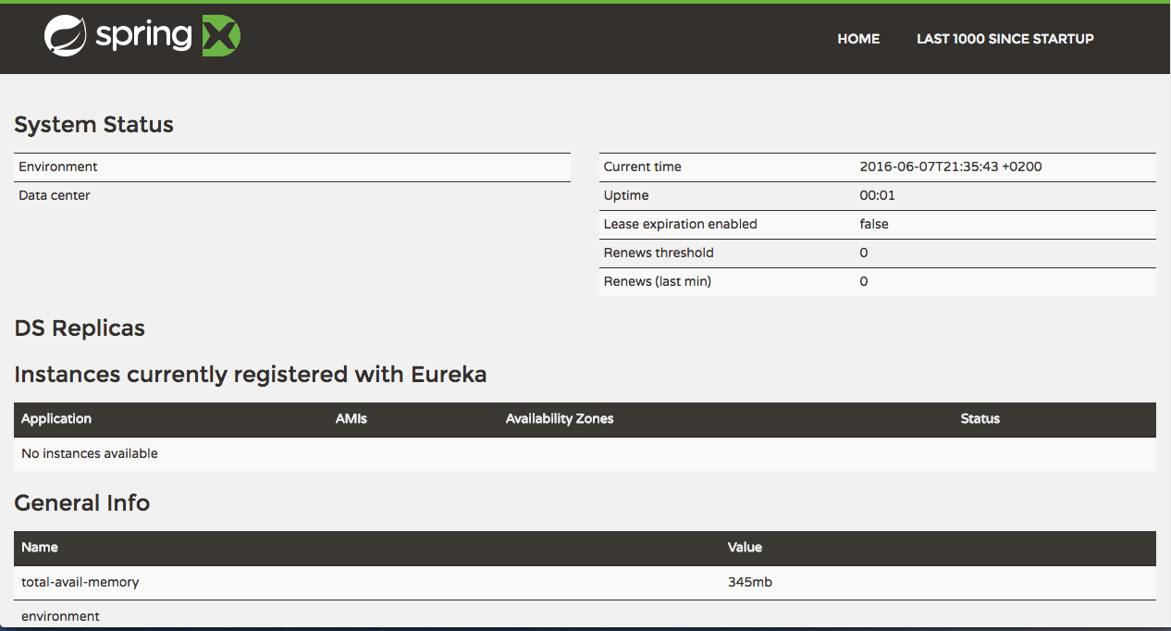

and that's it! Your Eureka Server is up and running.   
In the next post, we'll create a microservice that will register itself on Eureka.

If you want to see the code already, go to the final [github project](https://github.com/luizkowalski/microservices-netflix-sample)

🍻 🍻

[Luiz Eduardo's Picture](https://luizkowalski.net/author/kowalski/)

#### [Luiz Eduardo](https://luizkowalski.net/author/kowalski/)

Read [more posts](https://luizkowalski.net/author/kowalski/) by this author.

Berlin

#### Share this post

[Twitter](https://twitter.com/intent/tweet?text=Netflix%20OSS%3A%20A%20beginner%27s%20guide%20%5Bpt1%5D&url=https://luizkowalski.net/netflix-oss-a-beginners-guide-pt1/)[Facebook](https://www.facebook.com/sharer/sharer.php?u=https://luizkowalski.net/netflix-oss-a-beginners-guide-pt1/)[Google+](https://plus.google.com/share?url=https://luizkowalski.net/netflix-oss-a-beginners-guide-pt1/)

# Backup

The historic district of Rome  
(Prima sfide)  
Storia  
Romans  
Middle age  
900

So it is

A possible solution that realize both mobility and respect of environment could be led by smart electrical vehicle. Small that they can easily move among the small Street without no emission

The hystorical center of rrome is full of business activity, besides the seat of govermant institution so goods delivery is a critical   
To be much more

These vehicle colud lead an ideal  24/7 service without charging stops

Mobility sould be conducted in respect of ancient monuments and fragile buildings

Pit stop

Rome is the city where I live since I wos born. It counts about 3.5 official inhabitants to witch we have to add about 1 million of non resident people (students, tourists, workers). To these figures we have also to add about 700 vehicles each 1000 people, a rate that makes mobility a challenge.

Everyone could easily realize that with there figures besides mobility there are also pollution issues.

~~A partial solution of these issues could be addressed reducing the vehicles that daily deliver goods.~~

For a more sustainable for the environment AND RESPECTING THIS ARCHITECTONICAL VALUES and efficient mobility in such a context the daily delivery of goods could be done by means of (through) “smart” electrical vehicles.

~~To overcome the limited life of the batteries these vehicles has been enginnered with special battery pack that could be easily and rapidly changed in dedicated service station.~~

~~In this way these vehicle will not need to stop for charging their batteries and so could guarantee much more short breaks~~

~~Could be much more efficient in comparison to the other electric vehicle (that do non support this kind of batteries – not engineered in such a way)~~

I do not know if this is a realizable scenario but if so it is necessary a software solution by witch manage this scenario.

Each driver of this ecological delivery company according to his delivery plan each morning program the expected battery changes that will reasonably occur during a day. By means of a mobile application (web application) he will book one or more fresh batteries supplied by the stations distributed in the city.

In case of emergency it will be the vehicle itself that will notify to the driver the necessity to come to the nearest station with available fresh batteries, find by a software running in the vehicle.