1. MAven

C:\Programmi\apache-maven-3.2.5-bin

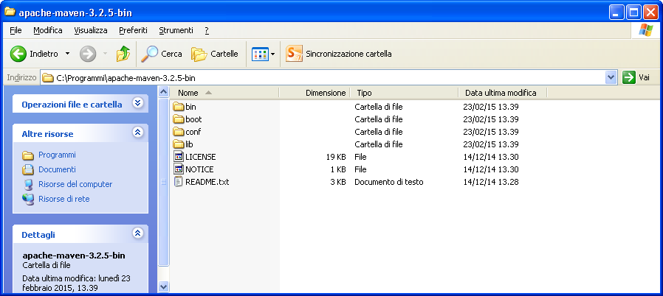

C:\Programmi\apache-maven-3.2.5-bin\conf

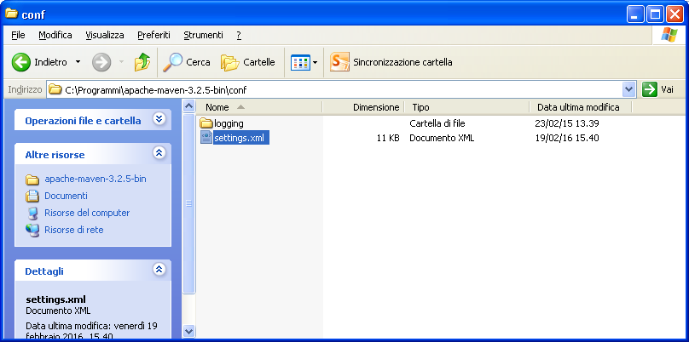

<localRepository>D:/MavenRepo</localRepository>

<proxies>

<proxy>

<active>true</active>

<protocol>http</protocol>

<host>localhost</host>

<port>5865</port>

</proxy>

<proxy>

<active>true</active>

<protocol>https</protocol>

<host>localhost</host>

<port>5865</port>

</proxy>

<servers>

<server>

<id>pivotal-cloud-foundry</id>

<username>l.bennardis@email.it</username>

<password>2Theknife.</password>

</server>

<server>

<id>github</id>

<username>l.bennardis@email.it</username>

<password>musical1.</password>

</server>

</servers>

Workspace Eclipse

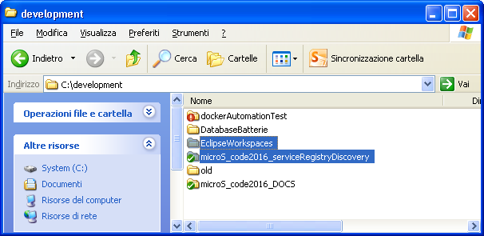

C:\development\EclipseWorkspaces\microS_code2016_01_serviceRegistryDiscovery_wksp (WORKSPACE ECLIPSE)

C:\development\microS_code2016_serviceRegistryDiscovery (TUTTI I PROGETTI CORRISPONDENTI A GITHUB REPO: https://github.com/lbennardis/microS_code2016_serviceRegistryDiscovery)

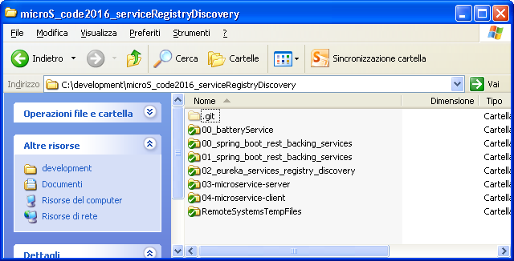

JAVA SETTINGS

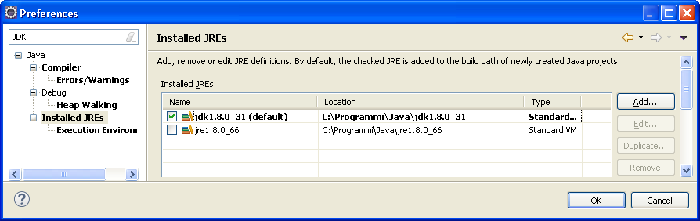

MAVEN INSTALLATION & SETTINGS

