LOCAL DOCKER

1. AVVIO DOCKER DA LINEA DI COMANDO

docker-machine start localDockerMachine

1. Visulizzazione lista immagini docker

docker images

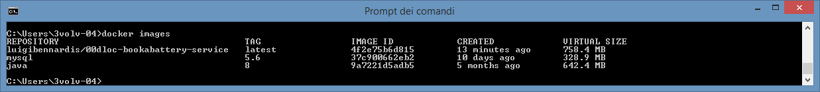

1. Build a new image

Wks C:\development\workspace\microS_code2016_serviceRegistryDiscovery_wksp

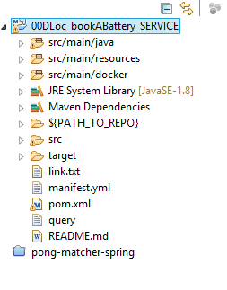

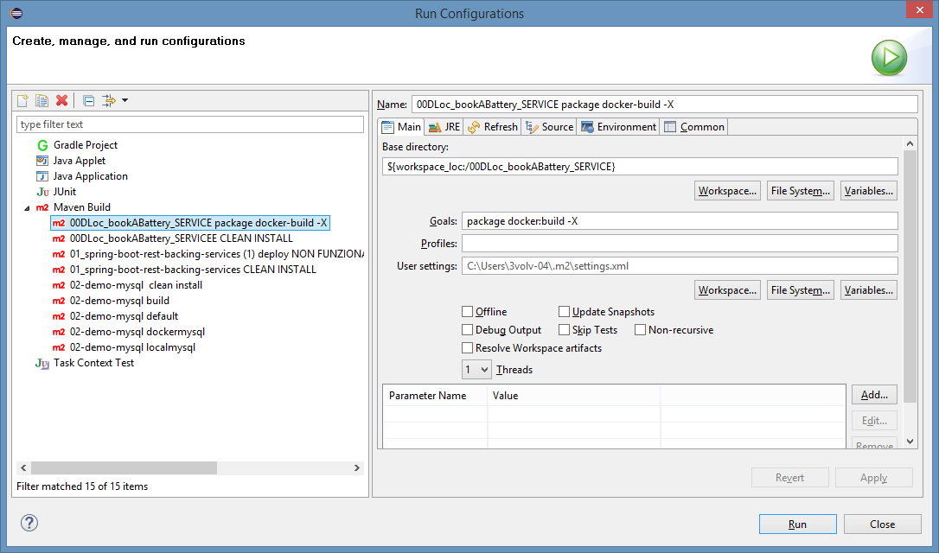

[INFO] Building image luigibennardis/00dloc-bookabattery-service

Step 0 : FROM java:8

---> 9a7221d5adb5

Step 1 : VOLUME /tmp

---> Using cache

---> 52e9b30dca40

Step 2 : ADD /00dloc-bookabattery-service-release.jar app.jar

---> ac4489f8ba5b

Removing intermediate container ec4d480719c5

Step 3 : RUN bash -c 'touch /app.jar'

---> Running in 61262e1379a2

---> 78c5b5d831ce

Removing intermediate container 61262e1379a2

Step 4 : ENTRYPOINT java -Djava.security.egd=file:/dev/./urandom -jar /app.jar

---> Running in 50e9016f1701

---> 4f2e75b6d815

Removing intermediate container 50e9016f1701

Successfully built 4f2e75b6d815

[INFO] Built luigibennardis/00dloc-bookabattery-service

[INFO] ------------------------------------------------------------------------

[INFO] BUILD SUCCESS

[INFO] ------------------------------------------------------------------------

[INFO] Total time: 01:13 min

[INFO] Finished at: 2016-08-12T16:26:06+02:00

[INFO] Final Memory: 32M/231M

[INFO] ------------------------------------------------------------------------

RUN DATABASE

docker run --name mysqldb -e MYSQL_USER=bab_USER -e MYSQL_PASSWORD=bab_USER -e MYSQL_DATABASE=batteryService -e MYSQL_ROOT_PASSWORD=

root -d mysql:5.6

RUN APP

C:\Users\3volv-04>docker run --name appdemo --link mysqldb:mysql -p 7111:7111 -t luigibennardis/00dloc-bookabattery-service

LISTA CONTEINER

Docker ps –a

STOP / REMOVE CONTAINER

Docker stop/rm <idcontainer>

ACCESS TO REST (ERRORE TABELLE RIVEDERE)