pVax1_AG · NINE CONSTRUCTS · DESIGN RATIONALE
Why these nine plasmids look the way they do
Every element in these constructs is there to answer a specific question. This is what each one does, and what we lose if it is missing.
01 — THE PROBLEM

A plain antigen mRNA can only do half the job
We want dendritic cells to present our antigens on both MHC class I (priming CD8 killers) and class II (recruiting CD4 help). Those two molecules are loaded in different physical compartments, and an mRNA delivered by LNP is translated on free ribosomes in the cytosol.
So a bare antigen ORF is a CD8-biased vaccine by construction. The proteasome is right there in the cytosol; the class II loading compartment is a sealed vesicle the protein has no way into. This is the mechanism behind "expressed but not presented" — and it is why a western blot cannot diagnose it. The protein is made perfectly well. It is in the wrong room.
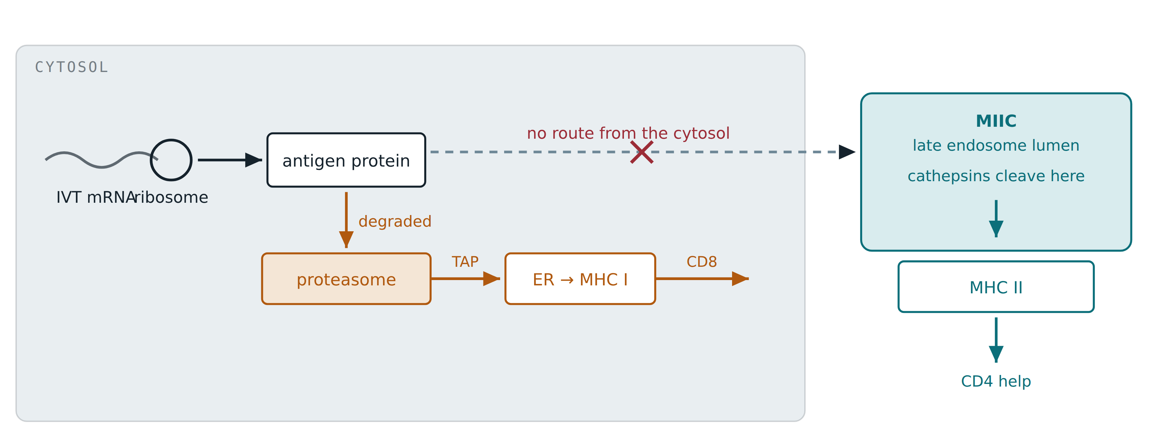
Figure 1. The compartments are the whole problem. Cytosolic translation feeds MHC I automatically (amber). The MIIC, where MHC II is loaded (teal), is a sealed lumen — a cytosolic protein cannot get in. Every routing module in this panel exists to build that missing arrow.
02 — THE FIX

A signal peptide and a transmembrane domain are a matched pair
You cannot push a protein into a membrane compartment; you make the cell’s own machinery carry it, and that needs two signals. Neither does anything useful alone, which is why every routed construct here carries both.
The signal peptide gets the chain out of the cytosol: SRP grabs its hydrophobic core as it emerges, pauses translation, and threads the chain into the ER lumen. SRP reads the first thing out of the ribosome — so a signal peptide only works at the extreme N-terminus. That single fact fixes module order in P7 and P8.
But a signal peptide alone gives you a secreted protein, which leaves the cell and is useless to us. The transmembrane domain stops that. When the translocon hits ~20 hydrophobic residues, transfer halts and you get type I topology: the antigen cassette ends up in the lumen — and ER lumen becomes endosome lumen becomes lysosome lumen — while the tail stays in the cytosol, where the sorting machinery can read it.
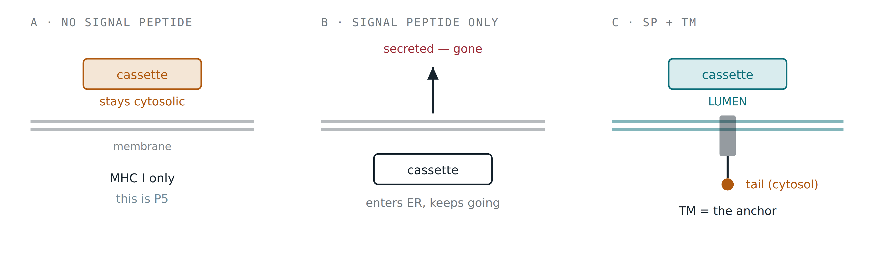
Figure 2. Why both modules, always. Drop the TM and the antigen is secreted (B) — the one outcome that helps nobody. Keep both (C) and the cassette sits in the lumen that becomes the MIIC, with the sorting tail left in the cytosol where adaptor proteins can read it. P5 deliberately has neither — it is the cytosolic baseline (A).
03 — THE CHOICE UNDER TEST

The tail is the postcode, and we are testing two of them
With the cassette in the lumen and the tail in the cytosol, the tail’s short sorting motif decides where the whole protein goes. We are comparing two, and the difference is the route, not the destination — both end at the MIIC.
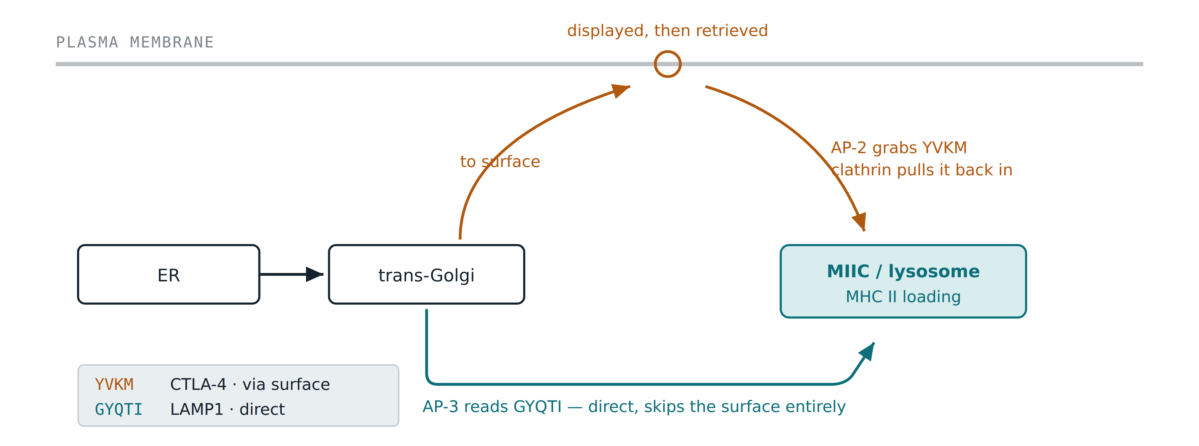
Figure 3. Same destination, different journey. The CTLA-4 tail sends the protein to the cell surface first, where AP-2 and clathrin rapidly pull it back into endosomes; the LAMP1 tail takes an AP-3 shortcut straight from the Golgi. P6 versus P0–P4 asks whether that detour via the surface helps or hurts. We keep the CTLA-4 extracellular IgV domain out of the construct — that is the part that would bind CD80/CD86 and do real checkpoint signalling.

Why the module order is not ours to choose
GYQTI only works as the last five residues of the protein. Append anything and the AP-3 adaptor stops binding, and the construct silently reroutes to the plasma membrane — which reads as a negative result, not as a mistake. YVKM has no such constraint: it sits internally with 19 native residues after it.
That asymmetry is the entire reason P7 and P8 are built the way they are. Each carries two separate proteins from one mRNA, split by a P2A ribosomal skipping element — and the LAMP1 arm has to be the downstream one, because only the downstream arm can end the polypeptide.
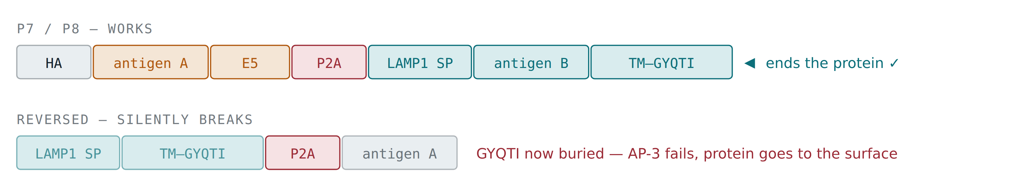
Figure 4. A positional constraint, drawn. The failure mode is quiet: the construct still expresses, still shows an HA signal, and simply routes to the wrong place. Our build checks this automatically — every LAMP1-bearing construct is asserted to end in GYQTI.

04 — THE PANEL

What each construct is for
Nine constructs, one variable moved at a time. P0 and P1/P2 are the controls that make the rest interpretable — without them, a weak signal from P3 could be the scaffold, the antigen, or the route, and we would not know which.
Construct | Route | Payload | The question it answers
P0 | CTLA-4 | none | Does the scaffold alone give signal? Sets the floor.
P1 | CTLA-4 | A | Single-antigen control — is A presented at all on this scaffold?
P2 | CTLA-4 | B | Same for B. Needed before any two-antigen result means anything.
P3 | CTLA-4 | A + B | The core question: can one transcript drive class I and class II presentation at once?
P4 | CTLA-4 | B + A | Order control for P3 — does cassette position change the outcome?
P5 | cytosolic | A + B + E5 | Baseline with no routing, and the only construct where the degron has a free C-terminus — so this is the degron-positive comparator.
P6 | LAMP1 | A + B | Does the direct AP-3 route beat the detour via the cell surface?
P7 | dual | A cyto · B lyso | Can one mRNA send two antigens to two compartments deliberately? Note E5 is internal here, so it is expected to be weak.
P8 | dual | B cyto · A lyso | Swap control for P7 — is the effect about the route, or about the antigen?
05 — THE VECTOR

Every element in the plasmid, and what it buys us
The backbone is unchanged from the eGFP version that already works; we swap only the coding sequence, at positions 699–1418. Each surrounding element is doing a specific job.
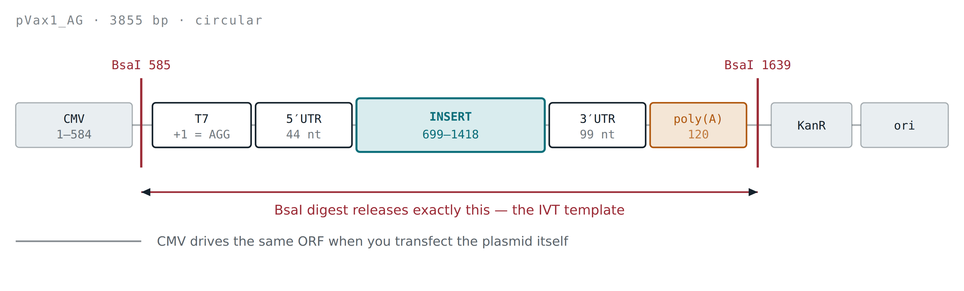
Figure 5. Two BsaI sites bracket the whole transcription unit, so one digest releases a clean linear IVT template. That is why no insert may contain a BsaI site — one inside the cassette would cut the template in half. All nine were screened and are clean.
Element | What it is for
T7, +1 = AGG | Not the textbook …CACTATAG. The transcript starts AGG, which is what CleanCap AG needs — this is the "AG" in pVax1_AG, and the one thing never to disturb if the UTRs are ever changed.
5′ UTR, 44 nt | Ends in the strong Kozak GCCACC and contains no upstream AUG. An upstream AUG would capture scanning ribosomes and quietly suppress the real ORF.
Insert window | 699–1418, replacing eGFP exactly. The 20-bp homology arms on each gBlock are backbone sequence, so the Kozak appears once in the finished plasmid and the ORF starts in frame.
3′ UTR, 99 nt | Globin-derived, for transcript stability. We corrected the map here: it was labelled 54 nt, leaving the UTR’s own AAUAAA unannotated. Harmless to the molecule, but a map that could not answer "does this transcript carry a poly(A) signal?".
poly(A), 120 | Encoded in the plasmid, and added again by PCR at the IVT step. We left it out of the gBlocks: a 120-nt A-tract is close to unsynthesisable, and since the primer adds the tail anyway the encoded copy does no work for the transcript.
CMV promoter | Lets the same plasmid be transfected directly, as a comparison arm. This is why we also screen every ORF for AAUAAA — in a nuclear transcript a cryptic poly(A) signal inside the coding sequence would truncate the mRNA.
HA and FLAG tags | These answer "was it made", on a different reagent from the pMHC antibodies that answer "was it presented". Without them, an absent pMHC signal has three indistinguishable causes: no translation, no processing, or wrong compartment.
29-aa native flanks | Not padding. ERAP1 trims N-terminal extensions in the ER, but nothing trims a C-terminal one — so the proteasome has to make the epitope’s C-terminus exactly right, first time, and the surrounding residues are what set that cleavage. Minimal epitopes would gamble on it.
E5 degron (EEEEE) | An acidic C-degron that accelerates proteasomal turnover, which is what MHC I peptide supply actually depends on. This is the element CVGBM carries and the one that performed best in CureVac’s own routing screen. It is positional: a C-degron needs a free C-terminus, so it works in P0–P5 where it ends the protein, and is expected to be weak or inactive in P7/P8 where it sits upstream of P2A and the skip product has no free C-terminus. Its codons are pinned to GAAGAGGAAGAGGAG — five glutamates in a row are inherently repetitive, and alternating GAA/GAG breaks a periodicity that would otherwise create a 12-nt direct repeat.
GGGGS linkers | Flexible spacers chosen to minimise junctional epitopes — the novel peptides created where one antigen is fused to the next, which exist nowhere in the tumour and compete for presentation with the real targets.

The result that will mislead you
Membrane-routed constructs still present on MHC I — via ERAD pulling misfolded protein back into the cytosol, failed translocation, and defective ribosomal products. So an MHC I signal is not evidence that the routing worked. Only the class II readout distinguishes the routes. The same care applies to the degron: E5 only has a free C-terminus in P0–P5; in P7 and P8 it sits upstream of the P2A skip and the upstream product never gets one, so P5 is the degron-positive comparator, not P7/P8. Plan the conclusions on that basis before the first experiment, not after.
06 — NOT YET TESTED

What this panel deliberately does not answer
This panel settles where an antigen goes. Two questions it cannot reach, both of which decide whether a multi-antigen vaccine is actually potent:
- Is there a presentation budget? Everything here carries one or two antigens. Whether per-epitope presentation decays as you add a fourth, sixth or eighth — dilution rather than breadth — is open, and it decides how many antigens a cassette should carry.
- Does uridine depletion trade expression against adjuvanticity? Lowering uridine raises expression and lowers innate sensing. For a prophylactic vaccine that is pure gain. For a cancer vaccine it may not be — the sensing being suppressed is part of what matures the dendritic cell and licenses it to prime CD8 T cells.
Constructs P0–P8 on pVax1_AG (3855 bp backbone; assembled plasmids 3402–3690 bp, matching the audited architecture table exactly). Nine gBlocks, 307–595 bp. Every map verified against the parent vector — reading frame, Kozak junction, AGG transcription start, BsaI count, poly(A) integrity and backbone elements re-derived from the assembled sequence rather than assumed.

