中学在线排课系统
-后台数据规范

2016年12月12日

目 录
目 录 II
第一章 功能介绍 1
1.1 系统适用范围 1
1.2 功能介绍 1
第二章 接口使用规范 3
M: 必填字段，不填会报错； 3
AM: 建议填写字段，不填可能不会报错，但数据不完整； 3
N: 该字段可以不传送，但是一旦传入必须按照说明传值，不可传空值。 3
2.1 基本信息录入 3
2.1.1 年级信息录入 3
2.1.2 教师信息录入 4
2.2 调整信息录入 4
2.3 后台规范说明 5
2.4 数据范例 5
3.1 环境地址 12
3.2 要点说明 12

第一章 功能介绍

系统适用范围
本在线排课系统适用于中小学课表。

功能介绍
如图1.1所示，基于所给定的年级信息以及基本的教师数据，系统自动编排出满意的课表，如图1.2所示为某次排课结果。
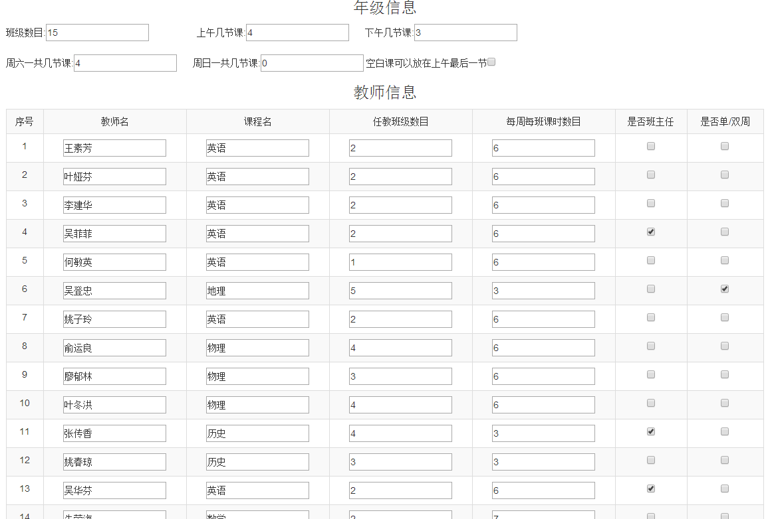
图1.1 输入数据
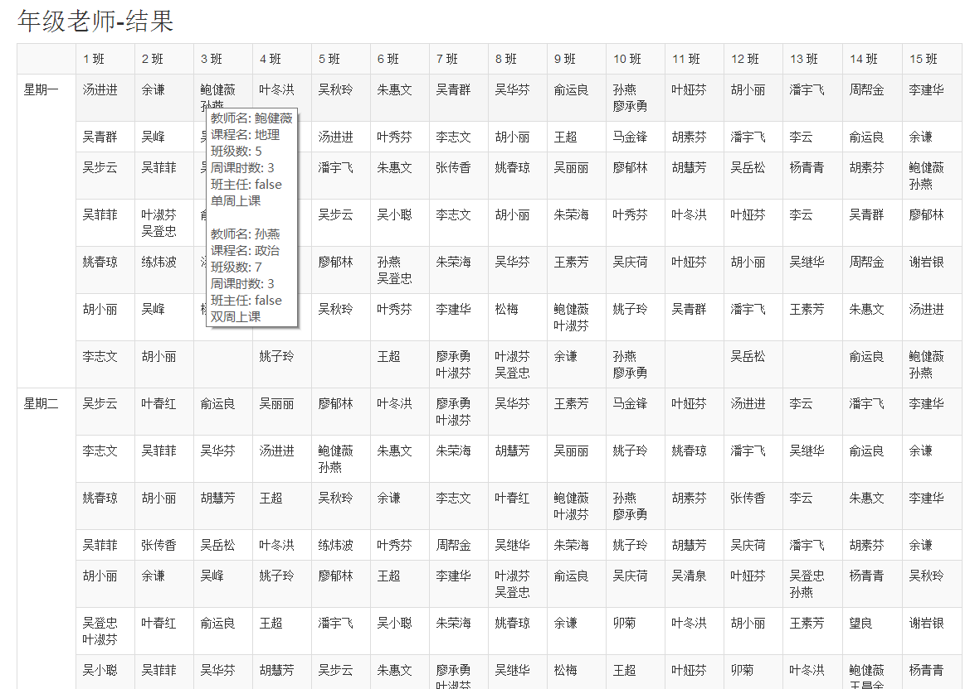
图1.2 排课结果

第二章 接口使用规范
字段标识说明：

M: 必填字段，不填会报错；

AM: 建议填写字段，不填可能不会报错，但数据不完整；

N: 该字段可以不传送，但是一旦传入必须按照说明传值，不可传空值。

基本信息录入
基本信息包括年级信息以及教师信息，这些数据均以post方式发送至http://项目名/deal.action路径。

2.1.1 年级信息录入
表2.1 年级信息报文规范
字段名 | 说明 | 标识 | 示例值 | 备注
classNum | 班级数目 | M | 15
morning | 上午可安排课时数 | M | 4
afternoon | 下午可安排课时数 | M | 3
saturday | 周六一天可安排课时数 | N | 4 | 默认0
sunday | 周日一天可安排课时数 | N | 0 | 默认0
allowMorning | 空白课是否可以放在上午最后一节 | N | true/false/on/off | 默认false
表2.1表示所有年级信息所需字段规范，注意：
所有字段严格区分大小写。

2.1.2 教师信息录入
表2.2显示了教师信息数据的录入规范，注意：
teachers[i] 表示第i位老师的信息，i从0开始，数字不可跳跃。
所有字段严格区分大小写。
表2.2 教师信息报文规范
字段名 | 说明 | 标识 | 示例值 | 备注
teachers[i].teacherName | 教师名 | AM | 王素芳
teachers[i].courseName | 课程名 | AM | 英语
teachers[i].perWeekClassNum | 每周任教班级数目 | AM | 2
teachers[i].perWeekTimeNum | 每周每班课时数目 | AM | 6
teachers[i].IsHead | 是否班主任 | N | true/false/on/off | 默认false
teachers[i].IsNext | 是否单双周 | N | true/false/on/off | 默认false

调整信息录入
基于2.1和2.2的信息可以排出一张完整的课表，后续对课表的修改操作全是基于以上的基本信息。故发送调整信息请求时，请确保是在同一个session会话下。
调整信息数据均以post方式提交至http://项目名/change.action路径。
表2.3 调整信息报文规范
字段名 | 说明 | 标识 | 示例值 | 备注
changeStr | 交换单元格 | M | ,8=14&5=8,,,,
fixTable | 固定单元格 | M | 0,0,0,0,0,1,0,0,0,0,0,0,0,0,0,0,0
交换单元格：从第一个班级开始，不间断的添加至最后一个班级数据，中间以“,”隔开。记录“8=14&5=8”表示先交换8和14节课时(课时索引号从0开始)，紧接着再交换5和8节课时，交换的先后顺序会影响输出结果，如果该班没有交换信息，则数据为空。例 ,8=14&5=8,,,, 只有第二班有交换数据，其他班级没有交换；
固定单元格：从第一班的第一节课时开始，到第一班的最后一节课，再到第二班的第一节课，再到第二班的最后一节课，依次到最后一个班级的最后一节课，中间均以“,”隔开，数值为0表示不固定，数值为1表示该位置固定。位置固定是发生在上述交换单元格之后。

后台规范说明
(1) 对于是否属性字段，基本上其标识都是N，表示该字段可以不传给后台，但不能传空值。该种类字段可传递的值有true/false/on/off四种，传空或者其他值均报错！
(2) 该系统仅考虑一周的课表安排，所以需要用户预先准备好仅一周的课时课程安排数据。如果一个学期的课程表前后期不一样，需要用户分别输入前后期一周的年级以及教师的信息。

数据范例
Step1: 以post方式提交以下数据至http://localhost:8080/sortCourse/deal.action
classNum=15
morning=4
afternoon=3
saturday=4
sunday=0
teachers[0].teacherName=王素芳
teachers[0].courseName=英语
teachers[0].perWeekClassNum=2
teachers[0].perWeekTimeNum=6
teachers[1].teacherName=叶娅芬
teachers[1].courseName=英语
teachers[1].perWeekClassNum=2
teachers[1].perWeekTimeNum=6
teachers[2].teacherName=李建华
teachers[2].courseName=英语
teachers[2].perWeekClassNum=2
teachers[2].perWeekTimeNum=6
teachers[3].teacherName=吴菲菲
teachers[3].courseName=英语
teachers[3].perWeekClassNum=2
teachers[3].perWeekTimeNum=6
teachers[3].IsHead=on
teachers[4].teacherName=何敏英
teachers[4].courseName=英语
teachers[4].perWeekClassNum=1
teachers[4].perWeekTimeNum=6
teachers[5].teacherName=吴登忠
teachers[5].courseName=地理
teachers[5].perWeekClassNum=5
teachers[5].perWeekTimeNum=3
teachers[5].IsNext=on
teachers[6].teacherName=姚子玲
teachers[6].courseName=英语
teachers[6].perWeekClassNum=2
teachers[6].perWeekTimeNum=6
teachers[7].teacherName=俞运良
teachers[7].courseName=物理
teachers[7].perWeekClassNum=4
teachers[7].perWeekTimeNum=5
teachers[8].teacherName=廖郁林
teachers[8].courseName=物理
teachers[8].perWeekClassNum=3
teachers[8].perWeekTimeNum=5
teachers[9].teacherName=叶冬洪
teachers[9].courseName=物理
teachers[9].perWeekClassNum=4
teachers[9].perWeekTimeNum=5
teachers[10].teacherName=张传香
teachers[10].courseName=历史
teachers[10].perWeekClassNum=4
teachers[10].perWeekTimeNum=3
teachers[10].IsHead=on
teachers[11].teacherName=姚春琼
teachers[11].courseName=历史
teachers[11].perWeekClassNum=3
teachers[11].perWeekTimeNum=3
teachers[12].teacherName=吴华芬
teachers[12].courseName=英语
teachers[12].perWeekClassNum=2
teachers[12].perWeekTimeNum=6
teachers[12].IsHead=on
teachers[13].teacherName=朱荣海
teachers[13].courseName=数学
teachers[13].perWeekClassNum=2
teachers[13].perWeekTimeNum=6
teachers[14].teacherName=叶秀芬
teachers[14].courseName=数学
teachers[14].perWeekClassNum=2
teachers[14].perWeekTimeNum=6
teachers[15].teacherName=谢岩银
teachers[15].courseName=数学
teachers[15].perWeekClassNum=2
teachers[15].perWeekTimeNum=6
teachers[15].IsHead=on
teachers[16].teacherName=胡素芬
teachers[16].courseName=数学
teachers[16].perWeekClassNum=2
teachers[16].perWeekTimeNum=6
teachers[17].teacherName=叶春红
teachers[17].courseName=数学
teachers[17].perWeekClassNum=2
teachers[17].perWeekTimeNum=6
teachers[18].teacherName=吴步云
teachers[18].courseName=数学
teachers[18].perWeekClassNum=2
teachers[18].perWeekTimeNum=6
teachers[18].IsHead=on
teachers[19].teacherName=李云
teachers[19].courseName=数学
teachers[19].perWeekClassNum=1
teachers[19].perWeekTimeNum=6
teachers[20].teacherName=吴青群
teachers[20].courseName=信技
teachers[20].perWeekClassNum=8
teachers[20].perWeekTimeNum=1
teachers[21].teacherName=练炜波
teachers[21].courseName=信技
teachers[21].perWeekClassNum=7
teachers[21].perWeekTimeNum=1
teachers[21].IsHead=on
teachers[22].teacherName=汤进进
teachers[22].courseName=音乐
teachers[22].perWeekClassNum=8
teachers[22].perWeekTimeNum=1
teachers[23].teacherName=姚红妹
teachers[23].courseName=音乐
teachers[23].perWeekClassNum=7
teachers[23].perWeekTimeNum=1
teachers[23].IsHead=on
teachers[24].teacherName=朱惠文
teachers[24].courseName=英语
teachers[24].perWeekClassNum=2
teachers[24].perWeekTimeNum=6
teachers[25].teacherName=胡小丽
teachers[25].courseName=物理
teachers[25].perWeekClassNum=4
teachers[25].perWeekTimeNum=5
teachers[25].IsHead=on
teachers[26].teacherName=潘宇飞
teachers[26].courseName=化学
teachers[26].perWeekClassNum=4
teachers[26].perWeekTimeNum=5
teachers[27].teacherName=余谦
teachers[27].courseName=化学
teachers[27].perWeekClassNum=4
teachers[27].perWeekTimeNum=5
teachers[27].IsHead=on
teachers[28].teacherName=松梅
teachers[28].courseName=体育
teachers[28].perWeekClassNum=5
teachers[28].perWeekTimeNum=1
teachers[29].teacherName=卯菊
teachers[29].courseName=体育
teachers[29].perWeekClassNum=5
teachers[29].perWeekTimeNum=1
teachers[30].teacherName=吴庆荷
teachers[30].courseName=语文
teachers[30].perWeekClassNum=2
teachers[30].perWeekTimeNum=5
teachers[30].IsHead=on
teachers[31].teacherName=吴小聪
teachers[31].courseName=语文
teachers[31].perWeekClassNum=2
teachers[31].perWeekTimeNum=5
teachers[32].teacherName=吴峰
teachers[32].courseName=语文
teachers[32].perWeekClassNum=2
teachers[32].perWeekTimeNum=5
teachers[33].teacherName=吴清泉
teachers[33].courseName=语文
teachers[33].perWeekClassNum=1
teachers[33].perWeekTimeNum=5
teachers[33].IsHead=on
teachers[34].teacherName=吴岳松
teachers[34].courseName=数学
teachers[34].perWeekClassNum=2
teachers[34].perWeekTimeNum=6
teachers[34].IsHead=on
teachers[35].teacherName=马金锋
teachers[35].courseName=化学
teachers[35].perWeekClassNum=1
teachers[35].perWeekTimeNum=5
teachers[36].teacherName=胡慧芳
teachers[36].courseName=化学
teachers[36].perWeekClassNum=4
teachers[36].perWeekTimeNum=5
teachers[37].teacherName=叶淑芬
teachers[37].courseName=政治
teachers[37].perWeekClassNum=7
teachers[37].perWeekTimeNum=3
teachers[37].IsNext=on
teachers[38].teacherName=孙燕
teachers[38].courseName=政治
teachers[38].perWeekClassNum=7
teachers[38].perWeekTimeNum=3
teachers[38].IsNext=on
teachers[39].teacherName=吴继华
teachers[39].courseName=语文
teachers[39].perWeekClassNum=2
teachers[39].perWeekTimeNum=5
teachers[39].IsHead=on
teachers[40].teacherName=吴丽丽
teachers[40].courseName=语文
teachers[40].perWeekClassNum=2
teachers[40].perWeekTimeNum=5
teachers[41].teacherName=廖承勇
teachers[41].courseName=地理
teachers[41].perWeekClassNum=5
teachers[41].perWeekTimeNum=3
teachers[41].IsNext=on
teachers[42].teacherName=望良
teachers[42].courseName=体育
teachers[42].perWeekClassNum=5
teachers[42].perWeekTimeNum=1
teachers[42].IsHead=on
teachers[43].teacherName=周帮金
teachers[43].courseName=语文
teachers[43].perWeekClassNum=2
teachers[43].perWeekTimeNum=5
teachers[44].teacherName=王超
teachers[44].courseName=历史
teachers[44].perWeekClassNum=4
teachers[44].perWeekTimeNum=3
teachers[45].teacherName=鲍健薇
teachers[45].courseName=地理
teachers[45].perWeekClassNum=5
teachers[45].perWeekTimeNum=3
teachers[45].IsNext=on
teachers[46].teacherName=吴秋玲
teachers[46].courseName=语文
teachers[46].perWeekClassNum=2
teachers[46].perWeekTimeNum=5
teachers[46].IsHead=on
teachers[47].teacherName=李志文
teachers[47].courseName=化学
teachers[47].perWeekClassNum=2
teachers[47].perWeekTimeNum=5
teachers[48].teacherName=王昌金
teachers[48].courseName=政治
teachers[48].perWeekClassNum=1
teachers[48].perWeekTimeNum=3
teachers[48].IsNext=on
teachers[49].teacherName=杨青青
teachers[49].courseName=历史
teachers[49].perWeekClassNum=4
teachers[49].perWeekTimeNum=3
Step2: 确保同一个session会话中，以post方式提交以下数据至http://localhost:8080/sortCourse/change.action
fixTable=0,0,0,0,0,0,0,0,0,0,0,0,0,0,0,0,0,0,0,0,0,0,0,0,0,0,0,0,0,0,0,0,0,0,0,0,0,0,0,0,0,0,0,0,0,0,0,0,0,0,0,0,0,0,0,0,0,0,0,0,0,0,1,0,0,0,0,0,0,0,0,0,0,0,0,0,0,0,0,0,0,0,0,0,0,0,0,0,0,0,0,0,0,0,0,0,0,0,0,0,0,0,0,0,0,0,0,0,0,0,0,0,0,0,0,0,0,0,0,0,0,0,0,0,0,0,0,0,0,0,0,0,0,0,0,0,0,0,0,0,0,0,0,0,0,0,0,0,0,0,0,0,0,0,0,0,0,0,0,0,0,0,0,0,0,0,0,0,0,0,0,0,0,0,0,0,0,0,0,0,0,0,0,0,0,0,0,0,0,0,0,0,0,0,0,0,0,0,1,0,0,0,0,0,0,0,0,1,0,0,0,0,0,0,0,0,0,0,0,0,0,0,0,0,0,0,0,0,0,0,0,0,0,0,0,0,0,0,0,0,0,0,0,0,0,0,0,0,0,0,0,0,0,0,0,0,0,0,0,0,0,0,0,0,0,0,0,0,0,0,0,1,0,0,0,0,0,0,0,0,0,0,0,0,0,0,0,0,0,0,0,0,0,0,0,0,0,0,0,0,0,0,0,0,0,0,0,0,0,0,0,0,0,0,0,0,0,0,0,0,0,0,0,0,0,0,0,0,0,0,0,0,0,0,0,0,0,0,0,0,0,0,0,0,0,0,0,0,0,0,0,1,1,0,0,0,0,0,0,0,0,0,0,0,0,0,0,0,0,0,0,0,0,0,0,0,0,0,0,0,0,0,0,0,0,0,0,0,0,0,0,0,0,0,0,0,0,0,0,0,0,0,0,0,0,0,0,0,0,0,0,0,0,0,0,0,0,0,0,1,0,0,0,0,0,0,0,0,0,0,0,0,0,0,0,0,0,0,0,0,0,0,0,0,0,0,0,0,0,0,0,0,0,0,0,0,0,0,0,0,0,0,0,0,0,0,0,0,0,0,0,0,0,0,0,0,0,0,0,0,0,0,0,0,0,0,0,0,0,0,0,0,0,0,0,0,0,0,0,0,0,0,0,0,0,0,0,0,0,0,0,0,0,0,0,1,0,0,0,0,0,0,0,0,0,0,0,0,0,0,0,0,0,0,0,0,0,0,0,0,0,0,0,0,0,0,0,0,0,0,0,0,0,0,0,0,0,0,0,0,0,0,0,0,0,0,0,0,0,0,0,0,0,0,0,0,0,0,0,0,0,0,0,0,0,0,0,0,0,0,0,0,0,0,0,0,0,0,0,0,0,0,0,0,0,0,0,0,0,0,0,0,0,0,0,0,0,0,0,0,0,0,0,0,0,0,0,0,0,0,0,0,0,0,0,0,0,0,0,0,0,0,0,0,0,0,0,0,0,0,0,0,0,0,0,0,0,0,0,0,0,0,0,0,0,0,0,0,0,0,0,0,0,0,0,0,0,0,0,0,0,0,0,0,0,0,0,0,1,0,0,0,0,0,0,0,0,0,0,0,0,0,0,0,0,0,0,0,0,0,0,0,0,0,0,0,0,0,0,0,0,0,0,0,0,0,0,0,0,0,0,0,0,0,0
changeStr=,2=10&7=12&9=12&12=14&,,4=9&,,,,3=8&,,4=9&,4=10&,3=9&,,,

第三章 现有环境说明

环境地址
https://util-fandy.rhcloud.com/input.action

要点说明
(1) 年级信息的班级数和教师信息中班主任数必须相等。
(2) 对于排课结果，鼠标放置于单元格上可以显示具体详细信息；拖动单元格可以调换课程，单击可以固定位置。

