This is a text with a lot of ABBR to test the ABBR. CCS and B&W.

Table 1: ABBR in the table caption TAB1

|  |  |  |
| --- | --- | --- |
| Table with ABBR | VW | BMW |
|  |  |  |

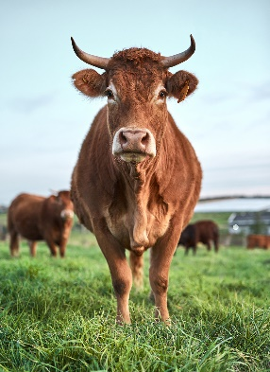

Figure 1: This is a picture caption ABBR called PCA

Just add more VW and BMW’s. Test [2], [23], [BRACK]

%%, &&, SS,