Human Computer Interface Using Kinect Sensor

|  |  |
| --- | --- |
| Binlong Li  NEU  360 Huntington Ave, Boston, MA 02115  li.b@neu.edu | Alexandru Vasile  NEU  360 Huntington Ave, Boston, MA 02115  vasile.a@neu.edu |

**Abstract**

Kinect has been released by Microsoft in November 2010 at an the affordable price, with real time 3D color-depth reconstruction and human pose estimation. The sensor has been widely accepted by the computer vision community in various fields of study, namely 3D reconstruction, human pose tracking and human computer interface (HCI). In this paper, we focus on expanding the default HCI capabilities by developing a 3D hand tracking algorithm with action recognition. The proposed implementation works with multiple basic functionalities, such as, single/double click, swipe up/down and back according to different actions respectively. Our demo shows that our method works in real time under real life noisy operational environments. Areas of interest for this type of HCI system include remote control of commercial TV/computer displays as well as for real-time remote control of robotics, such as online surgery.

# Introduction

Human-Computer Interfaces (HCI) using video imagery is central to many applications, such as surgery inspection, robotic control, helping disabled individuals communicate, as well as for game control. The key preprocessing aspect of such a system is human detection by background subtraction as well as full or partial human pose estimation for gesture recognition. In recent years, various engineers and companies have developed HCI systems with several well-known examples, namely the Apple multi-touch gesture[5] and IBM linguistics control system[6].

Previous HCI approaches have relied on both passive and active illumination sensors as input for the preprocessing tasks of human detection pose estimation. Passive sensors color and IR video imagery has been used directly for detecting body pose and gesture for computer control. While quite inexpensive, such systems tend to be sensitive to contrast and lighting conditions, leading to poor segmentation of humans subjects from the background, and limited to only recognizing certain body poses. Significant improvements were realized using calibrated multi-camera systems that performed stereo processing for 3D depth reconstruction. Passive stereo color-camera systems have been developed that create dense 3D maps, which in turn could be used for human detection and pose estimation. However, 3D depth processing with such systems is computationally expensive, leading to unacceptable interface lag. Sparse 3D depth computation helps to reduce the lag, however, there is loss of information that leads to a degradation of human detection and pose recognition.

An alternative to multiple passive sensors it the use of active sensors, with illumination used to determine range depth. Examples of such systems are VICON IR sensors[4], as well as 3D laser radar (lidar) sensors, which have been used for human foreground detection and pose recognition. One advantage of an active sensor over a multi-camera passive sensor is a significant increase in range accuracy as well as a reduction in computational time for reduced interface lag. One large disadvantage is that they are typically much more expensive than passive camera systems, making them prohibitive for individual purchase.

Recently, Microsoft introduced the Kinect system, and HCI system which combines both passive color video imagery as well active illumination for real time computation of dense 3D depth imagery. Unlike previous 3D color-depth commercial products, the sensor was quite inexpensive and marketed to a large population of computer gamers, leading to wide adoption of the platform. The wide adoption led to the development of open-source libraries to access the raw 3D color-depth data as well as the built-in human detection and pose estimation functionality, making the system a good candidate for usage in an enhanced HCI interface.

In this paper, we focus on expanding the default Kinect HCI capabilities by developing a 3D hand tracking algorithm with action recognition. The proposed implementation recognizes a typical set of actions for interfacing with a modern operating system (OS) graphical user interface (GUI), namely: single/double click, swipe up/down and back button functionalities. To the best of our knowledge, this is a first open-source system that provides this level of functionality for interfacing to an OS GUI.

Our research work leverages several open-source libraries, developed by a large community of computer vision researchers as well as skilled amateur programmers. For our algorithm, we used the following libraries: openKinect [1], openNI [2], NITE and rgbdemo[3].

The rest of the paper is divided into the following 3 sections: background overview of default Kinect functionality and implementation of 3D hand tracking combined with activity recognition in Section 2; visual results showing usage of the system in Section 3 and Conclusion and future work in Section 4.

# HCI Implementation using Kinect

In this section we briefly describe the default Kinect functionality as well as our HCI implementation based on 3D hand tracking combined with activity recognition for OS GUI functionality.

## Overview of Kinect sensor and built-in functionality

The Kinect sensor has an RGB video camera, and an active illumination IR light source separated by a baseline distance from a passive IR camera. The IR light source illuminates a view frustrum with time-coded structured light that is measured by a sensor chip which decodes the time of flight to recover range information on a per pixel basis. The 3D range image is augmented with RGB color information using previously determined camera calibrations. The end results is a RGB-Depth video image at 640x480 at 30fps, within a field of view of 57x43 degrees, with a dynamic 3D range of 0.8-10 meters. The range resolution varies with depth from 1.3mm at 0.8 meter to 5cm at 10 meters.

The RGB-depth information is streamed as two separate video frames over an USB connection. Using open-source driver and libraries, the data can be readily accessed with low, sub-30ms latency. Using previously determined camera calibration, along with a uint16-to-metric range scale factor, the two separate video streams can be combined into a single RGB-Depth (RGB-D) 3D point cloud. An example of the RGBD metric-upgraded 3D point cloud output is shown in Figure 1. From the video frames, we can readily determine features with a range resolution and angular resolution of about 1cm at 3 meters range.

Aside from the raw RGB-D data, we leverage several open-source libraries, namely openKinect, openNI and NITE to determine human body pose. Figure 2 shows the detected body pose for single human subject as a skeleton overlayed in 3D using the NITE and rgbdemo libraries. After detection of the human body pose, our system now has the position of both hands, which act as location queues for the implementation of hand detection and tracking algorithm.

Figure 1: a) Example of metric-upgraded 3D point cloud colored by z-depth in red-green-blue color scale. Red represents small z-depth, while blue represents large z depth. Black represents range nulls (no data). b) The same 3D point cloud now painted using RGB data, seen from Kinect camera perspective. C) Same RGB painted 3D point cloud now displayed from a different virtual camera perspective.

(a)

(b)

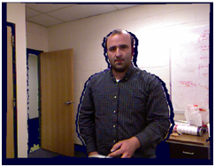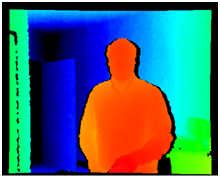

(c)

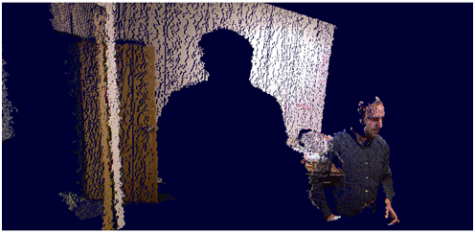

Figure 2: a) Human detection. b) Pose estimation and corresponding skeleton overlaid in 3D to visually confirm that the correct 3D pose was found.

(a)

(b)

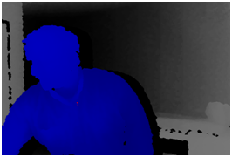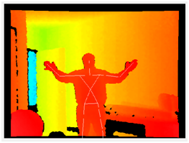

## Hand Tracking

Now that we have the body pose, we perform single hand detection followed by hand tracking. In our system, the hand tracking is analogous in GUI functionality to a computer mouse, in that our hand track direction moves the mouse in the same direction on the OS GUI, while the hand track velocity is mapped to a linearly proportional GUI OS cursor velocity.

To initialize the system to track a particular hand, we go into a mode where we are continually looking for what is known as “focus gesture,” which acts as queue that we chose that particular hand. For the focus gesture to be detected, the user has to be within a range of 1 to 3.5 meters, with the hand not occluded by other objects.

There are two focus gestures that can be detected to start the initialization process: either “hand waving” or “hand clicking”. The actions are detected by the presence of opposing 3D velocity vectors that add to a certain magnitude Mfocus(m/sec) within a short time window tfocus(sec).

Upon detection of the focus gesture, the hand is chosen for tracking. The algorithm for tracking is encapsulated within the NITE library and uses the 3D skeleton hand position to update the GUI xy pixel location. Because of the sensor noise due to hand shaking, there is a lot of noise embedded into the tracking location of the hand. We smooth the output x-y GUI position in time using a Gaussian time-window with tstd = 0.1 seconds. An example of the resulting smooth output hand trajectory is shown in Figure 3. Once we start tracking the hand, we now can move the GUI cursor. The relative movement of the GUI cursor in pixels is linearly proportional to the inter-frame relative movement of the hand in x-y Kinect camera location.

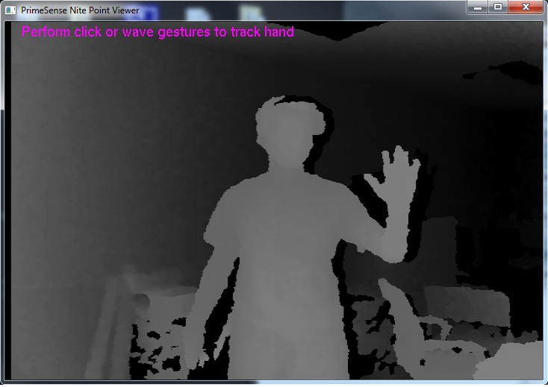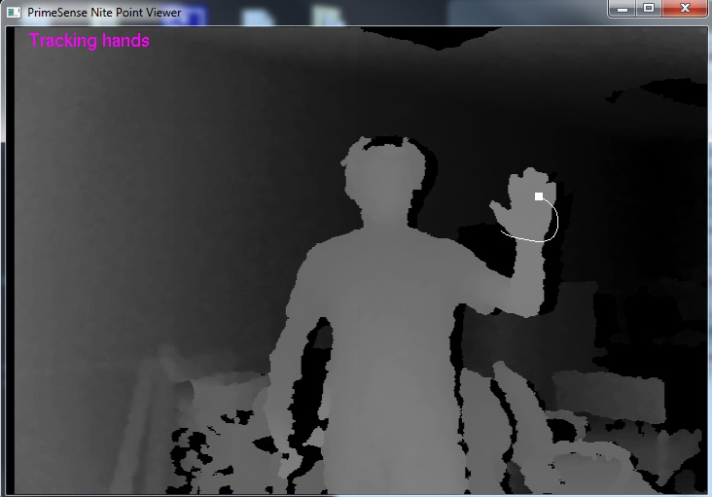

Figure 3. Example of Hand Tracking. (a) Initialization with a focus gesture. (b) tracking hand with trajectory.

(a)

(b)

## Gesture Detection

With the hand continuously tracked we enter a multi query mode where we asynchronously detect one of 3 major function classes:

1. Detect Click
2. Detect Steady
3. Detect Swipe

Figure 4 summarizes the gesture detection algorithm as a flow chart. The click function class is detected in a similar manner to the original focus gesture method: a click is detected by the presence of two video sub-frames with opposing range velocity vectors, adding to a certain magnitude large than Ms(m/sec) within a short time window tclick(sec). Within the function class, there are two subclasses, namely single-click and double-click. A single click is detected as opposing range velocity magnitude large than Ms(m/sec), but smaller than Md(m/sec). A double click is detected when there are opposing range velocity vectors with magnitude larger Md(m/sec) within the time window tclick(sec).

The steady detection is used to allow for fine motor control, such as when you might need to click a small icon to minimize, maximize or close a GUI window. The “steady” class is detected if the moving time-window xyz location variance is small, below a certain std deviation pixel threshold Pstd with a time window tsteady. If we detect a steady action, the average GUI xy pixel location within the time-window is saved. The value can be used in conjunction with a click detection: if the current xy cursor position is within Pt of the saved steady-stage xy position, then the click will be registered at the steady-state position instead of at the current cursor position.

We also have a swipe class that is only enabled within a GUI window, and disabled when the GUI cursor is on the main desktop. The swipe class is detected as a fast movement in a constant direction of at least Sd within time tswipe followed by a low or zero velocity hand stop of at least Pstop, tstop to indicate that the GUI cursor should be stopped. The angular direction in the Kinect xy camera coordinates is binned into 3 sub-class quadrants to represent the following: from 45 to 135 degrees (i.e up movement) is mapped as a scroll up, from -45 to -135 degrees (i.e. down movement) is mapped as scroll down, for 135 to 225 degrees (i.e. left movement) is mapped as back button.

Once we have detected the function class and respective subclass, we map the actions to GUI commands. In our case, we tested the code under Microsoft Windows 7 and utilized the Windows API library to control the mouse, scroll up and down, press the back button and single or double click.

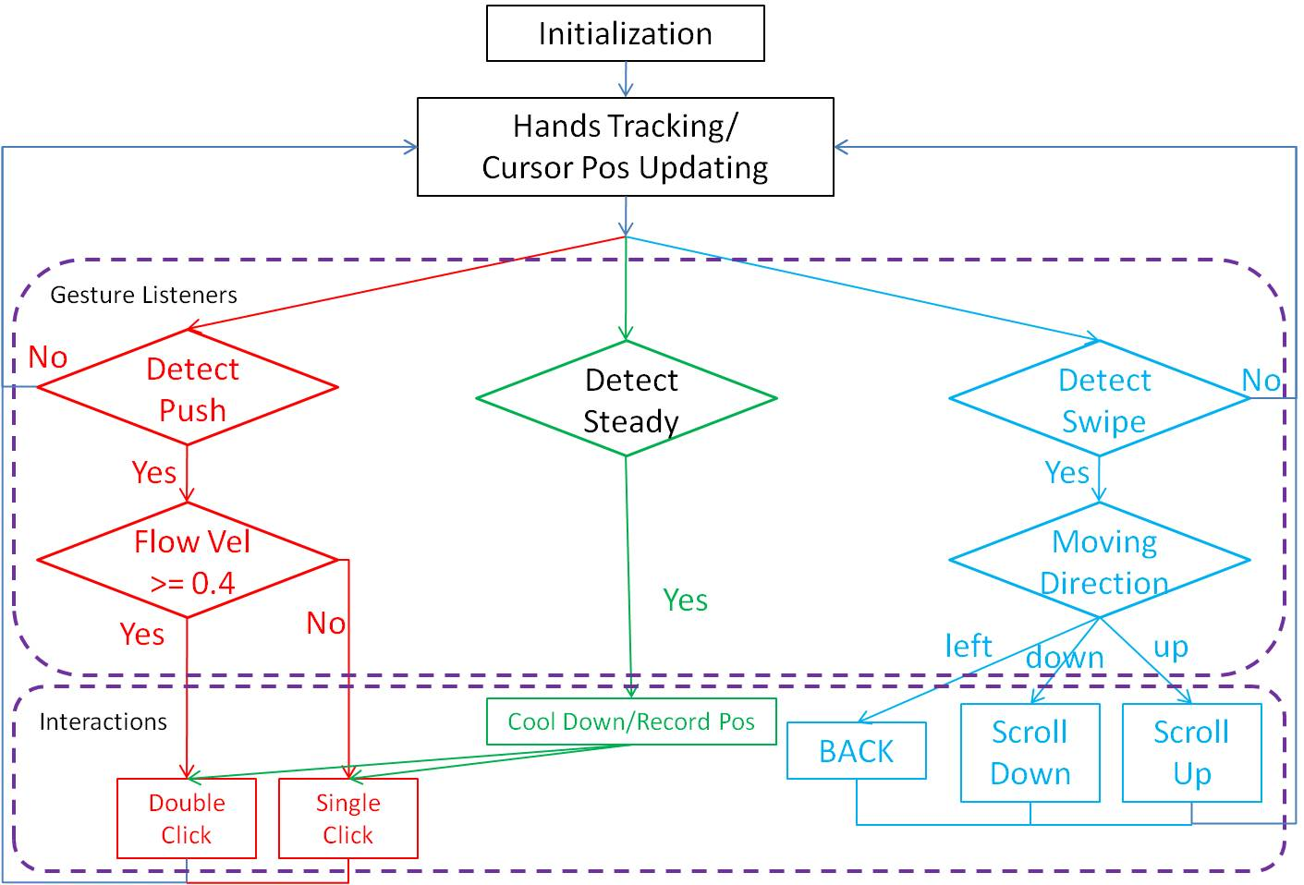

Figure 4: Overall working flow chart for the whole implementation.

## Computer Interaction Parameter Definition

We defined the following parameters for our system. The focus-gesture time window tfocus=2 seconds with Mfocus=0.3m/s. The click function time window, tclick =1 seconds, with an single-click lower velocity detection threshold Ms = 0.2m/sec and a single-click upper velocity threshold Md = 0.4m/sec. The steady detection tsteady=2 sec, with pixel standar deviation of no more than Pstd = 25 pixels. The saved steady detected xy location will be used for click as long as the click is within proximity pixel distance Pt = 50 pixels.

The swipe distance threshold was set to Sd = 0.25m within tswipe=0.3sec followed by a max delta position Pstop = 0.1m within delta tstop = 0.5sec.

# Results and Discussion

In this section we will show that we can detect the gestures we described. Figure 5 attempts to demonstrate visually that all the hand gestures mentioned in section 2 can be detected. Further demonstration of hand tracking and gesture recognition can be found in the supplemental video presentation.

While our implementation works well in practice, there still is room for improvement. Here are some of the known issues to be resolved:

1. Hand shaking artifacts still pass through to the GUI, leading the cursor to not be stable and continue oscillating. More advanced filtering is needed to remove such noise.
2. Clicking after steady-state position finding sometimes is hard to achieve as the cursor moves too much due to movement of hand in not only range direction, but also camera xy direction. One solution would be to use the start position of the cursor movement before the click operation for comparison to steady-state position, instead of cursor position after. Need to implement cursor buffer to achieve this objective, which requires more coding.
3. When hands are at the camera boundary, the cursor cannot traverse the whole GUI screen. We lack a method to stop hand tracking, which would be the equivalent of picking up your mouse to reposition it on the mouse pad to continue traversing the GUI screen without moving further in the mouse physical world coordinate space.
4. Click behavior is sometimes not detected to generate click events.

# Conclusion and Future Work

In this work we explore Human Computer Interface with Kinect Sensor. Kinect can capture the depth images directly with affordable price. Hand tracking with initial focus gesture and depth image make the Human Computer Interface real time. Define interactions between computer and gesture recognition through NITE framework. Multiple daily functionalities have been implemented through our implementation. The experiments shows that we can correctly detect actions through our system. The whole system can work in real time, real demo, binary executable program and source code is available for people to play with.

We have made a little contribution to the whole community. Our code is open and will be contributed into the Kinect open community, under some permission. This makes our project more realistic and has more contribution to the whole community. Since Kinect is relatively new, so far, the academic community just starts to explore the potential of this brand new integrated sensor; there are not too much paper about this topic so far.

We will further explores the potentials of our project in the future. Developing multi-hand tracking, gesture recognition, hand interactions and volume range identification could be our future work.

Develop future projects related to Kinect, such as more accurate 3D reconstruction by single / multiple Kinect, multiple Kinect surveillance system, mobile navigation system, Kinect robot interaction, Kinect Activity Recognition and so on.

# References

1. <http://openkinect.org/wiki/Main_Page>
2. [www.openni.org](http://www.openni.org)
3. http://nicolas.burrus.name/index.php/Research/KinectRgbDemoV5?from=Research.KinectRgbDemoV4
4. <http://www.vicon.com/>
5. www.apple.com
6. www.ibm.com

(e)

Figure 5: Different gesture detections under our implementation. The left side of each image is the depth image from Kinect with hand tracking trajectory. The right side is the detection results output. (a) Push Detection (b) Swipe Left Detection (c) Swipe Up Detection (d) Swipe Right Detection (e) Swipe Down Detection (f) Fast Push Detection.

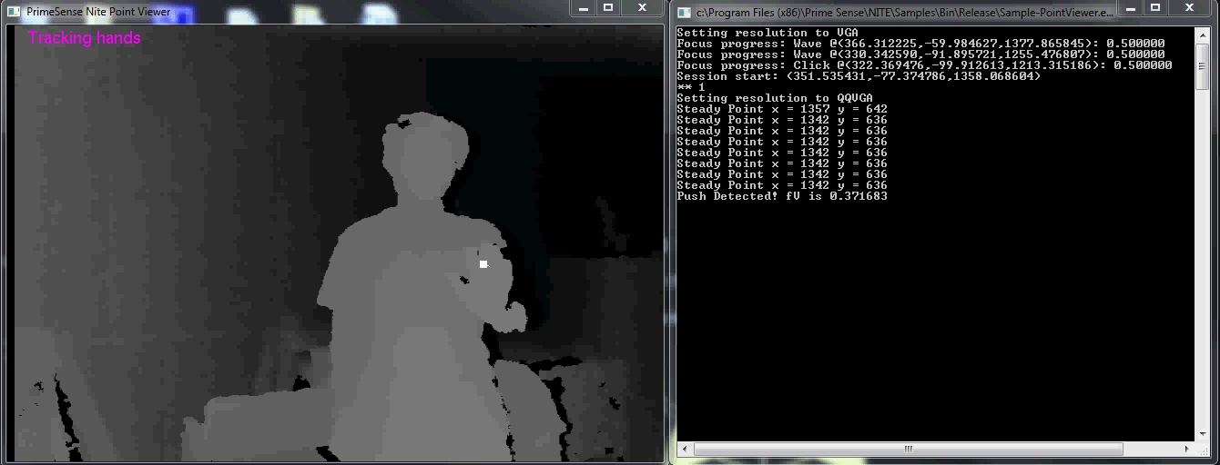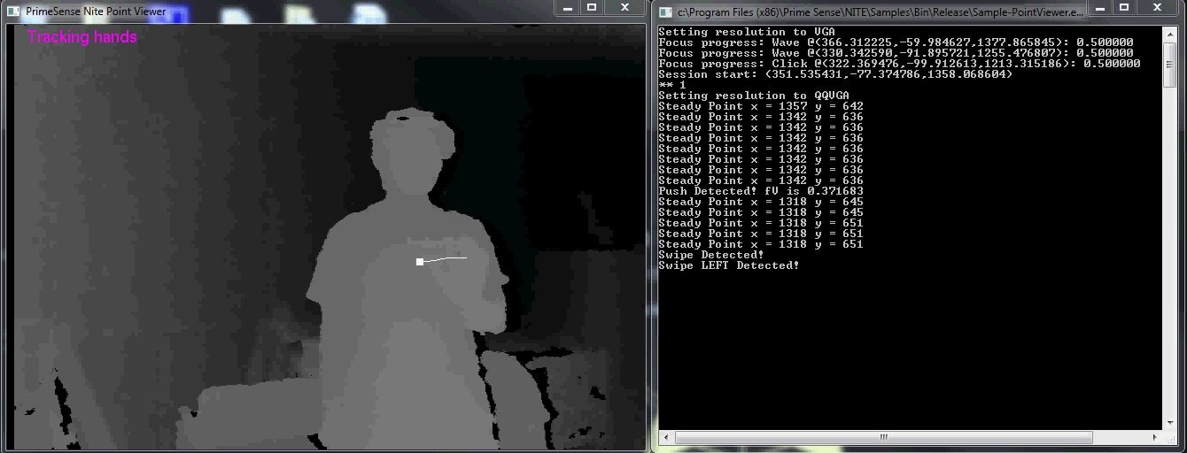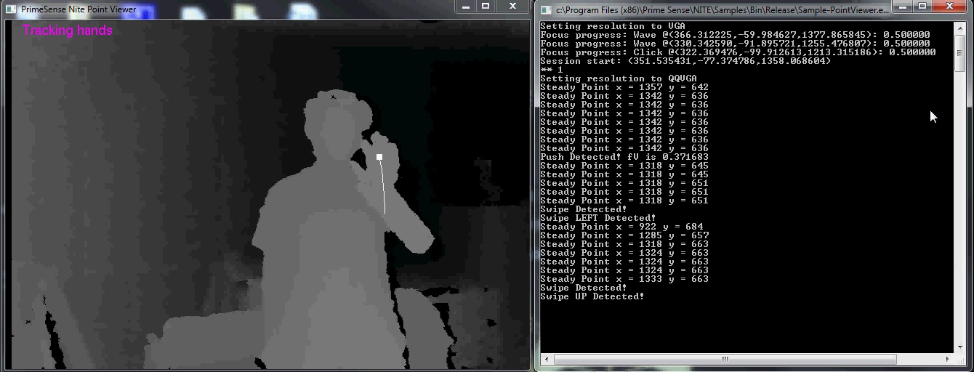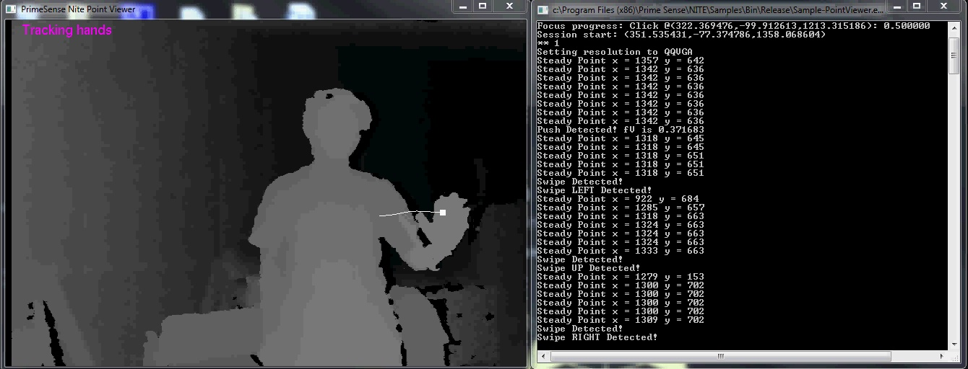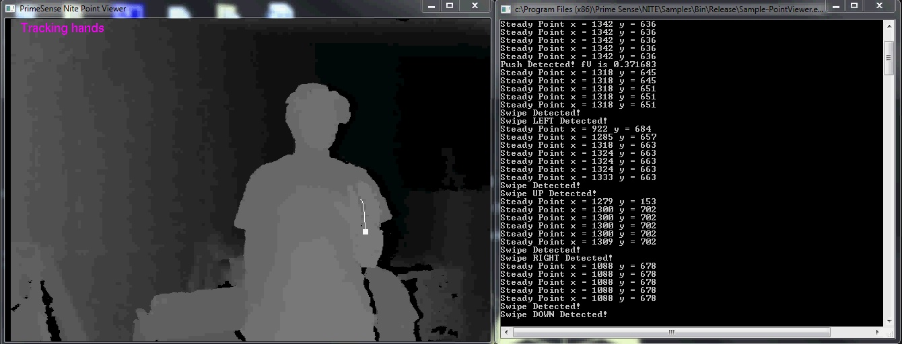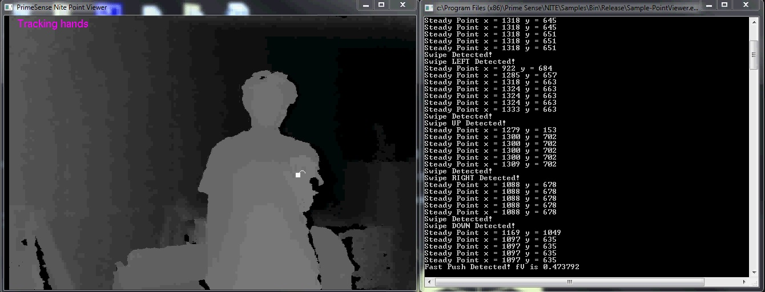

(a)

(b)

(c)

(d)

(f)