Literature Review

# Measures of Industry Concentration

## Hoberg and Phillips (2010)

The authors classify industries as competitive or concentrated and examine variation in cash flows and stock returns during booms and busts. Their classification examines both public and private companies using 3-digit SIC code from the US Census Bureau. Public financial and stock price data comes from Compustat and CRSP. This is merged with private Herfindahl data from the Commerce Department and employee data from the BLS. Industry classifications are derived from the following two-step procedure:

1. Actual industry HHI is regressed on:
   1. Compustat public-firm-only HHI
   2. Firm-size variables
      1. Average number of employees per firm (BLS)
      2. Number of employees per firm (Compustat)
   3. Interaction terms
2. Coefficient estimates are used to compute fitted HHI for all industries

The highest tercile is defined as concentrated, and the lowest tercile is defined as competitive.

Lorem ipsum dolor sit amet, consectetur adipiscing elit, sed do eiusmod tempor incididunt ut labore et dolore magna aliqua. Ut enim ad minim veniam, quis nostrud exercitation ullamco laboris nisi ut aliquip ex ea commodo consequat.(Dahlquist et al. 2003) Duis aute irure dolor in reprehenderit in voluptate velit esse cillum dolore eu fugiat nulla pariatur. Excepteur sint occaecat cupidatat non proident, sunt in culpa qui officia deserunt mollit anim id est laborum.

* Item 1
* Item 2
* Item 3

## Heading 2

Sed ut perspiciatis unde omnis iste natus error sit voluptatem accusantium doloremque laudantium, totam rem aperiam, eaque ipsa quae ab illo inventore veritatis et quasi architecto beatae vitae dicta sunt explicabo. Nemo enim ipsam voluptatem quia voluptas sit aspernatur aut odit aut fugit, sed quia consequuntur magni dolores eos qui ratione voluptatem sequi nesciunt. Neque porro quisquam est, qui dolorem ipsum quia dolor sit amet, consectetur, adipisci velit, sed quia non numquam eius modi tempora incidunt ut labore et dolore magnam aliquam quaerat voluptatem. Ut enim ad minima veniam, quis nostrum exercitationem ullam corporis suscipit laboriosam, nisi ut aliquid ex ea commodi consequatur? Quis autem vel eum iure reprehenderit qui in ea voluptate velit esse quam nihil molestiae consequatur, vel illum qui dolorem eum fugiat quo voluptas nulla pariatur?

### Heading 3

Sed ut perspiciatis unde omnis iste natus error sit voluptatem accusantium doloremque laudantium, totam rem aperiam, eaque ipsa quae ab illo inventore veritatis et quasi architecto beatae vitae dicta sunt explicabo. Nemo enim ipsam voluptatem quia voluptas sit aspernatur aut odit aut fugit, sed quia consequuntur magni dolores eos qui ratione voluptatem sequi nesciunt. Neque porro quisquam est, qui dolorem ipsum quia dolor sit amet, consectetur, adipisci velit, sed quia non numquam eius modi tempora incidunt ut labore et dolore magnam aliquam quaerat voluptatem. Ut enim ad minima veniam, quis nostrum exercitationem ullam corporis suscipit laboriosam, nisi ut aliquid ex ea commodi consequatur? Quis autem vel eum iure reprehenderit qui in ea voluptate velit esse quam nihil molestiae consequatur, vel illum qui dolorem eum fugiat quo voluptas nulla pariatur?

# Heading 2

plot(cars)

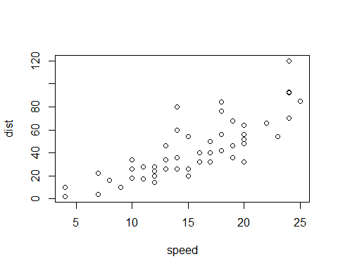

Add a new chunk by clicking the *Insert Chunk* button on the toolbar or by pressing *Ctrl+Alt+I*.

When you save the notebook, an HTML file containing the code and output will be saved alongside it (click the *Preview* button or press *Ctrl+Shift+K* to preview the HTML file).

The preview shows you a rendered HTML copy of the contents of the editor. Consequently, unlike *Knit*, *Preview* does not run any R code chunks. Instead, the output of the chunk when it was last run in the editor is displayed.

#### References

Dahlquist, Magnus, Lee Pinkowitz, René M. Stulz, and Rohan Williamson. 2003. “Corporate Governance and the Home Bias.” *Journal of Financial and Quantitative Analysis* 38 (1): 87–110.

Hoberg, Gerard, and Gordon Phillips. 2010. “Real and Financial Industry Booms and Busts.” *The Journal of Finance* 65 (1): 45–86.