WeHateDogs Wrangle Data Analysis

The WeHateDogs page makes several tweets about dogs, even funny pictures. From it, even a dictionary of dogs appeared like:

Pupper: a dog of miniature size
Puppo: A cute dog, usually a small one.
floofer: A very fluffy dog such as a Samoyed or Pomeranian.
doggo: a larger dog, one who woofs.

So here are some simple information that can be extracted from the analysis of tweets:

Within the posts that have some kind of dog, which are appearing more?

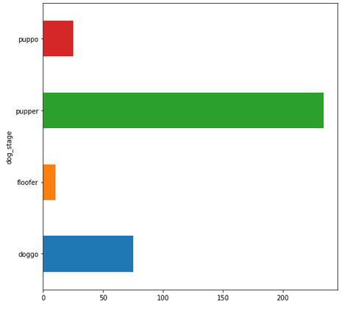
How many favorites and retweets in each kind of dog?

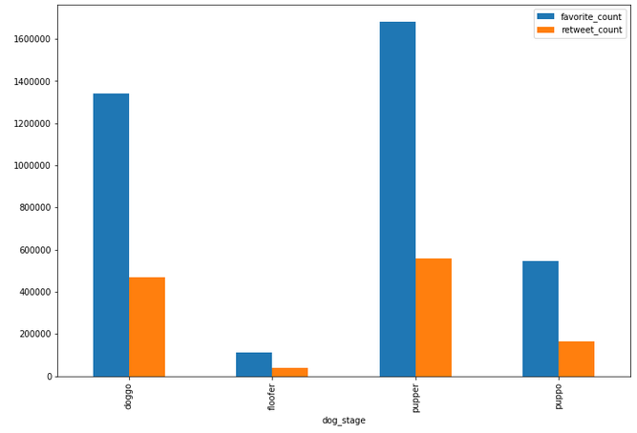

Of all the analyzed posts, is there a correlation between favorites and retweets?

