LORANN – Project JAVAhttps://raw.githubusercontent.com/lborruto/lorann_project/master/sprites/lorann_l.png



Projet java A1 EXIA CESI

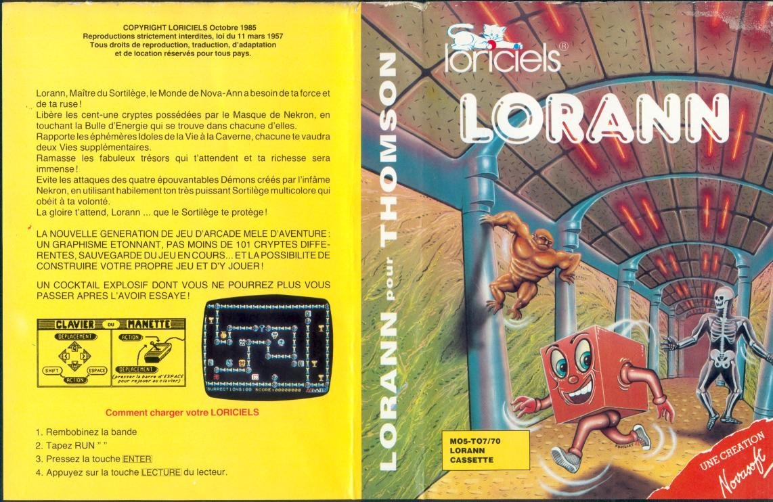

WORETH GUILLAUME, BORRUTO LUCA, AHMED BEN MBAREK

SUMMARY

1. THE GAME
2. CONTEXT
3. FUNCTIONNALITIES
4. CONSTRAINTS
5. THE TEAM
6. DELIVRABLES
   1. DIAGRAMS
   2. GITHUB
7. DEMONSTRATION
8. CONCLUSION
9. THE GAME

Lorann is a retro game which appeared in 1984. The synopsis is the following:

*Loran, Master magician, who come from the world of Nova-Ann need your strength and your guile. Free the 101 crypt possessed by the Nekron’s mask, by touching the energy orb present within each one. Bring back the ephemeral Life Idols to the cavern, each one will reward you 2 lives. Loot the famous treasure that are waiting for you and your wealth will be vast! Dodge the attacks of the 4 Treacherous demons created by the infamous Nekron himself by using skillfully your colorful spell.*

*Glory is waiting for you Lorann… May the spell protect you.*

*.*

This game was edited by Loriciel.

1. CONTEXT

This game was originally edited for M05 and T07(Shown below):

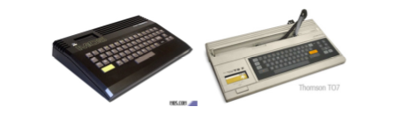

.

Lorann is a Pac Man like game, a character move from one frame to another trying to collect as many item as possible without being caught by 4 monsters in 101 levels. No super pacgom here, but a fireball that can be thrown by the character to kill the monsters. The difficulty is that you have only one fireball, the only way to obtain another one is by killing a monster or to retrieve the previous one.

1. FUNCTIONNALITIES

It comes to realize a number of accessible level with functionalities such as the possibility to switch between levels within the game. The levels are stocked inside a Database. The elements asked are the following:

* Lorann, The main character (the player)
* The spell, multicolour
* The energy orb
* The level’s exit door
* Impassable elements of the environment
* Stocked level in a Database

1. CONSTRAINTS

The constraints are the following: Utilisation of JAVA, Maven and Junit.

No graphic framework other that the swing are authorized. No SQL request should be present within the JAVA code. The entirety of the calls will be dealt via stocked procedure.

1. THE TEAM

BORRUTO Luca: Project manager and responsible of java code.

WORETH Guillaume: Responsible of BDD and java code.

BEN MBAREK Ahmed: Responsible of UML, Diagrams and java code.

1. DELIVRABLES
   1. DIAGRAMS

Class Diagram

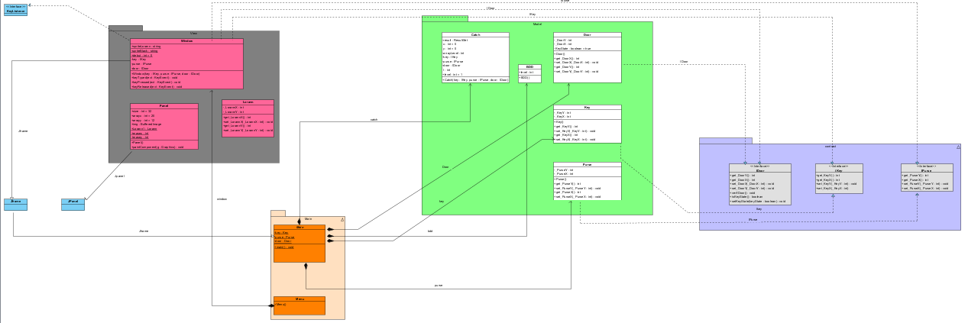

Component diagram

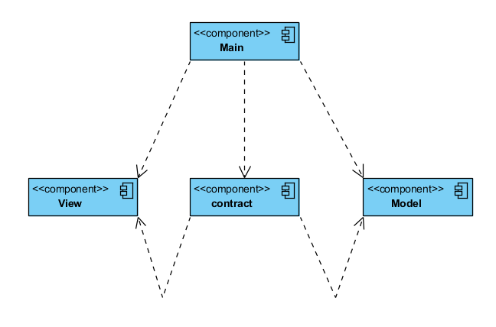

Package diagram

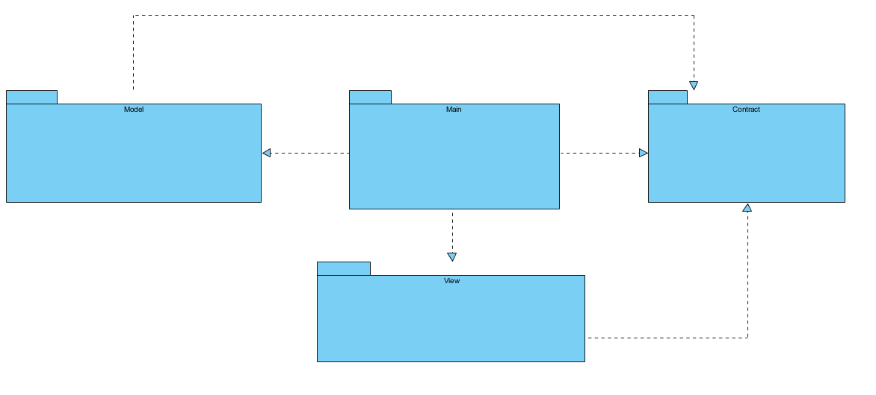

Sequence Diagram

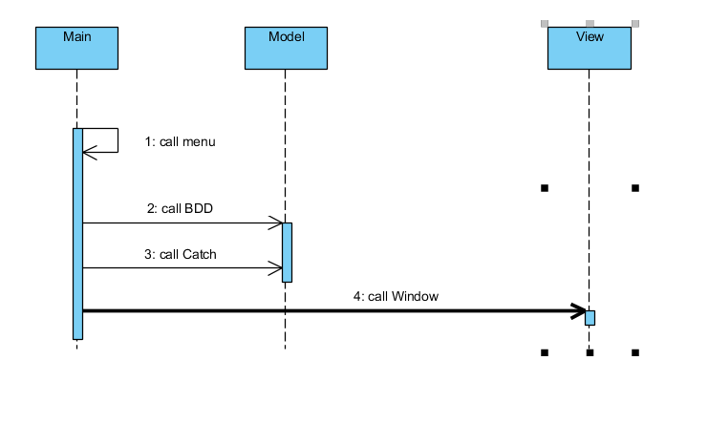

* 1. GITHUB

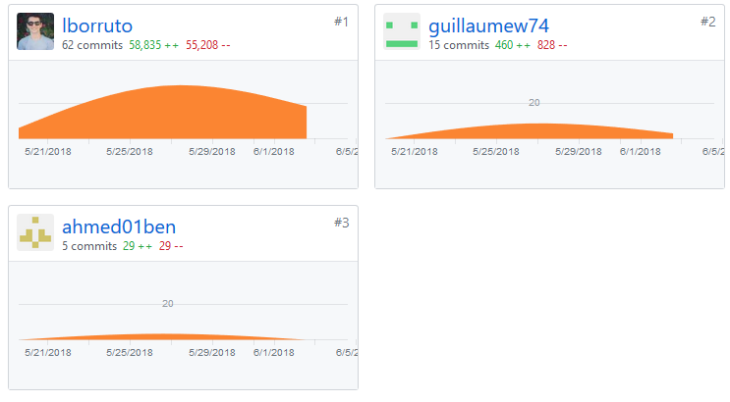

1. DEMONSTRATION

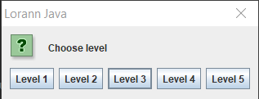

Main menu of the game

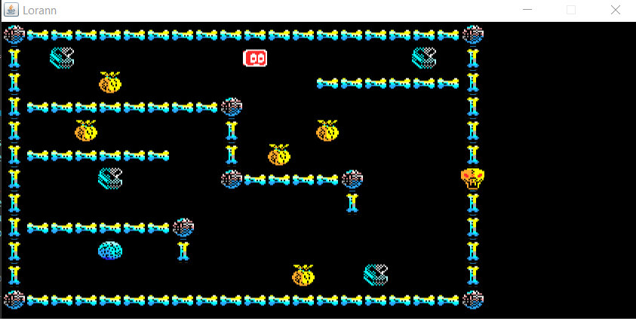

In game picture of the first level

1. CONCLUSION

Personal Review:

Guillaume:

This project was interesting but hard for me, because I have base on code but not that much. The delay was a bit short for a group of three.

Luca:

This project was a test really hard for us, we do our best but we didn’t finish the all project.

Ahmed:

It was a good project and I found it very interesting, but poorly this project wasn’t what I was expecting about the java. And I found it too long and the work we needed to provide was quite big. Some preconfigured files were useless, so we haven’t used them.