Matrix Two-Person Games

Duong Thi Kim Huyen

ORLab, Phenikaa School of Computing, PHENIKAA University

Outline

Matrix Two-Person Games

Outline

Matrix Two-Person Games
Solution

Outline

Matrix Two-Person Games
Solution
NASH equilibrium

Outline

Matrix Two-Person Games
Solution
NASH equilibrium
Symmetric Games

Introduction

John von Neumann

Introduction

John von Neumann
1928

Introduction

John von Neumann
1928
On the Theory of Games of Strategy

Introduction

John von Neumann
1928
On the Theory of Games of Strategy
1944

Introduction

John von Neumann
1928
On the Theory of Games of Strategy
1944
Theory of Games and Economic
Behavior (with Oskar Morgenstern)

Introduction

John von Neumann
1928
On the Theory of Games of Strategy
1944
Theory of Games and Economic
Behavior (with Oskar Morgenstern)
1950

Introduction

John von Neumann
1928
On the Theory of Games of Strategy
1944
Theory of Games and Economic
Behavior (with Oskar Morgenstern)
1950
The first mathematical discussion of
the prisoner’s dilemma appeared

Introduction

John von Neumann
1928
On the Theory of Games of Strategy
1944
Theory of Games and Economic
Behavior (with Oskar Morgenstern)
1950
The first mathematical discussion of
the prisoner’s dilemma appeared
John Nash

Introduction

John von Neumann
1928
On the Theory of Games of Strategy
1944
Theory of Games and Economic
Behavior (with Oskar Morgenstern)
1950
The first mathematical discussion of
the prisoner’s dilemma appeared
John Nash
Developed a criterion for mutual
consistency of players’ strategies

Introduction

John von Neumann
1928
On the Theory of Games of Strategy
1944
Theory of Games and Economic
Behavior (with Oskar Morgenstern)
1950
The first mathematical discussion of
the prisoner’s dilemma appeared
John Nash
Developed a criterion for mutual
consistency of players’ strategies
Nobel Memorial Prize in Economic
Sciences (1994)

Introduction

John von Neumann  1928  On the Theory of Games of Strategy  1944  Theory of Games and Economic  Behavior (with Oskar Morgenstern)  1950  The first mathematical discussion of the prisoner’s dilemma appeared  John Nash  Developed a criterion for mutual consistency of players’ strategies  Nobel Memorial Prize in Economic Sciences (1994) | 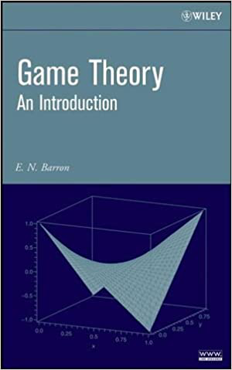

Player I −→strategy i, i = 1, ..., n
Player II −→strategy j, j = 1, ..., m

Player I −→strategy i, i = 1, ..., n
Player II −→strategy j, j = 1, ..., m
Matrix Two-Person Game (Zero sum game)
Player I chooses strategy i, Player II chooses strategy j
then Player I get aij and Player II get −aij.
Both players want to maximize their individual payoffs.

Player I −→strategy i, i = 1, ..., n
Player II −→strategy j, j = 1, ..., m
Matrix Two-Person Game (Zero sum game)
Player I chooses strategy i, Player II chooses strategy j
then Player I get aij and Player II get −aij.
Both players want to maximize their individual payoffs.
Game matrix A = (aij)n×m

Player I wants to have a strategy i∗∈I := {1, . . . , n} such that
  ai∗j ≥aij
  ∀i ∈I.

Player I wants to have a strategy i∗∈I := {1, . . . , n} such that
  ai∗j ≥aij
  ∀i ∈I.
Player II has the tendency to choose a strategy j∗∈J := {1, . . . , m.} such that
−aij∗≥−aij | ∀j ∈J,
or, equivalently,
  aij∗≤aij
  ∀j ∈J.

Player I wants to have a strategy i∗∈I := {1, . . . , n} such that
  ai∗j ≥aij
  ∀i ∈I.
Player II has the tendency to choose a strategy j∗∈J := {1, . . . , m.} such that
−aij∗≥−aij | ∀j ∈J,
or, equivalently,
  aij∗≤aij
  ∀j ∈J.
Put v−= min j | max i | aij | v+= max i | min j | aij

Player I wants to have a strategy i∗∈I := {1, . . . , n} such that
  ai∗j ≥aij
  ∀i ∈I.
Player II has the tendency to choose a strategy j∗∈J := {1, . . . , m.} such that
−aij∗≥−aij | ∀j ∈J,
or, equivalently,
  aij∗≤aij
  ∀j ∈J.
Put v−= min j | max i | aij | v+= max i | min j | aij
v−≤v+(Exercise!)

Saddle points in pure strategies

Player I −→row player

Saddle points in pure strategies

Player I −→row player
Player II −→column player

Saddle points in pure strategies

Player I −→row player
Player II −→column player
We call a pair of row i∗and a column j∗a saddle point in pure strategies of the
game if
  aij∗≤ai∗j∗≤ai∗j
  ∀i = 1, . . . , n; j = 1, . . . , m.

A game has a saddle point in pure strategies if and only if
 | max i |  | min j
  v−= min
  j
  aij = max i
  aij = v+

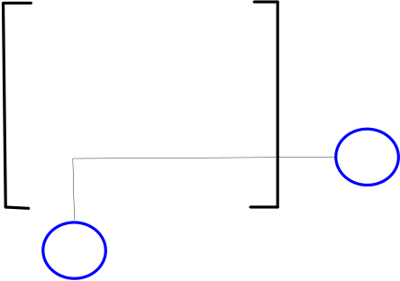
A game has a saddle point in pure strategies if and only if
 | max i |  |  | min j
  v−= min
  j
  aij = max i
  aij = v+
1 | 1 | 2 | 3 | Row min
1 | 1 | 2 | 3 | 1
2 | 4 | 5 | 6 | 4
3 | 7 | 8 | 9 | 7 |  | maximin
Column max | 7 | 8 | 9 |  |  | maximin
minimax

A game has a saddle point in pure strategies if and only if
 | max i |  |  | min j
  v−= min
  j
  aij = max i
  aij = v+
1 | 1 | 2 | 3 | Row min
1 | 1 | 2 | 3 | 1
2 | 4 | 5 | 6 | 4
3 | 7 | 8 | 9 | 7 |  | maximin
Column max | 7 | 8 | 9 |  |  | maximin
minimax
There may exist more than one solution (saddle point) in pure strategies

A game has a saddle point in pure strategies if and only if
 | max i |  |  | min j
  v−= min
  j
  aij = max i
  aij = v+
1 | 1 | 2 | 3 | Row min
1 | 1 | 2 | 3 | 1
2 | 4 | 5 | 6 | 4
3 | 7 | 8 | 9 | 7 |  | maximin
Column max | 7 | 8 | 9 |  |  | maximin
minimax
There may exist more than one solution (saddle point) in pure strategies v = v−= v+is called the value of the game

A game has a saddle point in pure strategies if and only if
min  j | max i | aij = max i | min j | aij

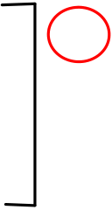

A game has a saddle point in pure strategies if and only if
1 | min j | max i | aij = max i |  | min j | aij
1 | 1 |  | 2 | 3 | 4 | Row min
1 | 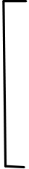 | 5  −4 4 | −3 | 3 | 4 | −3 | maximin
2 |  | 5  −4 4 | 5 | 4 | 4 | −3 | maximin
 |  |  |  |  | 5 | −4
3 |  | 5  −4 4 | −4 | −3 | 3 | −4
Column max | 5 |  | 5 | 4 | 5
minimax

A game has a saddle point in pure strategies if and only if
1 | min j | max i | aij = max i |  | min j | aij
1 | 1 |  | 2 | 3 | 4 | Row min
1 |  | 5  −4 4 | −3 | 3 | 4 | −3 | maximin
2 |  | 5  −4 4 | 5 | 4 | 4 | −3 | maximin
 |  |  |  |  | 5 | −4
3 |  | 5  −4 4 | −4 | −3 | 3 | −4
Column max | 5 |  | 5 | 4 | 5
minimax
A solution (saddle point) in pure strategies may not exist

John Nash proved that in any game where a finite number of players each has a finite number of choices, there is at least one position from which no single player alone can improve his/her position by changing strategy.

John Nash proved that in any game where a finite number of players each has a finite number of choices, there is at least one position from which no single player alone can improve his/her position by changing strategy.
Nash equilibrium

A mixed strategy

Suppose that the players play the game many times. A mixed strategy for player I is a vector x = (x1, . . . , xn) ∈Rnwith
xi ≥0 ∀i ∈I, | xi = 1. | (1)
i∈I
Denote by Sn the set of x = (x1, . . . , xn) satisfying (1). The choice of a mixed strategy x ∈Sn of player I means that this player selects strategy i ∈I with the probability xi. Similarly, a mixed strategy for player II is a vector y = (y1, . . . , ym) ∈Rmwith
yj ≥0 ∀j ∈J, | yj = 1. | (2)
j∈J
Let Sm be the set of y = (y1, . . . , ym) satisfying (2). The choice of a mixed strategy y ∈Sm of player II means that the player selects strategy j ∈J with the probability yj.

If Player I abides by a mixed strategy x ∈Sn and Player II abides by a mixed strategy y ∈Sm, then the expected average payoff to Player I of the game is
E(x, y) | = | i∈I | j∈J | aijProb(Player I uses i and Player II uses j)
E(x, y) | = | i∈I | j∈J | aijProb(Player I uses i). Prob(Player II uses j)
= xTAy.

Saddle points

Minimax Theorem

Saddle point in mixed strategies

A saddle point in mixed strategies is a pair (¯x, ¯y) of probability vectors ¯x ∈Sn
and ¯y ∈Sm satisfying
E(x, ¯y) ≤E(¯x, ¯y) ≤E(¯x, y) | ∀(x ∈Sn, y ∈Sm). | (3)

Saddle point in mixed strategies

A saddle point in mixed strategies is a pair (¯x, ¯y) of probability vectors ¯x ∈Sn
and ¯y ∈Sm satisfying
E(x, ¯y) ≤E(¯x, ¯y) ≤E(¯x, y) | ∀(x ∈Sn, y ∈Sm). | (3)
Put f(x, y) = xTAy. Then, (3) means
  f(x, ¯y) ≤f(¯x, ¯y) ≤f(¯x, y)
  ∀(x ∈Sn, y ∈Sm).

Game has a saddle point in mixed strategies if and only if
y∈Smmax x∈Snf(x, y) = max x∈Snmin y∈Smf(x, y)

Game has a saddle point in mixed strategies if and only if
y∈Smmax x∈Snf(x, y) = max x∈Snmin y∈Smf(x, y)
If (¯x, ¯y) is a saddle point in mixed strategies then
f(¯x, ¯y) = min y∈Smmax x∈Snf(x, y) = max x∈Snmin y∈Smf(x, y)

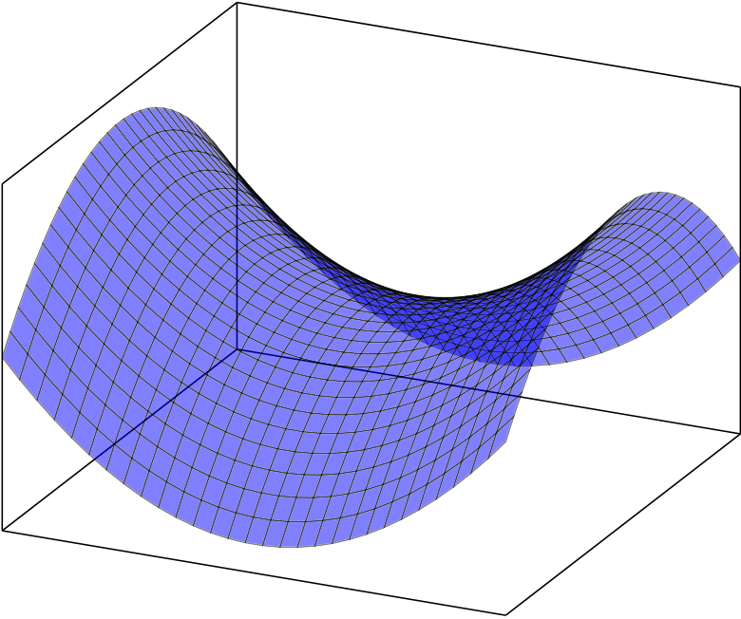
Game has a saddle point in mixed strategies if and only if
y∈Smmax x∈Snf(x, y) = max x∈Snmin y∈Smf(x, y)
If (¯x, ¯y) is a saddle point in mixed strategies then
f(¯x, ¯y) = min y∈Smmax x∈Snf(x, y) = max x∈Snmin y∈Smf(x, y)
f(x, y)
y
x

Hanoi



