Matrix Two-Person Games
Duong Thi Kim Huyen


ORLab, Phenikaa School of Computing, PHENIKAA University

Matrix Two-Person Games
1

Minimax algorithm
2

John von Neumann

John von Neumann
 1928

John von Neumann
1928
On the Theory of Games of Strategy

John von Neumann
1928
On the Theory of Games of Strategy
1944

John von Neumann
1928
On the Theory of Games of Strategy
1944
Theory of Games and Economic Behavior (with Oskar Morgenstern)

John von Neumann
1928
On the Theory of Games of Strategy
1944
Theory of Games and Economic Behavior (with Oskar Morgenstern)
1950

John von Neumann
1928
On the Theory of Games of Strategy
1944
Theory of Games and Economic Behavior (with Oskar Morgenstern)
1950
The first mathematical discussion of the prisoner’s dilemma appeared

John von Neumann
1928
On the Theory of Games of Strategy
1944
Theory of Games and Economic Behavior (with Oskar Morgenstern)
1950
The first mathematical discussion of the prisoner’s dilemma appeared
John Nash

John von Neumann
1928
On the Theory of Games of Strategy
1944
Theory of Games and Economic Behavior (with Oskar Morgenstern)
1950
The first mathematical discussion of the prisoner’s dilemma appeared
John Nash
Developed a criterion for mutual consistency of players’ strategies

John von Neumann
1928
On the Theory of Games of Strategy
1944
Theory of Games and Economic Behavior (with Oskar Morgenstern)
1950
The first mathematical discussion of the prisoner’s dilemma appeared
John Nash
Developed a criterion for mutual consistency of players’ strategies
Nobel Memorial Prize in Economic Sciences (1994)

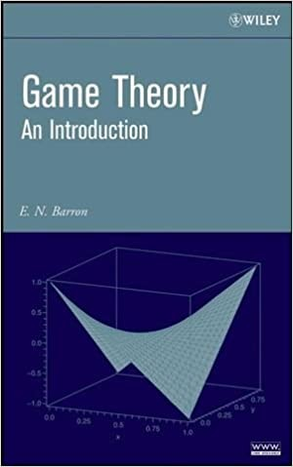
John von Neumann
1928
On the Theory of Games of Strategy
1944
Theory of Games and Economic Behavior (with Oskar Morgenstern)
1950
The first mathematical discussion of the prisoner’s dilemma appeared
John Nash
Developed a criterion for mutual consistency of players’ strategies
Nobel Memorial Prize in Economic Sciences (1994)

Player I −→ strategy i, i = 1, ..., n
Player II −→ strategy j, j = 1, ..., m

Player I −→ strategy i, i = 1, ..., n
Player II −→ strategy j, j = 1, ..., m
Matrix Two-Person Game (Zero sum game) Player I chooses strategy i, Player II chooses strategy j then Player I get a_{ij} and Player II get −a_{ij}.
Both players want to maximize their individual payoffs.

Player I −→ strategy i, i = 1, ..., n
Player II −→ strategy j, j = 1, ..., m
Matrix Two-Person Game (Zero sum game) Player I chooses strategy i, Player II chooses strategy j then Player I get a_{ij} and Player II get −a_{ij}.
Both players want to maximize their individual payoffs.
Game matrix A = (a_{ij})_{n×m}

Player II has the tendency to choose a strategy j∗ ∈ J := {1, . . . , m.} such that
−a_{ij}∗ ≥ −a_{ij} ∀j ∈ J,
or, equivalently,
aij∗ ≤ aij
∀j ∈ J.

Player II has the tendency to choose a strategy j∗ ∈ J := {1, . . . , m.} such that
−a_{ij}∗ ≥ −a_{ij} ∀j ∈ J,
or, equivalently,
aij∗ ≤ aij
∀j ∈ J.
Put v⁺ = min max a_{ij} v⁻ = max min a_{ij}
j i i j

Player II has the tendency to choose a strategy j∗ ∈ J := {1, . . . , m.} such that
−a_{ij}∗ ≥ −a_{ij} ∀j ∈ J,
or, equivalently,
aij∗ ≤ aij
∀j ∈ J.
Put v⁺ = min max a_{ij} v⁻ = max min a_{ij}
j i i j

v⁻ ≤ v⁺(Exercise!)

Player I −→ row player

Player I −→ row player
Player II −→ column player

Player I −→ row player
Player II −→ column player
We call a pair of row i∗ and a column j∗ a saddle point in pure strategies of the game if
aij∗ ≤ ai∗ j∗ ≤ ai∗ j
∀ i = 1, . . . , n; j = 1, . . . , m.

v⁺ = min max a_{ij} = max min a_{ij} = v⁻
j i
i j

2 3
5 6
8 9

v⁺ = min max a_{ij} = max min a_{ij} = v⁻
j i
i j

1 |  | 2 | 3 | Row min
1 | 1 |  |  | 1
2 | 4 |  |  | 4
3 | 7 |  |  |   7 maximin
Column max | 7  minimax | 8 | 9

v⁺ = min max a_{ij} = max min a_{ij} = v⁻
j i
i j

1 |  | 2 | 3 | Row min
1 | 1 |  |  | 1
2 | 4 |  |  | 4
3 | 7 |  |  | 7 | maximin
Column max | 7  minimax | 8 | 9
There may exist more than one solution (saddle point) in pure strategies
2 3
5 6
8 9

v⁺ = min max a_{ij} = max min a_{ij} = v⁻
j i
i j

1 |  | 2 | 3 | Row min
1 | 1 |  |  | 1
2 | 4 |  |  | 4
3 | 7 |  |  | 7 | maximin
Column max | 7  minimax | 8 | 9
There may exist more than one solution (saddle point) in pure strategies
2 3
5 6
8 9

v = v⁻ = v⁺ is called the value of the game

min max a_{ij} = max min a_{ij}
j i i j

min max a_{ij} = max min a_{ij}
j i i j

 | 1 | 2 | 3 | 4 | Row min
1 | 5 | −3 | 3 |   4 | −3 maximin
2 | −4 | 5 | 4 | 5 | −4
3 | 4 | −4 | −3 | 3 | −4
Column max | 5 | 5 |   4 | 5
minimax

min max a_{ij} = max min a_{ij}
j i i j

 | 1 | 2 | 3 | 4 | Row min
1 | 5 | −3 | 3 | 4 | −3 maximin
2 | −4 | 5 | 4 | 5 | −4
3 | 4 | −4 | −3 | 3 | −4
Column max | 5 | 5 | 4 | 5
minimax
A solution (saddle point) in pure strategies may not exist

John Nash proved that in any game where a finite number of players each has a finite number of choices, there is at least one position from which no single player alone can improve his/her position by changing strategy.

John Nash proved that in any game where a finite number of players each has a finite number of choices, there is at least one position from which no single player alone can improve his/her position by changing strategy.
Nash equilibrium

Suppose that the players play the game many times. A mixed strategy for player I is a vector x = (x₁, . . . , x_{n}) ∈ R^{n} with
A mixed strategy
x_{i} ≥ 0 ∀i ∈ I, Σ x_{i} = 1. (1)
i∈I

Denote by S_{n} the set of x = (x₁, . . . , x_{n}) satisfying (1). The choice of a mixed strategy x ∈ S_{n} of player I means that this player selects strategy i ∈ I with the probability x_{i}. Similarly, a mixed strategy for player II is a vector y = (y₁, . . . , y_{m}) ∈ R^{m} with
y_{j} ≥ 0 ∀j ∈ J, Σ y_{j} = 1. (2)
j∈J
Let S_{m} be the set of y = (y₁, . . . , y_{m}) satisfying (2). The choice of a mixed strategy y ∈ S_{m} of player II means that the player selects strategy j ∈ J with the probability y_{j}.

If Player I abides by a mixed strategy x ∈ S_{n} and Player II abides by a mixed strategy y ∈ S_{m}, then the expected average payoff to Player I of the game is
E(x, y) = Σ Σ a_{ij}Prob(Player I uses i and Player II uses j)
i∈I j∈J
Σ Σ
= a_{ij}Prob(Player I uses i). Prob(Player II uses j)
i∈I j∈J
= x^{T} Ay.

Definition 1
Let C and D be sets. A function f : C × D → R has at least a saddle point
(x∗, y∗) with x∗ ∈ C, y∗ ∈ D if
f (x, y∗) ≤ f (x∗, y∗) ≤ f (x∗, y) for all x ∈ C, y ∈ D.

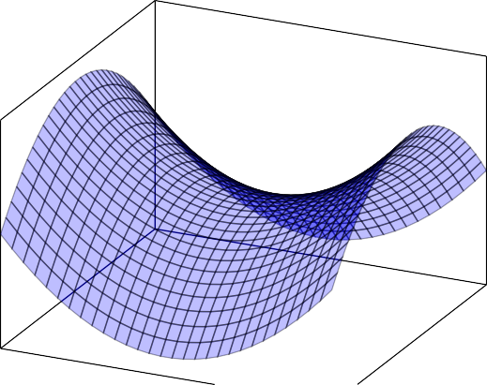
y
f (x, y)

Let f : C × D → R be convex, closed, and bounded. Suppose that x '→ f (x, y) is concave and y '→ f (x, y) is convex. Then
v⁺ = min max f (x, y) = max min f (x, y) = v⁻.
y∈D x∈C x∈C y∈D
Exercise:
Theorem 2
Proof that v− ≤ v+
Proof that if (x∗, y∗) is a saddle point of f then
v⁺ = v⁻ = f (x∗, y∗).

A saddle point in mixed strategies is a pair (x¯, y¯) of probability vectors x¯ ∈ S_{n}
and y¯ ∈ S_{m} satisfying
E(x, y¯) ≤ E(x¯, y¯) ≤ E(x¯, y) ∀ (x ∈ S_{n}, y ∈ S_{m}). (3)

A saddle point in mixed strategies is a pair (x¯, y¯) of probability vectors x¯ ∈ S_{n}
and y¯ ∈ S_{m} satisfying
E(x, y¯) ≤ E(x¯, y¯) ≤ E(x¯, y) ∀ (x ∈ S_{n}, y ∈ S_{m}). (3) Put f (x, y) = x^{T} Ay. Then, (3) means

f (x, y¯) ≤ f (x¯, y¯) ≤ f (x¯, y) ∀ (x ∈ S_{n}, y ∈ S_{m}).

Game has a saddle point in mixed strategies if and only if
min max f (x, y) = max min f (x, y)
y∈Sm x∈Sn x∈Sn y∈Sm

Game has a saddle point in mixed strategies if and only if
min max f (x, y) = max min f (x, y)
y∈Sm x∈Sn x∈Sn y∈Sm
If (x¯, y¯) is a saddle point in mixed strategies then
f (x¯, y¯) = min max f (x, y) = max min f (x, y)
y∈Sm x∈Sn x∈Sn y∈Sm

Cho Q ⊂ R^{n}, S ⊂ R^{m} là các tập lồi đóng khác rỗng. Giả sử rằng φ(x, y) lồi theo x, lõm theo y, và khả vi, hơn nữa các đạo hàm riêng thỏa mãn điều kiện Lipschitz trên Q × S, tức là tồn tại hằng số ℓ > 0 sao cho:
Extragradient Algorithm⋆
∇ φ(x, y) − ∇ φ(x′, y′) ≤ ℓ x − x′ ² + y − y′ ² 1/2 ,
x x
∇ φ(x, y) − ∇ φ(x′, y′) ≤ ℓ x − x′ ² + y − y′ ² 1/2 ,
y y
với mọi x, x′ ∈ R^{n} và y, y′ ∈ R^{m}.

⋆Korpelevich, G. M.: The extragradient method for finding saddle points and other problems, Ekonom. i Mat. Metody 12, 747–756 (1976) In Russian. (English translation in Matekon 13, 35–49 (1977))

Phương pháp Extragradientª để tìm điểm yên ngựa của hàm số φ(x, y) trên
Q × S được xác định bởi mối quan hệ sau:
x¯^{k} = P_{Q} x^{k} + α∇_{x}φ(x^{k}, y^{k}) , y¯^{k} = P_{S} y^{k} − α∇_{y}φ(x^{k}, y^{k}) ,
x^{k+1} = P_{Q} x^{k} + α∇_{x}φ(x¯^{k}, y¯^{k}) , y^{k+1} = P_{S} y^{k} − α∇_{y}φ(x¯^{k}, y¯^{k}) .
ªKorpelevich, G. M.: The extragradient method for finding saddle points and other problems, Ekonom. i Mat. Metody 12, 747–756 (1976) In Russian. (English translation in Matekon 13, 35–49 (1977))

Phương pháp Extragradientª để tìm điểm yên ngựa của hàm số φ(x, y) trên
Q × S được xác định bởi mối quan hệ sau:
x¯^{k} = P_{Q} x^{k} + α∇_{x}φ(x^{k}, y^{k}) , y¯^{k} = P_{S} y^{k} − α∇_{y}φ(x^{k}, y^{k}) ,
x^{k+1} = P_{Q} x^{k} + α∇_{x}φ(x¯^{k}, y¯^{k}) , y^{k+1} = P_{S} y^{k} − α∇_{y}φ(x¯^{k}, y¯^{k}) .
ªKorpelevich, G. M.: The extragradient method for finding saddle points and other problems, Ekonom. i Mat. Metody 12, 747–756 (1976) In Russian. (English translation in Matekon 13, 35–49 (1977))

Ví dụ sau đây là một minh họa sử dụng thuật toán Extragradient để tìm điểm yên ngựa của một hàm toàn phương hai biến số mà lồi theo một biến, lõm theo biến còn lại.
Ví dụ: Cho f (x, y) = y² − x². Bằng cách giới hạn x, y ∈ [−4, 4], chúng ta đặt Ω = Q = S = [−4, 4], chúng ta thực hiện thuật toán Extragradient tìm điểm yên ngựa của f (x, y) trên [−4, 4] × [−4, 4].

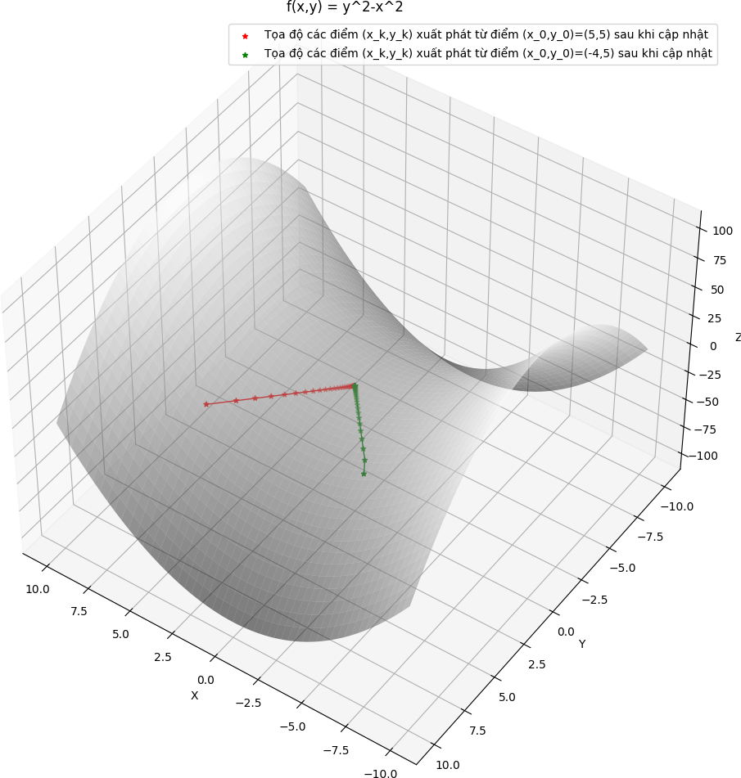

Như chúng ta đã biết nghiệm của trò chơi ma trận là điểm yên ngựa của hàm số
Extragradient Algorithm for Solving Matrix Games
f (x, y) = x^{T} Ay. Quan sát rằng f lõm theo biến x, lồi theo biến y, và
∇f (x, y) = (Ay, A^{T} x). Rõ ràng, ∇f (x, y) là Lipschitz với hằng số

ℓ := Σn
j=1
n i=1
a² 1/2 trên S
× S_{m}
. Do đó, thuật toán Extragradient có thể

được áp dụng để tìm điểm yên ngựa của f trên S_{n} × S_{m}. Chọn một điểm ban đầu
Σ
ij
n
(x⁰, y⁰) ∈ S_{n} × S_{m} và chọn một bước nhảy α với 0 < α < 1/ℓ.

Ta có thể xây dựng một dãy lặp hội tụ về một điểm yên ngựa của trò chơi ma trận hai người như sau:
x¯^{k} = P_{S} x^{k} + α∇_{x}f (x^{k}, y^{k}) , y¯^{k} = P_{S} y^{k} − α∇_{y}f (x^{k}, y^{k}) ,
n
n
x^{k+1} = P_{S} x^{k} + α∇_{x}f (x¯^{k}, y¯^{k}) , y^{k+1} = P_{S} y^{k} − α∇_{y}f (x¯^{k}, y¯^{k}) .
m m
Vì ∇_{x}f (x, y) = Ay và ∇_{y}f (x, y) = A^{T} x, các công thức trên có thể viết lại thành:
x¯^{k} = P_{S} (x^{k} + αAy^{k}), y¯^{k} = P_{S} (y^{k} − αA^{T} x^{k}), (4)
n
n
x^{k+1} = P_{S}m (x^{k} + αAy¯^{k}), y^{k+1} = P_{S}m (y^{k} − αA^{T} x¯^{k}). (5)

Nhập vào một ma trận bất kỳ, tìm điểm yên ngựa của trò chơi bằng thuật toán extragradient.
Bài tập


Hanoi

