1-) Use PLA to print the casing, except for the part that accommodates the pogopin connectors, where UV resin should be used for precision.

2-) Use two springs for the rod lock with the following specifications:
Wire diameter: 1.0mm;
Spring coil number: 6 laps;
Angle: 90 degrees;
Outer diameter: 7.0mm

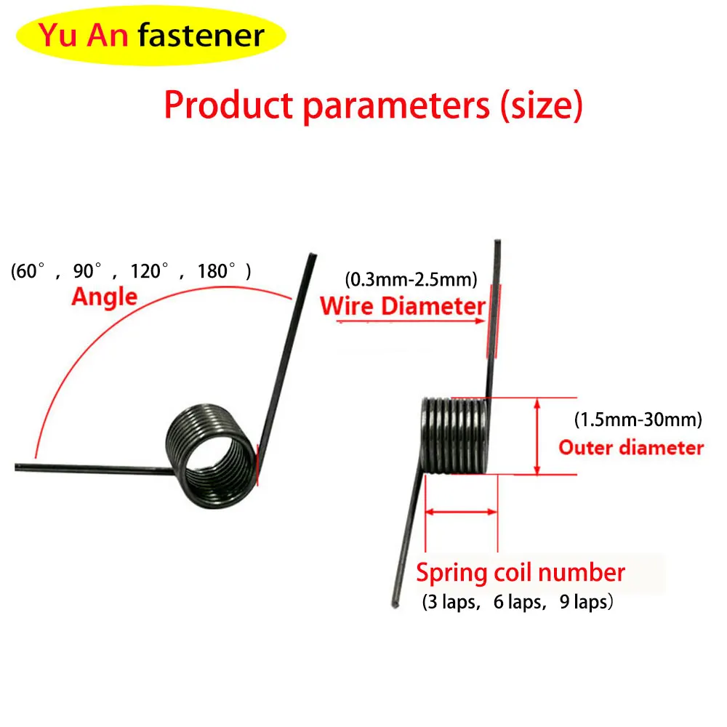

Use twenty pogopin connectors (height 12.5) as electrical contacts.

