corse_work.R

Logan

2021-03-29

library(tidyverse)

## Warning: package 'tidyverse' was built under R version 4.0.4

## -- Attaching packages --------------------------------------- tidyverse 1.3.0 --

## v ggplot2 3.3.3 v purrr 0.3.4  
## v tibble 3.0.6 v dplyr 1.0.4  
## v tidyr 1.1.2 v stringr 1.4.0  
## v readr 1.4.0 v forcats 0.5.1

## -- Conflicts ------------------------------------------ tidyverse_conflicts() --  
## x dplyr::filter() masks stats::filter()  
## x dplyr::lag() masks stats::lag()

library(ggplot2)  
library(ggpubr)  
library(fitdistrplus)

## Warning: package 'fitdistrplus' was built under R version 4.0.4

## Loading required package: MASS

##   
## Attaching package: 'MASS'

## The following object is masked from 'package:dplyr':  
##   
## select

## Loading required package: survival

library(grid)  
library(gridExtra)

##   
## Attaching package: 'gridExtra'

## The following object is masked from 'package:dplyr':  
##   
## combine

#1.A  
mice_before = data.frame(  
 mice_num = paste0(rep("mice number",200),1:200),  
 weight = rnorm(200,mean = 20 ,sd = 2))  
mice_after = data.frame(  
 mice_num = paste0(rep("mice number",200),1:200),  
 weight = rnorm(200,mean = 21 ,sd = 2.5))  
mices = merge(mice_before,mice_after, by = c("mice_num"))  
names(mices)[2] = "before"  
names(mices)[3] = "after"  
#1.B  
rats_before = data.frame(  
 rat_num = paste0(rep("rat number",200),1:200),  
 weight = rweibull(200,shape= 10,scale = 20))  
rats_after = data.frame(  
 rat_num = paste0(rep("rat number",200),1:200),  
 weight = rweibull(200,shape= 9,scale = 21))  
rats = merge(rats_before,rats_after, by = c("rat_num"))  
names(rats)[2] = "before"  
names(rats)[3] = "after"  
#1.C  
rat_graph_before = qplot(x = rats_before$weight, geom = "density")  
rat_graph_after = qplot(x = rats_after$weight, geom = "density")  
mice_graph_before = qplot(x = mice_before$weight, geom = "density")  
mice_graph_after= qplot(x = mice_after$weight, geom = "density")  
grid.arrange(mice_graph_before,mice_graph_after,rat_graph_before  
 ,rat_graph_after, nrow=2, ncol=2)

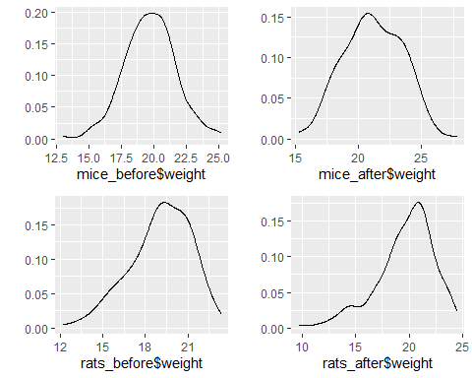

#1.D  
rats_before$condition = "before"  
rats_after$condition = "after"  
ratss = rbind(rats_after,rats_before)  
ggplot(ratss)+geom_boxplot(aes(condition,weight))

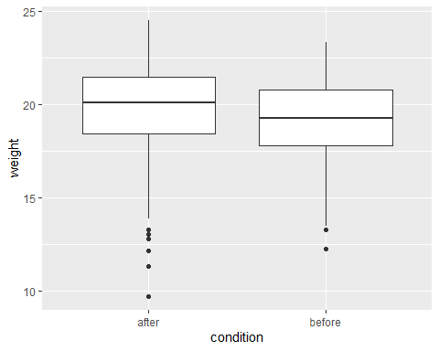

mice_before$condition = "before"  
mice_after$condition = "after"  
micess = rbind(mice_before,mice_after)  
ggplot(micess)+geom_boxplot(aes(condition,weight))

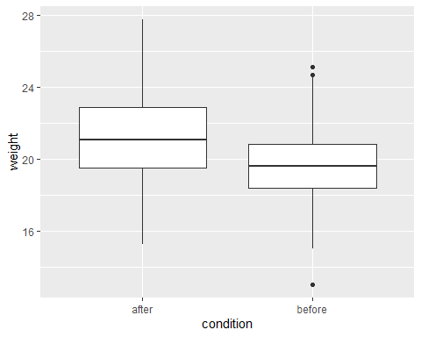

#2.a  
qqnorm(micess$weight)  
qqline(micess$weight, col="red")

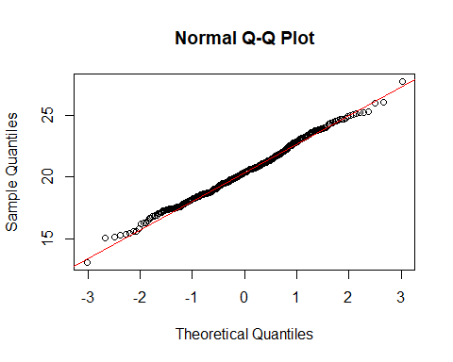

shapiro.test(micess$weight)

##   
## Shapiro-Wilk normality test  
##   
## data: micess$weight  
## W = 0.99588, p-value = 0.3822

#2.b  
qqnorm(ratss$weight)  
qqline(ratss$weight, col="red")

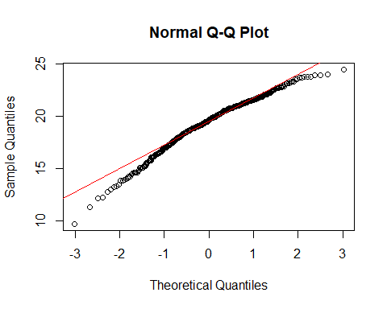

shapiro.test(ratss$weight)

##   
## Shapiro-Wilk normality test  
##   
## data: ratss$weight  
## W = 0.97061, p-value = 3.27e-07

#2.c  
sqrt_rat = sqrt(max(ratss$weight+1) - ratss$weight)  
qqnorm(sqrt_rat)  
qqline(sqrt_rat, col="red")

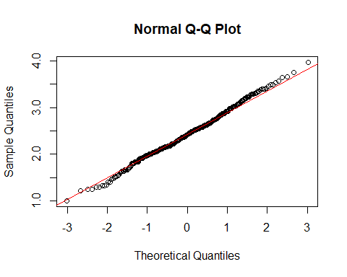

shapiro.test(sqrt_rat)

##   
## Shapiro-Wilk normality test  
##   
## data: sqrt_rat  
## W = 0.99662, p-value = 0.5679

#3.a  
t.test(mices$before,mices$after, paired = TRUE)

##   
## Paired t-test  
##   
## data: mices$before and mices$after  
## t = -7.0483, df = 199, p-value = 2.906e-11  
## alternative hypothesis: true difference in means is not equal to 0  
## 95 percent confidence interval:  
## -1.845840 -1.038787  
## sample estimates:  
## mean of the differences   
## -1.442313

mean(mices$before)

## [1] 19.70437

#3.b  
wilcox.test(x =rats$before, y = rats$after, paired = TRUE)

##   
## Wilcoxon signed rank test with continuity correction  
##   
## data: rats$before and rats$after  
## V = 7868, p-value = 0.007772  
## alternative hypothesis: true location shift is not equal to 0

#4  
dev.off()

## null device   
## 1

rats_w <- fitdist(ratss$weight, "weibull")  
rats_g <- fitdist(ratss$weight, "gamma")  
rats_l <- fitdist(ratss$weight, "lnorm")  
summary(rats_w)

## Fitting of the distribution ' weibull ' by maximum likelihood   
## Parameters :   
## estimate Std. Error  
## shape 9.640527 0.3783155  
## scale 20.385046 0.1112125  
## Loglikelihood: -908.9284 AIC: 1821.857 BIC: 1829.84   
## Correlation matrix:  
## shape scale  
## shape 1.0000000 0.3102704  
## scale 0.3102704 1.0000000

summary(rats_g)

## Fitting of the distribution ' gamma ' by maximum likelihood   
## Parameters :   
## estimate Std. Error  
## shape 57.200636 4.0329265  
## rate 2.955301 0.2092772  
## Loglikelihood: -941.1364 AIC: 1886.273 BIC: 1894.256   
## Correlation matrix:  
## shape rate  
## shape 1.0000000 0.9956327  
## rate 0.9956327 1.0000000

summary(rats_l)

## Fitting of the distribution ' lnorm ' by maximum likelihood   
## Parameters :   
## estimate Std. Error  
## meanlog 2.954219 0.006794702  
## sdlog 0.135894 0.004803409  
## Loglikelihood: -950.9111 AIC: 1905.822 BIC: 1913.805   
## Correlation matrix:  
## meanlog sdlog  
## meanlog 1 0  
## sdlog 0 1

par(mfrow=c(2,2))  
plot.legend <- c("weibull", "lognormal", "gamma")  
denscomp(list(rats_w,rats_g,rats_l),legendtext = plot.legend)  
cdfcomp(list(rats_w,rats_g,rats_l),legendtext = plot.legend)  
qqcomp(list(rats_w,rats_g,rats_l),legendtext = plot.legend)  
ppcomp(list(rats_w,rats_g,rats_l),legendtext = plot.legend)