## 

## System Metrics

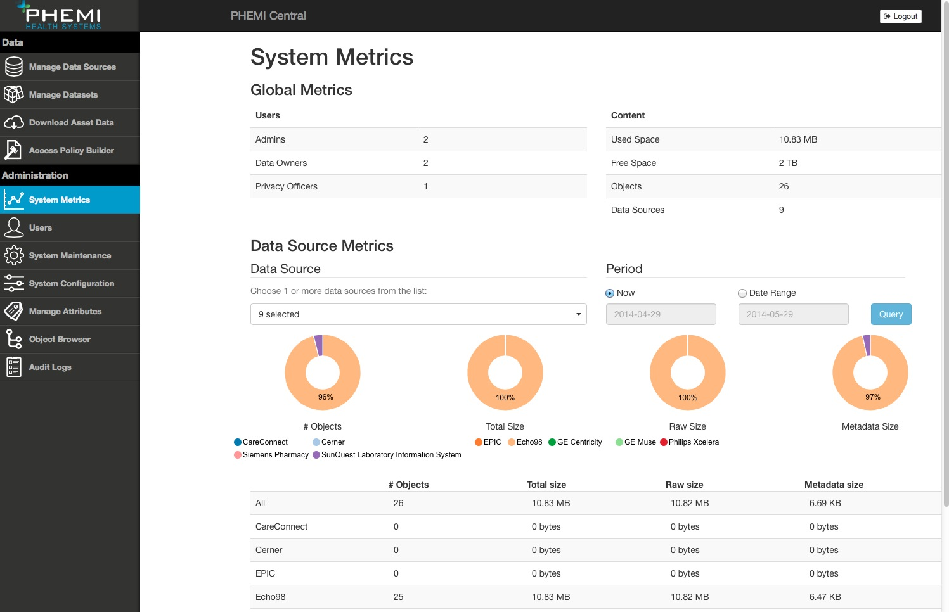

## Key Contact Information / Enquiries

PHEMITM Health Systems - [info@phemi.com](mailto:info@phemi.com)

To view a short video tutorial, please visit http:// vimeo.com/96581198 and enter your provided password.