# Diagram and Description

**Data Structure Diagram:**

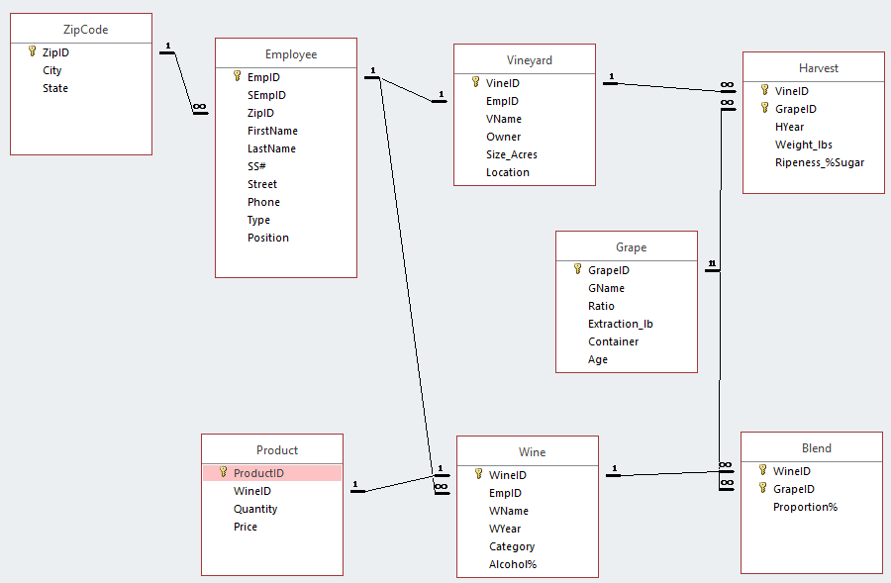

**Description of implementation:**

Purpose

The purpose of this implemented part of the application is to track information about Employees, Vineyards, Grapes, Wine, and Products. The application is enhanced by the intermediary relationships of Harvest and Blend. The data tracked here allows the user to know what types of grapes are harvested at which vineyards and when, in the case of the Harvest entity. While the Blend entity, allows the user to track the proportion of grape in each unique wine. All of this information is crucial to Valley Vineyards in order to manage their product effectively and efficiently.

Relationships

* The ZipCode table is used as a domain enforcement for the zip codes available in the Employee table.
* An employee can only manage one vineyard, so there’s a one-to-one connection between the two.
* An employee can make more than one type of wine, so there’s a one-to-may connection between the two.
* The type of grape grown at each vineyard each year is tracked in the Harvest entity, which is why both the Vineyard and Grape entities have a one-to-many relationship in the Harvest entity.
* The proportions of grape in each wine is tracked in the blend entity, which is why both Grape and Wine entities have a one-to-many relationship to the Blend entity.
* Each Product is made up of only one kind of wine, which is why there’s a one-to-one relationship between Product and Wine.