JAMES COOK UNIVERSITY
CP3407
SMART EXPENSE TRACKER WEB APPLICATION
FINAL PROJECT REPORT
Team members: Zhu Zhiwei, Jiang Jinsong and Fu Yuzhe
Campus: James Cook University Singapore
Submission date: 5 August 2026
Repository: https://github.com/lbw138286/cp3407
Latest verified release: v1.0.1

Contents
1 Executive Summary
2 Problem, Users and Requirements
3 Agile Planning and Week 1-10 Delivery
4 Architecture and Design
5 Database and Security
6 Implementation and User Interface
7 Testing, TDD and Defect Management
8 Version Control and Development Tools
9 Acceptance Feedback and Corrective Action
10 Persistence and Deployment
11 Conclusion
12 References

1 Executive Summary
The Smart Expense Tracker is a full-stack web application completed across three Agile iterations. The project responds to common problems identified during user research, including forgotten small expenses, overspending, inconsistent categories, limited budget visibility and concern about the security of personal financial records.
The final system provides account registration, secure login, expense creation and maintenance, category filtering, monthly budgets, budget alerts, monthly financial reports, spending trends, administrator account management and acceptance-feedback recording. The implemented architecture uses a browser-based graphical interface, a Node.js server and a relational SQLite database. This combination satisfies the project requirement for source code, a modern database and a modern graphical user interface (James Cook University, 2026).
The final verification result is 41 automated tests passed with 0 failures and 15 system tests passed with 0 failures. GitHub Issues, feature branches, Pull Requests, GitHub Actions, teammate review and release management were used throughout the final integration. The lecturer identified one usability issue during the final demonstration: the reports were presented in a way that was too complex for normal users. The interface was then changed to use summary cards, tables and comparison bars, while raw JSON was retained only as optional technical information.

2 Problem, Users and Requirements
The project began with three representative users. The first was a university student who required simple daily entry and allowance control. The second was a working adult who required secure access and monthly spending analysis. The third was a small-business owner who required organised, editable and protected records. These needs were converted into ten user stories and prioritised according to dependency and user value.
Table 1 Target users and project responses
User | Main need | Implemented response
University student | Simple entry and allowance control | Expense entry, monthly budgets and alerts
Working adult | Secure access and monthly analysis | Secure login, reports, categories and trends
Small-business owner | Organised and protected records | Categories, CRUD, relational storage and administrator controls

Table 2 User stories, priorities and estimates
US | Requirement | Priority | Estimate and iteration | Status
US1 | Register accounts | High | Final integration | Done
US2 | Secure login | High | Final integration | Done
US3 | Add expenses | High | 6 person-days, Iteration 1 | Done
US4 | Edit and delete expenses | High | 6 person-days, Iteration 1 | Done
US5 | Categorise and filter expenses | High | 6 person-days, Iteration 2 | Done
US6 | Set monthly budgets | High | 6 person-days, Iteration 2 | Done
US7 | Receive budget alerts | High | 3 person-days, Iteration 3 | Done
US8 | Generate monthly reports | High | 3 person-days, Iteration 3 | Done
US9 | Analyse spending trends | Medium | 3 person-days, Iteration 3 | Done
US10 | Administrator account management | Medium | 3 person-days, Iteration 3 | Done

The implementation order was based on technical dependencies. Expense records had to exist before category analysis and budgets could be meaningful. Budgets and spending history had to exist before alerts, reports and trends could be calculated. Secure registration and login were completed as cross-cutting final-integration work because the same identity and session controls were required by all private API routes.

3 Agile Planning and Week 1-10 Delivery
The team used an iterative process with user stories, task breakdowns, estimates, project-board states, burndown evidence, velocity review, TDD, bug tracking and retrospective updates. The capacity was fixed at 12 person-days per iteration, calculated from three team members working across four available project days.
Table 3 Week 1-10 project delivery
Week | Main focus | Delivered result
1 | Project selection and Agile setup | Product vision, team roles and working process
2 | User research and requirements | Three user profiles and US1-US10
3 | Iteration 1 planning | US3 and US4 prioritised, estimated and placed on the board
4 | Iteration 1 execution | Expense CRUD and design diagrams
5 | Iteration 1 review | Velocity and code-quality review
6 | Iteration 2 delivery | Categories and monthly budgets
7 | Automated testing | Practical test cases for US3-US7
8 | Iteration 3 TDD | Alerts, reports, trends and mock authentication
9 | Bug tracking and system test preparation | BUG-003 and regression evidence
10 | Final system demonstration | US1-US10, SQLite, administration and feedback response

Table 4 Iteration plan and result
Iteration | Capacity | Scope | Result
1 | 12 person-days | US3 Add expenses and US4 Edit/Delete expenses | Done
2 | 12 person-days | US5 Categories and US6 Monthly budgets | Done
3 | 12 person-days | US7 Alerts, US8 Reports, US9 Trends and US10 Administration | Done

Final integration completed US1 and US2, SQLite persistence, security controls, GitHub evidence and the feedback-driven report correction.
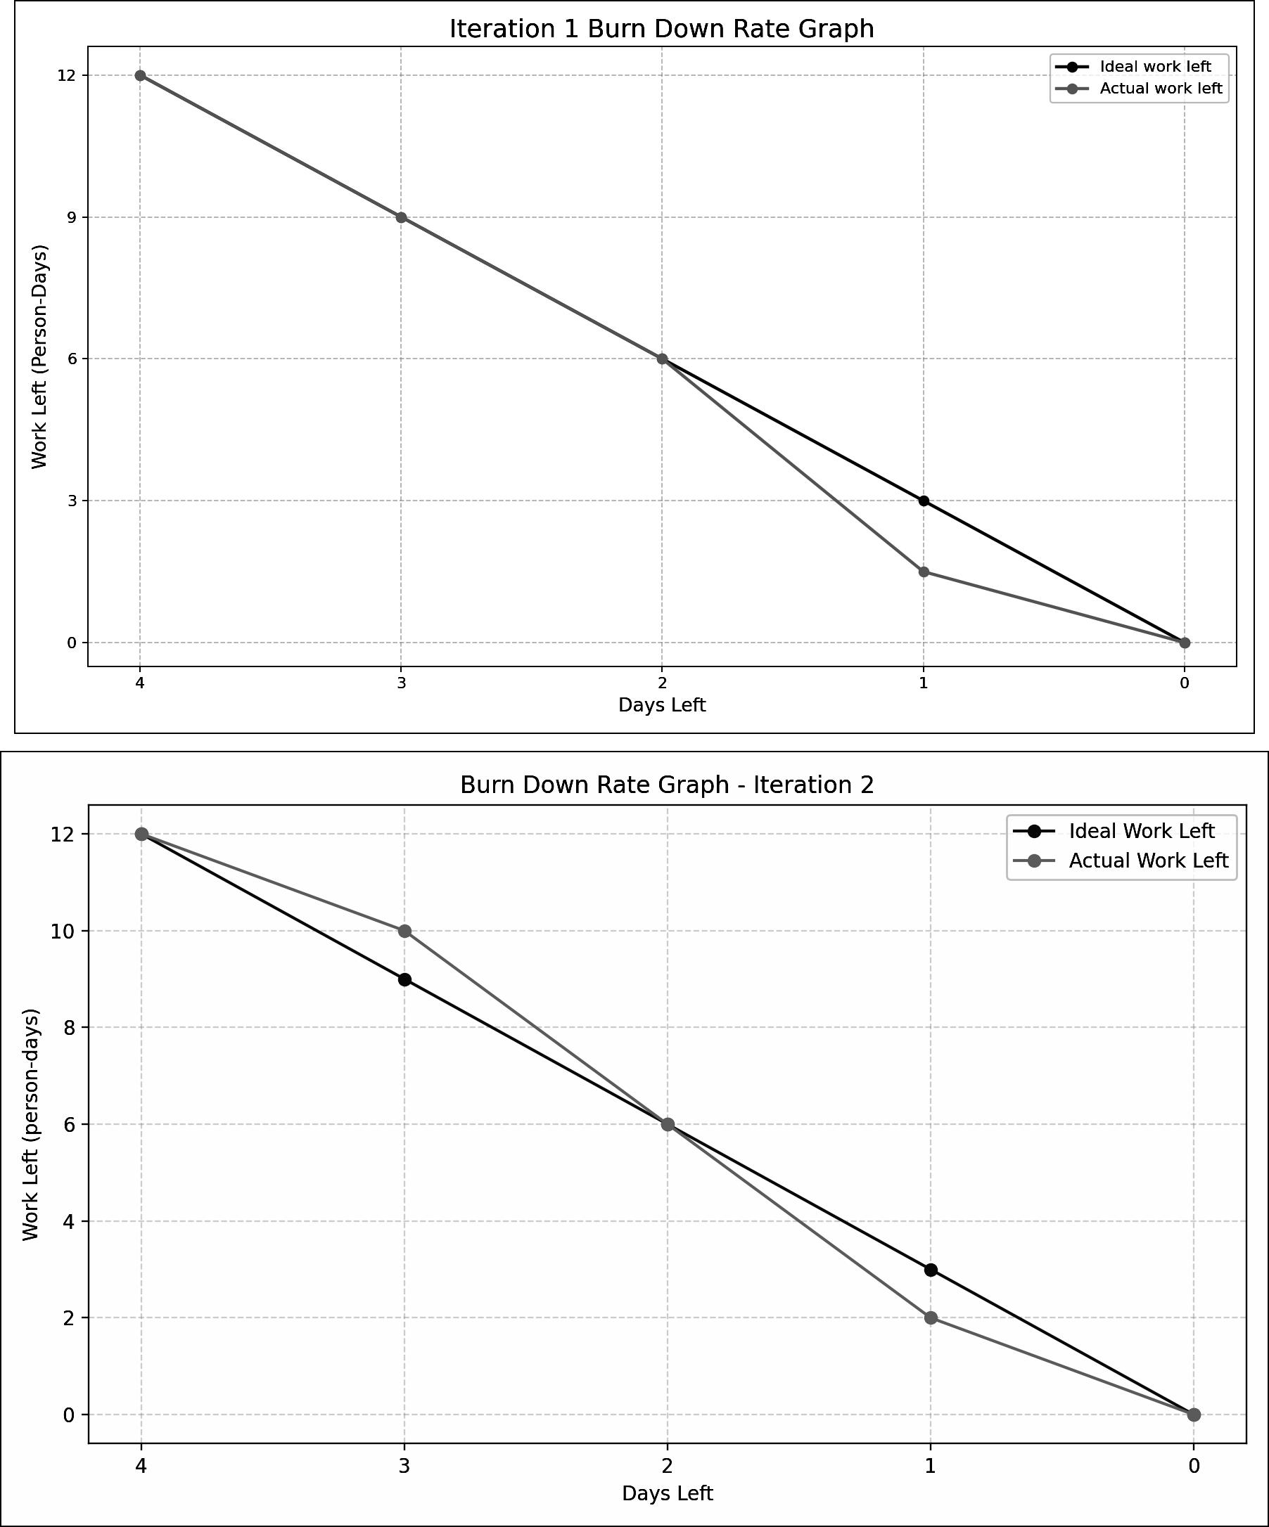
Figure 1 Iteration 1 and Iteration 2 burndown evidence
Both burndown records finished at zero remaining work. The difference between ideal and actual work was discussed during iteration reviews and was used to adjust later planning. Original weekly files are retained in the repository archive so that the development history remains available.

4 Architecture and Design
The final architecture separates the browser interface, HTTP API, security controls, business services and relational storage. This separation supports single responsibility, reduces duplicated validation and allows services and routes to be tested independently. Mermaid was used to maintain editable architecture, sequence and entity-relationship diagrams (Mermaid, n.d.).
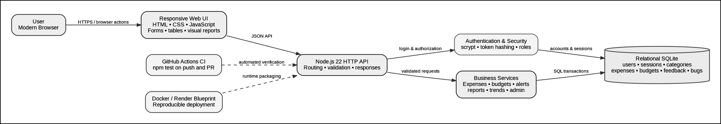
Figure 2 Layered system architecture and request flow
4.1 Relational Design
The database design uses users as the main ownership entity. A user can have many sessions, expenses and monthly budgets. Categories can be linked to many expenses. Acceptance feedback and bug records are retained as project evidence. Foreign keys are used to preserve relationships between records.
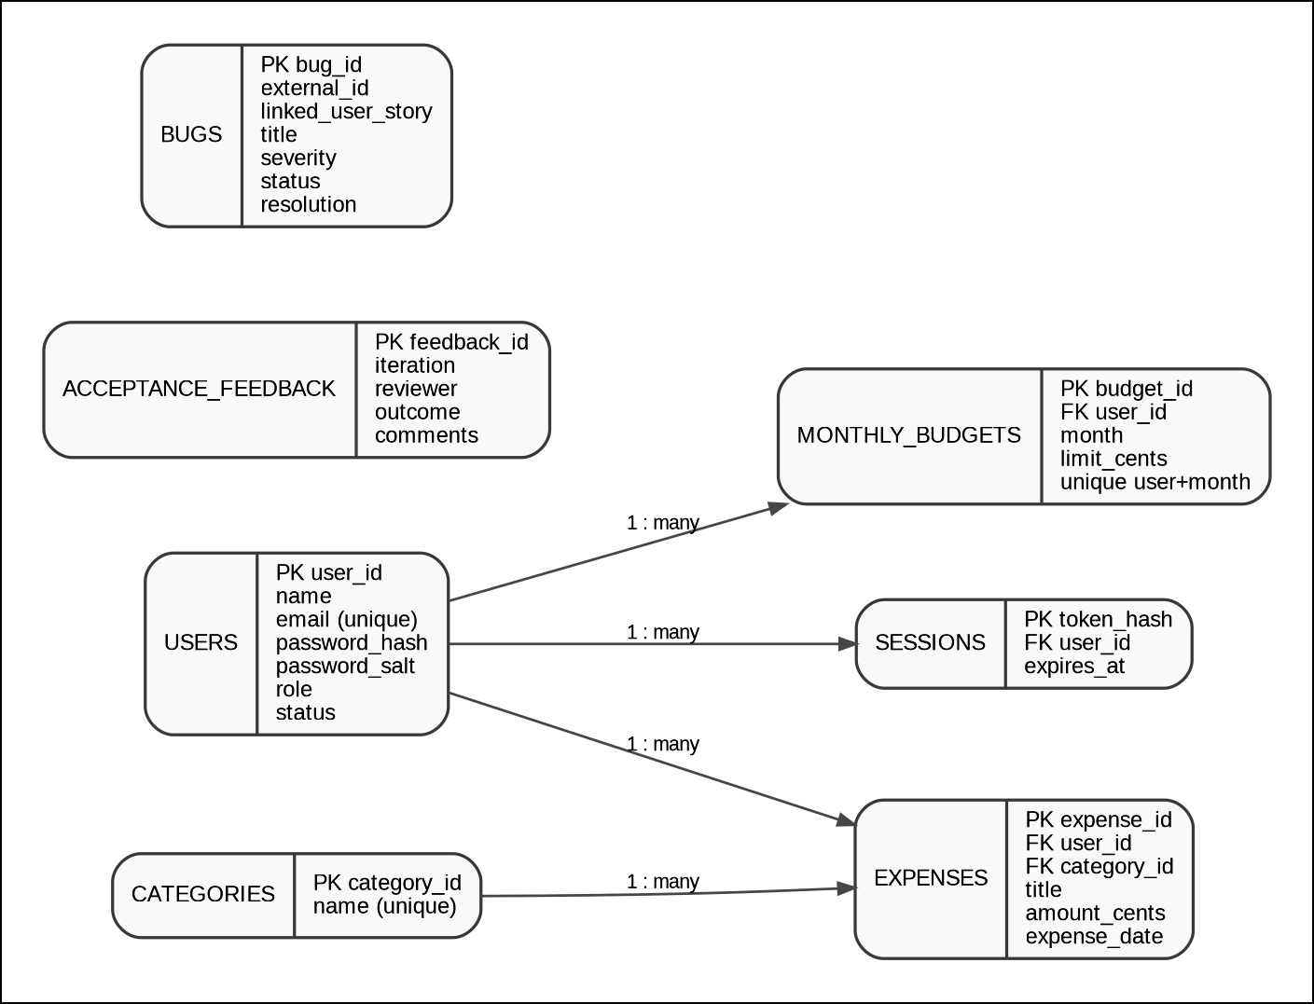
Figure 3 Relational database entity-relationship design
4.2 Behavioural Design
The sequence design shows that expense creation is not performed only in the browser. The request is sent to the server, validated, authenticated, stored in SQLite and then returned to the interface. This design supports integrity and persistence.
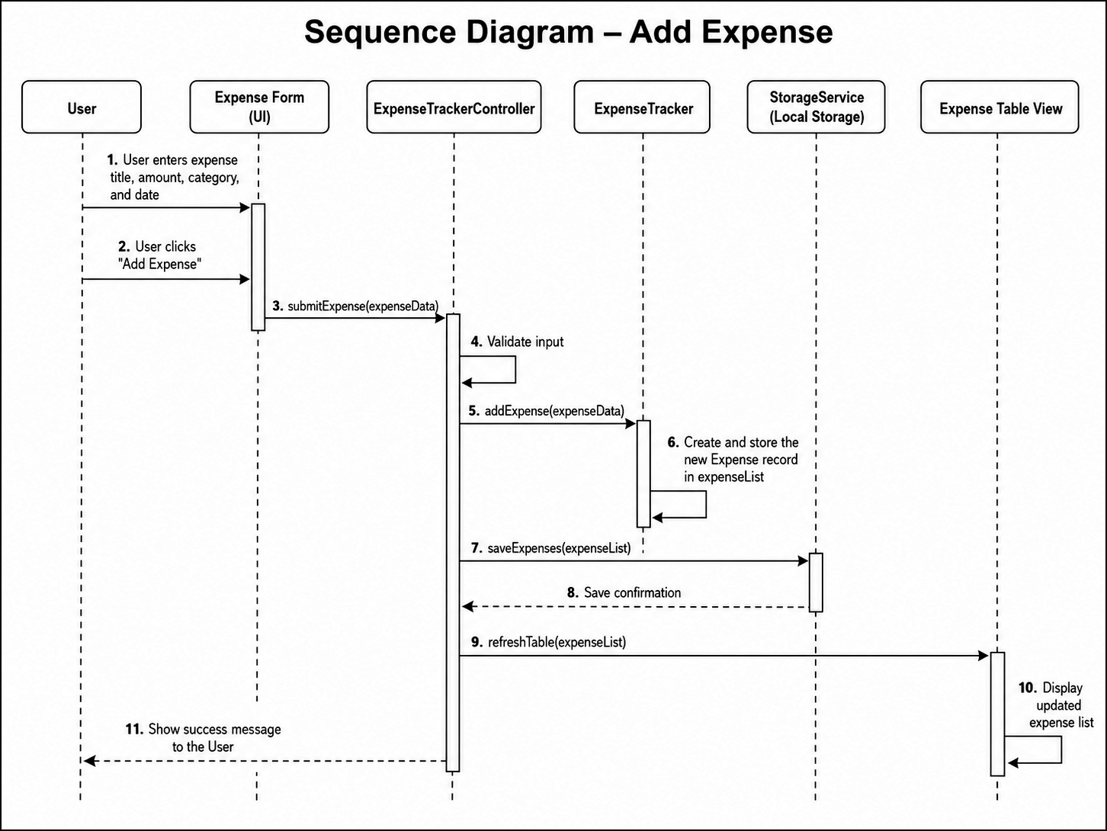
Figure 4 Add-expense sequence design
5 Database and Security
SQLite is the executable relational database used by the final application. Money is stored in integer cents to reduce floating-point storage errors. Foreign keys enforce relationships, and the database is created and seeded when the server starts. SQLite provides transactional relational storage suitable for this project scale (SQLite Consortium, n.d.).
Table 5 Database tables and controls
Table | Purpose | Main controls
users | Identity and authorisation | Unique email, role, status and salted password hash
sessions | Authenticated access | Hashed token, expiry and user foreign key
categories | Controlled category names | Unique category name
expenses | User expense records | User and category foreign keys; positive amount cents
monthly budgets | Budget by month | Unique user and month; positive limit cents
acceptance feedback | Reviewer feedback | Iteration, reviewer, outcome and comments
bugs | Defect evidence | User story, severity, status and resolution

Security functions use Node.js cryptographic APIs and server-side session handling (Node.js, n.d.). The main controls are listed below.
No | Statement
1 | Passwords are checked for minimum strength and are stored only as random-salt scrypt hashes.
2 | Plain passwords are never stored, and timing-safe comparison is used during authentication.
3 | Session tokens are random, while only SHA-256 token hashes are stored in SQLite.
4 | Private routes require an active database session, and administrator routes require the admin role.
5 | Disabled accounts cannot log in, and administrators can change account status or delete accounts.
6 | HTTP responses include Content-Security-Policy, X-Content-Type-Options, X-Frame-Options and Referrer-Policy.
7 | Production deployment requires HTTPS and environment-based credentials.

6 Implementation and User Interface
The browser interface communicates with authenticated server routes. Application records are not persisted in localStorage. Clear forms, validation messages, tables and action controls support both normal users and administrators. The interface is responsive and can be used in modern desktop browsers.
Table 6 Implemented application functions
Area | Implemented functions
Account | Register, login, logout, current session and disabled-account control
Expense | Add, edit, delete, validate, list and category filter
Budget | Set or update monthly budget and calculate safe, warning or over-budget status
Reporting | Selected-month totals, category totals, top category, summary cards and expense table
Trend | Sorted monthly totals, rounded change, direction and comparison bars
Administration | List users, update role or status, disable and delete
Feedback | Store genuine acceptance feedback in SQLite

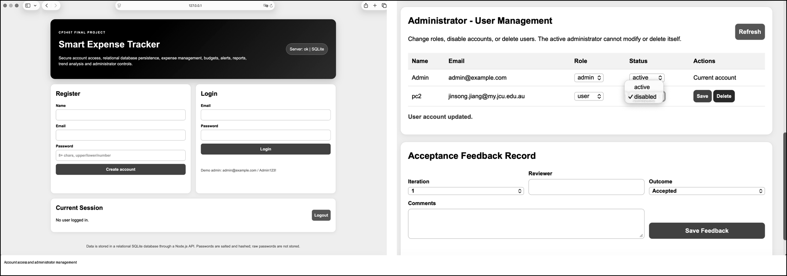
Figure 5 Account access, administrator management and feedback functions
After the final demonstration, the report interface was changed so that raw JSON is no longer the primary presentation. Monthly totals, record counts, categories and trends are now displayed in a format intended for normal users. The raw technical data remains available only in an expandable section.
7 Testing, TDD and Defect Management
The final command is npm test. The automated suite contains 41 tests and 0 failures. The tests cover validation, boundary conditions, authentication, relational persistence, expense CRUD, categories, budgets, alerts, reports, trends, administrator controls and regression defects. The final system-test result is 15 Pass, 0 Conditional Pass and 0 Fail.
Table 7 Automated test coverage
Test group | Count | Scope
Iteration 2 unit tests | 15 | US3-US7 expense, category, budget and alert logic
Iteration 3 unit and mock tests | 12 | US7-US10 reports, trends and mock authentication
Regression tests | 2 | BUG-003 month sorting and US9 decimal precision
Database and API integration | 12 | US1-US10 authentication, persistence, CRUD, reports and administration

The TDD process used during the practical work followed four repeatable stages.
No | Statement
1 | Write or update a test for the intended behaviour.
2 | Run the suite and observe the failure or regression.
3 | Implement the smallest valid correction.
4 | Re-run unit, mock, integration and CI checks.

BUG-003 showed that unordered month totals could produce an incorrect trend comparison. The correction sorts month keys chronologically. A later US9 defect displayed a floating-point value such as 0.04000000000000001. Pull Request 27 rounded the value to two decimals and added the forty-first automated test.
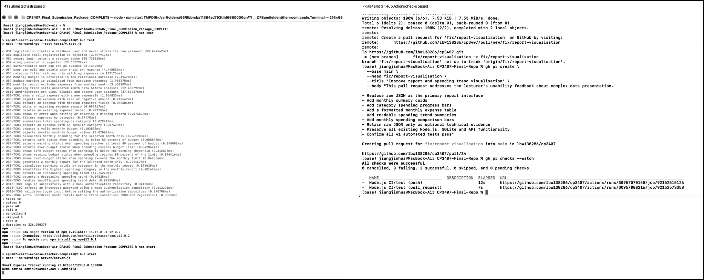
Figure 6 Automated tests and GitHub Actions evidence
8 Version Control and Development Tools
GitHub was used for the live repository, Issues, feature branches, Pull Requests, reviews, Actions and releases. This workflow provides a traceable record of changes and allows automated checks to run before merge (GitHub, n.d.).
Table 8 Development and build tools
Tool | Project use
Git and GitHub | Commits, branches, Issues, Pull Requests, review and releases
GitHub Actions | Run npm test on pushes and Pull Requests
Node.js 22 | HTTP server, crypto, built-in test runner and SQLite API
SQLite | Executable relational runtime database
Docker | Reproducible application container
Mermaid Live Editor | Editable online class, sequence and ER diagrams
GitHub Pages documentation | Static project documentation deployment support

Pull Request 27 corrected spending-trend precision. Pull Request 29 corrected the documented test total. Pull Request 30 recorded a formal teammate approval. Pull Request 31 removed an accidental nested repository reference. Pull Request 32 archived weekly coursework. Pull Request 34 implemented the report-interface correction. Pull Requests 35 and 36 aligned the acceptance and final-report documentation.
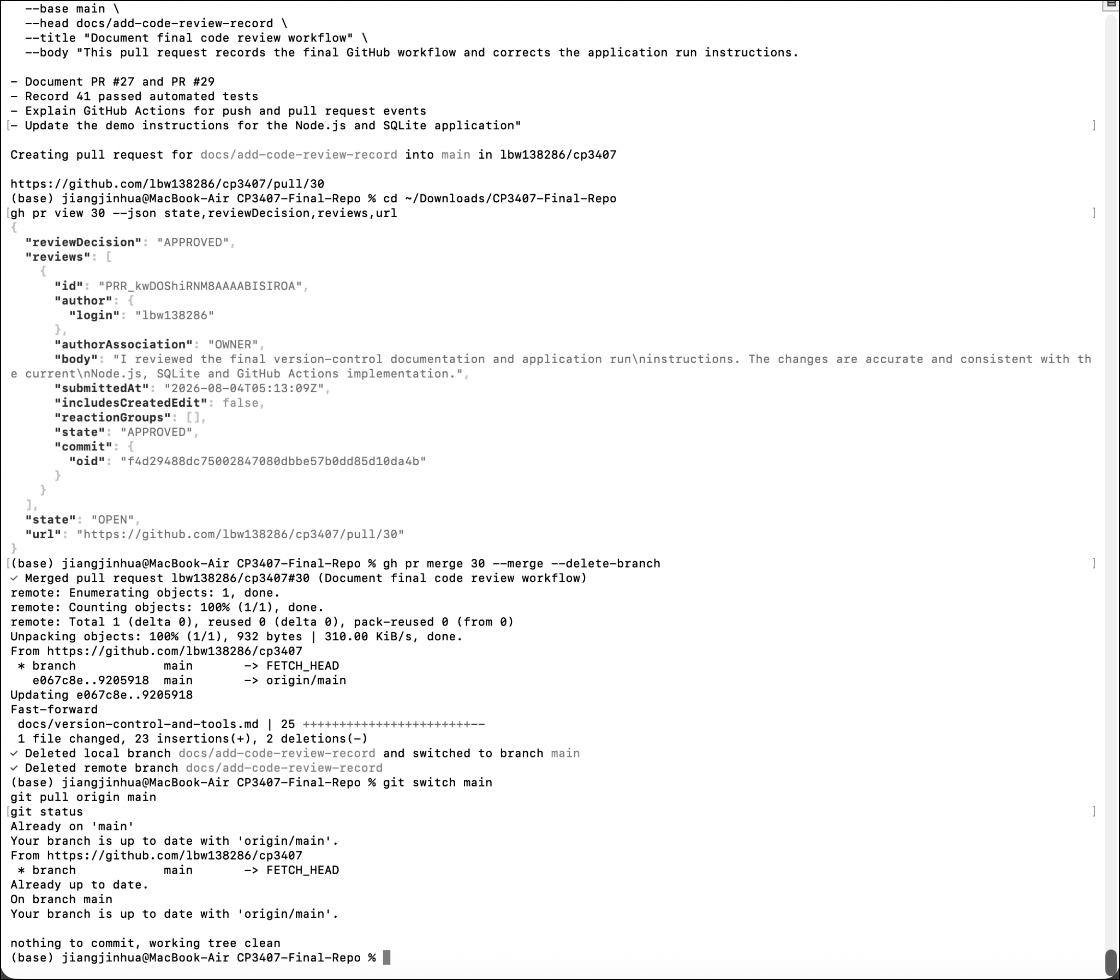
Figure 7 Pull Request, merge and clean-branch evidence
9 Acceptance Feedback and Corrective Action
During the final demonstration on 4 August 2026, Dasheng LIU stated that the data presentation was not convenient for users and used an overly complex method. The monthly report and spending trend information were mainly shown as raw JSON. The calculations were correct, but the display was more suitable for developers than normal users.
9.1 Corrective Action
No | Statement
1 | Raw JSON was removed as the primary report output.
2 | Total-spent, expense-count and top-category summary cards were added.
3 | Currency values and expense records were placed in a formatted table.
4 | Category and monthly comparison bars were added.
5 | Direction, change, period and latest-month summaries were added.
6 | Clear guidance was added when there was not enough data for trend analysis.
7 | Technical JSON was retained only as an optional expandable section.

The corrective action was implemented through Pull Request 34, verified by GitHub Actions and manual browser testing, and published in release v1.0.1. The original outcome remains recorded as Changes required because a second formal lecturer decision was not received. The completed response is documented without claiming a new acceptance decision.
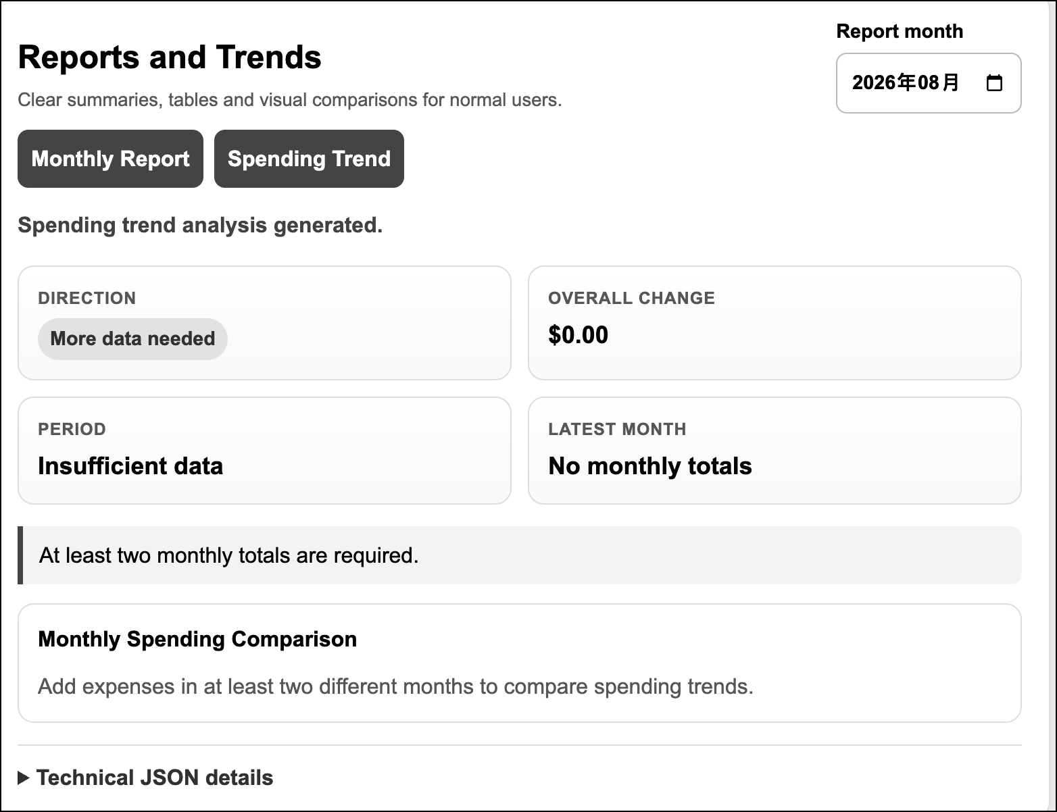
Figure 8 Report and spending-trend interface after the usability correction
10 Persistence and Deployment
10.1 SQLite Persistence Verification
The Node.js server was stopped and restarted without deleting the SQLite database. The same account could log in after restart, and the previously created user, expense and report data remained available. Runtime database files are excluded from Git through .gitignore.
Table 9 SQLite persistence verification
Stage | Observed evidence | Result
Before restart | Two expense records and cross-month trend data were visible | Passed
Server stop and start | Port was released and Node.js restarted from the correct repository | Passed
After restart | The same account logged in and stored SQLite data remained available | Passed

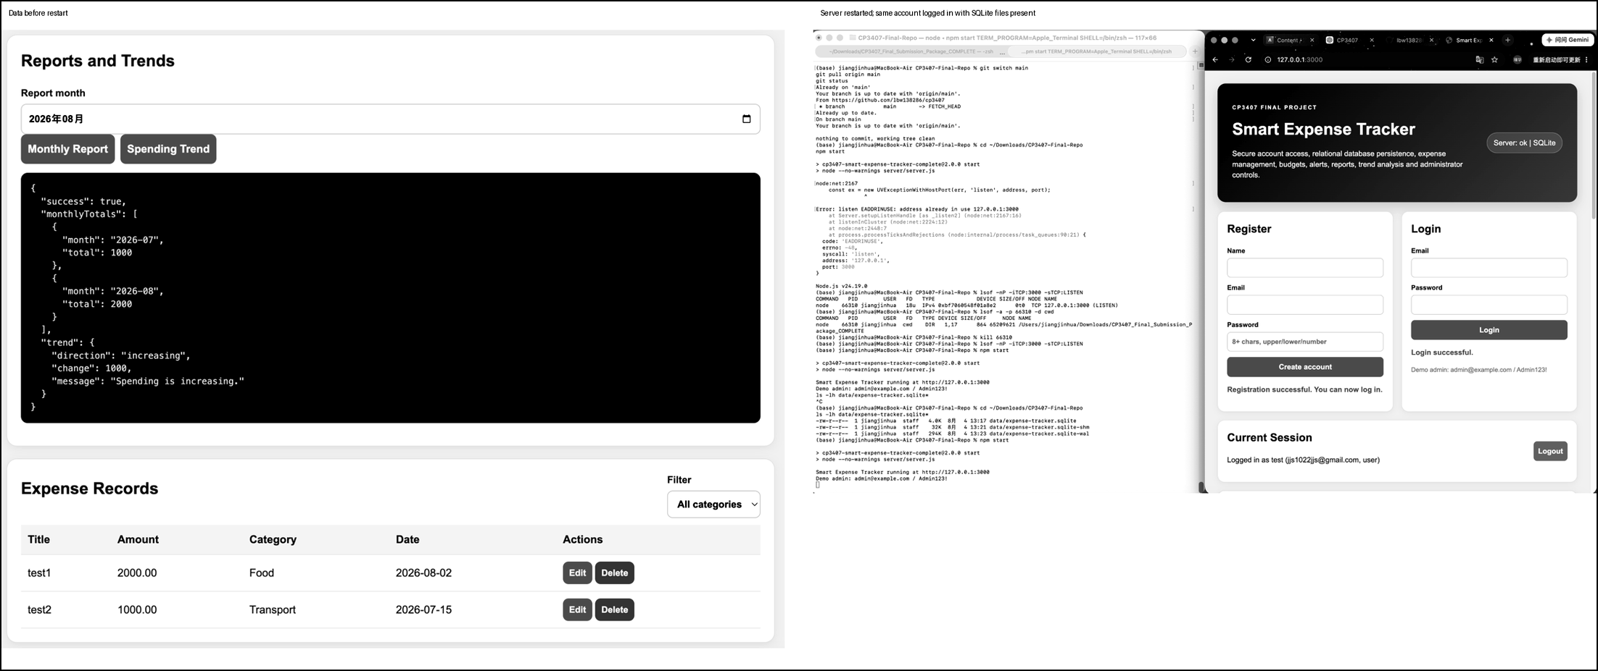
Figure 9 Data before restart and successful login after restarting the server
10.2 Deployment Status
Table 10 Deployment and release status
Item | Status | Evidence or limitation
Local application demo | Done | npm start at http://127.0.0.1:3000
Docker packaging | Done | Dockerfile and reproducible container configuration
Render deployment blueprint | Ready | Node.js and SQLite persistent-disk configuration
GitHub Actions CI | Done | Push and Pull Request checks pass
Release management | Done | v1.0.0 and v1.0.1 retained
Public Node.js URL | No URL | Requires a repository-owner hosting account
GitHub Pages | Pending | Documentation files prepared; publication URL unverified

11 Conclusion
The final Smart Expense Tracker provides a modern browser interface, relational SQLite persistence, secure server-side authentication, user and administrator functions, 41 passing automated tests, 15 passing system tests and a documented Agile development history. The project also includes architecture, database and sequence designs, defect records, GitHub collaboration evidence and release management.
The project responded directly to the lecturer feedback. The original raw-JSON report presentation was replaced with summary cards, tables, formatted values, comparison bars and clear guidance for insufficient data. The correction is traceable through Pull Request 34 and release v1.0.1. This response strengthens the implementation, usability, testing and technical-writing evidence expected in the HD rubric.

12 References
GitHub. (n.d.). GitHub Docs. Retrieved August 5, 2026, from https://docs.github.com/

James Cook University. (2026). CP3407 project rubric [Course document].

Jiang, J., Zhu, Z., & Fu, Y. (2026). Smart Expense Tracker (Version 1.0.1) [Computer software]. GitHub. https://github.com/lbw138286/cp3407

Mermaid. (n.d.). Mermaid documentation. Retrieved August 5, 2026, from https://mermaid.js.org/

Node.js. (n.d.). Node.js documentation. Retrieved August 5, 2026, from https://nodejs.org/docs/latest/api/

SQLite Consortium. (n.d.). SQLite documentation. Retrieved August 5, 2026, from https://www.sqlite.org/docs.html

