**ISYS3001 – Assignment 1 exercise**

Remember that this is a public repository - your changes could be seen by anyone who looks!

Add some comments about Version management outside this border, or just add some text so there is a change to this file.

Remember that your GitHub user ID must be submitted in your assignment report!

Once you’ve changed follow the next step in your assignment task.

Account Name:lbyyazj

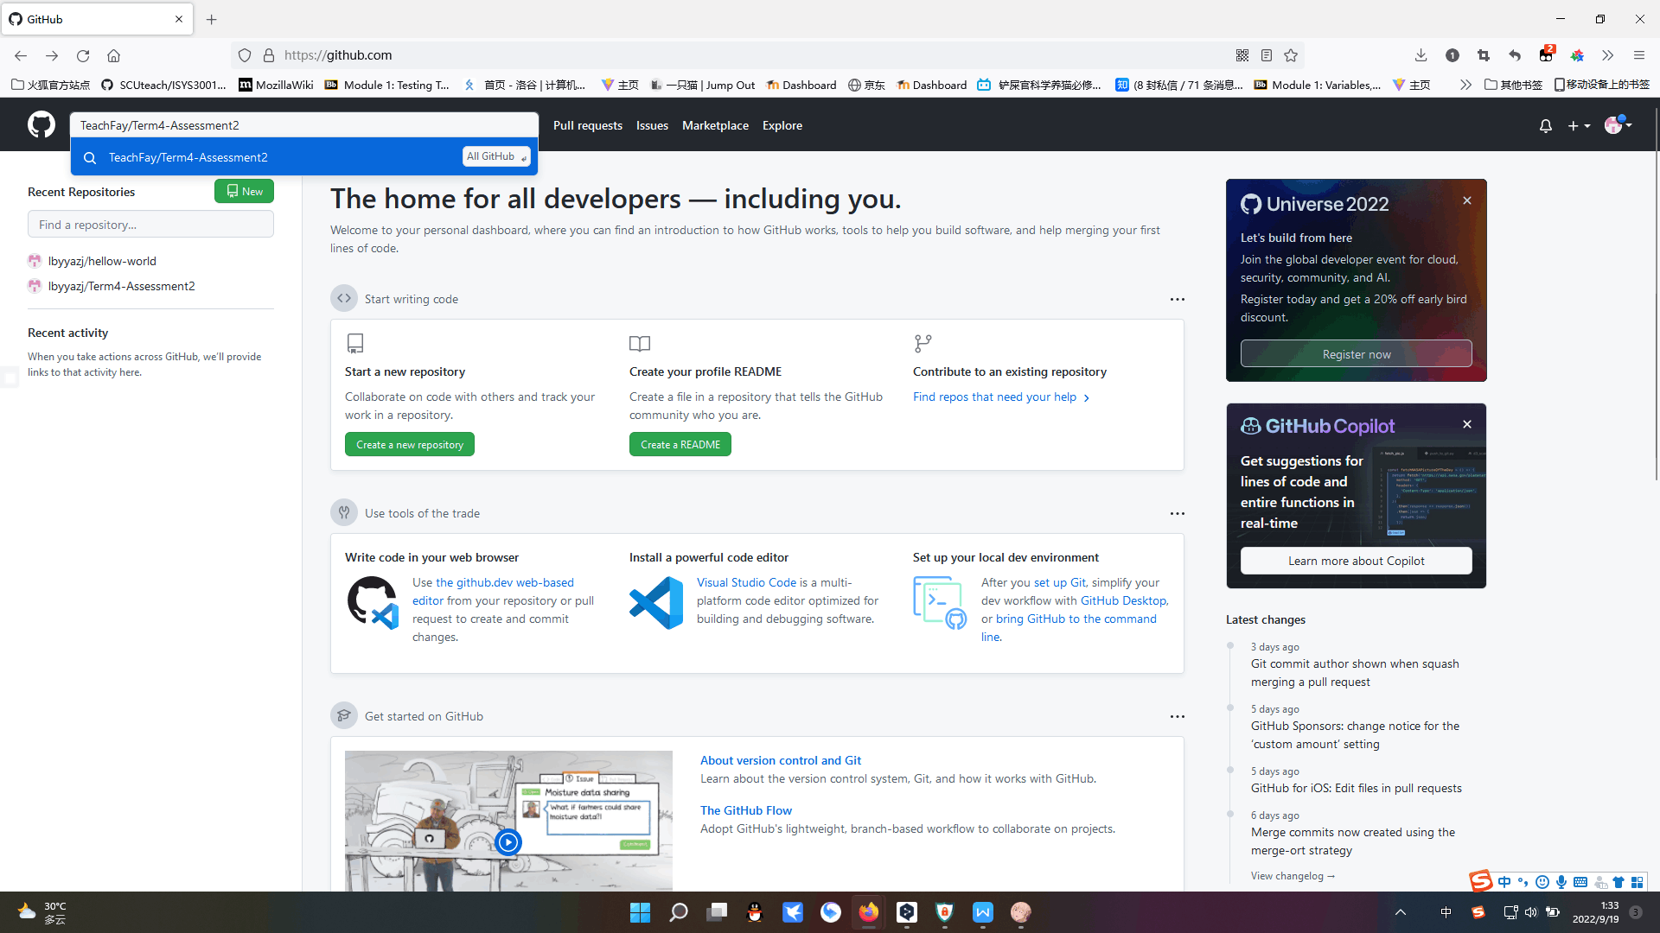

Search for TeachFay/Term4-Assessment2 in the top left hand corner of the website and open it.

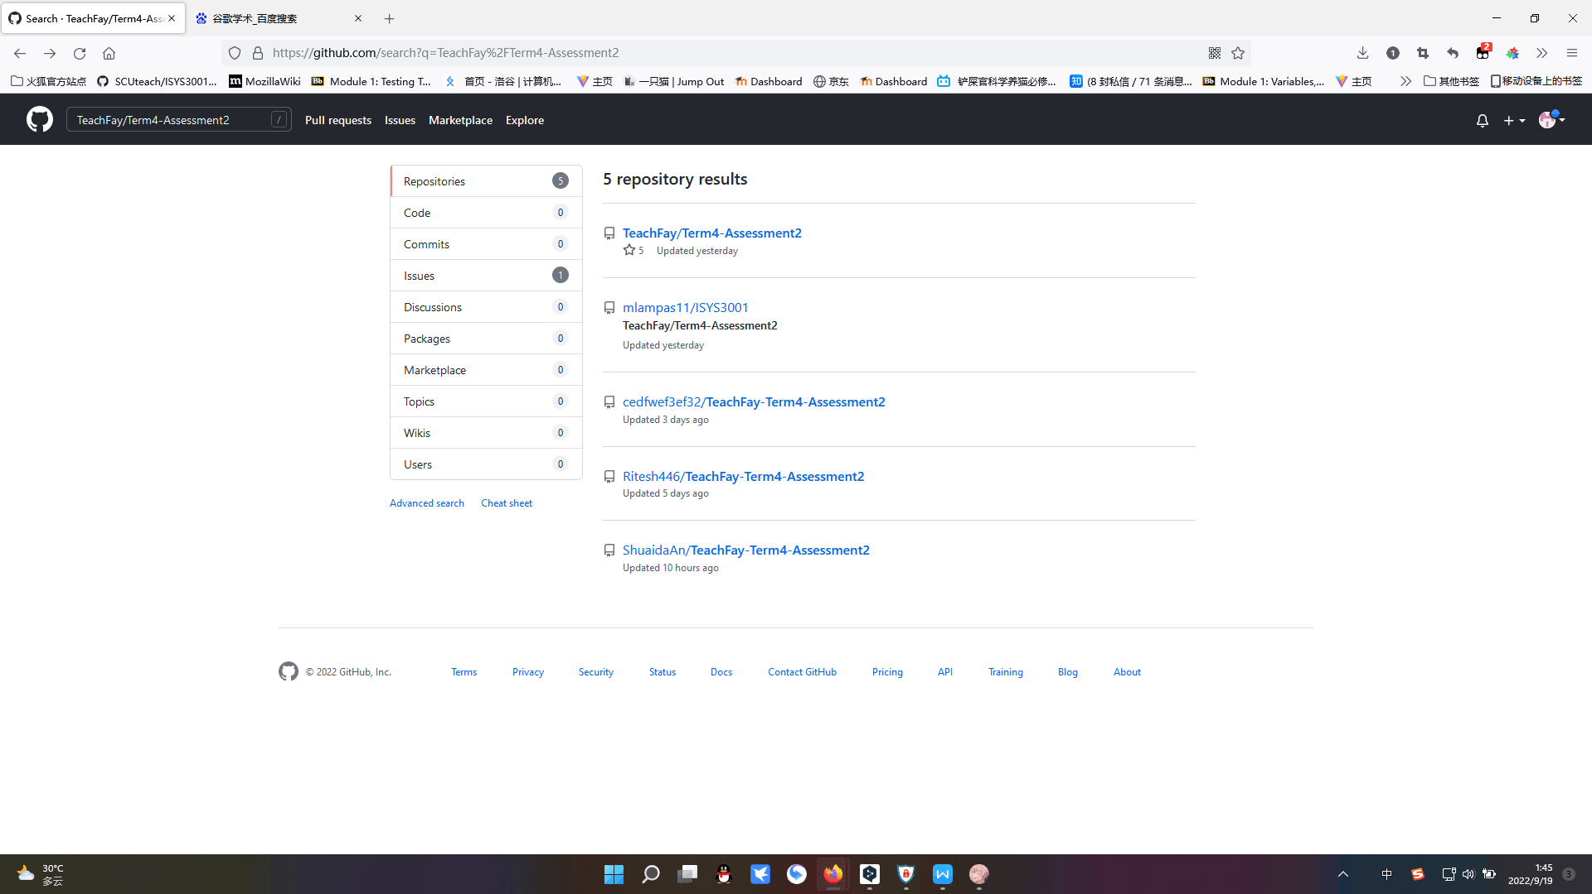

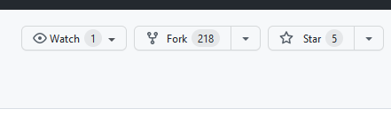

Click on the first one to enter and then click on fork in the top left corner.Click again to create your own fork.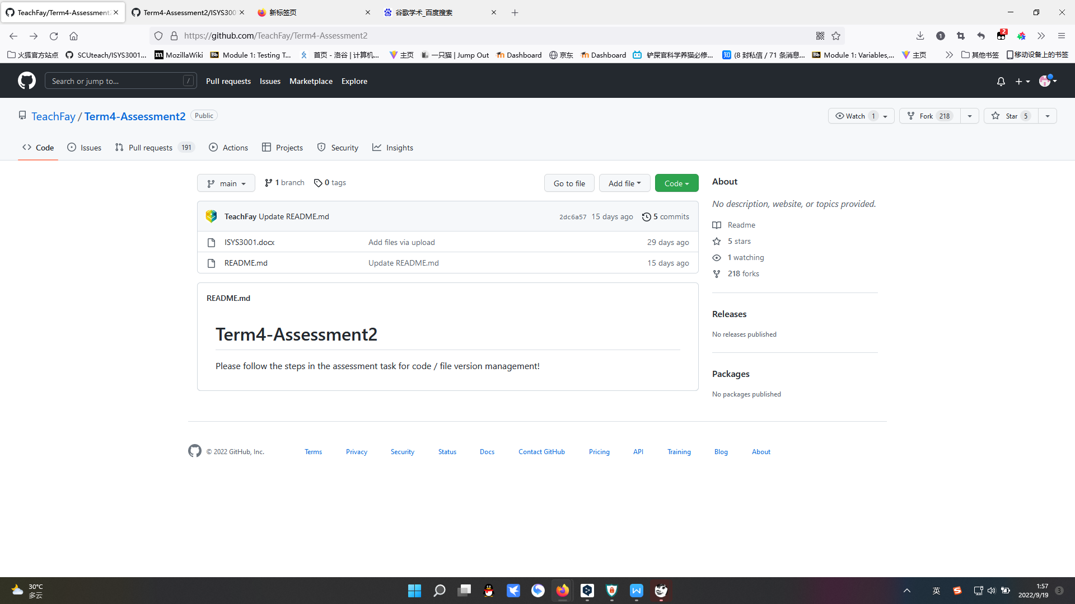

Find the fork you created and click download.

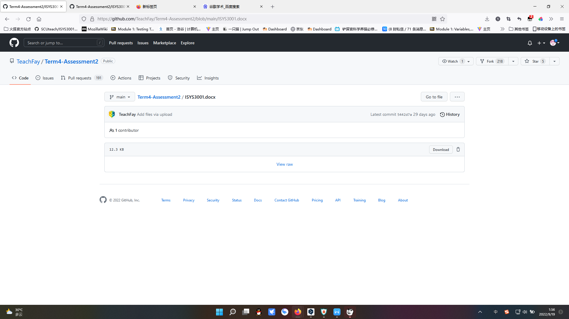

Download it and prepare the documentation.