PROG2002 – Web Development II
Assignment 3: A Complete Dynamic Website (Client-side & Admin-side)
Student ID: 24832203
Last Name: Hu
First Name: Xiang
Team members: Boyu Liu (24832407), Xiang Hu (24832203)
Title of the project: Hearts United – A Complete Dynamic Charity Events Website

Introduction / Motivation
Charity events such as gala dinners, fun runs, silent auctions and concerts are the main way local non-profit organisations raise money and awareness for their causes. In the case study used throughout this unit, members of the public must be able to view the details of these events and to register their participation by purchasing tickets as donations.
Assessment 2 produced "Hearts United": a dynamic client-side website backed by a MySQL database and a Node.js/Express REST API. Visitors could browse current and upcoming events, filter them by date, location or category, and read the story behind each cause together with its fundraising progress. That website was, however, strictly read-only – it displayed data but never accepted any.
Assessment 3 completes the system. The same case study and database are extended in two directions. First, the public can now actually register for an event and buy one or more tickets, and every event page shows who is coming. Second, the organisation’s staff receive a dedicated admin-side website, so they can create, update and delete charity events themselves, without writing SQL. A complete CRUD REST API sits between the database and the two front-ends, and the whole system is deployed to SCU cPanel so that it is reachable on the public Internet.
The project combines MySQL persistence, a Node.js and Express resource-based API, Angular 22 with TypeScript for both frontends, and the Open-Meteo weather service. Modern Angular is distinct from AngularJS 1.x; the report does not assume that it automatically qualifies for the optional AngularJS framework bonus.
Assessment 3 is a two-student group project. Work was divided between the two team members, and each member documents their own contribution in their individual video and in the confidential peer evaluation form submitted directly to the tutor.

Problem Statement
The Assessment 2 website solved discovery but not participation or management. That left five concrete problems.
- There was no registration feature. A supporter who decided to attend an event had no online way to register or buy tickets; the "Register" button was present but led nowhere.
- Staff had no way to administer events. There was no interface to add a new event, correct a detail, or remove a cancelled one, so every change had to be made by hand in MySQL.
- The organisation had no attendance record. It could not tell who was coming to an event, how many tickets had been sold, or which supporters to contact before the day.
- Duplicate registrations could not be prevented. Nothing stopped the same person from registering repeatedly for the same event, so any attendance figure would have been unreliable.
- Adding registrations requires a clear deletion rule. Once an event has registrations, its attendance records must remain intact, so the API blocks deletion and returns an explanation.
Two smaller gaps were also identified. Staff could not see suspended or past events at all, because the public API deliberately filters them out; and supporters had no information about the weather on the day of an outdoor fun run, walk or festival.

Solution
The problems are solved with a three-tier client-server application in which each tier has a single responsibility.
Data layer – the MySQL database charityevents_db, now with four related tables. The Node.js module event_db.js creates a mysql2 connection pool and is the only part of the application that talks to MySQL. Database credentials are read from a separate db-config.js file, which is excluded from the repository so that no password is ever published.
Application layer – a Node.js + Express REST API (server.js) that exposes resource-based URLs and returns JSON. Every query is parameterised, and every endpoint validates its input before a query is built. This layer is shared by both websites: neither of them contains any database code.
Presentation layer – two separate single-page applications built with Angular 22 and TypeScript: the public client-side site and the staff admin-side site. Both are served as static files and communicate with the API exclusively over HTTP using Angular’s HttpClient, which returns RxJS Observables.
Registration data flow. The Register link opens /event/:id/register. The component reads the route ID and calls GET /api/events/:id to display the selected event. When the user submits, client validation checks the required contact fields and ticket count and displays a form error if necessary. Valid data is sent to POST /api/events/:id/registrations. Express validates it again, checks that the event is available and inserts the record through a parameterised query. HTTP 201 triggers confirmation with navigation back to the event or home. Reloading the detail page retrieves the updated registrations in descending registration-date order.
Admin data flow. The dashboard calls GET /api/events/all for every event and its registration count. The edit page uses GET /api/admin/events/:id, which also includes suspended events and their registrations. Saving uses PUT /api/events/:id. Deletion uses DELETE /api/events/:id; an event with registrations returns HTTP 409 and the interface displays the reason.
Error handling is consistent across the whole system. The API answers 400 Bad Request for invalid input, 404 Not Found for an unknown or closed event, 409 Conflict for a duplicate registration or a blocked deletion, and 500 for an unexpected server error. Each Angular site subscribes to the Observable, and both the next and the error callbacks are implemented, so every response – success or failure – ends up as a visible message on the page instead of a blank screen.

Web UX
Navigation and consistency. Both websites keep the layout established in Assessment 2: a sticky menu with the current page highlighted, the same header, footer, colour scheme and card design. The client menu offers Home and Search Events; the admin menu offers Events and New Event, and it is present on every admin page as the brief requires. A first-time visitor can therefore move between pages without instructions, and a staff member always knows where the full list is.
Registration page. The selected event name, date, location and ticket price appear above labelled fields. Validation runs on submission and reports problems in the form message area. Ticket count must be a whole number from 1 to 20. Successful registration shows a confirmation and links back to the event and home. Past or suspended events do not offer an open registration flow.
Admin interface. The dashboard is a table rather than a wall of cards, because staff need to scan and compare: every event appears with its status rendered as a coloured pill (Upcoming, Past or Suspended), its date, location, category, price, fundraising figures and number of registrations. Delete requires a second confirming click to prevent accidents, and when the API refuses a deletion the exact reason is displayed in the same message area used for every other action.
Feedback, accessibility and responsiveness. Every asynchronous action shows a loading state, and an empty result shows a friendly sentence rather than a blank area. Labels are bound to all form controls, images carry alt text, result regions use aria-live so screen readers announce updates, and the colour scheme keeps a strong contrast. CSS grid and media queries collapse multi-column layouts into a single column on small screens, so both sites are usable on a phone.

Data Schema
The database charityevents_db now contains four related tables. organisations holds the charitable bodies that run the events (org_id PK, org_name, mission, description, email, phone, address, founded_year). categories holds the event types (category_id PK, category_name UNIQUE, description) and drives the search dropdown. events holds every charity event (event_id PK, event_name, event_date, end_date, location, venue, description, purpose, ticket_price, goal_amount, raised_amount, image_url, latitude, longitude, org_id FK, category_id FK, is_suspended, created_at). The new fourth table, registrations, records who is coming.

New table: registrations
Column | Type / notes
registration_id | INT AUTO_INCREMENT PRIMARY KEY
event_id | INT NOT NULL, FOREIGN KEY → events(event_id)
full_name | VARCHAR(100) NOT NULL
email | VARCHAR(100) NOT NULL
phone | VARCHAR(30) NOT NULL
ticket_count | INT NOT NULL DEFAULT 1
registration_date | TIMESTAMP NOT NULL DEFAULT CURRENT_TIMESTAMP
UNIQUE (event_id, email) | One person may register for many events, but only once per event

Relationships. events 1:N registrations – registrations.event_id references events.event_id, so a registration can never point at an event that does not exist, and deleting a parent event that still has children is prevented by the same rule. The existing relationships from Assessment 2 are unchanged: organisations 1:N events and categories 1:N events. Because there is no USER table, a person is identified by their email address, and the UNIQUE (event_id, email) constraint enforces the brief’s rule that one user may register for several events but only once for any single event. That rule is enforced by the database itself, not only by the interface, so it cannot be bypassed by calling the API directly.
Design decisions. A separate table was chosen over adding columns to events, because the number of registrations per event is unbounded and must grow over time. registration_date is generated by MySQL with DEFAULT CURRENT_TIMESTAMP rather than being sent by the browser, so the recorded time cannot be forged or arrive in the wrong timezone. ticket_count is stored on the registration rather than summed elsewhere, which lets the site show how many tickets each person bought and total them per event. Finally, the events table gained latitude and longitude so the external weather API can be queried for the event location.
Initial data. The SQL contains 3 organisations, 5 categories, 11 events and 10 registrations, meeting the required minimum of 10 registrations. Relative seed dates create a mixture of upcoming and past events when imported. charityevents_db.sql contains the complete schema and data. A second complete variant, charityevents_db_cpanel.sql, omits database creation and selection statements so it can be imported into the database selected in phpMyAdmin.

API design
The Node.js and Express API exposes eleven method-and-path combinations, covering public retrieval, administration and registration. Responses use JSON with HTTP status codes that distinguish success, validation errors, missing events and conflicting operations.

Endpoints
Method & endpoint | Purpose | Used by
GET /api/events | Current & upcoming (non-suspended) events | Client home
GET /api/events/all | Every event + registration counts | Admin list
GET /api/events/search | Filter by date, location, categoryId | Client search
GET /api/events/:id | One event + its registrations, latest first | Client detail and registration
GET /api/admin/events/:id | All statuses, including suspended, plus registrations | Admin edit
POST /api/events | Create an event | Admin new
PUT /api/events/:id | Update an event | Admin edit
DELETE /api/events/:id | Delete an event (409 if it has registrations) | Admin list
POST /api/events/:id/registrations | Create a registration | Client registration
GET /api/categories | Category list | Dropdowns
GET /api/organisations | Organisation list | Admin form

One endpoint in detail – POST /api/events/:id/registrations
Purpose. Record that a person registered for a specific event and bought a number of tickets, and remember when they did it.
Request body (JSON). full_name (required, up to 100 characters), email (required, must be a valid address), phone (required) and ticket_count (required, a whole number between 1 and 20). The registration date is deliberately not part of the body – the database sets it, so a client cannot backdate or forge it.
Processing. The id in the URL is validated as numeric, then each field is validated and all problems are collected into one error message. The event itself must exist, must not be suspended and must still be upcoming; only then is a parameterised INSERT executed against the registrations table.
Response. On success the endpoint returns 201 Created with { "message": "Registration successful.", "registration_id": 14 }. Invalid input returns 400 with the collected messages; an unknown, suspended or past event returns 404; and an email that has already registered for this same event returns 409 Conflict with "This email address has already registered for this event.", which is produced by catching MySQL error ER_DUP_ENTRY from the UNIQUE constraint rather than by a second query.
HTTP methods follow resource operations: GET retrieves data without modifying it; POST creates events or registrations; PUT updates an event at its known ID; DELETE removes an event when permitted. The unique event/email constraint means a repeated registration POST returns a conflict rather than creating a duplicate. Deleting an event with registrations also returns HTTP 409.
Security and robustness. SQL values are passed as bound parameters, reducing injection risk. Validation runs on both client and server. The public list and search exclude past and suspended events; public details exclude suspended events. Admin routes intentionally include all statuses. Authentication is outside the assessment scope, so these routes are not an access-control boundary. Errors return generic messages rather than raw database diagnostics. Database credentials remain in the private server configuration.

Admin-side website (new in A3)
List feature. GET /api/events/all provides all events with registration counts. The dashboard displays key details, status and Edit/Delete actions. Its local case-insensitive search matches name, location, category and organisation. Four sort options order by date in either direction, name, or registration count. The Raised / Goal column follows the same order as its values and displays zero fundraising amounts as $0.
New feature. The "New event" page presents a form for every column the API accepts, with the organisation and category offered as dropdowns populated from GET /api/organisations and GET /api/categories. Client-side validation checks the essential fields before anything is sent, and the Save button calls POST /api/events; on success the user is returned to the dashboard where the new event appears immediately.
Update feature. GET /api/admin/events/:id fills the shared edit form even when the event is suspended. Associated registration names, email addresses, phone numbers, ticket counts and dates are displayed below it. Dates are edited in Brisbane / AEST time with seconds preserved. Validation checks required fields, real calendar dates, end-after-start order, non-negative amounts and valid coordinate pairs before PUT /api/events/:id.
Delete feature. A Delete button on every row calls DELETE /api/events/:id after a confirming click. When the event has registrations the API returns 409 Conflict, and the dashboard shows that exact reason, for example "This event cannot be deleted because it already has 4 registration(s).", so the integrity rule is visible to the user instead of failing silently.
Navigation. Events and New Event appear in the menu on all admin pages. The create and edit pages also have a link back to the event list. Authentication is not required by the assessment brief.

External Weather API (optional extra)
To give supporters practical information about outdoor events, the event detail page calls the Open-Meteo API (https://api.open-meteo.com), which is free and needs no registration or API key. The latitude and longitude columns added to the events table exist for exactly this purpose.
The client requests daily weather code, maximum temperature and minimum temperature with timezone=Australia/Brisbane and forecast_days=16. It converts the event timestamp to its Brisbane calendar date before selecting the forecast. Weather codes are translated to readable conditions, and the card names Open-Meteo as the source. Missing coordinates and dates outside the returned forecast range show a suitable message.
If the weather request fails or the event date lies outside the returned forecast range, the weather card shows a message while the event details remain available.

Deployment
The public site, admin site and API are deployed on my SCU cPanel account at 24832203.it.scu.edu.au. The API runs as a Node.js application with server.js as the startup file. Compiled frontend files are served from public_html and public_html/admin. Both team members must maintain their own deployments; publishing repository changes does not automatically deploy them.
Both environment files now use an empty apiUrl for same-origin /api requests. Local development can instead use http://localhost:3000. The admin production build uses base href /admin/. Server routing must send API requests to Node and support direct loading of Angular routes. Each server keeps its own database credentials.
Public URLs - client: https://24832203.it.scu.edu.au/ ; admin: https://24832203.it.scu.edu.au/admin/ ; API: https://24832203.it.scu.edu.au/api/events
GitHub repository: https://github.com/lbyyy139/PROG2002-A3-Charity-Events

Screenshots
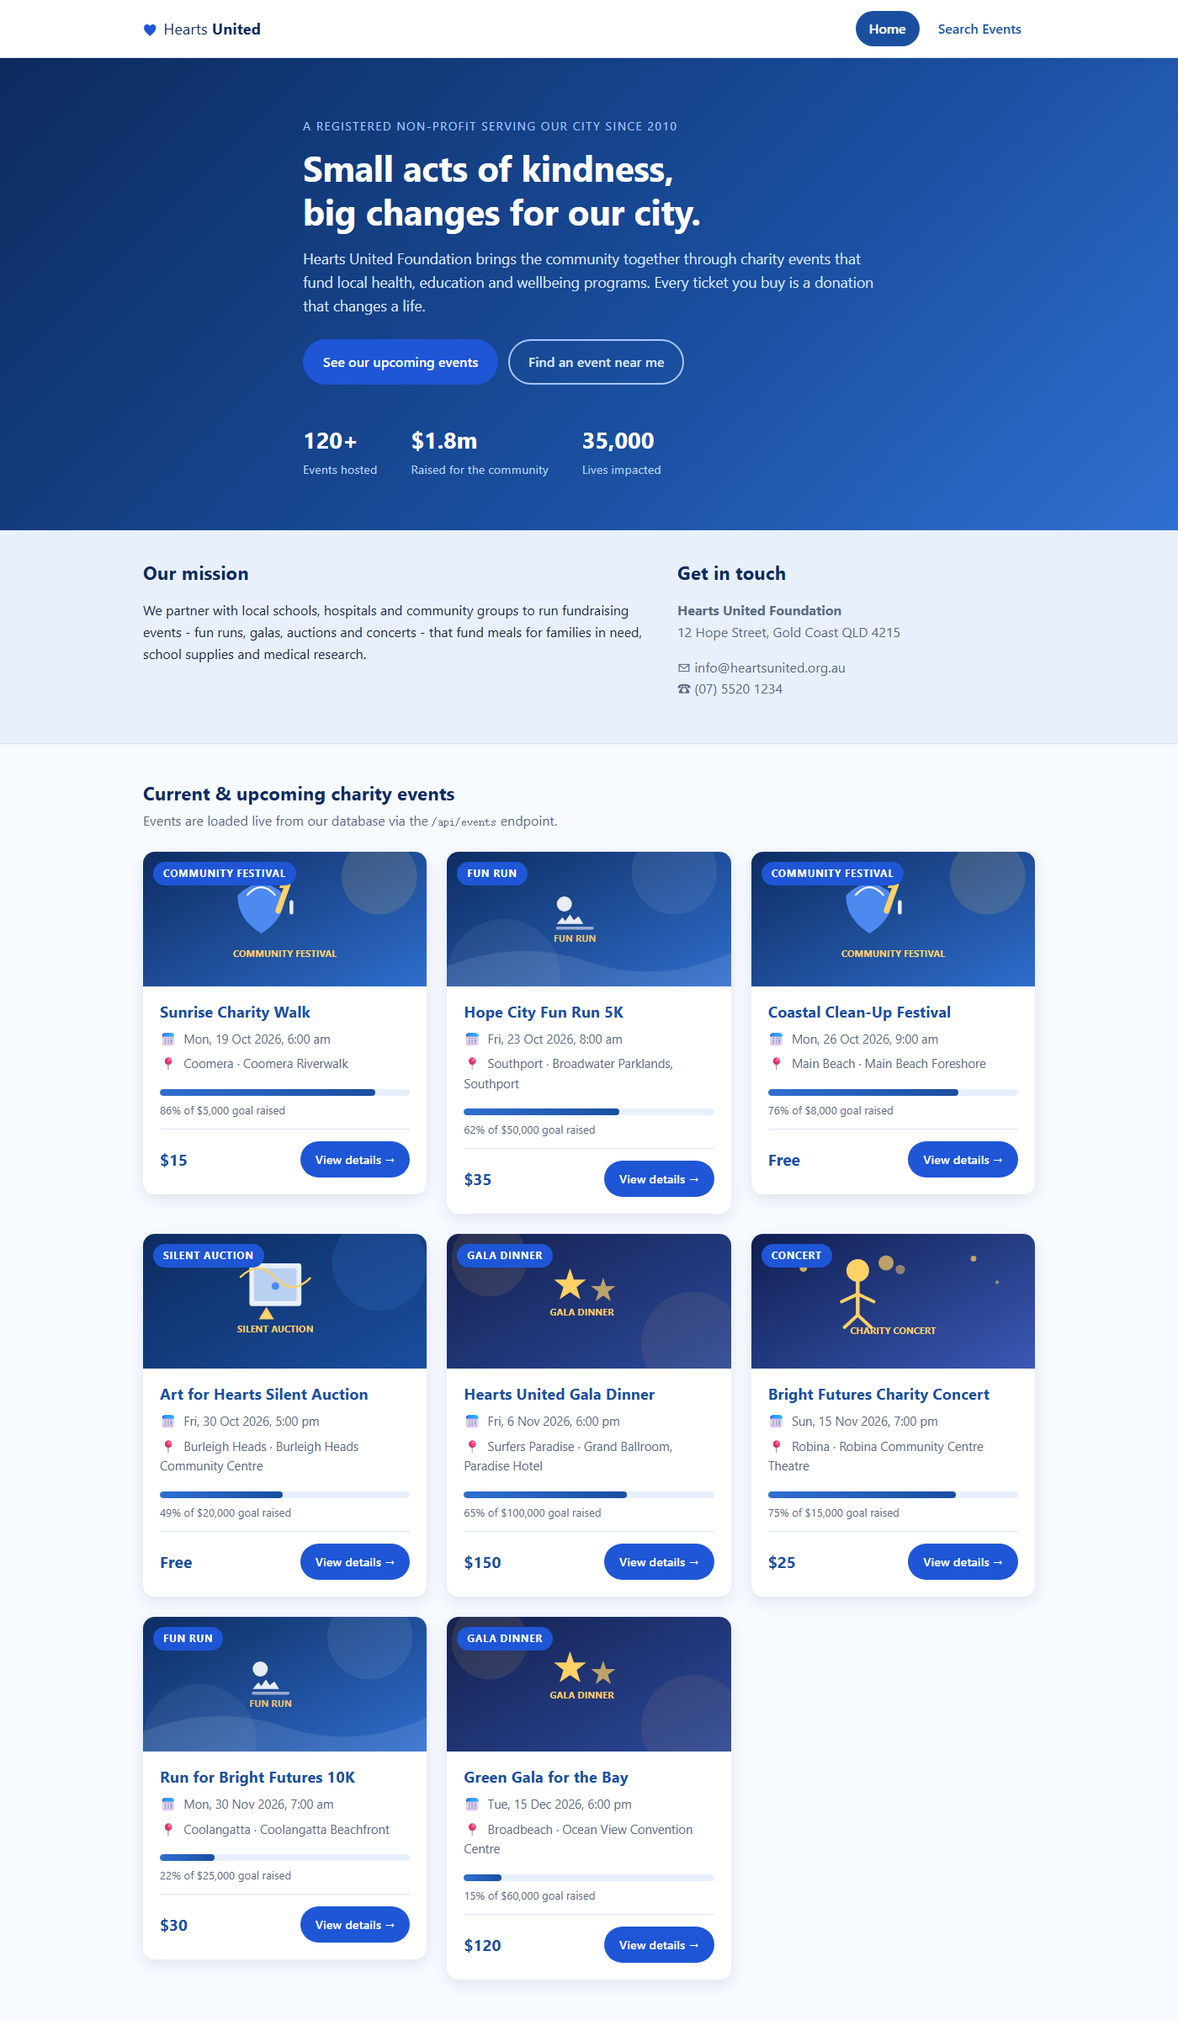
Figure 1: Client home page – hero, mission and the current/upcoming events loaded from GET /api/events.
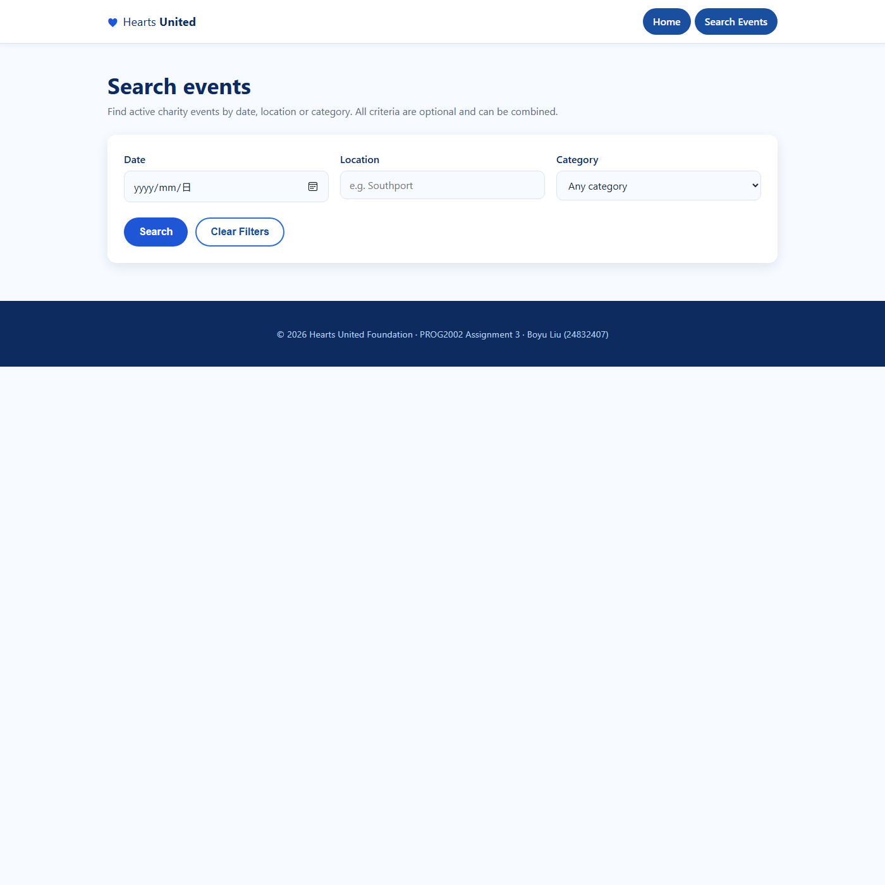
Figure 2: Client search page – date, location and category filters; the category dropdown is populated from GET /api/categories.
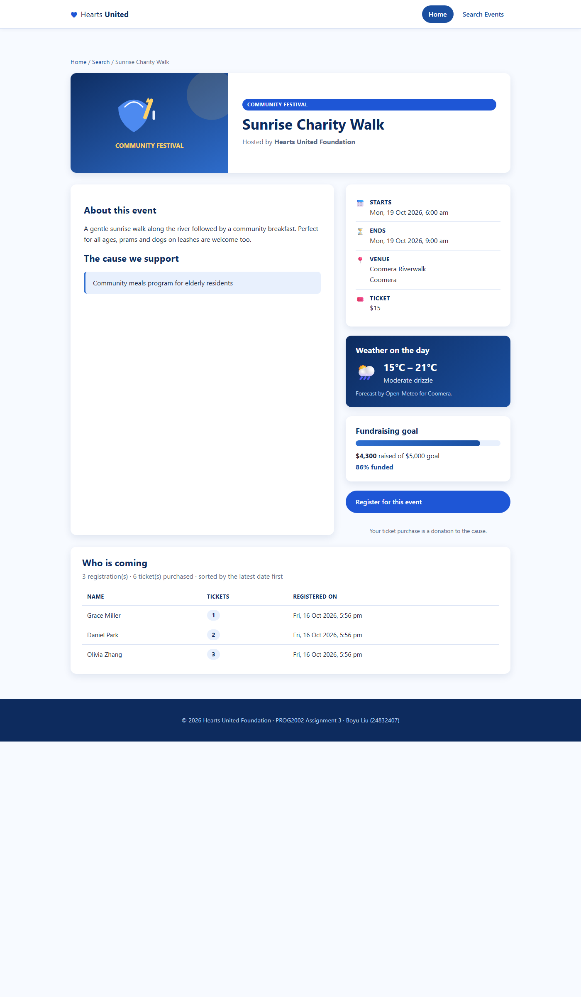
Figure 3: Event detail page – event data, the Open-Meteo weather forecast for the event day, the fundraising progress, the Register button and the registration list ("Who is coming") sorted by the latest date first.
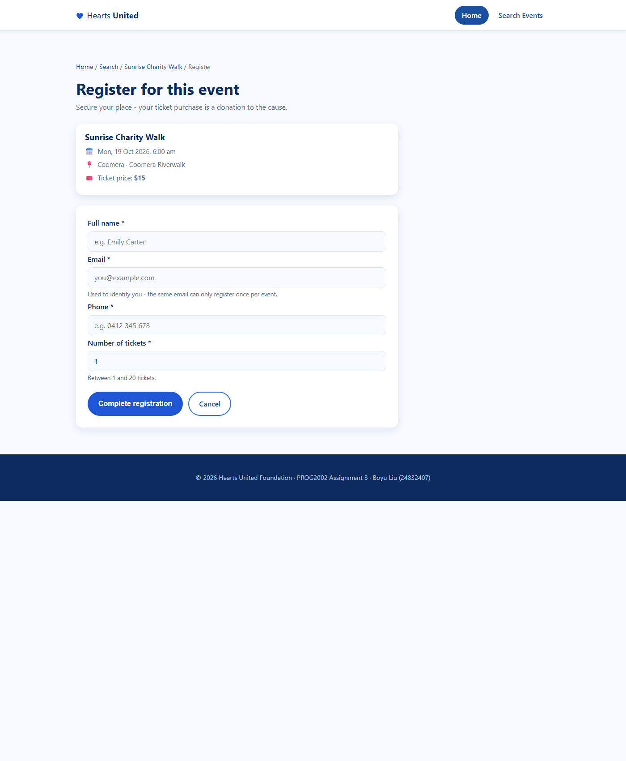
Figure 4: Registration page – the selected event is summarised on top and the form collects name, email, phone and the number of tickets.
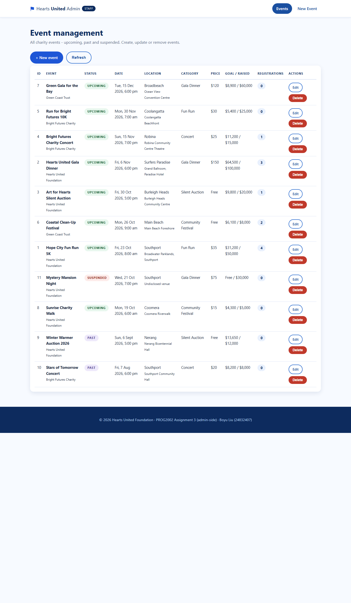
Figure 5: Admin list – every event regardless of status (Upcoming / Past / Suspended) with registration counts and Edit / Delete actions.
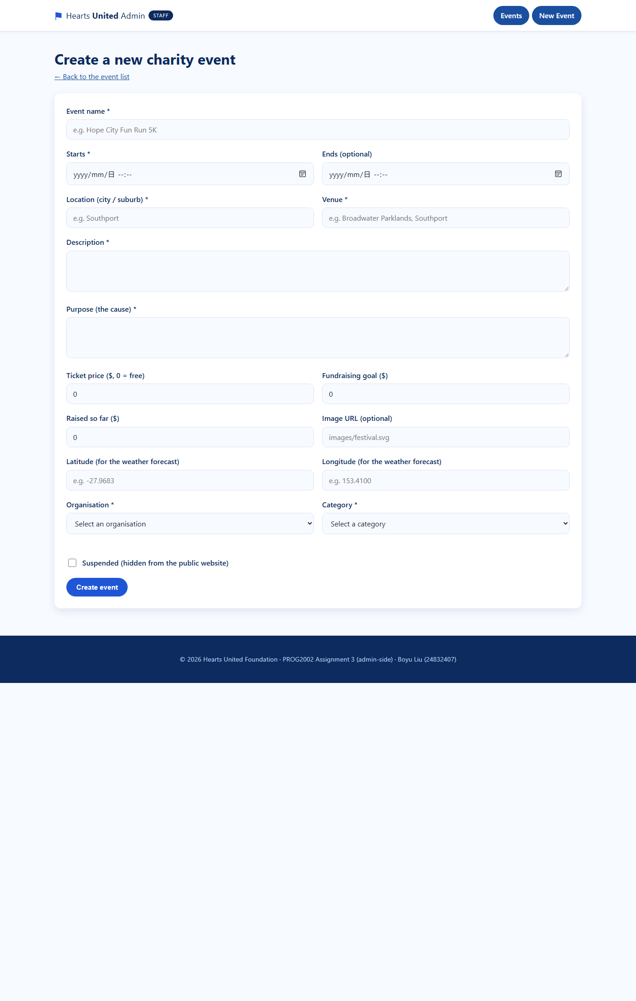
Figure 6: Admin "New event" form – validation ensures the essential fields are filled before POST /api/events is called.
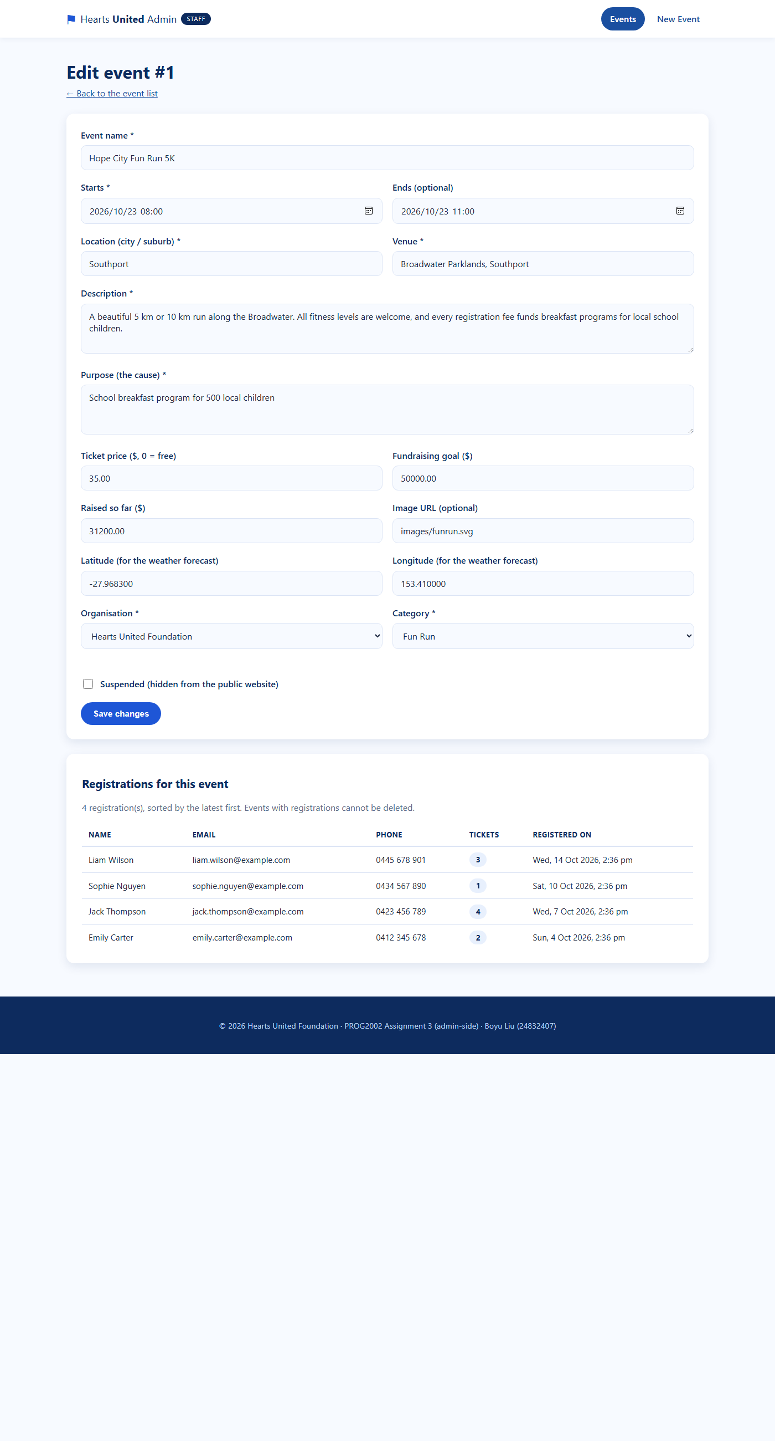
Figure 7: Admin edit form and associated registration list. The current implementation loads this form using GET /api/admin/events/:id, including suspended events.
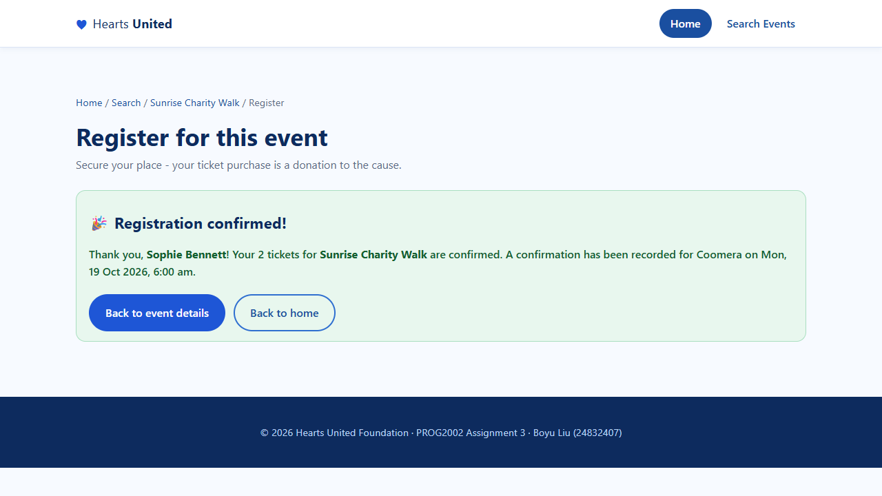
Figure 8: Registration confirmation — the API response confirms Sophie Bennett’s two tickets for the Sunrise Charity Walk, with navigation back to the event and to the home page.
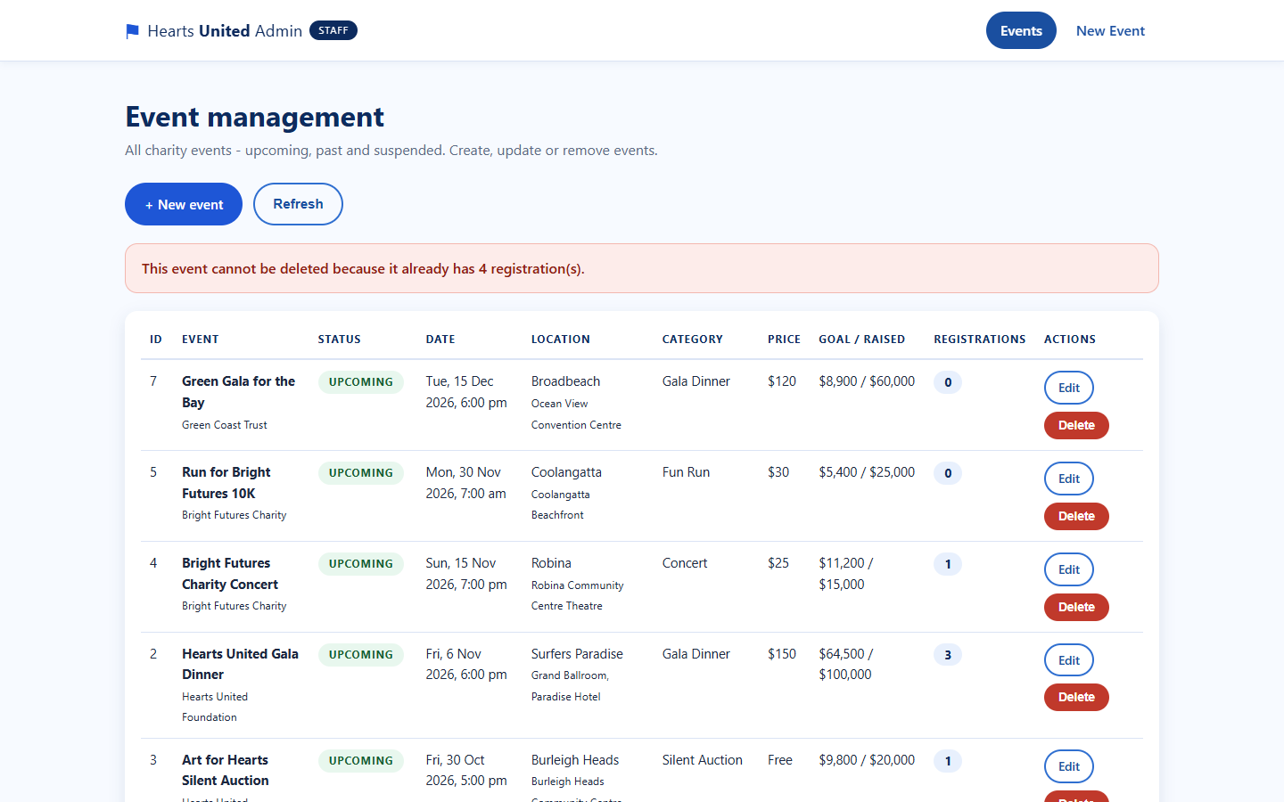
Figure 9: Blocked deletion — the dashboard calls DELETE /api/events/:id, the API answers 409 Conflict because the event still has registrations, and the reason is shown to the staff member.

Individual contribution
My assigned part of the group project is the admin-side website and its documentation, as recorded in TEAM-CONTRIBUTIONS.md. This includes the dashboard, search and sorting, the create and edit pages, the shared event form and the API service used by those pages.
My deployment work covers my own SCU cPanel database import, Node application configuration and frontend deployment. The shared source also includes corrections for suspended-event editing, input validation, Brisbane date handling and clear error feedback.
For quality assurance, the repository contains an admin architecture document, a manual integration checklist and 22 automated regression cases. The regression cases exercise API and validation logic with database substitutes; they do not prove real MySQL writes. The latest review also checked live read-only pages, API responses, weather, and empty-form validation.
Both frontend production builds were checked during preparation. Final manual integration testing should still cover successful registration, duplicate rejection, creation and update, unchanged-date preservation, and permitted or blocked deletion. My teammate Boyu Liu is responsible for the database, public website and main API implementation described in the team contribution document.

