**1. Design**

**Data model (features) :**

This model is mainly for displaying Best Restaurants in the particular locality of user. In this model, User in particular city provides his/her present location. The User then searches for the available best restaurants in his place. Here, the best restaurant information available of that particular locality is displayed based on the survey given by both government and by the people who went to that restaurants. So, based on that, the total information of the restaurant gets displayed. If the user likes to visit that restaurant, then the direction service to that restaurant is shown from his present location. If he likes to know the all other available restaurants then the map of all those restaurants present in that location is displayed in map.

**Predictive/recommendation model and algorithm :**

a) Recommendation algorithm: Here it recommends the Restaurants based on survey results

**Selection of datasets :**

a) <http://ratings.food.gov.uk/OpenDataFiles/FHRS112en-GB.xml>

b) data.gov.uk

**Mobile App/Web design :**

a) Mobile application using JQuery

**2. Features Implemented**

**Integration algorithms :**

a) Converting XML file to JSON data(JAVA)

b) Converting output result of recommender to JSON format(JAVA)

**Predictive algorithms:**

a) Recommender algorithm

**Solr indexing: Your own data services**

a) solr web service

**Reference**:https://blackboard.umkc.edu/webapps/portal/frameset.jsp?tab_tab_group_id=_241_1&url=%2Fwebapps%2Fblackboard%2Fexecute%2Flauncher%3Ftype%3DCourse%26id%3D_95483_1%26url%3D

**Software Services**

**1. Existing services/APIs :**

a) Google map API

**Mobile User Interface**

a) JSfiddle (JQuery 1.9.1)

**1. Your own design** :

This design is mainly for displaying Best Restaurants in the particular locality of user

**2. Outputs**:

a)

Initially I will convert my Data set which is in XML format to JSON format.

The Json format will be easy to push in the solr.

This java code will do this.

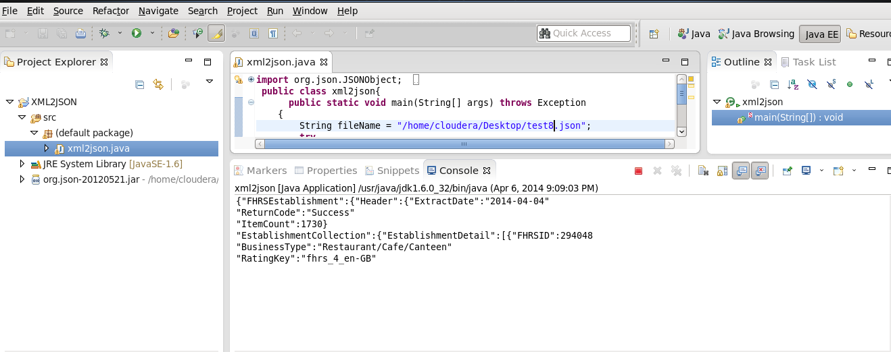

b) Next we will apply our Recommender algorithm to the Data set which we converted to JSON.

Here first we need to place our data sets to data folder in Mahout empty project we created initially

Compile the project as

* MVN compile

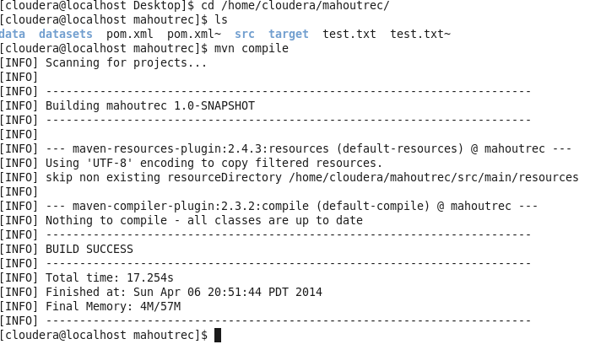

c) Execute the maven project as

> mvn exec:java –Dexec.mainclass=”com.unresyst.Restaurantrecommend”

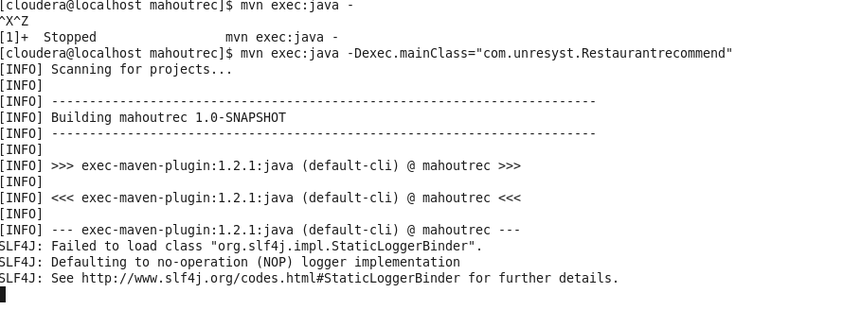

d) Output will get displayed with recommendations to the users

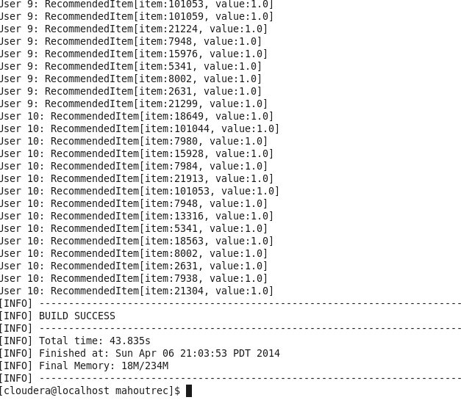

e) The output Result from the recommender is saved in text file.

We need to convert the text to JSOn format

This is achieved by the below java code.

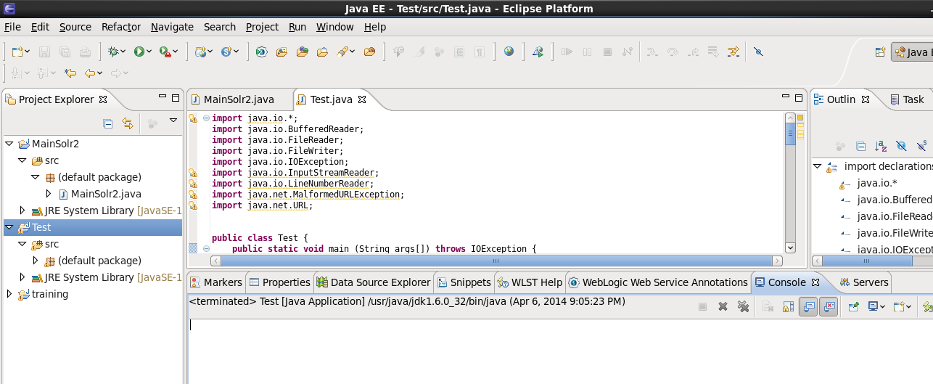

f) Now we need to push our Data and out put to solr as below.





g) We need to develop a mobile app to retrieve and analyze the data.

Develop mobile app as below.

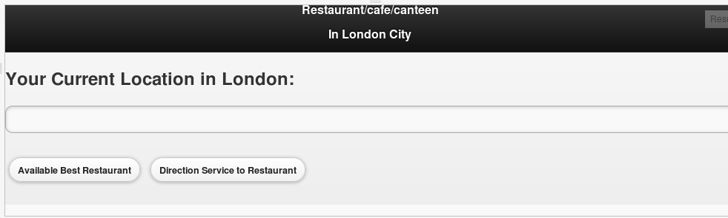

h) Enter the Location you want to search for the available best restaurant near to that location.

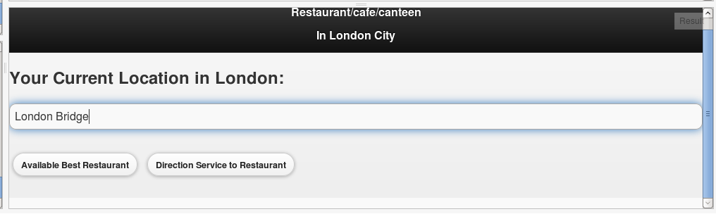

I) when you click on the Available best restaurant button,

Click Survey results button in next page.

Here the complete address of the best restaurant along with the information of Government survey and User survey result.

So based on this address and Survey results, User decides to go for the restaurant.

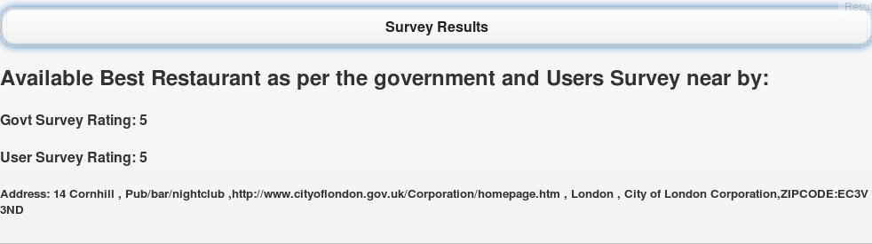

k) If he wants other available restaurants present in that locality, it will be displayed in map.

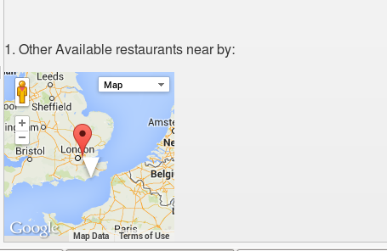

l) if user decides to go to restaurant, he can get the direction on clicking below button

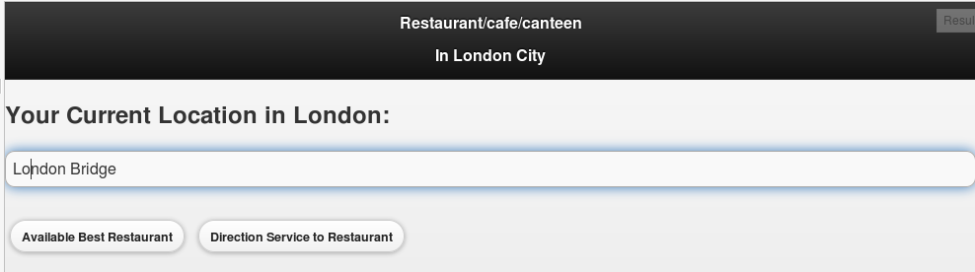

m) The current location is initially displayed,

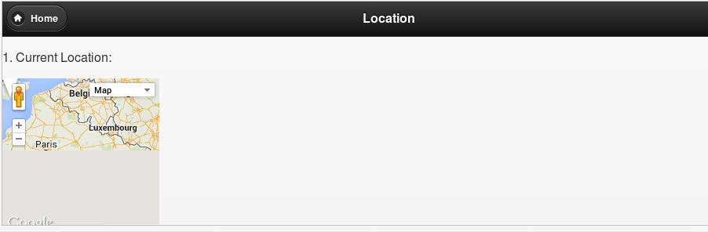

N) Next, the user gets his directions to the restaurant he chooses

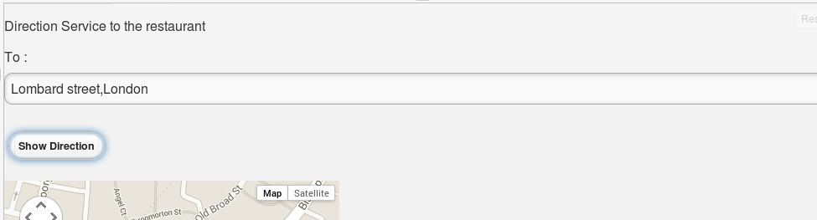

O) direction service is as below.

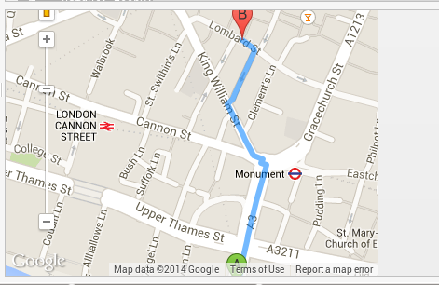

5. Your midterm Github URL :

6. Limitations :

a) Finding difficulty to display other available restaurants in the map.

b) The User survey is not getting displayed as per the recommendations provided by other users.

7. References

<http://lucene.472066.n3.nabble.com/how-to-make-getJson-parameter-dynamic-td3014941.html>

<http://stackoverflow.com/questions/4919403/javascript-compare-strings-without-being-case-sensitive>

<http://data.gov.uk/>