**Lab-2 Assignment: Mobile Client App using Web app Technologies**

**Name: Bathina L V Sandeep**

**Id: 16174348**

1) <http://jsfiddle.net/lbzv9/FrvLV/24/>

Link for the JsFiddle Lab2 Assignment

2)

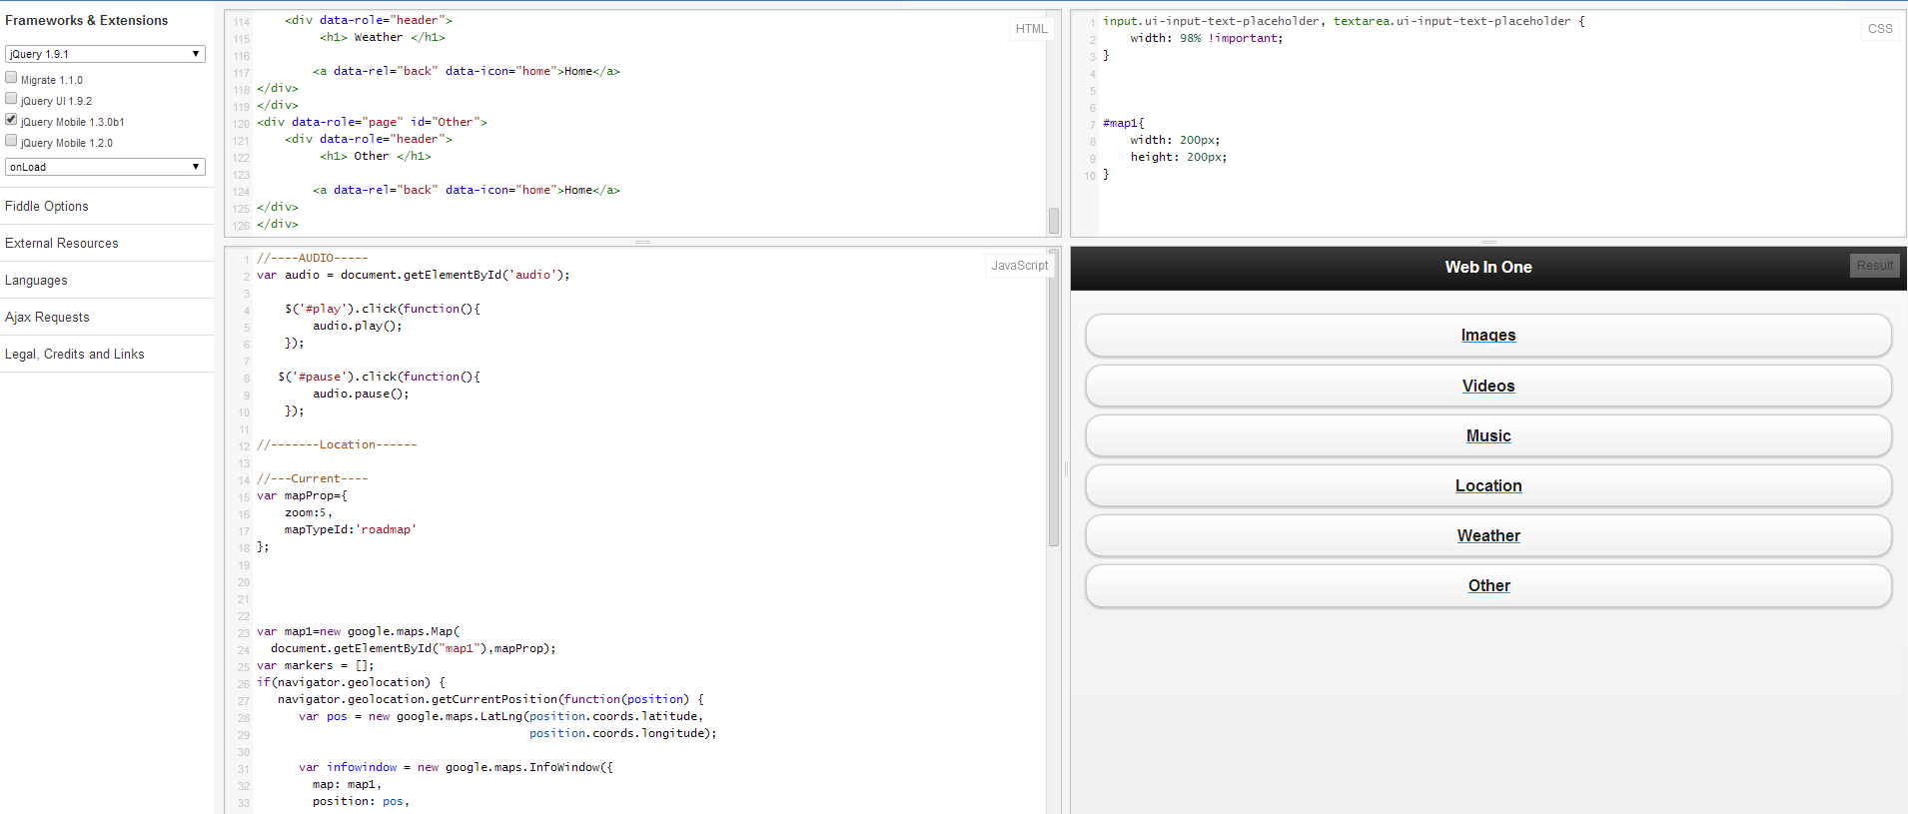

3)

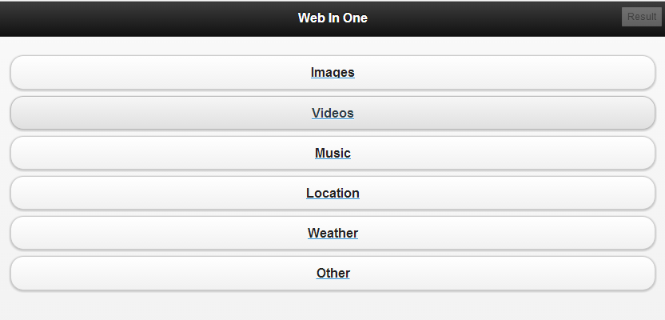

GUI for the LAB 2 Assignment

4)

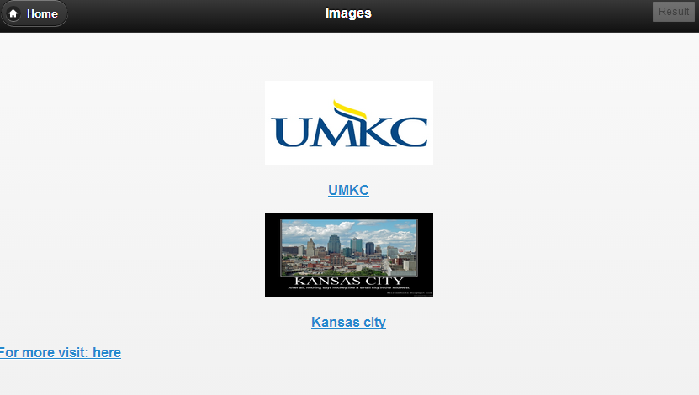

When we click Images button, the result shown is above

5)

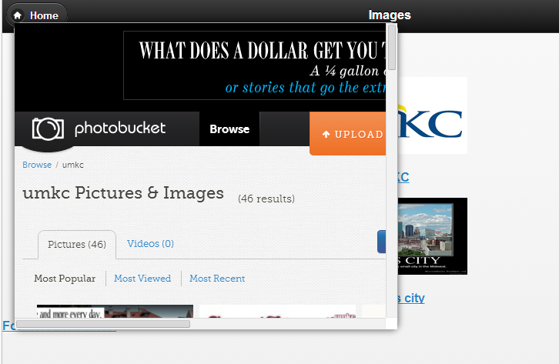

when we click UMKC image link, an iframe window with UMKC images gets displayed

6)

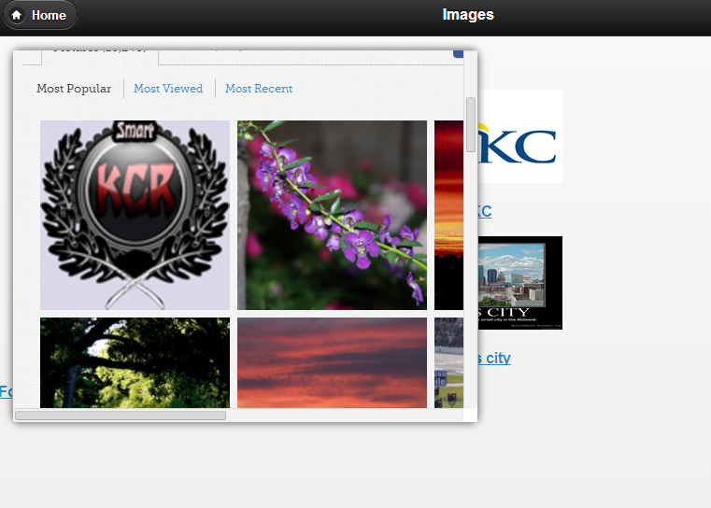

When we click Kansas city Image link, Kansas city images gets displayed in Iframe

7)

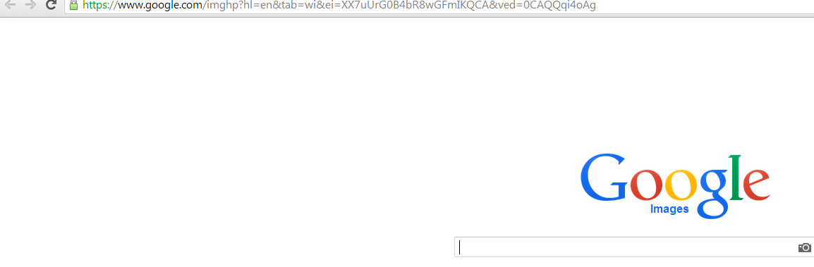

when we click here for more images, google images search engine gets displayed.

8)

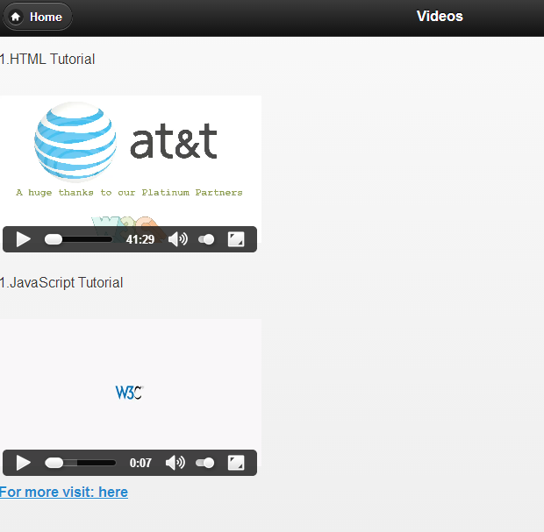

When we click Videos button, the above videos gets displayed.

9)

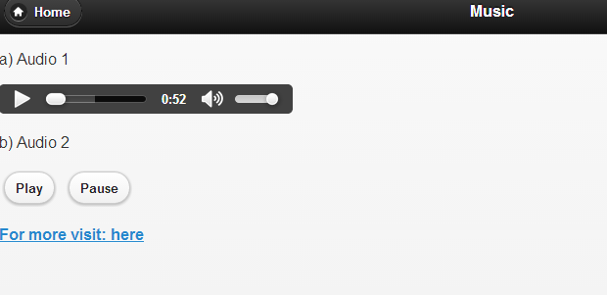

When we click Audio button, the above audios gets displayed

10)

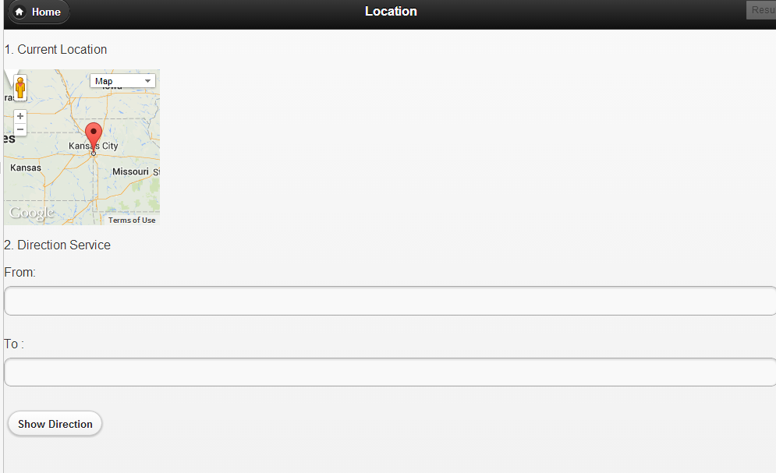

When we click Location button, Our current Location Map gets displayed.

11)

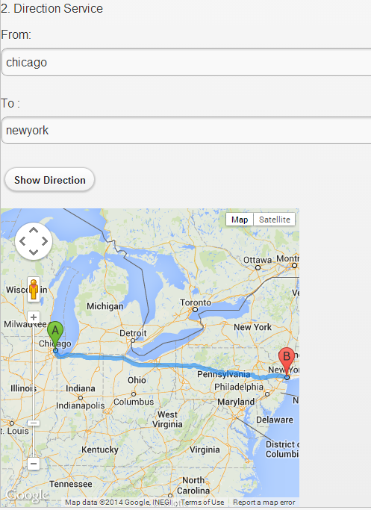

When we enter places in text fields and click show directions, The above roadmap gets displayed.

References:

<http://www.w3schools.com/html/default.asp>

<http://api.jquery.com/val/>

<http://stackoverflow.com/questions/17821977/google-map-not-displaying-correctly-after-adding-a-jquery-mobile-panel>

<http://www.w3schools.com/jquery/jquery_examples.asp>