logoFCT_horiz.pdf

**Interacção Pessoa-Máquina**

**2018/2019**

**Smarter Hub**

­­

Stage 4: Computer Prototype

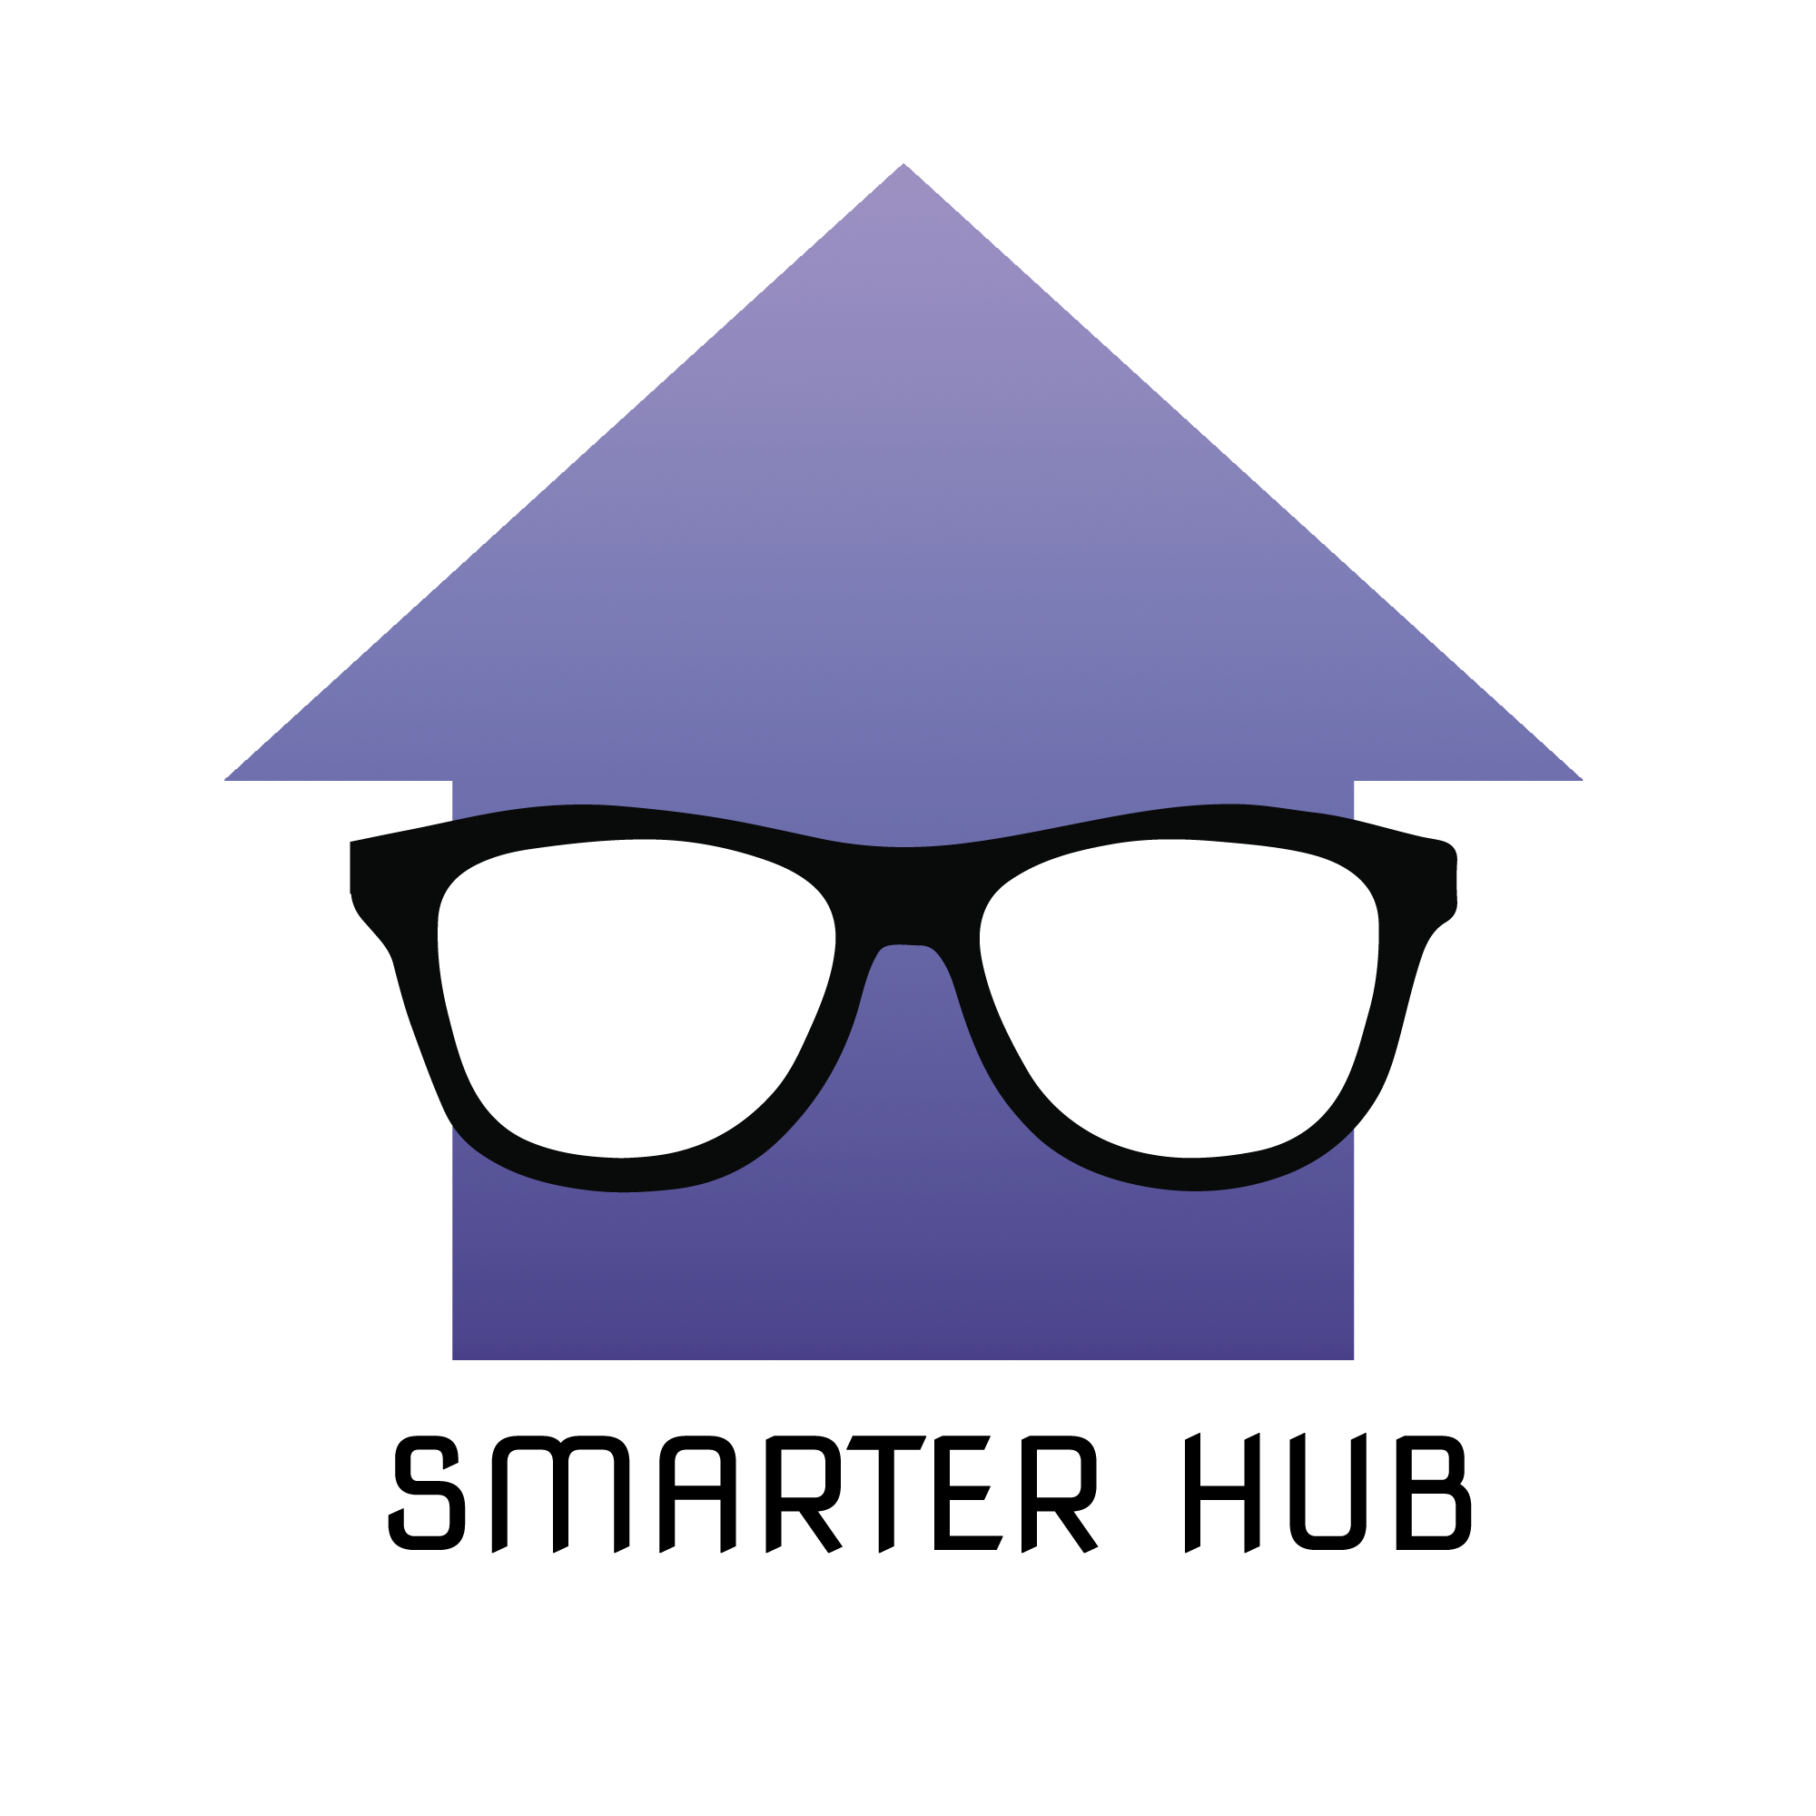

**Made by: Lab class Nº** P1

49544, Nuno Morais

47592, Marta Carlos **Professor:**

47651, Leonardo Correia Teresa Romão

47554, Jorge Alves

November 20, 2018

**Platform**

Given that Smarter Hub is a Web Application, the tools used during the development process of Smarter Hub varied from text editors, like SublimeText or Atom, to full-fledged IDEs, such as WebStorm.

Git was used to provide Version Control, GitHub being the repository host. In order to **XXXXXXXX** the usage of Git, we used desktop applications such as GitKraken and GitHub Desktop. These desktop applications provide visual representations of the repository status (branch control, merge conflicts) and conflict resolution tools.

**Usage Instructions**

To test the developed computer prototype, the user needs to access the URL below:

<https://happytogit.github.io/SmarterHome/index.html>

**Considerations:**

To enjoy Smarter Hub’s full potential, we recommend either using Google Chrome or Opera as your browser, in full screen mode (with 1920x1080 resolution), although it can be used in any resolution and mobile (with some loss of **X**XXXXXX).

The test user should be aware that this is still a prototype, therefore some problems may arise when testing Smarter Hub. These problems may appear when double clicking on the house blueprint and refreshing the page (we recommend clearing browser/page cache when refreshing to minimize errors).

A user database is not implemented, consequently Register and Sign In options are mere placeholders and will only work for the specified scenarios (explained in Task and Scenarios section), which means user data is not preserved across sessions.

To help the user map their house blueprint, a snapping feature was implemented. This feature works flawlessly when detecting collisions between two elements/objects. Although, functional, the user may encounter some difficulties when trying to snap three or more elements together.

**Briefing**

Many times, you’re in a rush to get somewhere and to just leave the house, but there’s still so many devices to turn off and to deal with in many divisions of said house. Or, even worse, you just left the house and realized the stove was on.

Many problems that derive from these types of situations can be called simple and mundane problems, but everyone has had the misfortune to deal with them and lost their precious time on them (and we all know time is money).

When all the devices are starting to become smart devices, our project envisions to solve this type of problems with the help of this new arriving technology. The main focus of this project is to help its' user have all their smart devices' information stored in only one website and be able to control them with just a few clicks.

The user will be able to map their house's blueprint to the system, place and control all their smart devices (according to the house's rooms).

**Tasks and Scenarios**

The test users were given certain scenarios to follow and each scenario aimed to describe possible tasks a future user of Smarter Hub would have to do. Further, we'll describe the scenarios provided to the test users and what tasks each scenario aims to describe.

**Scenario 1:**

**The Name’s House. Smarter House.**

Zachary just bought a new house and wants to buy a few appliances. After returning from the electronics shop Zac entered the Smarter House website and registers his account.

Not only is he a new user, he also doesn’t have any registered rooms (which are needed to register the appliances). To solve this issue Zac started by registering the rooms he has the appliances he wants to control in: his kitchen and living room. The home devices he wishes to control are specifically his television and fridge.

Once completed the register process, he wanted to test the system’s settings, so he decided to change the channel on his TV. Consequently, at the end of the test, the TV had its channel changed from SIC (channel 3) to TVI (channel 4).

**Tasks involved**:

1. Register user: register the user in the system so they can register their house’s blueprint, rooms and smart devices
2. Register house room: personalize the user’s interface according to their house’s blueprint
3. Register house device: personalize the user’s interface according to the devices present in each room
4. Execute device's action: a user chooses a device to control and alters its' state (depending on the device)

**Scenario 2:**

**Give John a break (give him a kitkat)**

John, who had such a lovely coffee machine, is now devastated because the machine came with manufacturing defects. Frustrated, John refuses to buy from that brand ever again and decides to go for the competition. John needs to delete the disappointing machine from Smarter Hub’s system and add the competition’s machine. Now, John can start doing his coffee while he takes his morning shower without putting a foot in the kitchen.

**Tasks involved:**

1. Delete device: personalize the user's interface by deleting a device
2. Execute device's action: a user chooses a device to control and alters its' state (depending on the device)

**Scenario 3:**

**Maria’s husband just wants to watch the game**

Maria is in her office and her husband asks her to turn on the living room’s TV since he doesn’t know where he put the remote and he just can’t miss the new Benfica game. Maria accesses the website, turns on the TV through the website and changes the channel to “Benfica TV” (channel 19).

**Tasks involved:**

1. Execute device’s action: a user chooses a device to control and alters its' state (depending on the device)

**Prototype Status**

Due to time restrictions, some features could not be implemented, like the resizing of rooms in the house blueprint. The idea behind the house blueprint was to provide an intuitive mapping, so providing the user the option to resize the rooms would benefit user experience immensely.

To keep this prototype’s high fidelity in look and feel, user sessions/state were not considered a priority, thus not carried out. It has only medium fidelity in breadth, only supporting user registering and sign for the specified scenarios.

As mentioned before, the snapping feature has known problems that would need to be fixed in the future, this could come by further polishing the feature or resort to a different implementation: snapping to a grid.

The alignment of devices in adjacent rooms (e.g. doors) is only achievable by trial and error. One last feature that could be considered is seeing adjacent rooms (and their devices) when a room is expanded (in focus).

**Tools**

To implement some of the features available in Smarter Hub, the following libraries/frameworks were used:

* **p5 API:** <https://p5js.org>, used for displaying the house blueprint (floors, rooms and devices) as well as the interactions between them (like snapping, expanding and minimizing rooms, etc);
* **Bootstrap template:** Tangre template by Colorlib, <https://colorlib.com/wp/template/tangre/>
* **W3School:** small implementation tutorials (like a toggle switch)
* **Device icons:** property of [Cursor Creative](www.flaticon.com/authors/cursor-creative) from [flaticon](www.flaticon.com).
* **‘Change floor’ icons:** taken from <https://fontawesome.com>