Environment:
Python version: Python 3.13.0
IDE: PyCharm 2024.1
Libraries: Scapy, Threading, queue, PyQt5, sys, time

Core code:
- Try to receive and analyze the input IP address. If there is an IP address with mask, all the host addresses belong to the network will be stored in a list. A network address with mask is also acceptable.
- Use ARP, ICMP and TCP protocol to build different kinds of packets, the details are present blow:
Packet type | Parameters | Expect to receive
ARP ping | dst MAX=ff.ff.ff.ff.ff.ff | ARP reply
ICMP ping request | Type=8, code=0 (Optional Type is 13,15 and 17) | ICMP ping reply (type=0,code=0)
UDP PING | Port=41025(Users can change it) | UDP destination unreachable (Type=3)
TCP SYN PING | Port=443 | TCP packet with syn, ack flag
TCP ACK PING | Port=80 | TCP packet with rst flag
- Make 20 threads to accelerate the packet sending rate. The program is able to send 20 packets simultaneously.
- Design an interface by using Pyqt5.

Interface:
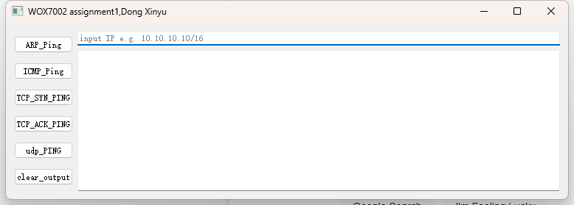

Example1: use tcp_ack_ping to find devices
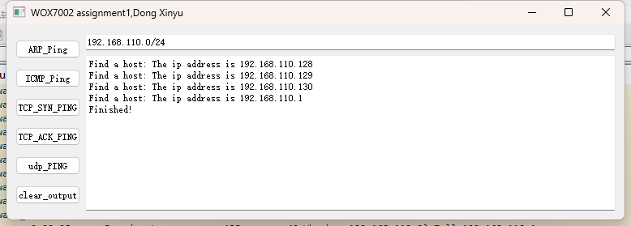
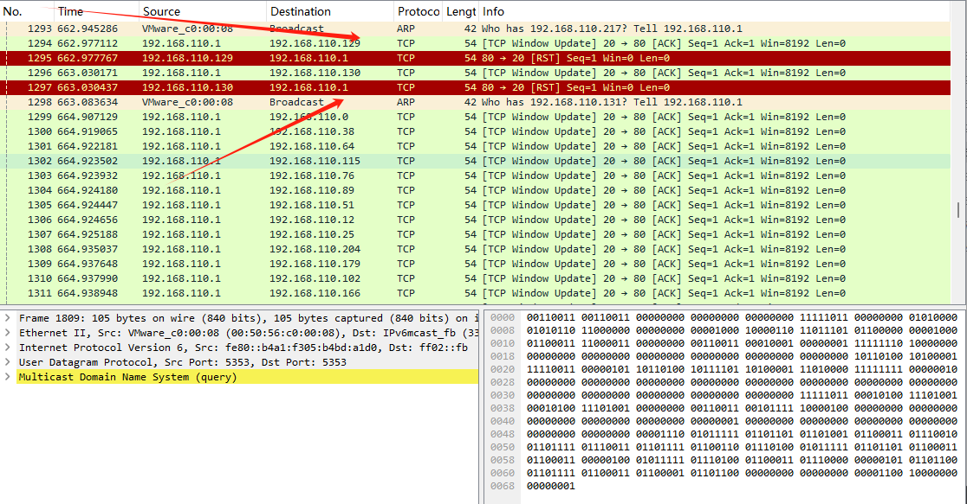

Example2: use udp_ping to find devices
