Convolutions Practice

- What values are produced by the convolution below?

Image Convolution matrix Result
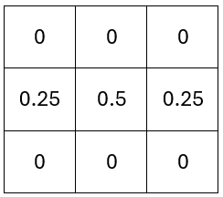
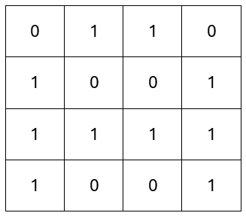
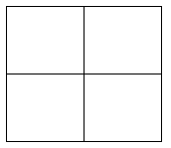

Can you suggest a name for this filter? ………………………………………………………………..

- What values are produced by the convolution below?

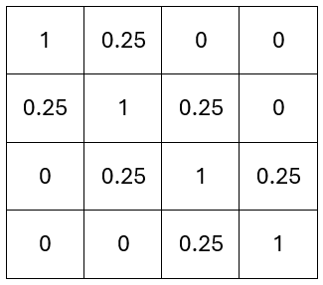
Image Convolution matrix Result

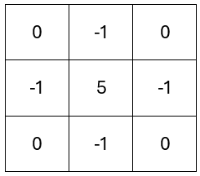

Can you suggest a name for this filter? ………………………………………………………………..

- Can you suggest a convolution matrix for the following filters?


Darken an image Detect horizontal lines

