Rasterising circles
- To count the number of pixels in a circle:

  - Add the line count = 0 at the start of the program.
  - Add the line count += 1 after the line which says plot(x, y)
You need to make sure it is indented from the left the same amount.
  - Add the line print(count) at the very end of your program.
Make sure you choose the text display to see the printed answer.

- Put your data into this table:

Radius | Number Of Pixels | Ideal Area | Percentage Error
3
3.5
4
4.5
5
5.5
6
7
8
9

- Plot a graph of your data on this grid:
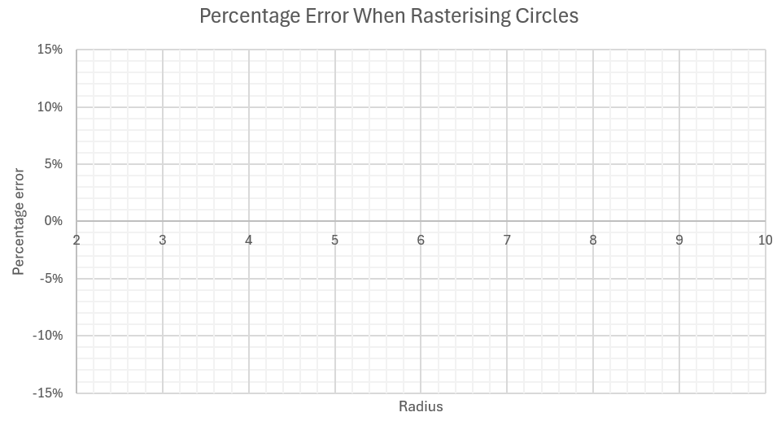

- What happens as the radius increases? Can you explain why?

……………………………………………………………………………………………………………………
……………………………………………………………………………………………………………………
……………………………………………………………………………………………………………………
……………………………………………………………………………………………………………………
……………………………………………………………………………………………………………………
……………………………………………………………………………………………………………………

- What other patterns do you notice? Can you explain why?

……………………………………………………………………………………………………………………
……………………………………………………………………………………………………………………
……………………………………………………………………………………………………………………
……………………………………………………………………………………………………………………
……………………………………………………………………………………………………………………
……………………………………………………………………………………………………………………

