**2. Create Results**

Containing

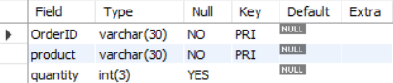

Customer

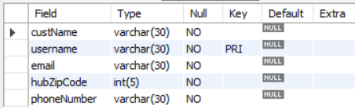

Hub

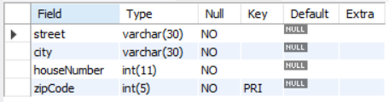

Job

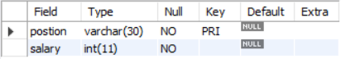

Product

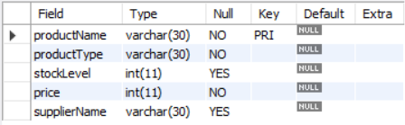

Review

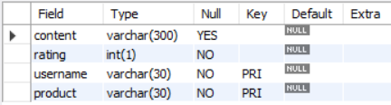

Staff

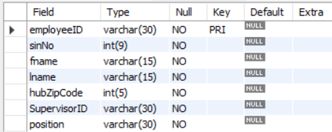

Supplier

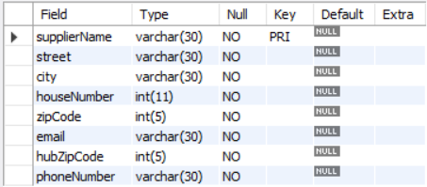

Transaction

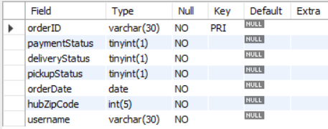

**3. Insert Results**

Supplier

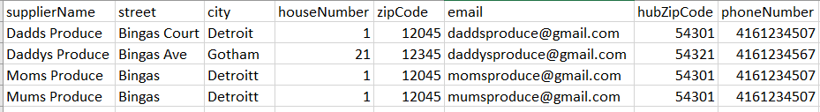

Product

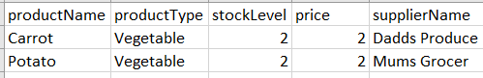

Hub

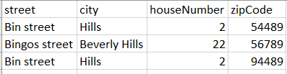

**4. Sample Data**

Containing

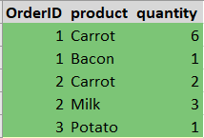

Customer

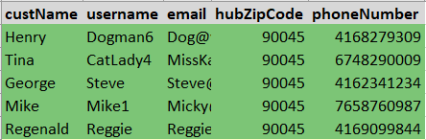

Hub

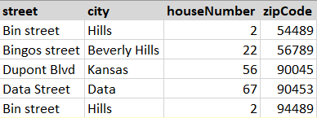

Job

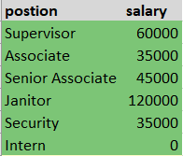

Product

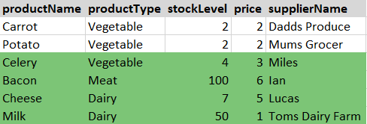

Review

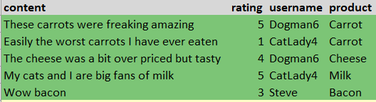

Staff

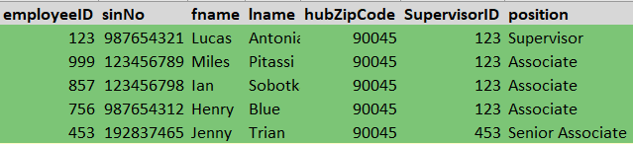

Supplier

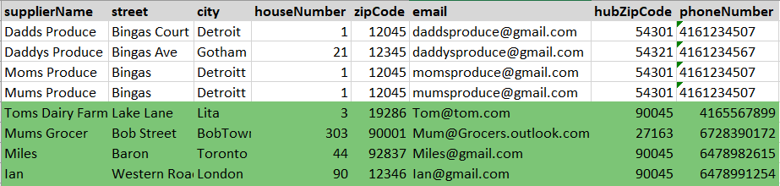

Transaction

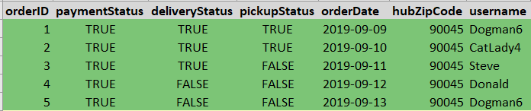

**5. Query Results**

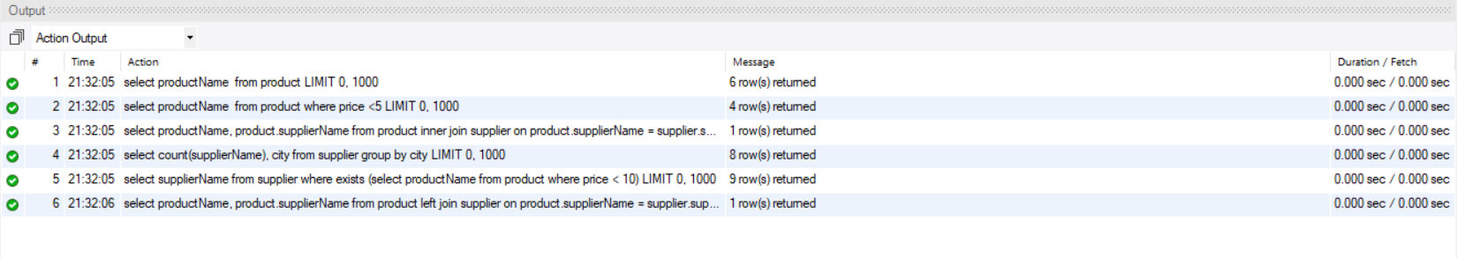

**6. Modification Response**







**7. Create Views**

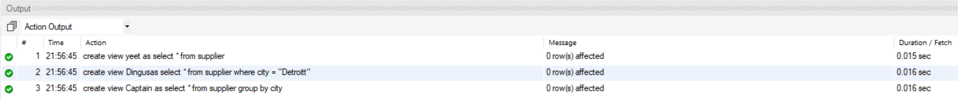

Yes, our view "yeet" is updatable because it is a selection on one base table.

**8.** No there weren’t any clauses in class that we needed to use in MySQL that we were unable to. However, it is a definite possibility as SQL is a bunch of dialects and they significantly overlap but have differences, like some databases not supporting functionalities such as “full outer join”.