**PE_SBA301_SUM25_TrialExam**

SUMMER 2025  
Subject: SBA301  
Duration: 85 minutes

**INSTRUCTIONS**

**Please read the instructions carefully before doing the questions.**

* You are **NOT allowed** to use any other materials. You are **NOT allowed** to use any device to share data with others.
* You must use IDE as **IntelliJ IDEA 2023 or later, MSSQL Server 2019 or** **later** for your development tools.

**IMPORTANT – Before you start doing your solution, MUST do the following steps:**

1. To do your program, you must use **Spring REST**, apply 3-Layer architecture. *Note that* *you are not allowed to connect directly to the database from REST Controller, every database connection must be used with Service and Repository. The database connection string must get from hibernate.cfg.xml file  or application.properties file.* ***In the case your program connects directly to the database from a REST Controller or hardcode connection string, you will get 0 point.***
2. ***If there are syntax errors or compilation errors in your PE program, you will not pass the PE requirements, the point will be 0.***
3. Create a new ReactJS project in Visual Studio Code named **pe_sba301_sum25_trial_fe_studentcode**
4. Create a new Spring REST project in IntelliJ IDEA named **pe_sba301_sp25_trial_be_studentcode**
5. Create your MS SQL database named **Sum2025BlindBoxesDB** using a code-first approach with Spring Data JPA and ensure that it includes the data provided in the **PE_SBA301_SUM25_TrialExam_Note** file
6. ***Your work will be considered invalid (0 point) if your code inserts stuff that is unrelated to the test.***

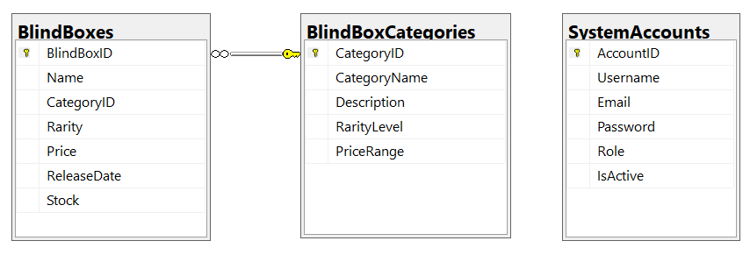

Note that: *Role: Administrator = 1; Moderator = 2; Developer = 3; Member=4*

**1. Table data type**

*SystemAccounts*

|  |  |  |
| --- | --- | --- |
| **Column Name** | **Data Type** | **Description** |
| AccountID | INT (Primary Key) | Unique identifier for each system account. |
| Username | VARCHAR(100) NOT NULL | Login username for the account. |
| Email | VARCHAR(255) NOT NULL | Email address associated with the account. |
| Password | VARCHAR(255) NOT NULL | The password associated with the account. |
| Role | int | User role (e.g., Administrator (1), Member (4), Moderator(2), Developer (3)). |
| IsActive | BOOLEAN DEFAULT TRUE | Indicates if the account is active (TRUE/FALSE). |

*BlindBoxCategories*

|  |  |  |
| --- | --- | --- |
| **Column Name** | **Data Type** | **Description** |
| CategoryID | INT (Primary Key) | Unique identifier for each blind box category. |
| CategoryName | VARCHAR(255) | Name of the blind box category (e.g., Anime, Gaming, NFTs). |
| Description | TEXT | Short description of the category. |
| RarityLevel | VARCHAR(50) | Rarity classification (e.g., Common, Rare, Ultra Rare). |
| PriceRange | VARCHAR(100) | Typical price range (e.g., $10-$50, $50-$100). |

*BlindBoxes*

|  |  |  |
| --- | --- | --- |
| **Column Name** | **Data Type** | **Description** |
| BlindBoxID | INT (Primary Key) | Unique identifier for each blind box. |
| Name | VARCHAR(255) | Name of the blind box series or product. |
| CategoryID | INT (Foreign Key) | Links to BlindBoxCategories(CategoryID). |
| Rarity | VARCHAR(50) | Rarity level (e.g., Common, Rare, Ultra Rare). |
| Price | DECIMAL(10,2) | Price of the blind box. |
| ReleaseDate | DATE | Date when the blind box was released. |
| Stock | INT | Number of units available in stock. |

**2. Data** *(must input these information)*

*SystemAccounts*

|  |  |  |  |  |  |
| --- | --- | --- | --- | --- | --- |
| ***AccountID*** | ***Username*** | ***Email*** | ***Password*** | ***Role*** | ***IsActive*** |
| 1 | adminsys | admin@blindboxes.vn | @2 | 1 | 1 |
| 2 | johndoe | john@blindboxes.vn | @2 | 4 | 1 |
| 3 | modmichel | michel@blindboxes.vn | @2 | 2 | 1 |
| 4 | vanvan | vanavan@blindboxes.vn | @2 | 4 | 0 |
| 5 | devops | dev@blindboxes.vn | @2 | 3 | 1 |

*BlindBoxCategories*

|  |  |  |  |  |
| --- | --- | --- | --- | --- |
| ***CategoryID*** | ***CategoryName*** | ***Description*** | ***RarityLevel*** | ***PriceRange*** |
| 1 | Fantasy | Mystical creatures, wizards, and legendary beings. | Common to Ultra Rare | $10 - $60 |
| 2 | Gaming | Blind boxes featuring characters from popular video games. | Common to Epic | $25 - $70 |
| 3 | Sci-Fi | Space, futuristic themes, and robotic collectibles. | Rare to Legendary | $30 - $80 |
| 4 | Anime | Popular anime characters and themed mystery figures. | Common to Legendary | $15 - $100 |
| 5 | Steampunk | Victorian-era inspired mechanical and fantasy figures. | Rare to Epic | $100 - $190 |

*BlindBoxes*

|  |  |  |  |  |  |  |
| --- | --- | --- | --- | --- | --- | --- |
| ***BlindBoxID*** | ***Name*** | ***CategoryID*** | ***Rarity*** | ***Price*** | ***ReleaseDate (mm/dd/yyyy)*** | ***Stock*** |
| 1 | Mystic Creatures Series 1 | 1 | Rare | 29.99 | 1/15/2024 | 150 |
| 2 | Cyberpunk Warriors | 2 | Ultra Rare | 49.99 | 11/20/2023 | 75 |
| 3 | Fantasy Legends | 1 | Common | 19.99 | 2/10/2024 | 200 |
| 4 | Space Explorers | 3 | Epic | 59.99 | 12/5/2023 | 50 |
| 5 | Neon Anime Stars | 4 | Legendary | 99.99 | 3/1/2024 | 25 |
| 6 | Retro Arcade Heroes | 2 | Common | 24.99 | 1/30/2024 | 180 |
| 7 | Mythical Beasts Collection | 1 | Ultra Rare | 54.99 | 10/10/2023 | 60 |
| 8 | Superhero Legends | 3 | Rare | 39.99 | 2/20/2024 | 120 |
| 9 | Steampunk Adventurers | 2 | Epic | 69.99 | 12/15/2023 | 40 |
| 10 | Kawaii Anime Pets | 4 | Common | 14.99 | 3/5/2024 | 250 |