Calculator Supplement
for TI-82/83

# 0 Introduction
# 1 Computations
# 2 Tables of Values
# 3 Graphing
# 4 The Calculate Submenu

# 1 Introduction

A. Double Action of the Keys

Take a close look at your calculator keyboard. Notice that there are groups of keys with different colors. One key stands out with a color all its own: light blue on the TI-82, yellow on the TI-83. It is labeled 2nd and works like the shift key on a typewriter. If you just press any key, you get the action labeled in white on top of the key. However, if you first press 2nd and then you press any key, you get the action labeled above the key, color-coded light blue on the TI-82 and yellow on the TI-83.
For example ON (bottom left corner) turns on the calculator; but
2nd ON (equivalent to OFF) turns off the calculator.
Try turning your calculator on and then off.

B. Setting the Contrast

When you turn on your calculator you should see a small blinking black rectangle called the cursor. If the screen is blank, or if the cursor is hard to see, you may need to make it darker. This is done by hitting a two-keystroke sequence over and over until the cursor looks sharp and dark (the second key is the up arrow): 2nd ↑
If this doesn't darken the screen, batteries may be low, and you may need to replace them. If the screen is too dark you can make it lighter by hitting:
2nd ↓

C. Clearing the Memory

At some point, you may find your calculator responding in a quirky unexpected manner. This usually happens after you inadvertently change its usual settings. The easiest way to fix this is to reset the calculator to its factory setting. This requires four keystrokes on the TI-82:
2nd + 3 2
which lead to the following message:
Mem cleared
To reset the TI-83 requires five keystrokes:
2nd + 7 1 2
which lead to the following message:
RAM cleared

D. The Calculator as an Educational Toy

The calculator is a very powerful computing and graphing tool. It can do many things. However, in this supplement, we deliberately limit ourselves to very few of the calculator's capabilities. Our bias is to use the calculator as an educational toy rather than a magic box to get quick
push-button answers. For example, there is a one-step command that magically solves equations. We avoid that command in favor of a much slower and, hopefully, more thought-provoking process. This way, although we still use the calculator to do the heavy lifting, we give full control and responsibility to you, the student. The idea is not to become dependent on the calculator but rather to use it to learn to think for yourself. The right time to use a short-cut command is after you have mastered the concept.
When you approach a problem, don't rush for your calculator. You need a plan. And, the calculator comes last in that plan, not first. The calculator will do whatever you ask (if you ask nicely). And, if you don't ask a good question, you won't get a good answer. You should do as much as you can on your own (in your head or on paper) before you involve the calculator. You can't use the calculator intelligently if you have no idea where you are going. Think first and, then, use it properly to confirm and refine your estimate or rough sketch.
# 1 Computations

1. Overview

•Estimate. The TI-82/83 is a powerful and convenient tool for numerical computations. Among the most common errors made in computations are keying errors. This often leads to huge mistakes in the answers. One way to catch these mistakes is to make ballpark estimates of your answers before you compute them. With some practice, it gets easy. Think through the following:
= 11. something
86 is less than one million
20,000 ( 1 + )12(7) is more than 20,000
• Experiment. There may be times when you are not sure about the right way to key in a computation. Feel free to experiment. Try some test cases involving easy numbers you can figure in your head or on paper. If the calculator doesn't produce the result you are looking for, make some changes in your command.

• Home Screen. Computations on the TI-82/83 take place in the home screen. When you turn on the calculator for the first time, you are in the home screen. There are other screens that do other things. If you are in another screen, or if you don't know where you are, you can always get back to the home screen by pressing:
2nd MODE (which is equivalent to QUIT )

2. Arithmetic Operations

Keys for basic arithmetic operations are clustered in the lower right hand corner. From top to bottom they are:
^ (Exponent)
÷ ( / on screen)
× ( ∗ on screen)
–
+
Notice that, very conveniently, the position of these keys on the keyboard agrees with the operations' precedence ranking. The TI-82 obeys the same precedence rule that humans follow in algebra. A computation is not carried out when you type it in until you press
ENTER.

Squares and square roots use the same key:
x2 (for squaring )
2nd x2 (for square roots)

Other operations can be accessed from the MATH menu by pressing the key MATH

Try the following calculations; don't forget to press ENTER; pay attention to the way the expressions look on the screen.
2 + 3
2 × 3
12 – 9
2 ÷ 3
2 ^ 5
(TI-82 doesn't parentheses)

Humans use one and the same symbol "– " for two logically different purposes: we use it to indicate subtraction (between two numbers) and we also use it to change the sign of a number ( from + to – or – to +). The context tells a human which of these two uses is intended. However, machines can't handle that type of ambiguity. So, there are two minus keys on the calculator. The plain – is used for subtraction only. To minus a number, to change its sign, requires the key labelled (–) ; on screen, that minus looks shorter and higher up than the subtraction minus.

Try the following operations:
Calculator: Human Notation:
(–)3 × 4 (–3) 4
(– )3 – (–)4 –3 – (–4)

There is another difference between the notations used by humans and calculators. Humans can express divisions as fractions written on two levels, using the fraction bar to group and separate numerator and denominator. Since calculator expressions are written on a single level, the job of grouping numerators and denominators must be handled outright by parentheses.
Try the following computation:
Calculator: Human Notation:
6 ÷ (2 + 1)
(40 – 5) ÷ (3 + 4)
Humans and calculators also handle grouping differently in relation to square roots. Humans use the length of the bar in the radical symbol to group numbers. The calculator's radical symbol has fixed length; so, parentheses are needed to group the numbers:

Calculator: Human Notation:

The TI-83 always provides the first parentheses for the radical; the second parenthesis is your responsibility.
The TI-82 provides no parentheses, you must type in both (no parenthesis is needed if there is only one term)

3. Scientific Notation

If the answer to a computation is a very large or very small number, it is displayed in scientific form:
Calculator Human Notation
6.325 E – 6 6.325 × 10 – 6

You may also enter numbers in scientific notation. To enter 1.47 × 10 8 you type:
1.47 2nd , 8
(the comma is not punctuation; it is the key labeled with a comma)

Try this on your calculator; hit ENTER and check the display.

4. Recalling the Previous Answer and the Previous Command

The calculator always remembers the previous answer and the previous command.

• Previous Answer. The previous answer is stored in a memory location called Ans . It is automatically recalled if a command starts with an operation symbol. For example, the two-keystroke command + 1 shows on the screen as Ans + 1 and, when you press ENTER , it adds 1 to the last answer.
You can also control the recall of Ans within a command line with two keystrokes
2nd (–)

This is very useful in chain computations. Suppose you want to compute b if
b = a – 3 where a2 = 482 + 172 – 2(48)(17)(.1365)
The following three commands will do it: Try it!

482 + 172 – 2 × 48 × 17 × .1365 ENTER (computes a2 = 2370.232)
2nd x2 ( 2nd (–) ) ENTER (computes a = 48.6850285)
– 3 ENTER (computes b = 45.6850285)

5. Editing
If you make mistakes there are ways of correcting them without typing the whole thing over. The first step is to move the cursor where the mistake is. The cursor is the blinking rectangle that tells you where the next thing you type will appear. It can be moved up, down, left or right by pressing one of the four arrow keys clustered in the upper right hand corner of the keyboard.

A. Overwriting
Suppose you wrote 497 instead of 467. To fix it, move the cursor on the 9 and type 6. The 9 is gone and replaced by the 6. Typing over any unwanted character erases the old and replaces with the new.
Try this on your calculator.

B. Deleting
Suppose you wrote 421 instead of 41. To fix it, move the cursor on the 2 and press DEL. The 2 , as well as the space it occupied, is gone. Pressing DEL erases the character and the space occupied by the cursor.
Try this on your calculator.

C. Inserting
Suppose you wrote 2 + + 25 instead of 2 + 367 + 25. To fix it, move the cursor on the second + press 2nd DEL and type 367. Pressing 2nd DEL opens up new spaces to receive any characters you type to the left of the cursor.
Try this on your calculator.
If you discover an error after you hit ENTER, it is too late to correct this command line. Fortunately, you don't have to retype it; You can bring it back for correction by pressing:
2nd ENTER
Try this on your calculator.

5. Errors in Keying Commands

Human beings are usually able to figure out what you mean even when you make errors in spelling or in grammar. But calculators can't. We need to distinguish between two types of mistakes made in typing a command.
A. Syntax Errors
If a command is not properly formed, it can't be carried out. The calculator has no idea what you want to do. For example, the following command is unintelligible to the calculator:
2++3 ENTER
You get an error message:
ERR: SYNTAX
1: Goto
2:Quit
This gives you two option to recover from your mistake you can choose by hitting either 1 or 2:
1: Gives you a chance to edit the flawed command. It gets you back to the original expression with the cursor on the first problem keystroke: in this case, the second + sign. That is the choice you want if you see how to fix the problem quickly by editing: in this case delete the second + sign.
2: Gives you a fresh start. That is the choice you want if the command is so messed up, you want to do it all over from scratch.

B. Other Errors
If a command is properly formed it is be carried out even if it is not the command you want or need. You get no help from the calculator in discovering or fixing this type of error.

Homework

1. Rewrite each expression in ordinary algebraic notation. Then, compute the answers for each group on your calculator and explain why they are different:

(a) (1 + 2)^(1 + 2) 1 + 2^(1 + 2) (1 + 2)^1 + 2 1 + 2^1 + 2
(b) (2 + 3)/(.5 + .2) 2 + 3/(.5 + .2) (2 + 3)/.5 + .2 2 + 3/.5 + .2
(c) (2 + 32 + 3+ 16 2 + 3 + 16

2. There is a limit to how big a number any computer or calculator can represent. Experiment to find out the biggest number your calculator can represent. (Use scientific notation or the exponent operation. When you think you have the biggest number, try making it bigger (add to it or multiply). You will know you have reached the limit when you get an OVERFLOW ERROR).

3. Estimate the answer and use your calculator to compute:
(a) 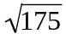 (b) 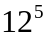 (c) 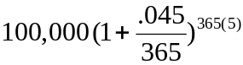

4. Compute each expression on your calculator. Rewrite each one in ordinary algebraic notation and explain the different answers you get:
(a) 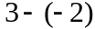 (b) 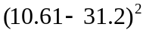 (c) 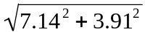
(d) 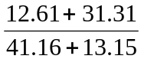 (e) 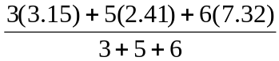

5. If and find

#2 Tables of Values

The calculator can be used to study functions numerically. It can evaluate a function for a specific input x-values; it can even compute and display an entire input-output table of values for one or more functions. Tables of value can help explore the domain and range of a function. They can also help us set up the graph of a function, as we will see in the next section.

1. The Function Screen: Y =

To do any with a function, you must define it for the calculator. This is done in the function screen which is activated by pressing the key:
Y =
In this screen you have the capability to define up to ten functions labeled:
y1 , y2 , y3 , y4 , y5 , y6 , y7 , y8 , y9 , y0

Suppose we want to define a function y1 :
f(x) = 3 x3 + 4 x2 – 3 x – 3
The key we use to display the variable x is labeled X,T,Θ. So, putting the cursor at the right of the topmost equal sign we key in:
3 X,T,Θ ^ 3 + 4 X,T,Θ ^ 2 – 3 X,T,Θ – 3 ENTER
Try this on your calculator.

Notice that the equal sign after y1 is highlighted; this indicates that the function is selected. The calculator will only work with a function if it is selected. You can de-select or re-select any previously defined function. To
de-select a function move the cursor to the corresponding equal sign and hit ENTER. The equal sign is no longer highlighted. To re-select a function, follow the same steps.

2. Table Setup and Table Display

There are basically two kinds of tables of values:
(a) On-demand. If want the output (y-values) of a function for one or more isolated inputs (x-values) you have to ask for them one at a time. You get each one after you type in the chosen x-value followed by ENTER.
(a) Automatically. If want the output (y-values) of a function for a whole block of equally spaced inputs (x-values) you have to describe the block. Then you get the whole table automatically.
Either way, there are two steps: first you design the kind of table you want, then you get to see it. The first step is done in the Table Setup Screen activated by two keystrokes:
2nd WINDOW (equivalent to TblSet)
The second step is done in the Table Screen activated by two keystrokes:
2nd GRAPH (equivalent to TABLE)
•On-Demand Display

Step 1: Activate the Function Screen with one keystroke:
Y=
Type in the function you want to investigate. We illustrate with f(x) = :
TI-82: 2nd x2 X,T,Θ (no parentheses needed)
TI-82: 2nd x2 X,T,Θ ) (first parenthesis is free)

Step 2: Activate the Table Setup Screen with two keystrokes:
2nd WINDOW
Ignore all but the bottom two lines of the Table Setup Screen. Use the arrow keys and the ENTER key to highlight Indpnt:Ask and Depend:Auto. On TI-82 we get
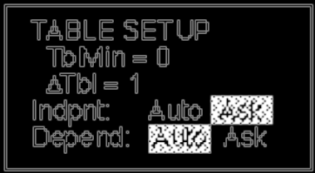
On the TI-83 TblMin is called TblStart

Note: independent variable refers to x-values or inputs, and dependent variable refers to y-values or outputs.

Step 3: Now activate the Table Screen with two keystrokes:
2nd GRAPH
In that screen you can key in any input value for X, and get the corresponding output value for Y1 by hitting ENTER. You can enter as many values as you like. We illustrate with the function

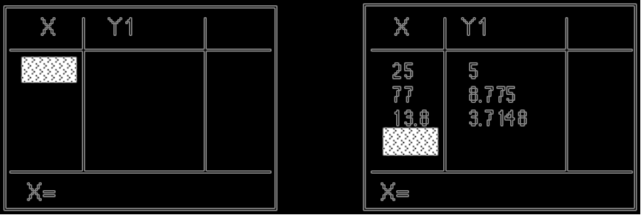

•Automatic Display

This mode is most convenient to evaluate a function for a block of equally spaced inputs. Go to the Table Setup Screen and type in two numbers that define the desired block of input values:
TblMin = startup input value ( TblStart on TI-83)
ΔTbl = the spacing between successive inputs
Suppose we choose TblMin = 4 and ΔTbl = 2. To obtain automatic display, highlight Indpnt:Auto and Depend:Auto.
The display appears in the Table Screen after the command
2nd GRAPH:
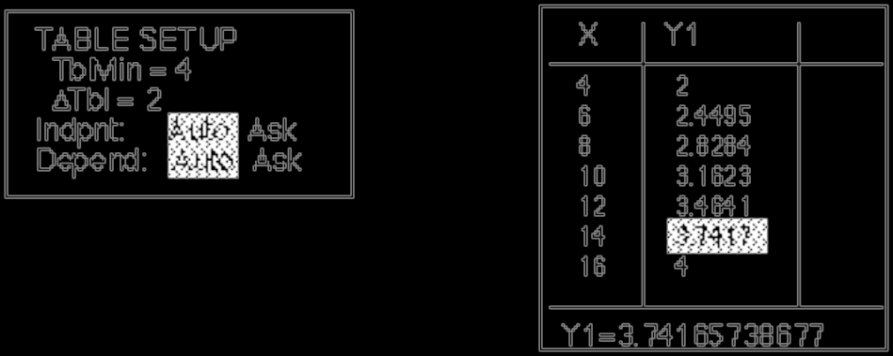

Table Setup Screen Table Display Screen

The table shows seven entries at one time. Computed values are rounded off. Placing the cursor on a Y1 entry shows its value at the bottom of the screen with more decimal places.

More entries can be seen by scrolling up or down (pressing the up or down arrow with the cursor in the X column). Notice how the Y1 column shows ERROR when the X-value goes below 0. This happens whenever we inputs fall outside the domain of a function.

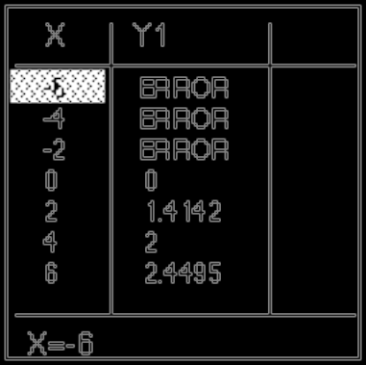

Example. (a) Use a table of values to explore the apparent domain and range of the function: f(x) = 1 + 2
(b) Determine the domain and range of the function by analyzing the equation.
Solution:
(a) Define the function Y1=1+2.
Set up the table using TblMin = 0 , ΔTbl = 1 , Indpnt:Auto and Depend:Auto. The display appears in the Table Screen:

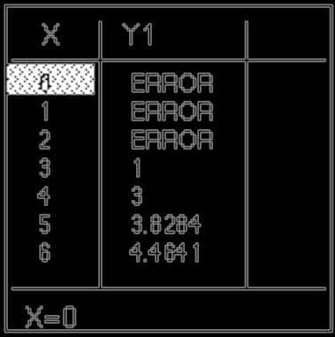

Scrolling up and down this table suggests:
apparent domain: x ≥ 3, since inputs below 3 yield ERROR. apparent range: y ≥ 1, since outputs start at 1 and go up indefinitely

(b) Domain. The only questionable operation is the square root, which yields a real value if and only if x – 3 ≥ 0.
Adding 3 to both sides: x ≥ 3.
Range. A square root is always positive; Multiplying by 2, yields a product that is still positive. Therefore:
y = 1 + 2 ≥ 1.

Homework

1. Are the following functions? Yes or no. If not, find one input x-value with two output y-values.
(a) x2 + y2 = 4 (b) x2 + y2 = 4, y ≥ 0 (c) x2 + y2 = 4, y ≥ 0, x ≥ 0
(d) y2 = x (e) y2 = x, y ≥ 0 (f) y = 1 (g) |y| = x (h) x = 4

2. A. Compute and simplify f(0), f(3), f(–2) for the following functions:
(a) f(x) = 3x – 4 (b) f(x) = x2 – 3x + 1 (c) f(x) = f(x) =
B. After you have completed by hand, verify your answers on the TI-82 using suitable on-demand table displays.

3. A. Explore the domain and range of each function using automatic table displays. Set a suitable TblMin and try ΔTbl = 1 and ΔTbl = .1 :
(a) f(x) = 3x – 1 (b) f(x) = 3 (c) f(x) = – (x + 1)2 (d) f(x) = (x – 2)2 – 5
(e) y = 3 + y = 2 – f(x) = – f(x) = 2 +
B. Find the domain and range of the functions by analyzing the equations.

# 3 Graphing

Graphing on your calculator is a lot like taking a photograph with an automatic camera. The biggest challenge is framing the shot. The "frame" of a graph is called a window. Often, we start out not knowing what the graph looks like. In such cases, we are more like a blind man taking a photograph. We needs some clues that tell us what the subject looks like and where it is located.

1. The Standard Window

Some graphs are adequately displayed as a close-up of the origin. This is comparable to an ID picture taken at a set distance from the camera. The standard window extends 10 units in all four directions from the origin:
10 units to the left, 10 units to the right, 10 units down, 10 units up
It has tick marks 1 unit apart on the vertical and horizontal axes.
The standard window may be adequate for basic functions like:
f(x) = x f(x) = x2 f(x) = |x| f(x) = f(x) =
After a function has been defined in the function screen, it is displayed in the standard window with two keystrokes:
ZOOM 6

Try graphing f(x) = x3 on your calculator.

2. The Window Screen: WINDOW

In most cases we need to customize the window. This is done in the window screen activated by pressing the key labelled:
WINDOW

This screen allows you to define the viewing rectangle by setting 6 numbers by moving the cursor down to each positions and typing in the desired value for:
Xmin =
Xmax =
Xscl =
Ymin =
Ymax =
Yscl =
(For now, ignore Xres and Yres that show up on the TI-83.)The values for Xscl and Yscl determine the scale, the distance between successive tick marks on the horizontal axis and the vertical axis.
(y-axis). The other four numbers box in the rectangle as follows:
Xmin ≤ x ≤ Xmax, Ymin ≤ y ≤ Ymax.

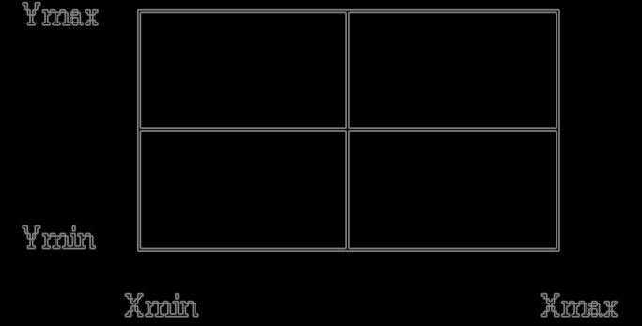

Press WINDOW and check out the six values automatically set earlier by ZOOM 6. Now reset the four values:
Xmin = –2 Xmax = 2 Ymin = –8 Ymax = 8
(Remember to use the correct minus key (–) )

3. The Graph Screen: GRAPH

To see the graph of y = x3 in the newly reset window we enter the graph screen by pressing the key labelled:
GRAPH
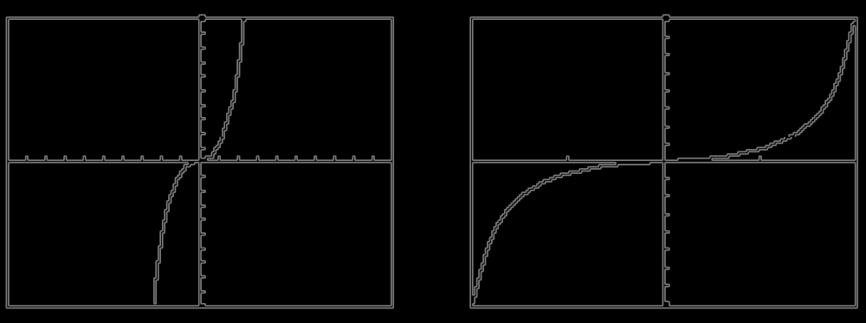 Graph in standard window Graph in custom window

4. Customizing the Window

How do we know what window is suitable for graphing a function?
The is no easy answer to that questions. We need to get clues by analyzing the equation or by exploring the table of values. These clues include the domain and range of the function as well as transformations of functions such as reflections, dilations and shifts.

A. Windows and Domain and Range

Suppose we want to graph x2 + y2 = 1. To begin with the calculator cannot graph equations unless they are solved for y. Subtract x2 from both sides: x2 + y2 = 1
–x2 – x2
y2 = 1 – x2
Take the square root: y = ± .
We get two functions: y =
y = –

y1 = 2nd x2 ( 1 – X,T,Θ ^ 2 x2 ) ENTER
y2 = (-) 2nd x2 ( 1 – X,T,Θ ^ 2 x2 ) ENTER

The domain of both functions is –1 ≤ x ≤ 1. This can be determined either by solving the inequality 1 – x2 ≥ 0 or by looking at the table of values with, say,
TblMin = 0
ΔTbl = .1
In the same way, we can see that the range of the first function is 0 ≤ y ≤ 1 and the range of the second function is –1 ≤ y ≤ 0.
Therefore both functions will fit in the window with:
Xmin = –1, Xmax = 1, Xscl =.1, Ymin = –1, Ymax = 1, Yscl = .1

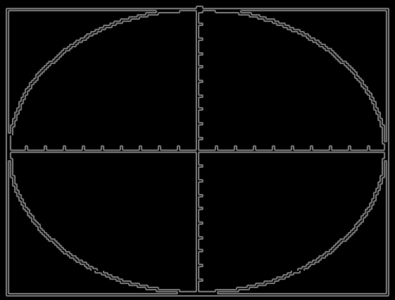

Consider the following equation: y = x3 (x – 1)3
Key in X,T,Θ ^ 3 ( X,T,Θ – 1 ) ^ 3 ENTER

In the standard window, the graph we get looks U-shaped entirely on or above the x-axis; a very important detail is wiped out.
A look at the equation tells us that y can be negative for x between 0 and 1. For example if you take x = , you get:
y = ( )3 ( – 1)3 = ( )3 (– )3 = ( ) (– ) = – ≈ –.02
Alternatively, explore the table of values with:
TblMin = 0
ΔTbl = .1
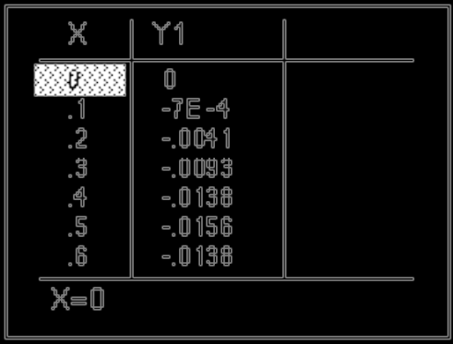

The table also reveals that the function is symmetric across the value
x = .5. Using all this information we choose the custom window:
Xmin = –1, Xmax = 2, Xscl = .5
Ymin = –.02, Ymax = .02, Yscl = .01
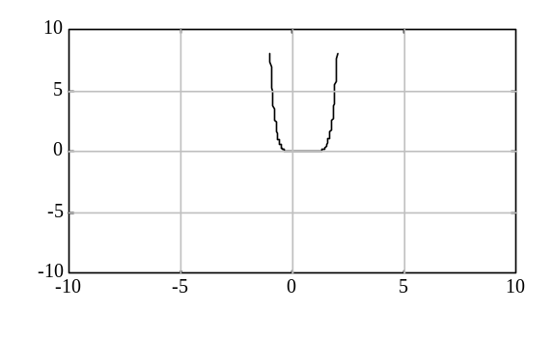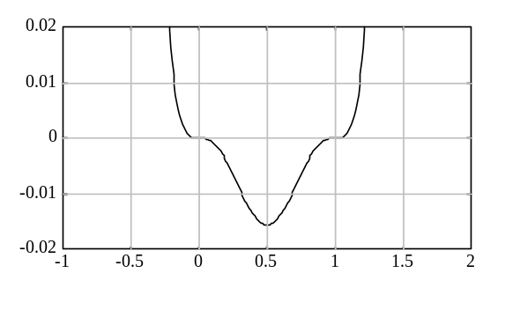
Standard Window Custom Window

To show gridlines in a window:

WINDOW → Format GridOn

B. Windows and Transformations

A transformation of the function y = f(x) is the function
y = b f ( ) + k or (more symmetrically) = f ( )
where the numbers h, k, a, b have the following graphical significance
• h is the horizontal shift • k is the vertical shift
• |a| is the horizontal dilation factor • |b| is the vertical dilation factor
• a < 0 indicates a reflection • b < 0 indicates a reflection
across the y-axis across the x-axis

Once a transformation is recognized, it can be used to customize a suitable window.

Suppose we want to graph y = (x – 20)2 – 30 or y + 30 = (x – 20)2 . Recognize that we are dealing with: the basic model y = x2
shifted 20 units to the right and 30 units down
If we start out with the basic model in the standard window, all we have to do is shift the window in the same way as the transformed function. We obtain the following custom window:
Xmin = –10 + 20 = 10 Ymin = –10 – 30 = –40
Xmax = 10 + 20 = 30 Ymax = 10 – 30 = –20
Xscl = Yscl = 1 don't change during a shift.

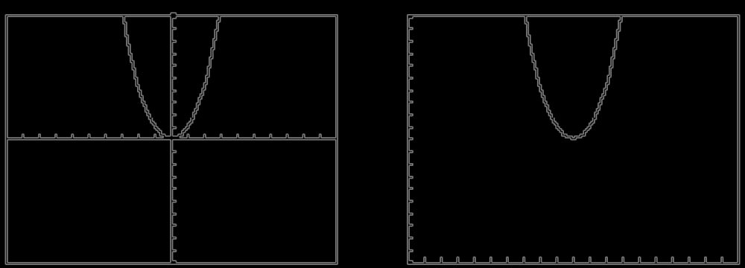
y = x2 y = (x – 20)2 – 30
in standard window in custom window

Notice that the transformed graph looks the same in the transformed window as the basic model does in its original window. This is true no matter what the transformation is, as long as it is applied equally to the graph and the window.

Suppose we want to graph y = since 20x = = , we have a horizontal dilation factor of .05. If we start out with the basic model
y = in startup window, say:
Xmin = 0, Xmax = 16, Xscl = 1; Ymin = 0, Ymax = 4, Yscl = 1
We construct our custom window as follows: Keep Ymin = 0, Ymax = 4,
Yscl = 1, unchanged since the transformation has no vertical component.
Xmin = 0(.05) = 0, Xmax = 16(.05) = .8, Yscl = 1(.05) =.05
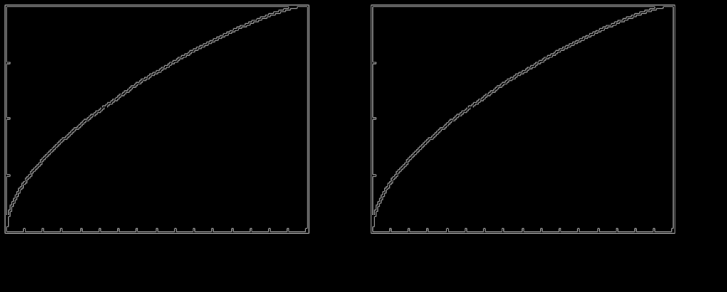
y = in window y = in window
Xmin = 0, Xmax = 16, Xscl =1 Xmin = 0, Xmax = .8, Xscl =.05
Ymin = 0, Ymax = 4, Yscl = 1 Ymin = 0, Ymax = 4, Yscl = 1

Suppose we want to graph y = 300x + 1500, 10 ≤ x ≤ 50. The horizontal dimensions of the window are built into the question:
Xmin = 10, Xmax = 50, Xscl = 5
(We never want more than 20 tick marks).
Now, to the vertical dimension of our window. Compared to y = x, our function ( = x ) is dilated by a factor of 300 vertically and shifted up by 1500 units. Therefore
Ymin = 10(300) + 1500 = 4500 Ymax = 50(300) + 1500 = 16500
We want Yscl ≥ = 600, so Yscl = 1000
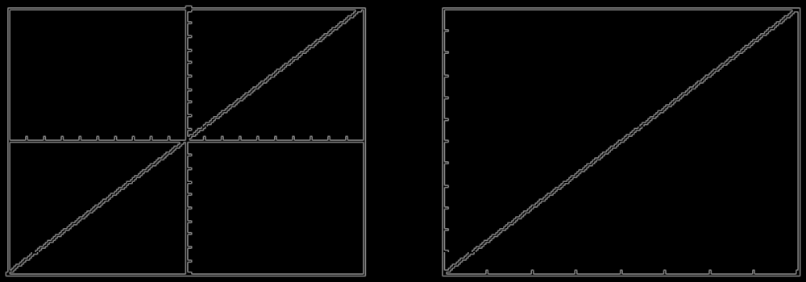
y = x in standard window y = 300x + 1500, 10 ≤ x ≤ 50

Homework

1. A. Graph the following by hand:
(a) 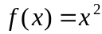 (b) 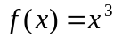 (c) 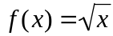 (d) 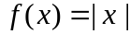

B. Now, graph the same functions in your calculator’s standard window

2. Graph the following functions in your calculator’s standard window
(a) 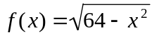 (b) 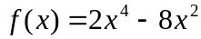 (c) 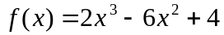

3. Graph the following functions in a suitably customized window:

(a) 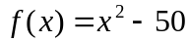 (b) 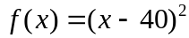 (c) 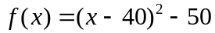
(d) 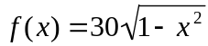 (e) 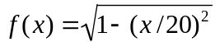 (f) 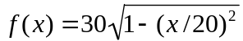
(g) 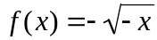 (h) 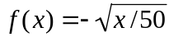 (i) 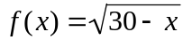
(j) 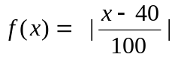 (k) 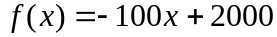 (l) 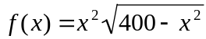

#4 The Calculate Submenu

The TI-82/83 can be used to visualize and to solve equations graphically. It can also be used to pinpoint the top of a graph’s peak and the bottom of its valleys.
To access the calculate submenu requires two key strokes:
2nd TRACE
The following submenu opens:

CALCULATE
1:value
2:zero
3:minimum
4:maximum

Option 2 is called root in the TI-82. An option is activated by typing its corresponding number. Option 2 is used to solve an equation or for finding the
x-intercepts of a graph. Option 3 is used for finding the bottom of a graph’s valleys. Option 4 is used for finding the top of a graph’s peaks.

1. Graphical Solution of Equations

First, let us dispose of some pesky terminology by means of an example. Consider the function:
y = 2x3 + 4x2 – 2x – 3.
There is an obvious equation associated with that function, namely:
2x3 + 4x2 – 2x – 3 = 0.
We have three words that refer to the same thing. A zero of the function means the same thing as a solution of the equation which means the same thing as (the x-coordinate of) an x-intercept of the graph. As if this were not enough, when the function is a polynomial, as is the case here, there is one more equivalent word: we speak of the root of the polynomial. The meaning is the same; it is all a question of usage.
We already know how to graph the function y1 = 2x3 + 4x2 – 2x – 3 in a standard window:
Y =
2 X,T,Θ ^ 3 + 4 X,T,Θ ^ 2 – 2 X,T,Θ – 3
ZOOM 6
We can tell that the graph crosses the x-axis 3 times. This means that there are 3 zeros, 3 solutions, 3 x-intercepts, 3 roots. We get a slightly better look if we narrow down the window:
Xmin=–3 Xmax=2

Suppose we want to find the largest zero: the one that is most to the right. To start, we activate the suitable option:
2nd TRACE 2

Next, we need to tell the calculator which zero we want so it knows which piece of the graph to focus on. The calculator helps us by asking a series of questions:
Left Bound? (TI-82: Lower Bound?)
We answer by moving the cursor using the LEFT or RIGHT ARROW slightly to the left of the zero we want and pressing ENTER.
Right Bound? (TI-82: Upper Bound?)
We answer by moving the cursor slightly to the right of the zero we want and pressing ENTER.
The exact positions of the cursor are not important. The idea is to select the piece of the graph to be investigated. That piece is marked off on the screen by two wedges. It isolates the zero we want and excludes the zeros we don’t want at this time.
Finally, the calculator asks a third question:
Guess?
We answer by moving the cursor as close as we can to the zero we want and pressing ENTER.
The calculator gives a numerical answer:

Zero

X=.91004469 Y=0

It also marks the zero it found on the graph with an ×.

Now, you find the other two zeros by the same method. Hint: the values are X= – 2.139726 and X= – 0.7703185.

Note that one side of any equation can always be made equal to zero. If it is not zero, subtract the expression from both sides of the equation. After zeroing out one side if necessary, any equation can be solved by the previous approach

2. Finding Relative Maxima and Minima

The Calculate Submenu can also be used to find the coordinates of a function’s relative maxima (the top of its graph’s peaks) and of its relative minima (the bottom of its graph’s valleys or troughs).
Start out with the graph of the function in a suitable window containing the points whose coordinates we are seeking. Consider the function:
y = 2x3 + 4x2 – 2x – 3
in the standard window. Notice that the graph has a maximum and a minimum. Suppose we want to find its maximum.
We start by activating the suitable option with three key strokes:
2nd TRACE 4

Next, we need to identify which maximum we want (there may be several). The calculator helps us by asking a series of questions:
Left Bound? (TI-82: Lower Bound?)
We answer by moving the cursor using the LEFT or RIGHT ARROW slightly to the left of the maximum we want and pressing ENTER.
Right Bound? (TI-82: Upper Bound?)
We answer by moving the cursor slightly to the right of the maximum we want and pressing ENTER.
As noted earlier, the exact positions of the cursor are not important. The idea is to select the piece of the graph to be investigated. That piece is marked off on the screen by two wedges. It isolates the point we want and excludes the points we don’t want at this time.
Finally, the calculator asks a third question:
Guess?
We answer by moving the cursor as close as we can to the maximum we want and pressing ENTER.
The calculator gives the coordinates of the maximum:

Maximum

X=–1.548582 Y=2.2622606

Now, you find the coordinates of the minimum point by the same method. Hint: the values are X= .21525171 Y= – 3.225224
.

