SMR Calculations - US Reference Population

Mar 14, 2025 - 05:29 PM

| **Characteristic** | **All death causes** N = 6,881 | **BC death** N = 3,636 | **CVD death** N = 470 | **Other Death** N = 2,775 | **p-value** |
| --- | --- | --- | --- | --- | --- |
| Age at Diagnosis (Continuous) |  |  |  |  | <0.001 |
| Mean(±SD) | 64.9(±14.6) | 60.1(±14.4) | 73.9(±11.0) | 69.6(±13.0) |  |
| Median (Q1-Q3) | 66.0 (55.0-76.0) | 60.0 (50.0-70.0) | 75.0 (67.0-82.0) | 71.0 (62.0-79.0) |  |
| Min-Max | 18.0-104.0 | 18.0-97.0 | 35.0-101.0 | 26.0-104.0 |  |
| Age at Diagnosis (Categorical) |  |  |  |  | <0.001 |
| 18-39 | 362 (5.3%) | 288 (7.9%) | 2 (0.4%) | 72 (2.6%) |  |
| 40-49 | 779 (11%) | 618 (17%) | 13 (2.8%) | 148 (5.3%) |  |
| 50-59 | 1,241 (18%) | 849 (23%) | 31 (6.6%) | 361 (13%) |  |
| 60-69 | 1,650 (24%) | 897 (25%) | 105 (22%) | 648 (23%) |  |
| 70-79 | 1,660 (24%) | 630 (17%) | 160 (34%) | 870 (31%) |  |
| 80+ | 1,189 (17%) | 354 (9.7%) | 159 (34%) | 676 (24%) |  |
| FollowUpYears |  |  |  |  | <0.001 |
| Mean(±SD) | 4.4(±3.6) | 3.5(±3.2) | 5.3(±3.7) | 5.3(±3.9) |  |
| Median (Q1-Q3) | 3.3 (1.4-6.4) | 2.6 (1.2-4.9) | 4.5 (2.1-7.7) | 4.5 (2.1-7.8) |  |
| Min-Max | 0.1-16.6 | 0.1-16.4 | 0.1-16.6 | 0.1-16.6 |  |
| Age at Death |  |  |  |  | <0.001 |
| 18-39 | 196 (2.8%) | 164 (4.5%) | 0 (0%) | 32 (1.2%) |  |
| 40-49 | 510 (7.4%) | 416 (11%) | 6 (1.3%) | 88 (3.2%) |  |
| 50-59 | 998 (15%) | 738 (20%) | 21 (4.5%) | 239 (8.6%) |  |
| 60-69 | 1,393 (20%) | 917 (25%) | 53 (11%) | 423 (15%) |  |
| 70-79 | 1,665 (24%) | 782 (22%) | 123 (26%) | 760 (27%) |  |
| 80+ | 2,119 (31%) | 619 (17%) | 267 (57%) | 1,233 (44%) |  |
| Time to death (years) |  |  |  |  | <0.001 |
| Mean(±SD) | 4.4(±3.6) | 3.5(±3.2) | 5.3(±3.7) | 5.3(±3.9) |  |
| Median (Q1-Q3) | 3.3 (1.4-6.4) | 2.6 (1.2-4.9) | 4.5 (2.1-7.7) | 4.5 (2.1-7.8) |  |
| Min-Max | 0.1-16.6 | 0.1-16.4 | 0.1-16.6 | 0.1-16.6 |  |
| Health Region |  |  |  |  | 0.091 |
| Noreste Metro | 1,731 (25%) | 918 (25%) | 127 (27%) | 686 (25%) |  |
| Central Bayamon | 1,030 (15%) | 532 (15%) | 59 (13%) | 439 (16%) |  |
| Oeste Aguadilla/Mayaguez | 1,041 (15%) | 546 (15%) | 75 (16%) | 420 (15%) |  |
| Sureste Caguas | 953 (14%) | 499 (14%) | 61 (13%) | 393 (14%) |  |
| Sur Ponce | 1,018 (15%) | 582 (16%) | 75 (16%) | 361 (13%) |  |
| Norte Arecibo | 833 (12%) | 418 (11%) | 55 (12%) | 360 (13%) |  |
| Este Fajardo | 270 (3.9%) | 140 (3.9%) | 18 (3.8%) | 112 (4.0%) |  |
| County Unknown | 5 (<0.1%) | 1 (<0.1%) | 0 (0%) | 4 (0.1%) |  |
| Marital Status |  |  |  |  | <0.001 |
| Married | 2,996 (44%) | 1,700 (47%) | 159 (34%) | 1,137 (41%) |  |
| Unmarried | 3,242 (47%) | 1,629 (45%) | 263 (56%) | 1,350 (49%) |  |
| Unknown | 643 (9.3%) | 307 (8.4%) | 48 (10%) | 288 (10%) |  |
| Treatment |  |  |  |  | <0.001 |
| Surgery Only | 1,066 (15%) | 436 (12%) | 105 (22%) | 525 (19%) |  |
| Chemotherapy Only | 686 (10.0%) | 492 (14%) | 23 (4.9%) | 171 (6.2%) |  |
| Radiotherapy Only | 889 (13%) | 321 (8.8%) | 80 (17%) | 488 (18%) |  |
| Chemotherapy and Radiotherapy | 1,753 (25%) | 1,156 (32%) | 74 (16%) | 523 (19%) |  |
| Other | 2,487 (36%) | 1,231 (34%) | 188 (40%) | 1,068 (38%) |  |
| Stage at Diagnosis |  |  |  |  | <0.001 |
| Distant | 621 (9.0%) | 490 (13%) | 10 (2.1%) | 121 (4.4%) |  |
| Localized | 2,893 (42%) | 1,042 (29%) | 300 (64%) | 1,551 (56%) |  |
| Regional | 2,980 (43%) | 1,895 (52%) | 137 (29%) | 948 (34%) |  |
| Unstaged | 387 (5.6%) | 209 (5.7%) | 23 (4.9%) | 155 (5.6%) |  |

Figure 1 Flow diagram defining selection of women diagnosed with first breast cancer between 2004-2019 and followed through 2021 in PR and 17 SEER registries. 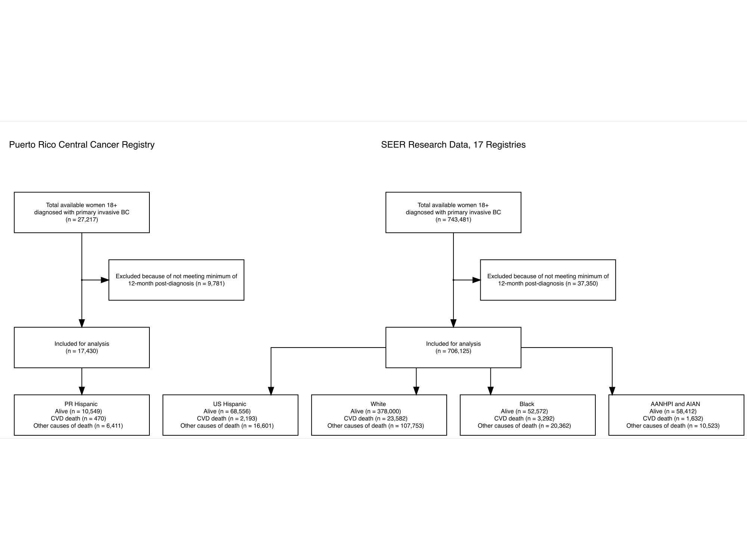

Table 1 Baseline Characteristics of women who died in Puerto Rico diagnosed with Breast Cancer from 2004-2019 and followed through 2021

| **Characteristic** | **All death causes** N = 6,881 | **BC death** N = 3,636 | **CVD death** N = 470 | **Other Death** N = 2,775 | **p-value** |
| --- | --- | --- | --- | --- | --- |
| Age at Diagnosis (Continuous) |  |  |  |  | <0.001 |
| Mean(±SD) | 64.9(±14.6) | 60.1(±14.4) | 73.9(±11.0) | 69.6(±13.0) |  |
| Median (Q1-Q3) | 66.0 (55.0-76.0) | 60.0 (50.0-70.0) | 75.0 (67.0-82.0) | 71.0 (62.0-79.0) |  |
| Min-Max | 18.0-104.0 | 18.0-97.0 | 35.0-101.0 | 26.0-104.0 |  |
| Age at Diagnosis (Categorical) |  |  |  |  | <0.001 |
| 18-39 | 362 (5.3%) | 288 (7.9%) | 2 (0.4%) | 72 (2.6%) |  |
| 40-49 | 779 (11%) | 618 (17%) | 13 (2.8%) | 148 (5.3%) |  |
| 50-59 | 1,241 (18%) | 849 (23%) | 31 (6.6%) | 361 (13%) |  |
| 60-69 | 1,650 (24%) | 897 (25%) | 105 (22%) | 648 (23%) |  |
| 70-79 | 1,660 (24%) | 630 (17%) | 160 (34%) | 870 (31%) |  |
| 80+ | 1,189 (17%) | 354 (9.7%) | 159 (34%) | 676 (24%) |  |
| FollowUpYears |  |  |  |  | <0.001 |
| Mean(±SD) | 4.4(±3.6) | 3.5(±3.2) | 5.3(±3.7) | 5.3(±3.9) |  |
| Median (Q1-Q3) | 3.3 (1.4-6.4) | 2.6 (1.2-4.9) | 4.5 (2.1-7.7) | 4.5 (2.1-7.8) |  |
| Min-Max | 0.1-16.6 | 0.1-16.4 | 0.1-16.6 | 0.1-16.6 |  |
| Age at Death |  |  |  |  | <0.001 |
| 18-39 | 196 (2.8%) | 164 (4.5%) | 0 (0%) | 32 (1.2%) |  |
| 40-49 | 510 (7.4%) | 416 (11%) | 6 (1.3%) | 88 (3.2%) |  |
| 50-59 | 998 (15%) | 738 (20%) | 21 (4.5%) | 239 (8.6%) |  |
| 60-69 | 1,393 (20%) | 917 (25%) | 53 (11%) | 423 (15%) |  |
| 70-79 | 1,665 (24%) | 782 (22%) | 123 (26%) | 760 (27%) |  |
| 80+ | 2,119 (31%) | 619 (17%) | 267 (57%) | 1,233 (44%) |  |
| Time to death (years) |  |  |  |  | <0.001 |
| Mean(±SD) | 4.4(±3.6) | 3.5(±3.2) | 5.3(±3.7) | 5.3(±3.9) |  |
| Median (Q1-Q3) | 3.3 (1.4-6.4) | 2.6 (1.2-4.9) | 4.5 (2.1-7.7) | 4.5 (2.1-7.8) |  |
| Min-Max | 0.1-16.6 | 0.1-16.4 | 0.1-16.6 | 0.1-16.6 |  |
| Health Region |  |  |  |  | 0.091 |
| Noreste Metro | 1,731 (25%) | 918 (25%) | 127 (27%) | 686 (25%) |  |
| Central Bayamon | 1,030 (15%) | 532 (15%) | 59 (13%) | 439 (16%) |  |
| Oeste Aguadilla/Mayaguez | 1,041 (15%) | 546 (15%) | 75 (16%) | 420 (15%) |  |
| Sureste Caguas | 953 (14%) | 499 (14%) | 61 (13%) | 393 (14%) |  |
| Sur Ponce | 1,018 (15%) | 582 (16%) | 75 (16%) | 361 (13%) |  |
| Norte Arecibo | 833 (12%) | 418 (11%) | 55 (12%) | 360 (13%) |  |
| Este Fajardo | 270 (3.9%) | 140 (3.9%) | 18 (3.8%) | 112 (4.0%) |  |
| County Unknown | 5 (<0.1%) | 1 (<0.1%) | 0 (0%) | 4 (0.1%) |  |
| Marital Status |  |  |  |  | <0.001 |
| Married | 2,996 (44%) | 1,700 (47%) | 159 (34%) | 1,137 (41%) |  |
| Unmarried | 3,242 (47%) | 1,629 (45%) | 263 (56%) | 1,350 (49%) |  |
| Unknown | 643 (9.3%) | 307 (8.4%) | 48 (10%) | 288 (10%) |  |
| Treatment |  |  |  |  | <0.001 |
| Surgery Only | 1,066 (15%) | 436 (12%) | 105 (22%) | 525 (19%) |  |
| Chemotherapy Only | 686 (10.0%) | 492 (14%) | 23 (4.9%) | 171 (6.2%) |  |
| Radiotherapy Only | 889 (13%) | 321 (8.8%) | 80 (17%) | 488 (18%) |  |
| Chemotherapy and Radiotherapy | 1,753 (25%) | 1,156 (32%) | 74 (16%) | 523 (19%) |  |
| Other | 2,487 (36%) | 1,231 (34%) | 188 (40%) | 1,068 (38%) |  |
| Stage at Diagnosis |  |  |  |  | <0.001 |
| Distant | 621 (9.0%) | 490 (13%) | 10 (2.1%) | 121 (4.4%) |  |
| Localized | 2,893 (42%) | 1,042 (29%) | 300 (64%) | 1,551 (56%) |  |
| Regional | 2,980 (43%) | 1,895 (52%) | 137 (29%) | 948 (34%) |  |
| Unstaged | 387 (5.6%) | 209 (5.7%) | 23 (4.9%) | 155 (5.6%) |  |

## CVD SMR for PR BC Survivors with PR Population as Referent

| Observed | Expected | SMR (95%) |
| --- | --- | --- |
| 470 | 219 | 2.1(2.0-2.3%) |

Table 2 CVD SMRs by Year of Death for BC Survivors in Puerto Rico Using PR Population as Referent

| deathyear | observed | expected | pyrs | sir | sir.lo | sir.hi | p_value |
| --- | --- | --- | --- | --- | --- | --- | --- |
| 2005 | 0 | 1.7876 | 523.6932 | 0.0000 | 0.0000000 | 2.063593 | 0.99957 |
| 2006 | 7 | 5.0225 | 1472.4000 | 1.3937 | 0.5603510 | 2.871613 | 0.37976 |
| 2007 | 10 | 7.8021 | 2147.0603 | 1.2817 | 0.6146279 | 2.357103 | 0.43255 |
| 2008 | 10 | 9.8859 | 2799.4645 | 1.0115 | 0.4850736 | 1.860261 | 0.97105 |
| 2009 | 11 | 12.3280 | 3474.8575 | 0.8923 | 0.4454218 | 1.596531 | 0.70542 |
| 2010 | 19 | 14.9116 | 4094.0795 | 1.2742 | 0.7671371 | 1.989783 | 0.29089 |
| 2011 | 14 | 16.4184 | 4647.6904 | 0.8527 | 0.4661800 | 1.430689 | 0.55104 |
| 2012 | 26 | 17.3435 | 5112.0082 | 1.4991 | 0.9792754 | 2.196559 | 0.03897 |
| 2013 | 25 | 18.4390 | 5497.7507 | 1.3558 | 0.8774164 | 2.001461 | 0.12800 |
| 2014 | 33 | 19.5731 | 5453.1068 | 1.6860 | 1.1605561 | 2.367753 | 0.00269 |
| 2015 | 46 | 17.0879 | 5536.9260 | 2.6920 | 1.9708555 | 3.590702 | 0.00000 |
| 2016 | 28 | 18.0690 | 5496.6421 | 1.5496 | 1.0297082 | 2.239626 | 0.02046 |
| 2017 | 26 | 17.4810 | 5257.8055 | 1.4873 | 0.9715727 | 2.179282 | 0.04295 |
| 2018 | 45 | 14.7810 | 4893.2055 | 3.0445 | 2.2206420 | 4.073712 | 0.00000 |
| 2019 | 61 | 12.2768 | 4362.2493 | 4.9687 | 3.8006782 | 6.382531 | 0.00000 |
| 2020 | 57 | 10.2415 | 3528.8497 | 5.5656 | 4.2153243 | 7.210869 | 0.00000 |
| 2021 | 52 | 5.5307 | 2080.2000 | 9.4021 | 7.0219117 | 12.329557 | 0.00000 |

Figure 2 CVD SMRs by Year of Death for BC survivors in Puerto Rico Using PR population as Referent 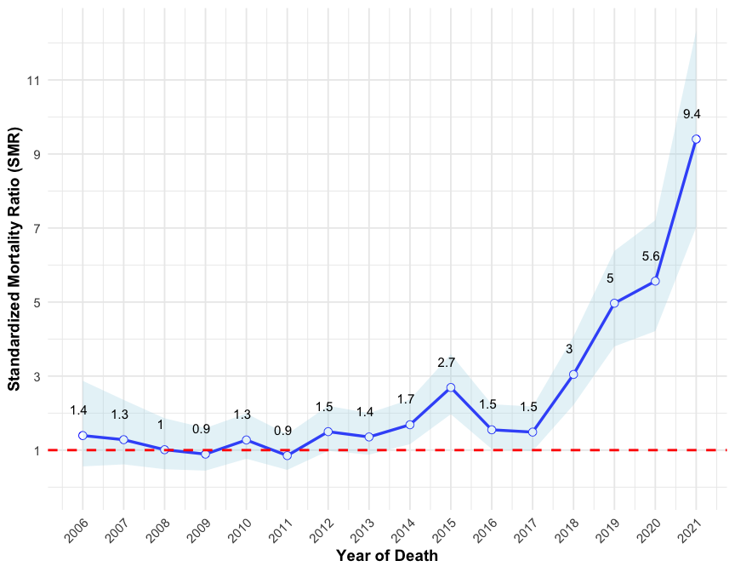

Table 3 CVD SMRs by Year of Death for BC Survivors in Puerto Rico Using PR Population as Referent

| Year of Death | Observed | Expected | SMR | CI.Lower | CI.Upper |
| --- | --- | --- | --- | --- | --- |
| 2005-2010 | 57 | 51.7377 | 1.101711 | 0.8344253 | 1.427395 |
| 2011-2016 | 172 | 106.9309 | 1.608515 | 1.3771058 | 1.867683 |
| 2017-2021 | 241 | 60.3110 | 3.995954 | 3.5073389 | 4.533596 |

Figure 3 CVD SMRs by Year of Death for BC survivors in Puerto Rico Using PR population as Referent 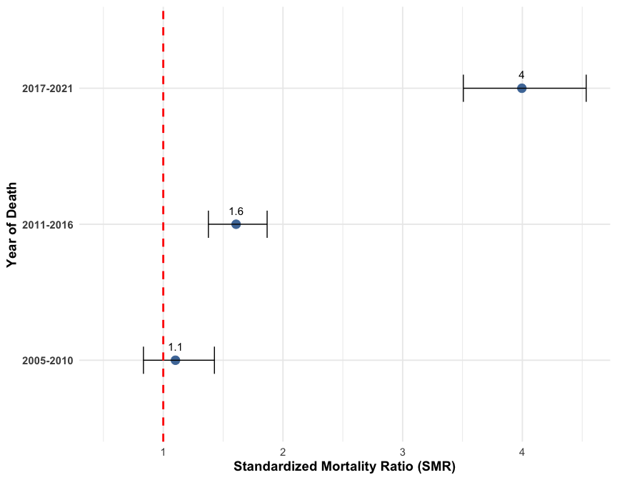

Table 4 CVD SMRs by Year of Diagnosis for BC Survivors in Puerto Rico Using PR Population as Referent

| ydiag | observed | expected | pyrs | sir | sir.lo | sir.hi | p_value |
| --- | --- | --- | --- | --- | --- | --- | --- |
| 2004 | 45 | 30.0760 | 6945.3897 | 1.4962 | 1.091346 | 2.002046 | 0.00687 |
| 2005 | 41 | 25.4642 | 6888.3128 | 1.6101 | 1.155438 | 2.184287 | 0.00229 |
| 2006 | 40 | 22.6376 | 5938.2341 | 1.7670 | 1.262351 | 2.406114 | 0.00032 |
| 2007 | 47 | 23.9226 | 6237.3750 | 1.9647 | 1.443565 | 2.612594 | 0.00000 |
| 2008 | 37 | 21.6141 | 6084.2441 | 1.7118 | 1.205297 | 2.359554 | 0.00108 |
| 2009 | 45 | 17.3703 | 5354.7157 | 2.5906 | 1.889622 | 3.466465 | 0.00000 |
| 2010 | 33 | 16.7004 | 5409.2472 | 1.9760 | 1.360188 | 2.775039 | 0.00009 |
| 2011 | 35 | 14.3978 | 4762.5874 | 2.4309 | 1.693230 | 3.380831 | 0.00000 |
| 2012 | 27 | 11.7011 | 4093.9995 | 2.3075 | 1.520641 | 3.357256 | 0.00001 |
| 2013 | 26 | 9.8842 | 3749.2226 | 2.6305 | 1.718304 | 3.854234 | 0.00000 |
| 2014 | 19 | 7.6202 | 2853.5634 | 2.4934 | 1.501173 | 3.893711 | 0.00007 |
| 2015 | 19 | 6.1120 | 2587.7168 | 3.1086 | 1.871604 | 4.854524 | 0.00000 |
| 2016 | 21 | 4.3810 | 1985.2865 | 4.7934 | 2.967206 | 7.327261 | 0.00000 |
| 2017 | 13 | 3.1486 | 1506.9074 | 4.1289 | 2.198422 | 7.060407 | 0.00000 |
| 2018 | 11 | 2.6134 | 1232.3728 | 4.2090 | 2.101156 | 7.531200 | 0.00000 |
| 2019 | 11 | 1.3361 | 748.8141 | 8.2328 | 4.109842 | 14.730962 | 0.00000 |

Figure 4 CVD SMRs by Year of Diagnosis for BC survivors in Puerto Rico Using PR population as Referent 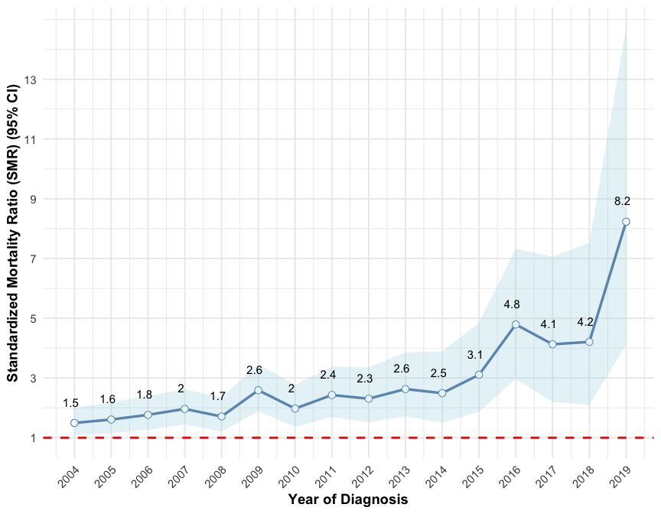 V2: Figure 5 CVD SMRs by Year of Diagnosis for BC survivors in Puerto Rico Using PR population as Referent 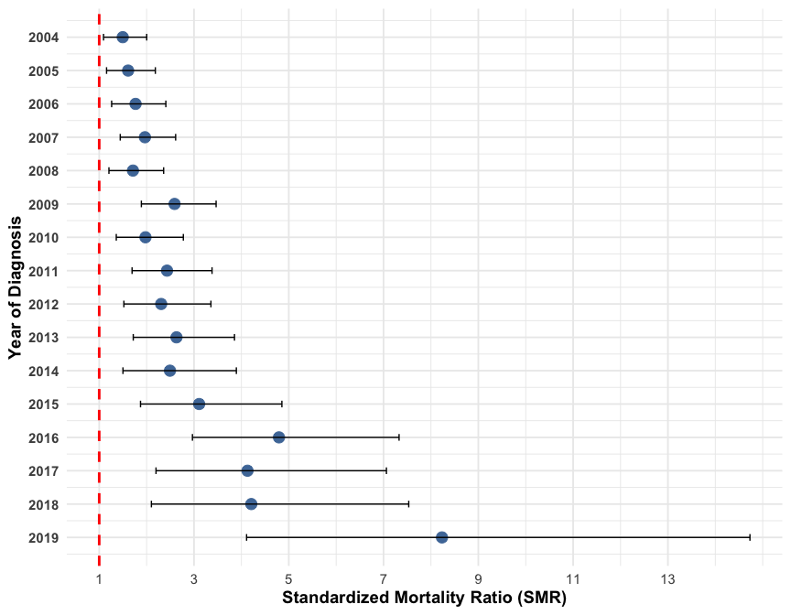

Table 5 CVD SMRs by Year of Diagnosis for BC Survivors in Puerto Rico Using PR Population as Referent

| Year of Diagnosis | Observed | Expected | SMR | CI.Lower | CI.Upper |
| --- | --- | --- | --- | --- | --- |
| 2004-2009 | 255 | 141.0848 | 1.807424 | 1.592372 | 2.043420 |
| 2010-2014 | 140 | 60.3037 | 2.321582 | 1.952958 | 2.739558 |
| 2015-2019 | 75 | 17.5911 | 4.263520 | 3.353529 | 5.344359 |

Figure 6 CVD SMRs by Year of Diagnosis for BC survivors in Puerto Rico Using PR population as Referent 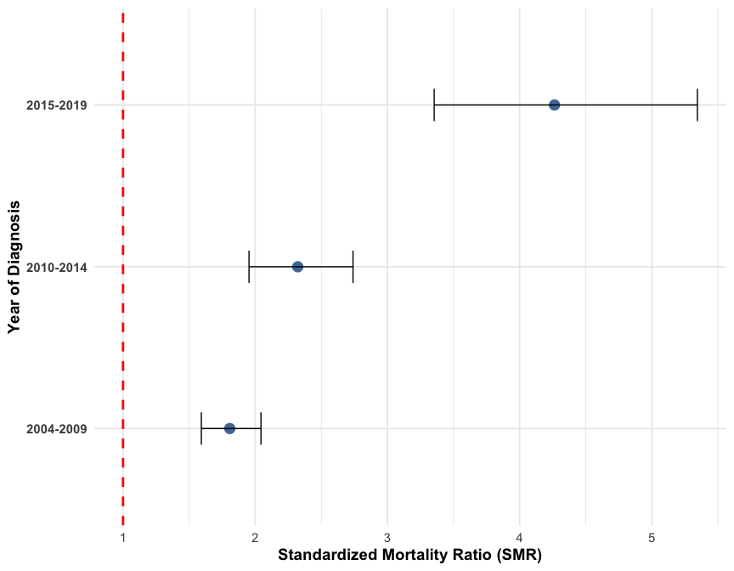

Table 6 CVD SMRs by Age for BC Survivors in Puerto Rico Using PR Population as Referent

| AgeDxCat | observed | expected | pyrs | sir | sir.lo | sir.hi | p_value |
| --- | --- | --- | --- | --- | --- | --- | --- |
| 18-39 | 2 | 0.3618 | 4335.471 | 5.5282 | 0.6694563 | 19.968733 | 0.0156 |
| 40-49 | 13 | 3.0177 | 11221.510 | 4.3079 | 2.2937842 | 7.366669 | 0.0000 |
| 50-59 | 31 | 10.3163 | 15789.738 | 3.0049 | 2.0417200 | 4.265291 | 0.0000 |
| 60-69 | 105 | 31.8479 | 17462.728 | 3.2969 | 2.6965545 | 3.991123 | 0.0000 |
| 70-79 | 160 | 92.2412 | 12236.839 | 1.7346 | 1.4762222 | 2.025151 | 0.0000 |
| 80+ | 159 | 81.1944 | 5331.703 | 1.9583 | 1.6657077 | 2.287411 | 0.0000 |

Figure 7 CVD SMRs by Age for BC survivors in Puerto Rico Using PR population as Referent 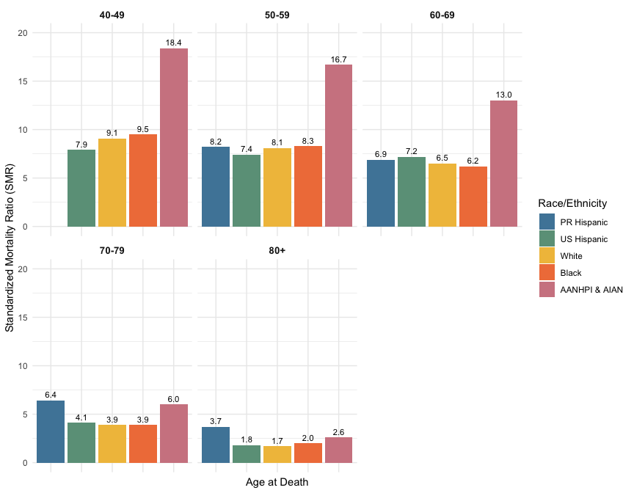

Table 7 CVD SMRs by Initial Treatment Type for BC Survivors in Puerto Rico Using PR Population as Referent

| Procedure | observed | expected | pyrs | sir | sir.lo | sir.hi | p_value |
| --- | --- | --- | --- | --- | --- | --- | --- |
| Surgery Only | 105 | 49.4422 | 10255.05 | 2.1237 | 1.736970 | 2.570859 | 0e+00 |
| Chemotherapy Only | 23 | 10.0487 | 6180.92 | 2.2889 | 1.450937 | 3.434404 | 7e-05 |
| Radiotherapy Only | 80 | 45.8998 | 11781.60 | 1.7429 | 1.382033 | 2.169224 | 0e+00 |
| Chemotherapy and Radiotherapy | 74 | 30.7605 | 17319.30 | 2.4057 | 1.888978 | 3.020114 | 0e+00 |
| Other | 188 | 82.8283 | 20841.12 | 2.2698 | 1.956887 | 2.618421 | 0e+00 |

Figure 8 CVD SMRs by Initial Treatment Type for BC survivors in Puerto Rico Using PR population as Referent 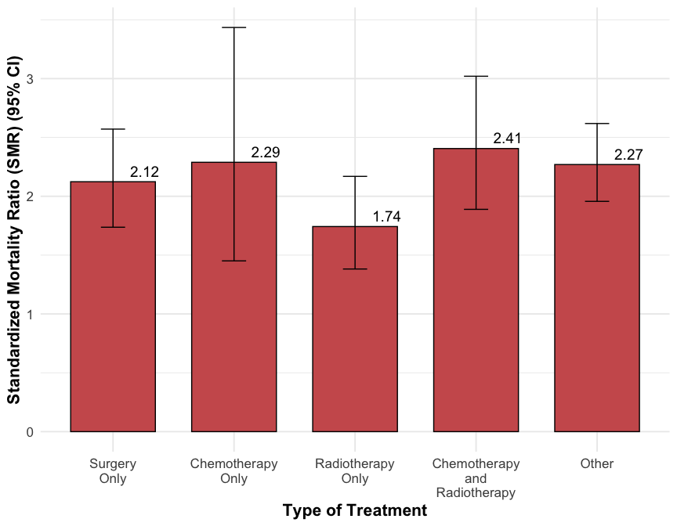

Table 8 CVD SMRs for BC Survivors in Puerto Rico and US Race/Ethnicity Groups Using US Population as Referent

| **PR Hispanic** | | | | **US Hispanic** | | | | **White** | | | | **Black** | | | | **AANHPI & AIAN** | | | |
| --- | --- | --- | --- | --- | --- | --- | --- | --- | --- | --- | --- | --- | --- | --- | --- | --- | --- | --- | --- |
| O | E | SMR | 95% CI | O | E | SMR | 95% CI | O | E | SMR | 95% CI | O | E | SMR | 95% CI | O | E | SMR | 95% CI |
| 470 | 101.6 | 4.6 | (4.2 - 5.1) | 2,193 | 901.9 | 2.4 | (2.3 - 2.5) | 23,582 | 11,360.5 | 2.1 | (2.0 - 2.1) | 3,292 | 1,089.8 | 3.0 | (2.9 - 3.1) | 1,632 | 467.6 | 3.5 | (3.3 - 3.7) |
| SMRs were calculated as the observed number of cardiovascular disease deaths among breast cancer patients divided by the expected number of cardiovascular disease deaths in the race- and ethnic-matched general female U.S. population. SMR calculations for results with <10 events were suppressed. O = Observed; E = Expected; SMR = Standarized Mortality Ratio; AANHPI & AIAN encompasses: Asian American, Native Hawaiian and other Pacific Islanders along with American Indian/Alaska Natives. | | | | | | | | | | | | | | | | | | | |

Figure 1 CVD SMRs for BC survivors in Puerto Rico and US Race/Ethnicity groups using US population as referent 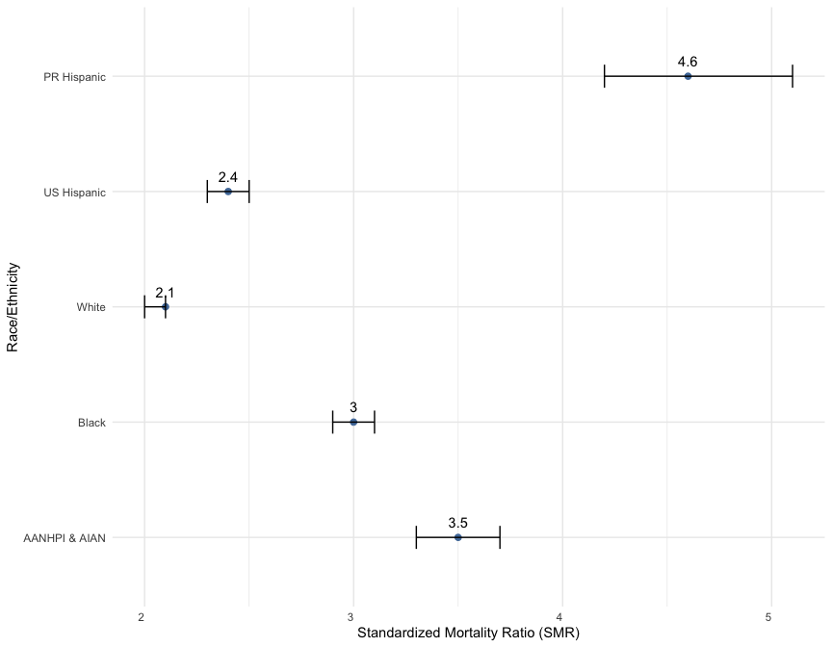

Table 9 CVD SMRs by Year of Death for BC Survivors in Puerto Rico and US Race/Ethnicity Groups Using US population as Referent

|  | **PR Hispanic** | | | | **US Hispanic** | | | | **White** | | | | **Black** | | | | **AANHPI & AIAN** | | | |
| --- | --- | --- | --- | --- | --- | --- | --- | --- | --- | --- | --- | --- | --- | --- | --- | --- | --- | --- | --- | --- |
| Year of Death | O | E | SMR | 95% CI | O | E | SMR | 95% CI | O | E | SMR | 95% CI | O | E | SMR | 95% CI | O | E | SMR | 95% CI |
| 2005 | <10 | - | - | - | <10 | - | - | - | 98 | 3.8 | 25.6 | (20.8 - 31.3) | 13 | 0.4 | 34.0 | (18.1 - 58.1) | <10 | - | - | - |
| 2006 | <10 | - | - | - | 24 | 1.7 | 13.9 | (8.9 - 20.8) | 280 | 26.3 | 10.6 | (9.4 - 12.0) | 49 | 3.5 | 13.9 | (10.3 - 18.4) | 19 | 0.6 | 31.5 | (18.9 - 49.1) |
| 2007 | 10 | 3.0 | 3.3 | (1.6 - 6.0) | 22 | 3.8 | 5.8 | (3.6 - 8.8) | 435 | 69.1 | 6.3 | (5.7 - 6.9) | 57 | 7.6 | 7.5 | (5.7 - 9.8) | 25 | 2.0 | 12.3 | (8.0 - 18.2) |
| 2008 | 10 | 4.0 | 2.5 | (1.2 - 4.6) | 61 | 9.0 | 6.8 | (5.2 - 8.7) | 600 | 115.6 | 5.2 | (4.8 - 5.6) | 77 | 14.8 | 5.2 | (4.1 - 6.5) | 31 | 3.1 | 9.9 | (6.8 - 14.1) |
| 2009 | 11 | 5.1 | 2.2 | (1.1 - 3.9) | 63 | 12.5 | 5.1 | (3.9 - 6.5) | 710 | 189.7 | 3.7 | (3.5 - 4.0) | 97 | 19.4 | 5.0 | (4.0 - 6.1) | 48 | 5.0 | 9.5 | (7.0 - 12.7) |
| 2010 | 19 | 5.9 | 3.2 | (1.9 - 5.0) | 76 | 18.6 | 4.1 | (3.2 - 5.1) | 970 | 259.1 | 3.7 | (3.5 - 4.0) | 134 | 26.7 | 5.0 | (4.2 - 5.9) | 63 | 7.6 | 8.2 | (6.3 - 10.6) |
| 2011 | 14 | 6.8 | 2.1 | (1.1 - 3.5) | 79 | 23.7 | 3.3 | (2.6 - 4.2) | 1,071 | 354.9 | 3.0 | (2.8 - 3.2) | 158 | 38.3 | 4.1 | (3.5 - 4.8) | 55 | 11.0 | 5.0 | (3.8 - 6.5) |
| 2012 | 26 | 7.5 | 3.5 | (2.3 - 5.1) | 108 | 28.2 | 3.8 | (3.1 - 4.6) | 1,226 | 457.9 | 2.7 | (2.5 - 2.8) | 169 | 42.3 | 4.0 | (3.4 - 4.6) | 83 | 13.8 | 6.0 | (4.8 - 7.5) |
| 2013 | 25 | 8.4 | 3.0 | (1.9 - 4.4) | 91 | 39.8 | 2.3 | (1.8 - 2.8) | 1,364 | 563.0 | 2.4 | (2.3 - 2.5) | 188 | 49.9 | 3.8 | (3.2 - 4.3) | 70 | 18.5 | 3.8 | (3.0 - 4.8) |
| 2014 | 33 | 8.6 | 3.9 | (2.7 - 5.4) | 119 | 45.1 | 2.6 | (2.2 - 3.2) | 1,514 | 652.7 | 2.3 | (2.2 - 2.4) | 194 | 58.7 | 3.3 | (2.9 - 3.8) | 90 | 22.7 | 4.0 | (3.2 - 4.9) |
| 2015 | 46 | 9.0 | 5.1 | (3.8 - 6.8) | 150 | 57.1 | 2.6 | (2.2 - 3.1) | 1,784 | 812.7 | 2.2 | (2.1 - 2.3) | 226 | 71.6 | 3.1 | (2.8 - 3.6) | 111 | 33.3 | 3.3 | (2.7 - 4.0) |
| 2016 | 28 | 8.7 | 3.2 | (2.1 - 4.6) | 190 | 72.9 | 2.6 | (2.2 - 3.0) | 1,957 | 947.6 | 2.1 | (2.0 - 2.2) | 246 | 85.3 | 2.9 | (2.5 - 3.3) | 137 | 34.2 | 4.0 | (3.4 - 4.7) |
| 2017 | 26 | 8.5 | 3.0 | (2.0 - 4.5) | 199 | 88.8 | 2.2 | (1.9 - 2.6) | 2,124 | 1,106.1 | 1.9 | (1.8 - 2.0) | 279 | 104.3 | 2.7 | (2.4 - 3.0) | 162 | 46.0 | 3.5 | (3.0 - 4.1) |
| 2018 | 45 | 7.9 | 5.7 | (4.2 - 7.7) | 211 | 93.0 | 2.3 | (2.0 - 2.6) | 2,185 | 1,239.4 | 1.8 | (1.7 - 1.8) | 330 | 112.5 | 2.9 | (2.6 - 3.3) | 160 | 52.3 | 3.1 | (2.6 - 3.6) |
| 2019 | 61 | 6.8 | 9.0 | (6.9 - 11.5) | 233 | 112.8 | 2.1 | (1.8 - 2.4) | 2,307 | 1,309.0 | 1.8 | (1.7 - 1.8) | 350 | 127.3 | 2.8 | (2.5 - 3.0) | 182 | 66.7 | 2.7 | (2.4 - 3.1) |
| 2020 | 57 | 5.6 | 10.2 | (7.8 - 13.3) | 264 | 135.1 | 1.9 | (1.7 - 2.2) | 2,469 | 1,599.8 | 1.5 | (1.5 - 1.6) | 339 | 160.0 | 2.1 | (1.9 - 2.4) | 184 | 74.1 | 2.5 | (2.1 - 2.9) |
| 2021 | 52 | 3.1 | 17.0 | (12.7 - 22.3) | 294 | 159.4 | 1.8 | (1.6 - 2.1) | 2,488 | 1,653.7 | 1.5 | (1.4 - 1.6) | 386 | 167.1 | 2.3 | (2.1 - 2.5) | 206 | 76.5 | 2.7 | (2.3 - 3.1) |
| SMRs were calculated as the observed number of cardiovascular disease deaths among breast cancer patients divided by the expected number of cardiovascular disease deaths in the race- and ethnic-matched general female U.S. population. SMR calculations for results with <10 events were suppressed. O = Observed; E = Expected; SMR = Standarized Mortality Ratio; AANHPI & AIAN encompasses: Asian American, Native Hawaiian and other Pacific Islanders along with American Indian/Alaska Natives. | | | | | | | | | | | | | | | | | | | | |

Figure 2 CVD SMRs by Year of Death for BC survivors in Puerto Rico and US Race/Ethnicity Groups Using US population as Referent 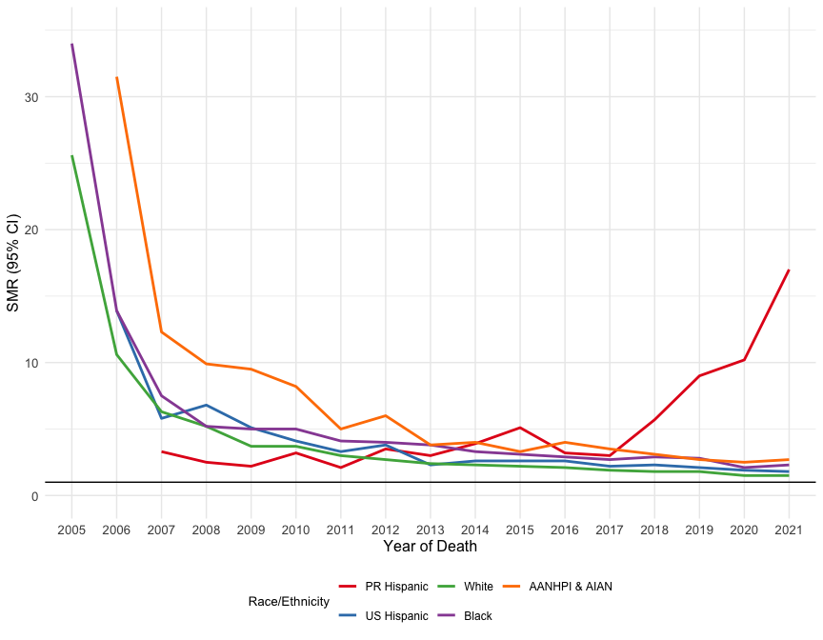

Table 10 CVD SMRs by Year of Death for BC Survivors in Puerto Rico and US Race/Ethnicity Groups Using US population as Referent

|  | **PR Hispanic** | | | | **US Hispanic** | | | | **White** | | | | **Black** | | | | **AANHPI & AIAN** | | | |
| --- | --- | --- | --- | --- | --- | --- | --- | --- | --- | --- | --- | --- | --- | --- | --- | --- | --- | --- | --- | --- |
| Year of Death | O | E | SMR | 95% CI | O | E | SMR | 95% CI | O | E | SMR | 95% CI | O | E | SMR | 95% CI | O | E | SMR | 95% CI |
| 2005-2010 | 57 | 20.8 | 2.7 | (2.1 - 3.5) | 255 | 46.0 | 5.5 | (4.9 - 6.3) | 3,093 | 663.6 | 4.7 | (4.5 - 4.8) | 427 | 72.4 | 5.9 | (5.4 - 6.5) | 192 | 18.5 | 10.4 | (9.0 - 11.9) |
| 2011-2016 | 172 | 49.0 | 3.5 | (3.0 - 4.1) | 737 | 266.8 | 2.8 | (2.6 - 3.0) | 8,916 | 3,788.8 | 2.4 | (2.3 - 2.4) | 1,181 | 346.1 | 3.4 | (3.2 - 3.6) | 546 | 133.5 | 4.1 | (3.8 - 4.4) |
| 2017-2021 | 241 | 31.8 | 7.6 | (6.6 - 8.6) | 1,201 | 589.1 | 2.0 | (1.9 - 2.2) | 11,573 | 6,908.0 | 1.7 | (1.6 - 1.7) | 1,684 | 671.2 | 2.5 | (2.4 - 2.6) | 894 | 315.5 | 2.8 | (2.7 - 3.0) |
| SMRs were calculated as the observed number of cardiovascular disease deaths among breast cancer patients divided by the expected number of cardiovascular disease deaths in the race- and ethnic-matched general female U.S. population. SMR calculations for results with <10 events were suppressed. O = Observed; E = Expected; SMR = Standarized Mortality Ratio; AANHPI & AIAN encompasses: Asian American, Native Hawaiian and other Pacific Islanders along with American Indian/Alaska Natives. | | | | | | | | | | | | | | | | | | | | |

Figure 3 CVD SMRs by Year of Death for BC survivors in Puerto Rico and US Race/Ethnicity Groups Using US population as Referent 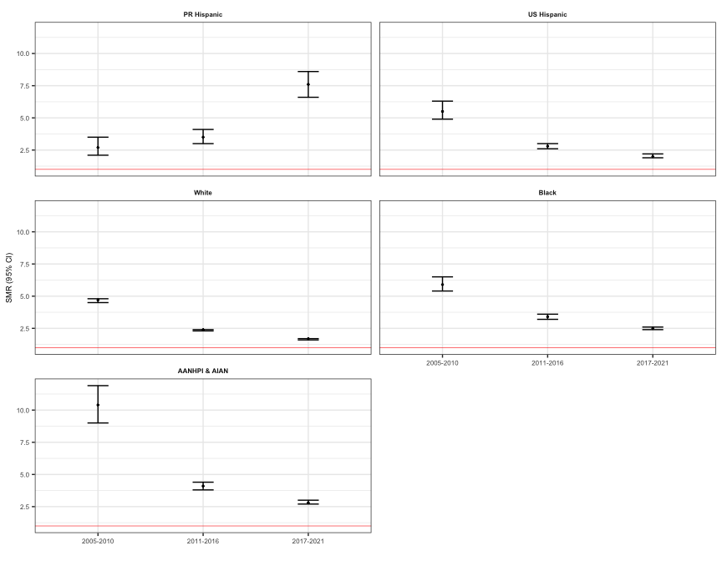

Table 11 CVD SMRs by Year of Diagnosis for BC Survivors in Puerto Rico and US Race/Ethnicity Groups Using US population as Referent

|  | **PR Hispanic** | | | | **US Hispanic** | | | | **White** | | | | **Black** | | | | **AANHPI & AIAN** | | | |
| --- | --- | --- | --- | --- | --- | --- | --- | --- | --- | --- | --- | --- | --- | --- | --- | --- | --- | --- | --- | --- |
| Year of Diagnosis | O | E | SMR | 95% CI | O | E | SMR | 95% CI | O | E | SMR | 95% CI | O | E | SMR | 95% CI | O | E | SMR | 95% CI |
| 2004 | 45 | 13.0 | 3.4 | (2.5 - 4.6) | 227 | 124.8 | 1.8 | (1.6 - 2.1) | 2,927 | 1,858.3 | 1.6 | (1.5 - 1.6) | 340 | 154.5 | 2.2 | (2.0 - 2.5) | 162 | 62.9 | 2.6 | (2.2 - 3.0) |
| 2005 | 41 | 11.1 | 3.7 | (2.7 - 5.0) | 246 | 128.6 | 1.9 | (1.7 - 2.2) | 2,695 | 1,611.2 | 1.7 | (1.6 - 1.7) | 317 | 129.5 | 2.5 | (2.2 - 2.7) | 181 | 64.7 | 2.8 | (2.4 - 3.2) |
| 2006 | 40 | 9.9 | 4.0 | (2.9 - 5.5) | 189 | 97.0 | 2.0 | (1.7 - 2.2) | 2,510 | 1,437.0 | 1.8 | (1.7 - 1.8) | 306 | 122.7 | 2.5 | (2.2 - 2.8) | 158 | 51.9 | 3.0 | (2.6 - 3.6) |
| 2007 | 47 | 10.8 | 4.4 | (3.2 - 5.8) | 190 | 96.5 | 2.0 | (1.7 - 2.3) | 2,304 | 1,269.1 | 1.8 | (1.7 - 1.9) | 278 | 115.4 | 2.4 | (2.1 - 2.7) | 154 | 53.0 | 2.9 | (2.5 - 3.4) |
| 2008 | 37 | 9.8 | 3.8 | (2.7 - 5.2) | 182 | 82.0 | 2.2 | (1.9 - 2.6) | 2,058 | 1,092.4 | 1.9 | (1.8 - 2.0) | 286 | 111.5 | 2.6 | (2.3 - 2.9) | 143 | 47.0 | 3.0 | (2.6 - 3.6) |
| 2009 | 45 | 8.0 | 5.6 | (4.1 - 7.5) | 187 | 70.8 | 2.6 | (2.3 - 3.0) | 1,952 | 956.3 | 2.0 | (2.0 - 2.1) | 269 | 87.3 | 3.1 | (2.7 - 3.5) | 126 | 41.2 | 3.1 | (2.5 - 3.6) |
| 2010 | 33 | 7.9 | 4.2 | (2.9 - 5.8) | 168 | 60.7 | 2.8 | (2.4 - 3.2) | 1,700 | 773.2 | 2.2 | (2.1 - 2.3) | 230 | 80.0 | 2.9 | (2.5 - 3.3) | 123 | 32.4 | 3.8 | (3.2 - 4.5) |
| 2011 | 35 | 7.0 | 5.0 | (3.5 - 7.0) | 150 | 60.4 | 2.5 | (2.1 - 2.9) | 1,521 | 637.1 | 2.4 | (2.3 - 2.5) | 209 | 67.5 | 3.1 | (2.7 - 3.5) | 118 | 28.6 | 4.1 | (3.4 - 4.9) |
| 2012 | 27 | 5.8 | 4.7 | (3.1 - 6.8) | 132 | 45.9 | 2.9 | (2.4 - 3.4) | 1,321 | 511.4 | 2.6 | (2.5 - 2.7) | 210 | 62.7 | 3.4 | (2.9 - 3.8) | 106 | 24.3 | 4.4 | (3.6 - 5.3) |
| 2013 | 26 | 5.0 | 5.2 | (3.4 - 7.6) | 127 | 41.1 | 3.1 | (2.6 - 3.7) | 1,112 | 396.4 | 2.8 | (2.6 - 3.0) | 194 | 50.9 | 3.8 | (3.3 - 4.4) | 103 | 21.4 | 4.8 | (3.9 - 5.8) |
| 2014 | 19 | 3.9 | 4.8 | (2.9 - 7.5) | 114 | 34.2 | 3.3 | (2.8 - 4.0) | 977 | 284.9 | 3.4 | (3.2 - 3.6) | 152 | 35.1 | 4.3 | (3.7 - 5.1) | 66 | 13.7 | 4.8 | (3.7 - 6.1) |
| 2015 | 19 | 3.2 | 6.0 | (3.6 - 9.4) | 95 | 23.6 | 4.0 | (3.3 - 4.9) | 817 | 221.7 | 3.7 | (3.4 - 4.0) | 149 | 28.2 | 5.3 | (4.5 - 6.2) | 58 | 10.8 | 5.4 | (4.1 - 7.0) |
| 2016 | 21 | 2.3 | 9.0 | (5.6 - 13.8) | 58 | 15.9 | 3.6 | (2.8 - 4.7) | 648 | 151.1 | 4.3 | (4.0 - 4.6) | 120 | 19.2 | 6.2 | (5.2 - 7.5) | 54 | 7.3 | 7.4 | (5.5 - 9.6) |
| 2017 | 13 | 1.7 | 7.6 | (4.0 - 12.9) | 54 | 11.4 | 4.7 | (3.6 - 6.2) | 458 | 89.1 | 5.1 | (4.7 - 5.6) | 117 | 14.3 | 8.2 | (6.8 - 9.8) | 37 | 4.3 | 8.6 | (6.0 - 11.8) |
| 2018 | 11 | 1.4 | 7.7 | (3.8 - 13.7) | 45 | 6.2 | 7.2 | (5.3 - 9.7) | 376 | 51.8 | 7.3 | (6.6 - 8.0) | 72 | 8.2 | 8.8 | (6.9 - 11.1) | 24 | 2.8 | 8.7 | (5.6 - 12.9) |
| 2019 | 11 | 0.7 | 14.9 | (7.4 - 26.7) | 29 | 2.8 | 10.3 | (6.9 - 14.7) | 206 | 19.4 | 10.6 | (9.2 - 12.2) | 43 | 3.0 | 14.4 | (10.4 - 19.4) | 19 | 1.3 | 14.5 | (8.8 - 22.7) |
| SMRs were calculated as the observed number of cardiovascular disease deaths among breast cancer patients divided by the expected number of cardiovascular disease deaths in the race- and ethnic-matched general female U.S. population. SMR calculations for results with <10 events were suppressed. O = Observed; E = Expected; SMR = Standarized Mortality Ratio; AANHPI & AIAN encompasses: Asian American, Native Hawaiian and other Pacific Islanders along with American Indian/Alaska Natives. | | | | | | | | | | | | | | | | | | | | |

Figure 4 CVD SMRs by Year of Diagnosis for BC survivors in Puerto Rico and US Race/Ethnicity Groups Using US population as Referent 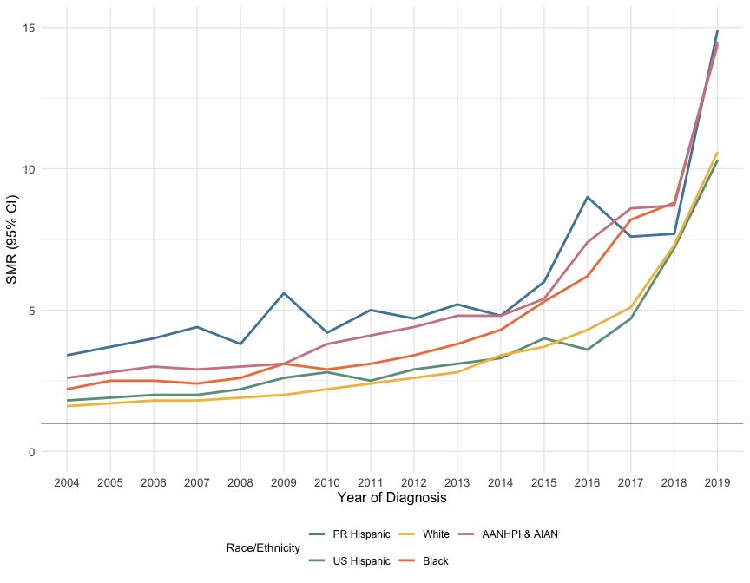

Table 12 CVD SMRs by Year of Diagnosis for BC Survivors in Puerto Rico and US Race/Ethnicity Groups Using US population as Referent

|  | **PR Hispanic** | | | | **US Hispanic** | | | | **White** | | | | **Black** | | | | **AANHPI & AIAN** | | | |
| --- | --- | --- | --- | --- | --- | --- | --- | --- | --- | --- | --- | --- | --- | --- | --- | --- | --- | --- | --- | --- |
| Year of Diagnosis | O | E | SMR | 95% CI | O | E | SMR | 95% CI | O | E | SMR | 95% CI | O | E | SMR | 95% CI | O | E | SMR | 95% CI |
| 2004-2009 | 255 | 62.6 | 4.1 | (3.6 - 4.6) | 1,221 | 599.8 | 2.0 | (1.9 - 2.2) | 14,446 | 8,224.3 | 1.8 | (1.7 - 1.8) | 1,796 | 720.8 | 2.5 | (2.4 - 2.6) | 924 | 320.6 | 2.9 | (2.7 - 3.1) |
| 2010-2015 | 159 | 32.8 | 4.9 | (4.1 - 5.7) | 786 | 265.8 | 3.0 | (2.8 - 3.2) | 7,448 | 2,824.7 | 2.6 | (2.6 - 2.7) | 1,144 | 324.3 | 3.5 | (3.3 - 3.7) | 574 | 131.3 | 4.4 | (4.0 - 4.7) |
| 2016-2021 | 56 | 6.2 | 9.0 | (6.8 - 11.7) | 186 | 36.3 | 5.1 | (4.4 - 5.9) | 1,688 | 311.4 | 5.4 | (5.2 - 5.7) | 352 | 44.7 | 7.9 | (7.1 - 8.7) | 134 | 15.7 | 8.5 | (7.2 - 10.1) |
| SMRs were calculated as the observed number of cardiovascular disease deaths among breast cancer patients divided by the expected number of cardiovascular disease deaths in the race- and ethnic-matched general female U.S. population. SMR calculations for results with <10 events were suppressed. O = Observed; E = Expected; SMR = Standarized Mortality Ratio; AANHPI & AIAN encompasses: Asian American, Native Hawaiian and other Pacific Islanders along with American Indian/Alaska Natives. | | | | | | | | | | | | | | | | | | | | |

Figure 5 CVD SMRs by Year of Diagnosis for BC survivors in Puerto Rico and US Race/Ethnicity Groups Using US population as Referent 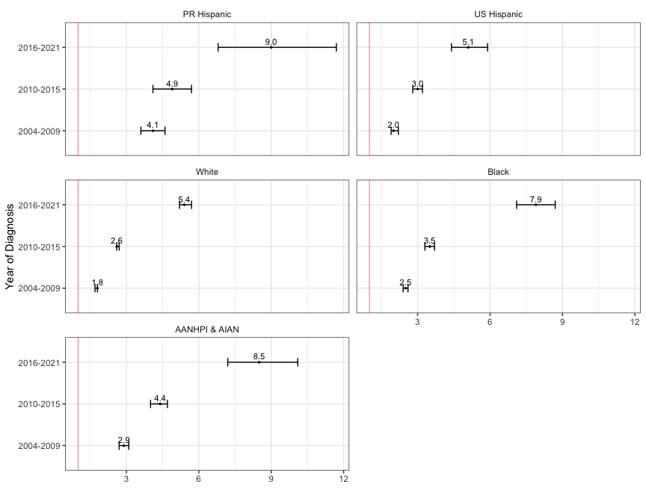

Table 13 CVD SMRs by Age at Diagnosis for BC Survivors in Puerto Rico and US Race/Ethnicity Groups Using US population as Referent

|  | **PR Hispanic** | | | | **US Hispanic** | | | | **White** | | | | **Black** | | | | **AANHPI & AIAN** | | | |
| --- | --- | --- | --- | --- | --- | --- | --- | --- | --- | --- | --- | --- | --- | --- | --- | --- | --- | --- | --- | --- |
| Age at Diagnosis | O | E | SMR | 95% CI | O | E | SMR | 95% CI | O | E | SMR | 95% CI | O | E | SMR | 95% CI | O | E | SMR | 95% CI |
| 18-39 | <10 | - | - | - | 15 | 1.1 | 13.2 | (7.4 - 21.8) | 43 | 2.9 | 14.8 | (10.7 - 19.9) | 40 | 2.6 | 15.6 | (11.2 - 21.3) | 12 | 0.3 | 36.3 | (18.8 - 63.4) |
| 40-49 | 13 | 1.5 | 8.4 | (4.5 - 14.4) | 63 | 7.2 | 8.8 | (6.7 - 11.2) | 299 | 28.0 | 10.7 | (9.5 - 12.0) | 206 | 17.8 | 11.6 | (10.1 - 13.3) | 43 | 2.2 | 19.3 | (14.0 - 26.0) |
| 50-59 | 31 | 5.1 | 6.0 | (4.1 - 8.5) | 189 | 23.4 | 8.1 | (7.0 - 9.3) | 1,190 | 138.2 | 8.6 | (8.1 - 9.1) | 490 | 64.2 | 7.6 | (7.0 - 8.3) | 157 | 9.1 | 17.2 | (14.6 - 20.1) |
| 60-69 | 105 | 15.2 | 6.9 | (5.7 - 8.4) | 493 | 79.0 | 6.2 | (5.7 - 6.8) | 3,665 | 663.6 | 5.5 | (5.3 - 5.7) | 774 | 157.2 | 4.9 | (4.6 - 5.3) | 295 | 32.9 | 9.0 | (8.0 - 10.1) |
| 70-79 | 160 | 42.8 | 3.7 | (3.2 - 4.4) | 710 | 316.1 | 2.2 | (2.1 - 2.4) | 7,610 | 3,500.8 | 2.2 | (2.1 - 2.2) | 971 | 361.6 | 2.7 | (2.5 - 2.9) | 541 | 153.2 | 3.5 | (3.2 - 3.8) |
| 80+ | 159 | 36.8 | 4.3 | (3.7 - 5.0) | 723 | 475.1 | 1.5 | (1.4 - 1.6) | 10,775 | 7,027.0 | 1.5 | (1.5 - 1.6) | 811 | 486.5 | 1.7 | (1.6 - 1.8) | 584 | 269.9 | 2.2 | (2.0 - 2.4) |
| SMRs were calculated as the observed number of cardiovascular disease deaths among breast cancer patients divided by the expected number of cardiovascular disease deaths in the race- and ethnic-matched general female U.S. population. SMR calculations for results with <10 events were suppressed. O = Observed; E = Expected; SMR = Standarized Mortality Ratio; AANHPI & AIAN encompasses: Asian American, Native Hawaiian and other Pacific Islanders along with American Indian/Alaska Natives. | | | | | | | | | | | | | | | | | | | | |

Figure 6 CVD SMRs by Age at Diagnosis for BC survivors in Puerto Rico and US Race/Ethnicity Groups Using US population as Referent 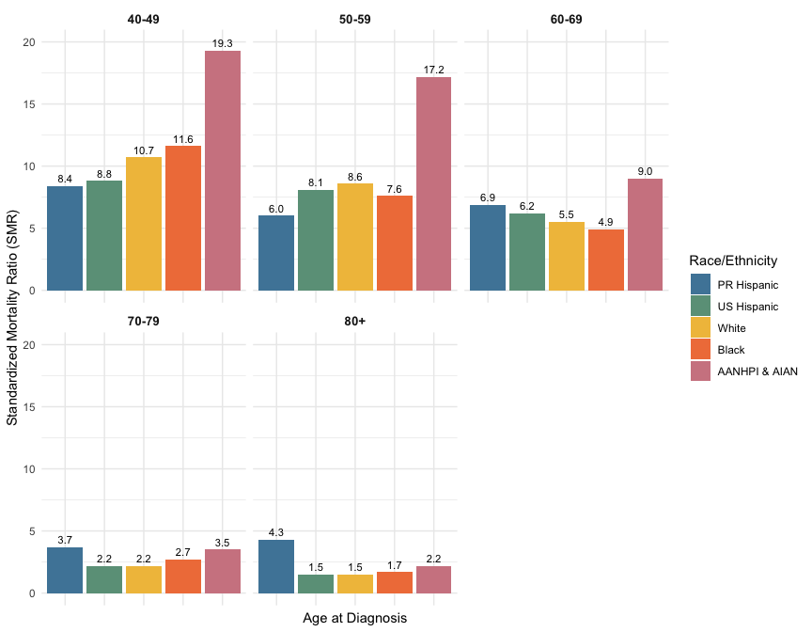

Table 14 CVD SMRs by Age at Death for BC Survivors in Puerto Rico and US Race/Ethnicity Groups Using US population as Referent

|  | **PR Hispanic** | | | | **US Hispanic** | | | | **White** | | | | **Black** | | | | **AANHPI & AIAN** | | | |
| --- | --- | --- | --- | --- | --- | --- | --- | --- | --- | --- | --- | --- | --- | --- | --- | --- | --- | --- | --- | --- |
| Age Group | O | E | SMR | 95% CI | O | E | SMR | 95% CI | O | E | SMR | 95% CI | O | E | SMR | 95% CI | O | E | SMR | 95% CI |
| 18-39 | <10 | - | - | - | <10 | - | - | - | 16 | 0.8 | 21.3 | (12.2 - 34.6) | 15 | 0.8 | 18.9 | (10.6 - 31.2) | <10 | - | - | - |
| 40-49 | <10 | - | - | - | 25 | 3.1 | 7.9 | (5.1 - 11.7) | 87 | 9.6 | 9.1 | (7.3 - 11.2) | 72 | 7.6 | 9.5 | (7.4 - 12.0) | 17 | 0.9 | 18.4 | (10.7 - 29.5) |
| 50-59 | 21 | 2.6 | 8.2 | (5.1 - 12.5) | 94 | 12.7 | 7.4 | (6.0 - 9.1) | 471 | 58.5 | 8.1 | (7.3 - 8.8) | 296 | 35.5 | 8.3 | (7.4 - 9.3) | 72 | 4.3 | 16.7 | (13.0 - 21.0) |
| 60-69 | 53 | 7.7 | 6.9 | (5.2 - 9.1) | 269 | 37.2 | 7.2 | (6.4 - 8.1) | 1,693 | 262.0 | 6.5 | (6.2 - 6.8) | 591 | 96.1 | 6.2 | (5.7 - 6.7) | 198 | 15.3 | 13.0 | (11.2 - 14.9) |
| 70-79 | 123 | 19.3 | 6.4 | (5.3 - 7.6) | 516 | 126.6 | 4.1 | (3.7 - 4.4) | 4,556 | 1,171.2 | 3.9 | (3.8 - 4.0) | 865 | 222.2 | 3.9 | (3.6 - 4.2) | 337 | 56.0 | 6.0 | (5.4 - 6.7) |
| 80+ | 267 | 71.6 | 3.7 | (3.3 - 4.2) | 1,285 | 721.9 | 1.8 | (1.7 - 1.9) | 16,759 | 9,858.4 | 1.7 | (1.7 - 1.7) | 1,453 | 727.6 | 2.0 | (1.9 - 2.1) | 1,005 | 391.0 | 2.6 | (2.4 - 2.7) |
| SMRs were calculated as the observed number of cardiovascular disease deaths among breast cancer patients divided by the expected number of cardiovascular disease deaths in the race- and ethnic-matched general female U.S. population. SMR calculations for results with <10 events were suppressed. O = Observed; E = Expected; SMR = Standarized Mortality Ratio; AANHPI & AIAN encompasses: Asian American, Native Hawaiian and other Pacific Islanders along with American Indian/Alaska Natives. | | | | | | | | | | | | | | | | | | | | |

Figure 7 CVD SMRs by Age at Death for BC survivors in Puerto Rico and US Race/Ethnicity Groups Using US population as Referent 

Table 15 CVD SMRs by Stage for BC Survivors in Puerto Rico and US Race/Ethnicity Groups Using US population as Referent

|  | **PR Hispanic** | | | | **US Hispanic** | | | | **White** | | | | **Black** | | | | **AANHPI & AIAN** | | | |
| --- | --- | --- | --- | --- | --- | --- | --- | --- | --- | --- | --- | --- | --- | --- | --- | --- | --- | --- | --- | --- |
| Stage | O | E | SMR | 95% CI | O | E | SMR | 95% CI | O | E | SMR | 95% CI | O | E | SMR | 95% CI | O | E | SMR | 95% CI |
| Localized | 300 | 63.9 | 4.7 | (4.2 - 5.3) | 1,417 | 603.3 | 2.4 | (2.2 - 2.5) | 16,604 | 8,124.6 | 2.0 | (2.0 - 2.1) | 1,957 | 683.5 | 2.9 | (2.7 - 3.0) | 1,108 | 323.0 | 3.4 | (3.2 - 3.6) |
| Regional | 137 | 30.2 | 4.5 | (3.8 - 5.4) | 685 | 247.5 | 2.8 | (2.6 - 3.0) | 6,008 | 2,720.3 | 2.2 | (2.1 - 2.3) | 1,138 | 334.9 | 3.4 | (3.2 - 3.6) | 441 | 120.5 | 3.7 | (3.3 - 4.0) |
| Distant | 10 | 2.7 | 3.7 | (1.8 - 6.9) | 47 | 28.0 | 1.7 | (1.2 - 2.2) | 516 | 277.0 | 1.9 | (1.7 - 2.0) | 131 | 37.5 | 3.5 | (2.9 - 4.1) | 53 | 13.9 | 3.8 | (2.9 - 5.0) |
| Unknown/unstaged | 23 | - | - | - | 44 | - | - | - | 454 | - | - | - | 66 | - | - | - | 30 | - | - | - |
| SMRs were calculated as the observed number of cardiovascular disease deaths among breast cancer patients divided by the expected number of cardiovascular disease deaths in the race- and ethnic-matched general female U.S. population. SMR calculations for results with <10 events were suppressed. O = Observed; E = Expected; SMR = Standarized Mortality Ratio; AANHPI & AIAN encompasses: Asian American, Native Hawaiian and other Pacific Islanders along with American Indian/Alaska Natives. | | | | | | | | | | | | | | | | | | | | |

Table 16 CVD SMRs by Treatment for BC Survivors in Puerto Rico and US Race/Ethnicity Groups Using US population as Referent

|  | **PR Hispanic** | | | | **US Hispanic** | | | | **White** | | | | **Black** | | | | **AANHPI & AIAN** | | | |
| --- | --- | --- | --- | --- | --- | --- | --- | --- | --- | --- | --- | --- | --- | --- | --- | --- | --- | --- | --- | --- |
| Treatment | O | E | SMR | 95% CI | O | E | SMR | 95% CI | O | E | SMR | 95% CI | O | E | SMR | 95% CI | O | E | SMR | 95% CI |
| Surgery Only | 105 | 22.5 | 4.7 | (3.8 - 5.6) | 1,015 | 436.5 | 2.3 | (2.2 - 2.5) | 11,353 | 5,716.7 | 2.0 | (2.0 - 2.0) | 1,287 | 488.9 | 2.6 | (2.5 - 2.8) | 724 | 230.2 | 3.1 | (2.9 - 3.4) |
| Chemotherapy Only | 23 | 4.8 | 4.8 | (3.0 - 7.2) | 245 | 67.3 | 3.6 | (3.2 - 4.1) | 1,621 | 539.3 | 3.0 | (2.9 - 3.2) | 512 | 114.6 | 4.5 | (4.1 - 4.9) | 151 | 28.7 | 5.3 | (4.5 - 6.2) |
| Radiotherapy Only | 80 | 21.0 | 3.8 | (3.0 - 4.7) | 513 | 248.7 | 2.1 | (1.9 - 2.2) | 6,961 | 3,715.9 | 1.9 | (1.8 - 1.9) | 707 | 257.3 | 2.8 | (2.5 - 3.0) | 440 | 143.0 | 3.1 | (2.8 - 3.4) |
| Chemotherapy and Radiotherapy | 74 | 14.5 | 5.1 | (4.0 - 6.4) | 245 | 71.6 | 3.4 | (3.0 - 3.9) | 1,957 | 650.0 | 3.0 | (2.9 - 3.1) | 522 | 125.7 | 4.2 | (3.8 - 4.5) | 191 | 35.5 | 5.4 | (4.6 - 6.2) |
| Other | 188 | 38.8 | 4.8 | (4.2 - 5.6) | 175 | 77.9 | 2.2 | (1.9 - 2.6) | 1,690 | 738.6 | 2.3 | (2.2 - 2.4) | 264 | 103.4 | 2.5 | (2.2 - 2.9) | 126 | 30.2 | 4.2 | (3.5 - 5.0) |
| SMRs were calculated as the observed number of cardiovascular disease deaths among breast cancer patients divided by the expected number of cardiovascular disease deaths in the race- and ethnic-matched general female U.S. population. SMR calculations for results with <10 events were suppressed. O = Observed; E = Expected; SMR = Standarized Mortality Ratio; AANHPI & AIAN encompasses: Asian American, Native Hawaiian and other Pacific Islanders along with American Indian/Alaska Natives. | | | | | | | | | | | | | | | | | | | | |

Table 17 CVD SMRs by Stage and Treatment for BC Survivors in Puerto Rico and US Race/Ethnicity Groups Using US population as Referent

|  | **PR Hispanic** | | | | **US Hispanic** | | | | **White** | | | | **Black** | | | | **AANHPI & AIAN** | | | |
| --- | --- | --- | --- | --- | --- | --- | --- | --- | --- | --- | --- | --- | --- | --- | --- | --- | --- | --- | --- | --- |
| Stage | O | E | SMR | 95% CI | O | E | SMR | 95% CI | O | E | SMR | 95% CI | O | E | SMR | 95% CI | O | E | SMR | 95% CI |
| **Surgery Only** | | | | | | | | | | | | | | | | | | | | |
| Localized | 77 | 15.9 | 4.8 | (3.8 - 6.1) | 759 | 331.0 | 2.3 | (2.1 - 2.5) | 8,791 | 4,463.9 | 2.0 | (1.9 - 2.0) | 925 | 357.4 | 2.6 | (2.4 - 2.8) | 561 | 174.2 | 3.2 | (3.0 - 3.5) |
| Regional | 24 | 5.7 | 4.2 | (2.7 - 6.3) | 245 | 96.8 | 2.5 | (2.2 - 2.9) | 2,379 | 1,150.0 | 2.1 | (2.0 - 2.1) | 338 | 119.5 | 2.8 | (2.5 - 3.1) | 147 | 51.4 | 2.9 | (2.4 - 3.4) |
| Distant | <10 | - | - | - | <10 | - | - | - | 80 | 47.7 | 1.7 | (1.3 - 2.1) | 12 | 3.3 | 3.7 | (1.9 - 6.4) | <10 | - | - | - |
| **Chemotherapy Only** | | | | | | | | | | | | | | | | | | | | |
| Localized | 10 | 1.8 | 5.4 | (2.6 - 10.0) | 70 | 21.2 | 3.3 | (2.6 - 4.2) | 650 | 186.8 | 3.5 | (3.2 - 3.8) | 176 | 37.6 | 4.7 | (4.0 - 5.4) | 52 | 9.6 | 5.4 | (4.1 - 7.1) |
| Regional | 10 | 2.5 | 4.0 | (1.9 - 7.3) | 152 | 38.7 | 3.9 | (3.3 - 4.6) | 828 | 293.0 | 2.8 | (2.6 - 3.0) | 281 | 64.6 | 4.3 | (3.9 - 4.9) | 80 | 15.8 | 5.1 | (4.0 - 6.3) |
| Distant | <10 | - | - | - | 18 | 6.0 | 3.0 | (1.8 - 4.7) | 130 | 54.1 | 2.4 | (2.0 - 2.9) | 50 | 11.1 | 4.5 | (3.4 - 6.0) | 16 | 3.0 | 5.4 | (3.1 - 8.8) |
| **Radiotherapy Only** | | | | | | | | | | | | | | | | | | | | |
| Localized | 69 | 16.3 | 4.2 | (3.3 - 5.3) | 416 | 191.5 | 2.2 | (2.0 - 2.4) | 5,573 | 2,927.5 | 1.9 | (1.9 - 1.9) | 541 | 199.0 | 2.7 | (2.5 - 3.0) | 366 | 116.1 | 3.1 | (2.8 - 3.5) |
| Regional | 10 | 4.2 | 2.4 | (1.1 - 4.4) | 91 | 51.8 | 1.8 | (1.4 - 2.2) | 1,299 | 722.8 | 1.8 | (1.7 - 1.9) | 152 | 52.2 | 2.9 | (2.5 - 3.4) | 69 | 24.6 | 2.8 | (2.2 - 3.5) |
| Distant | <10 | - | - | - | <10 | - | - | - | 71 | 53.8 | 1.3 | (1.0 - 1.7) | 13 | 5.0 | 2.6 | (1.4 - 4.4) | <10 | - | - | - |
| **Chemotherapy and Radiotherapy** | | | | | | | | | | | | | | | | | | | | |
| Localized | 25 | 5.8 | 4.3 | (2.8 - 6.3) | 71 | 20.6 | 3.4 | (2.7 - 4.3) | 683 | 199.1 | 3.4 | (3.2 - 3.7) | 178 | 40.5 | 4.4 | (3.8 - 5.1) | 71 | 11.2 | 6.3 | (5.0 - 8.0) |
| Regional | 44 | 7.9 | 5.6 | (4.1 - 7.5) | 157 | 46.4 | 3.4 | (2.9 - 4.0) | 1,197 | 417.6 | 2.9 | (2.7 - 3.0) | 313 | 78.6 | 4.0 | (3.5 - 4.5) | 113 | 21.9 | 5.2 | (4.3 - 6.2) |
| Distant | <10 | - | - | - | 11 | 3.6 | 3.1 | (1.5 - 5.5) | 67 | 28.8 | 2.3 | (1.8 - 3.0) | 29 | 6.1 | 4.8 | (3.2 - 6.9) | <10 | - | - | - |
| **Other** | | | | | | | | | | | | | | | | | | | | |
| Localized | 119 | - | - | - | 101 | - | - | - | 907 | - | - | - | 137 | - | - | - | 58 | - | - | - |
| Regional | 49 | - | - | - | 40 | - | - | - | 305 | - | - | - | 54 | - | - | - | 32 | - | - | - |
| Distant | <10 | - | - | - | <10 | - | - | - | 168 | - | - | - | 27 | - | - | - | 18 | - | - | - |
| SMRs were calculated as the observed number of cardiovascular disease deaths among breast cancer patients divided by the expected number of cardiovascular disease deaths in the race- and ethnic-matched general female U.S. population. SMR calculations for results with <10 events were suppressed. O = Observed; E = Expected; SMR = Standarized Mortality Ratio; AANHPI & AIAN encompasses: Asian American, Native Hawaiian and other Pacific Islanders along with American Indian/Alaska Natives. | | | | | | | | | | | | | | | | | | | | |

Figure 8 CVD SMRs by Stage and Treatment for BC survivors in Puerto Rico and US Race/Ethnicity Groups Using US population as Referent 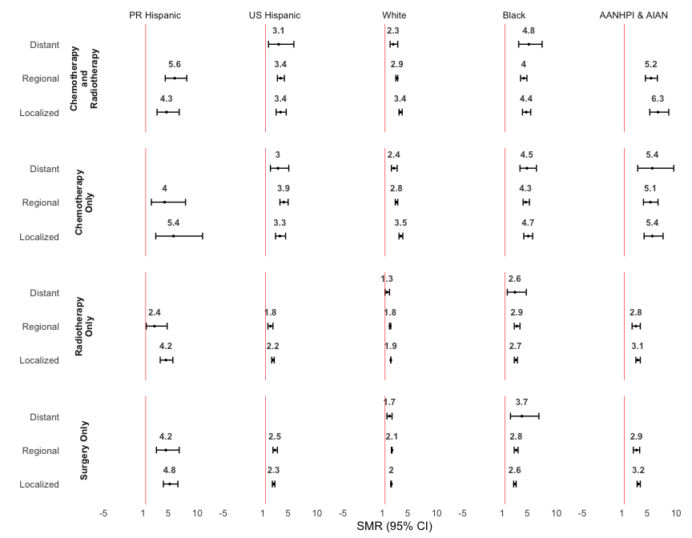

Table 18 CVD SMRs for BC Survivors in Puerto Rico and US Race/Ethnicity Groups Using US population as Referent

|  | **PR Hispanic** | | | | **US Hispanic** | | | | **White** | | | | **Black** | | | | **AANHPI & AIAN** | | | |
| --- | --- | --- | --- | --- | --- | --- | --- | --- | --- | --- | --- | --- | --- | --- | --- | --- | --- | --- | --- | --- |
| Variable | O | E | SMR | 95% CI | O | E | SMR | 95% CI | O | E | SMR | 95% CI | O | E | SMR | 95% CI | O | E | SMR | 95% CI |
| Overall | 470 | 101.6 | 4.6 | (4.2 - 5.1) | 2,193 | 901.9 | 2.4 | (2.3 - 2.5) | 23,582 | 11,360.5 | 2.1 | (2.0 - 2.1) | 3,292 | 1,089.8 | 3.0 | (2.9 - 3.1) | 1,632 | 467.6 | 3.5 | (3.3 - 3.7) |
| **Age at Diagnosis** |  |  |  |  |  |  |  |  |  |  |  |  |  |  |  |  |  |  |  |  |
| 18-39 | <10 | - | - | - | 15 | 1.1 | 13.2 | (7.4 - 21.8) | 43 | 2.9 | 14.8 | (10.7 - 19.9) | 40 | 2.6 | 15.6 | (11.2 - 21.3) | 12 | 0.3 | 36.3 | (18.8 - 63.4) |
| 40-49 | 13 | 1.5 | 8.4 | (4.5 - 14.4) | 63 | 7.2 | 8.8 | (6.7 - 11.2) | 299 | 28.0 | 10.7 | (9.5 - 12.0) | 206 | 17.8 | 11.6 | (10.1 - 13.3) | 43 | 2.2 | 19.3 | (14.0 - 26.0) |
| 50-59 | 31 | 5.1 | 6.0 | (4.1 - 8.5) | 189 | 23.4 | 8.1 | (7.0 - 9.3) | 1,190 | 138.2 | 8.6 | (8.1 - 9.1) | 490 | 64.2 | 7.6 | (7.0 - 8.3) | 157 | 9.1 | 17.2 | (14.6 - 20.1) |
| 60-69 | 105 | 15.2 | 6.9 | (5.7 - 8.4) | 493 | 79.0 | 6.2 | (5.7 - 6.8) | 3,665 | 663.6 | 5.5 | (5.3 - 5.7) | 774 | 157.2 | 4.9 | (4.6 - 5.3) | 295 | 32.9 | 9.0 | (8.0 - 10.1) |
| 70-79 | 160 | 42.8 | 3.7 | (3.2 - 4.4) | 710 | 316.1 | 2.2 | (2.1 - 2.4) | 7,610 | 3,500.8 | 2.2 | (2.1 - 2.2) | 971 | 361.6 | 2.7 | (2.5 - 2.9) | 541 | 153.2 | 3.5 | (3.2 - 3.8) |
| 80+ | 159 | 36.8 | 4.3 | (3.7 - 5.0) | 723 | 475.1 | 1.5 | (1.4 - 1.6) | 10,775 | 7,027.0 | 1.5 | (1.5 - 1.6) | 811 | 486.5 | 1.7 | (1.6 - 1.8) | 584 | 269.9 | 2.2 | (2.0 - 2.4) |
| **Stage** |  |  |  |  |  |  |  |  |  |  |  |  |  |  |  |  |  |  |  |  |
| Localized | 300 | 63.9 | 4.7 | (4.2 - 5.3) | 1,417 | 603.3 | 2.4 | (2.2 - 2.5) | 16,604 | 8,124.6 | 2.0 | (2.0 - 2.1) | 1,957 | 683.5 | 2.9 | (2.7 - 3.0) | 1,108 | 323.0 | 3.4 | (3.2 - 3.6) |
| Regional | 137 | 30.2 | 4.5 | (3.8 - 5.4) | 685 | 247.5 | 2.8 | (2.6 - 3.0) | 6,008 | 2,720.3 | 2.2 | (2.1 - 2.3) | 1,138 | 334.9 | 3.4 | (3.2 - 3.6) | 441 | 120.5 | 3.7 | (3.3 - 4.0) |
| Distant | 10 | 2.7 | 3.7 | (1.8 - 6.9) | 47 | 28.0 | 1.7 | (1.2 - 2.2) | 516 | 277.0 | 1.9 | (1.7 - 2.0) | 131 | 37.5 | 3.5 | (2.9 - 4.1) | 53 | 13.9 | 3.8 | (2.9 - 5.0) |
| Unknown/unstaged | 23 | - | - | - | 44 | - | - | - | 454 | - | - | - | 66 | - | - | - | 30 | - | - | - |
| **Treatment** |  |  |  |  |  |  |  |  |  |  |  |  |  |  |  |  |  |  |  |  |
| Surgery Only | 105 | 22.5 | 4.7 | (3.8 - 5.6) | 1,015 | 436.5 | 2.3 | (2.2 - 2.5) | 11,353 | 5,716.7 | 2.0 | (2.0 - 2.0) | 1,287 | 488.9 | 2.6 | (2.5 - 2.8) | 724 | 230.2 | 3.1 | (2.9 - 3.4) |
| Chemotherapy Only | 23 | 4.8 | 4.8 | (3.0 - 7.2) | 245 | 67.3 | 3.6 | (3.2 - 4.1) | 1,621 | 539.3 | 3.0 | (2.9 - 3.2) | 512 | 114.6 | 4.5 | (4.1 - 4.9) | 151 | 28.7 | 5.3 | (4.5 - 6.2) |
| Radiotherapy Only | 80 | 21.0 | 3.8 | (3.0 - 4.7) | 513 | 248.7 | 2.1 | (1.9 - 2.2) | 6,961 | 3,715.9 | 1.9 | (1.8 - 1.9) | 707 | 257.3 | 2.8 | (2.5 - 3.0) | 440 | 143.0 | 3.1 | (2.8 - 3.4) |
| Chemotherapy and Radiotherapy | 74 | 14.5 | 5.1 | (4.0 - 6.4) | 245 | 71.6 | 3.4 | (3.0 - 3.9) | 1,957 | 650.0 | 3.0 | (2.9 - 3.1) | 522 | 125.7 | 4.2 | (3.8 - 4.5) | 191 | 35.5 | 5.4 | (4.6 - 6.2) |
| Other | 188 | 38.8 | 4.8 | (4.2 - 5.6) | 175 | 77.9 | 2.2 | (1.9 - 2.6) | 1,690 | 738.6 | 2.3 | (2.2 - 2.4) | 264 | 103.4 | 2.5 | (2.2 - 2.9) | 126 | 30.2 | 4.2 | (3.5 - 5.0) |
| **Year of Diagnosis** |  |  |  |  |  |  |  |  |  |  |  |  |  |  |  |  |  |  |  |  |
| 2004-2009 | 255 | 62.6 | 4.1 | (3.6 - 4.6) | 1,221 | 599.8 | 2.0 | (1.9 - 2.2) | 14,446 | 8,224.3 | 1.8 | (1.7 - 1.8) | 1,796 | 720.8 | 2.5 | (2.4 - 2.6) | 924 | 320.6 | 2.9 | (2.7 - 3.1) |
| 2010-2015 | 159 | 32.8 | 4.9 | (4.1 - 5.7) | 786 | 265.8 | 3.0 | (2.8 - 3.2) | 7,448 | 2,824.7 | 2.6 | (2.6 - 2.7) | 1,144 | 324.3 | 3.5 | (3.3 - 3.7) | 574 | 131.3 | 4.4 | (4.0 - 4.7) |
| 2016-2021 | 56 | 6.2 | 9.0 | (6.8 - 11.7) | 186 | 36.3 | 5.1 | (4.4 - 5.9) | 1,688 | 311.4 | 5.4 | (5.2 - 5.7) | 352 | 44.7 | 7.9 | (7.1 - 8.7) | 134 | 15.7 | 8.5 | (7.2 - 10.1) |
| **Year of Death** |  |  |  |  |  |  |  |  |  |  |  |  |  |  |  |  |  |  |  |  |
| 2005-2010 | 57 | 20.8 | 2.7 | (2.1 - 3.5) | 255 | 46.0 | 5.5 | (4.9 - 6.3) | 3,093 | 663.6 | 4.7 | (4.5 - 4.8) | 427 | 72.4 | 5.9 | (5.4 - 6.5) | 192 | 18.5 | 10.4 | (9.0 - 11.9) |
| 2011-2016 | 172 | 49.0 | 3.5 | (3.0 - 4.1) | 737 | 266.8 | 2.8 | (2.6 - 3.0) | 8,916 | 3,788.8 | 2.4 | (2.3 - 2.4) | 1,181 | 346.1 | 3.4 | (3.2 - 3.6) | 546 | 133.5 | 4.1 | (3.8 - 4.4) |
| 2017-2021 | 241 | 31.8 | 7.6 | (6.6 - 8.6) | 1,201 | 589.1 | 2.0 | (1.9 - 2.2) | 11,573 | 6,908.0 | 1.7 | (1.6 - 1.7) | 1,684 | 671.2 | 2.5 | (2.4 - 2.6) | 894 | 315.5 | 2.8 | (2.7 - 3.0) |
| SMRs were calculated as the observed number of cardiovascular disease deaths among breast cancer patients divided by the expected number of cardiovascular disease deaths in the race- and ethnic-matched general female U.S. population. SMR calculations for results with <10 events were suppressed. O = Observed; E = Expected; SMR = Standarized Mortality Ratio; AANHPI & AIAN encompasses: Asian American, Native Hawaiian and other Pacific Islanders along with American Indian/Alaska Natives. | | | | | | | | | | | | | | | | | | | | |

# Details

Figure legends should be an in-depth explanation of each figure, including a figure TITLE, and a CAPTION that includes the purpose of the figure, and brief method, results, and discussion statements pertaining to the figure. All abbreviations used in the figure should be identified either after their first mention in the legend or in alphabetical order at the end of each legend. All symbols used (arrows, circles, etc.) must be explained. Target length should be 50-100 words per figure.

* All figures must have a number, title, and caption.
* Figures should be cited in numerical order in the text.
* Supplemental figures should be cited as “Online Figure 1, Online Figure 2,” etc.
* Figure titles should be short and followed by a 2 to 3 sentence caption.

# Figures

* Figures and graphs should be provided in EPS or TIF format.
* Color images must be at least 300 DPI. Gray scale images should be at least 300 DPI.
* All abbreviations used in the figure should be identified in an alphabetical order at the end of each legend.
* All symbols used (arrows, circles, etc.) must be explained.
* Figure legends should be typed double-spaced on pages separate from the text.
* Figure numbers must correspond with the order in which they are mentioned in the text.
* If previously published figures are used, written permission from the original publisher is required. See STM Guidelines for details: <http://www.stm-assoc.org/copyright-legal-affairs/permissions/permissions-guidelines/>.
* If the figure has been previously published, cite the figure source in the legend.

Graphics software, such as Photoshop and Illustrator, should be used to create the art, but not presentation software such as PowerPoint, CorelDraw, or Harvard Graphics. Line art (black and white or color) and combinations of gray scale images and line art should be at least 1200 DPI. Lettering should be of sufficient size to be legible after reduction for publication. The optimal size is 12 points. Symbols should be of a similar size. Figures should be no smaller than 13 cm × 18 cm (500 × 700). Decimals, lines, and other details must be strong enough for reproduction. Use only black and white—not gray—in charts and graphs. Place crop marks on photomicrographs to show only the essential field. Designate special features with arrows. All symbols, arrows, and lettering on half-tone illustrations must contrast with the background. There is no fee for the publication of color figures. Our editors encourage authors to submit figures in color, as we feel it improves the clarity and visual impact of the images.

* Your Central Illustration, if not an existing figure, should be listed first.
* If the figure has been previously published, cite the figure source in the legend.
* All abbreviations used in the figure should be identified in alphabetical order at the end of each legend (see also Figures).

# Tables

Each table should be on a separate page, with the table number and title centered above the table and explanatory notes below the table. Use Arabic numbers. Table numbers must correspond with the order cited in the text. Tables should be self-explanatory, and the data presented in them should not be duplicated in the text or figures.

* All tables must have a title.
* Abbreviations should be listed in a footnote under the table in alphabetical order.
* Footnote symbols should appear in the following order: *,†,‡,§,‖,#,**,††, etc.
* If previously published tables are used, written permission from the original publisher/author is required.
* Cite the source of the table in the footnote.