FIT5032 eFolio Evidence Report
Tasks 3 and 4
Student: He Li
Student ID: 35381043
Weeks: Week 3 and Week 4

1. Week 3 - Component, HTML and CSS
I created the LibraryRegistrationForm component and displayed it from App.vue. I added the form fields and used the CSS selectors from the studio activity.
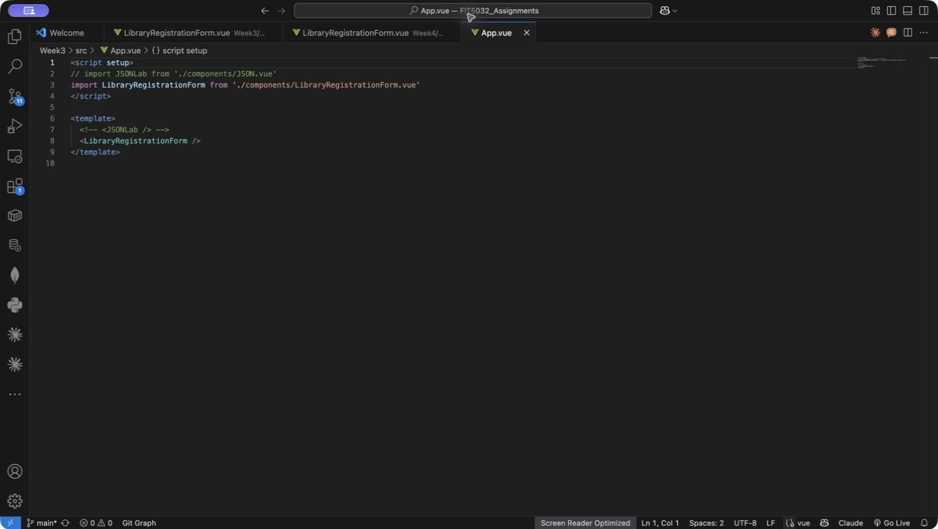
Figure 1. Activity 1 component import and display in App.vue.
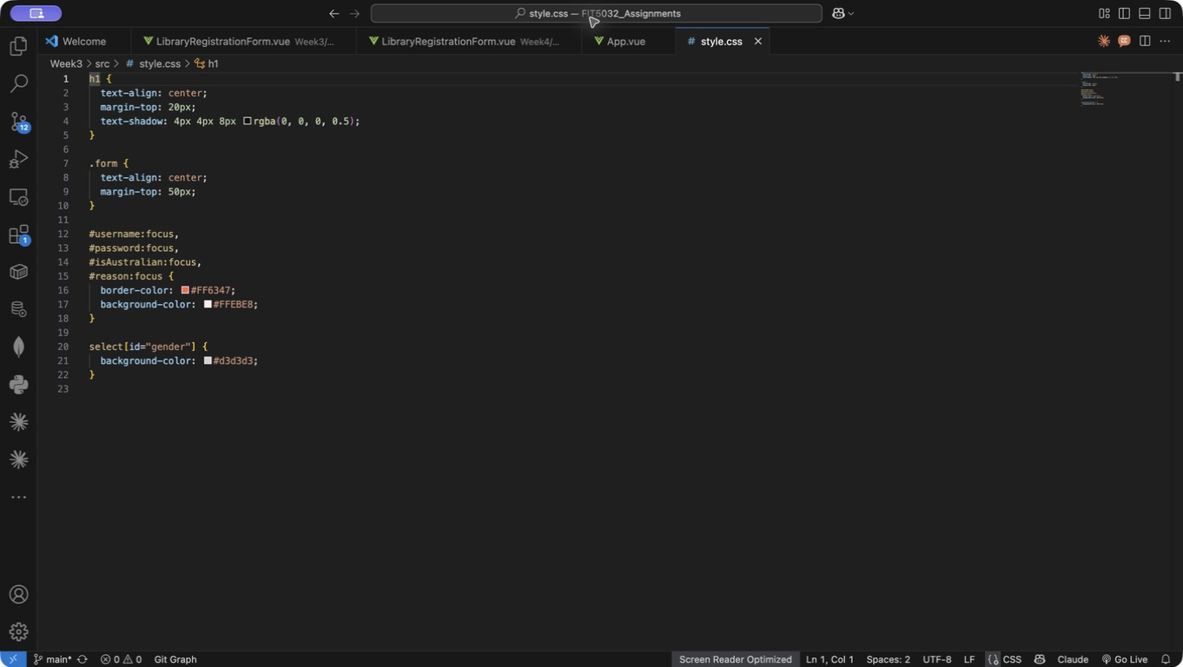
Figure 2. Activity 3 tag, class, ID and attribute selectors.

2. Week 3 - Bootstrap Form
I imported Bootstrap CSS in main.js and used Bootstrap classes to arrange the form.
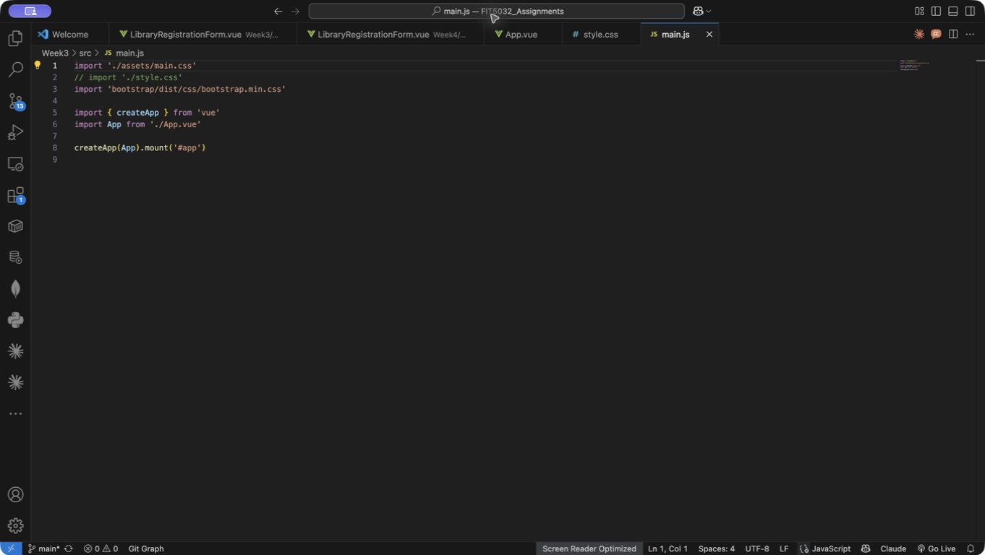
Figure 3. Activity 4 Bootstrap CSS import.
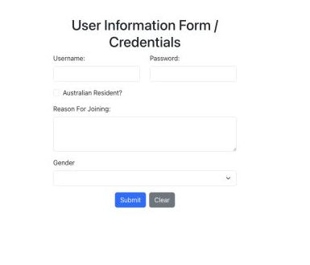
Figure 4. Activity 5 Bootstrap form on a wider screen.

3. Submitted User Card (Week 3)
I used v-model to store the form values. After I click Submit, the entered information is shown in a Bootstrap card.
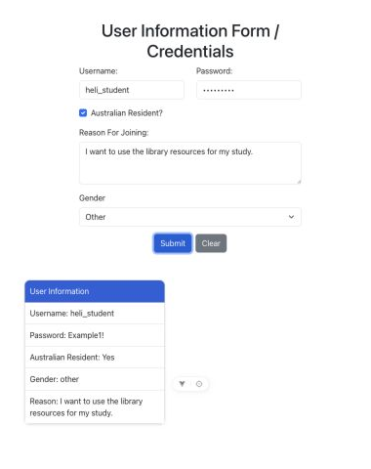
Figure 5. Activity 6 submitted user information card.

4. Responsive Breakpoint (Week 3)
I changed the input columns to col-sm-6. The username and password fields stay in two columns at 600px, while a very small screen can stack them.
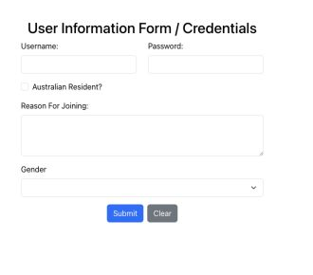
Figure 6. Activity 7 form tested at a 600px viewport.
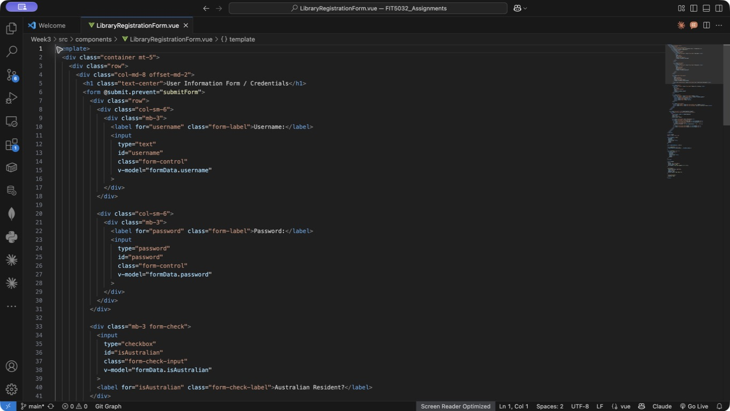
Figure 7. Bootstrap sm breakpoint used for the two input columns.

5. Week 4 - Form Validation Result
I added validation for username, password, Australian residency, reason for joining and gender. Invalid fields show Bootstrap error styles and a clear message.
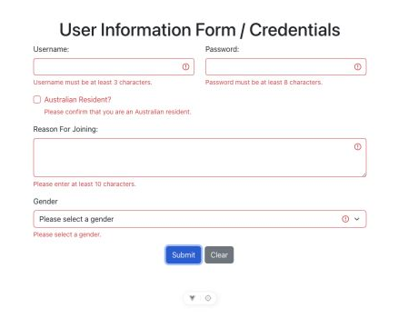
Figure 8. Five validation messages after submitting an empty form.

6. Week 4 - Validation Code
The validation functions return true or false. They also place the message in the errors object when an input is invalid.
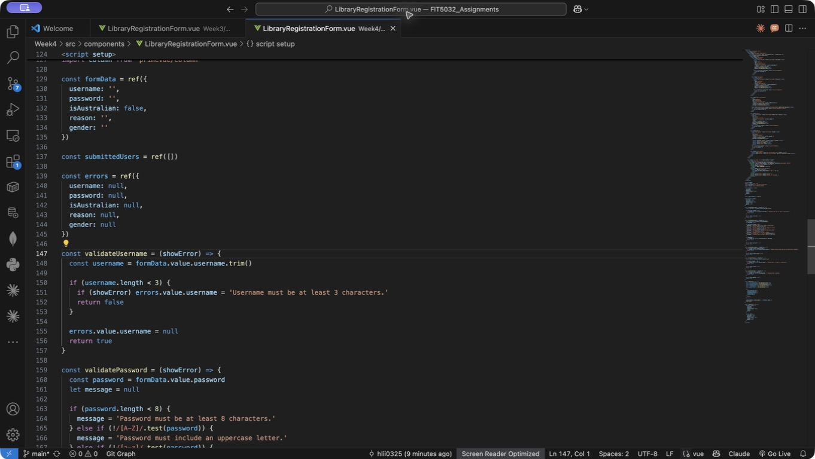
Figure 9. Username and password validation code.
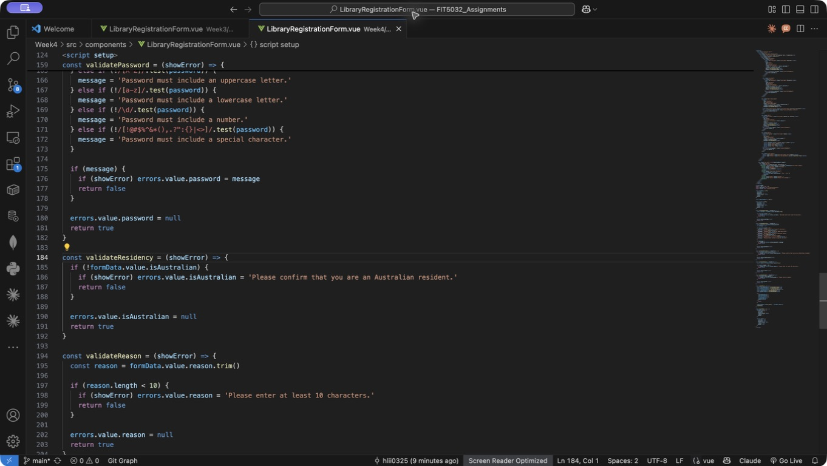
Figure 10. Residency and reason validation code.

7. Final Validation Check (Week 4)
The submit function calls all five validation functions. The form only adds the user when every result is valid.
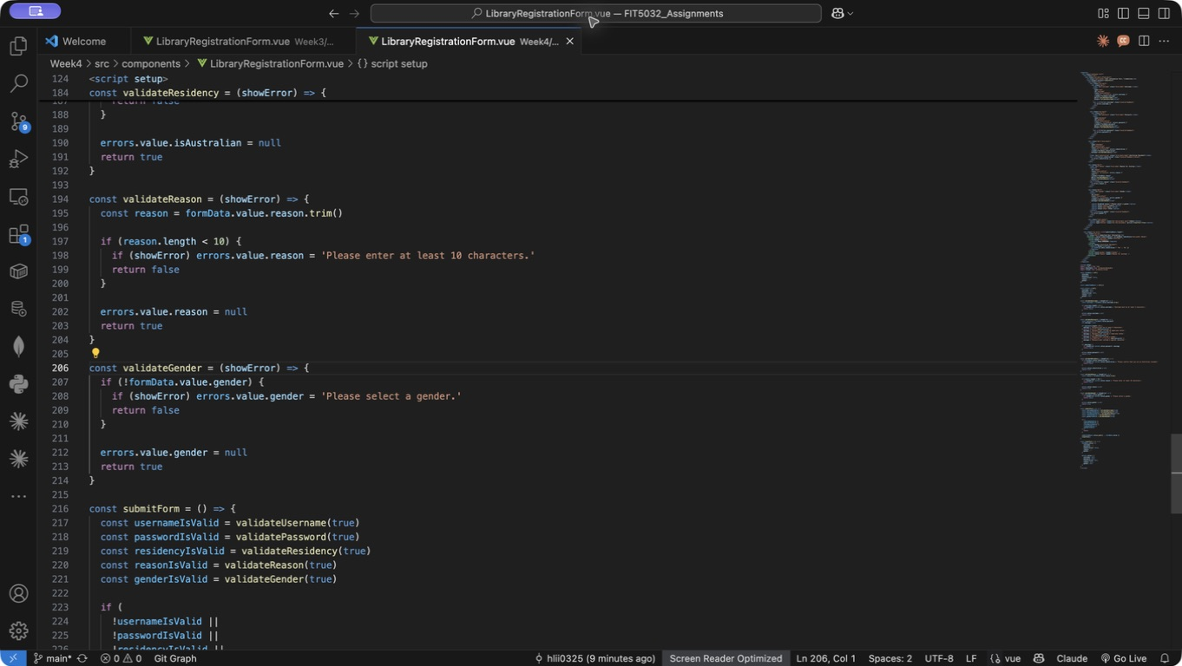
Figure 11. Gender validation and the five checks in submitForm.

8. Week 4 - PrimeVue DataTable
I used PrimeVue DataTable and Column components to show submitted users. The password is masked in the table instead of displaying the real value.
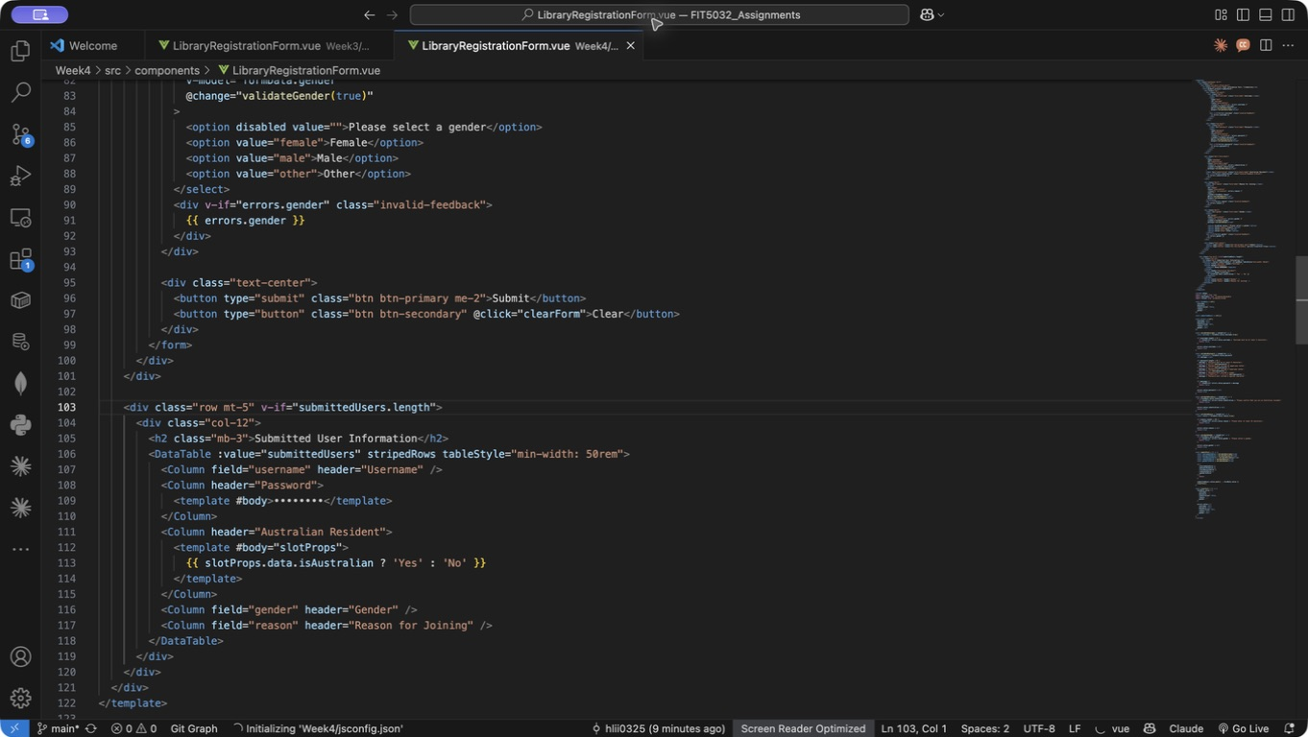
Figure 12. PrimeVue DataTable template code.
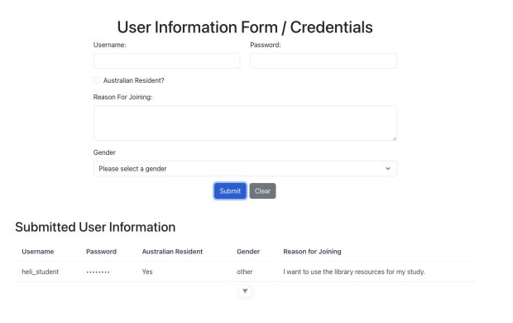
Figure 13. Submitted user information displayed in the DataTable.

