Declaration
I, He Li, declare that this assignment, titled Urban greening, tree-planting & biodiversity, is my own original work and has not been copied from any other source except where explicitly acknowledged. I have not engaged in plagiarism, collusion, or any other form of academic misconduct in the preparation and submission of this assignment. All sources of information and data used in this assignment have been properly cited and referenced in accordance with the prescribed guidelines. I have not used unauthorized assistance in the preparation of this assignment and have not allowed any other student to copy my work. I am aware that any breach of academic integrity may result in disciplinary action as per the policies of Monash University, which may include failing this assignment or the course, and further academic penalties.

Signature: He Li Date: 13/08/2026

Github Check
Enter your Github details here.
Github Username  Enter your username here | lcchorizon
Repository Shared?  Have you started and shared your assignment repository with your tutor yet? | Yes

Self-Evaluation
Rate your performance for each criteria. Put a ✓ (tick) in the box where you think your work belongs.

Criteria | Exceeds Expectations | Meets Expectations | Needs Improvement | Fail to meet expectations
Executive Summary |  | ✓
User Personas | ✓
Sitemap | ✓
Wireframes/Low-fidelity Prototype |  | ✓

Section 1: Executive Summary
For this project, I am planning a web application for a not-for-profit organisation in Melbourne. The organisation focuses on urban greening, tree planting and biodiversity. Its purpose is to encourage more local residents to take part in environmental activities. At the moment, information about planting events is often separated across different websites and social media pages. People may not know which activity is close to them or suitable for their situation. This website will put the main information in one place.
The target users include young volunteers, parents and NFP staff members. Young volunteers may want to join an activity but have limited time and no previous experience. Parents need to know if an event is safe and suitable for children. They may need information about toilets, transport, equipment and age requirements. NFP staff need to create events, manage registrations and contact volunteers. The website needs to support these different users without making the navigation too complicated.
Users will be able to search for events by postcode, date and activity type. A map will show nearby activities and their locations. Each event page will include the time, equipment, safety information and experience level. Users can create an account, register for an event and check their previous activities. The website will include simple learning resources about native plants and urban biodiversity. Staff members will have a separate dashboard. They can publish events, check participant numbers, search registration data, send updates and export information.
I looked at TreeProject, National Tree Day and Greening Australia for some design ideas. TreeProject has useful planting guides and different information for volunteers, growers and landholders. Its menu has many options, which may be confusing for a new user. National Tree Day has a useful “Find a Site” function. Users can search for planting activities by postcode or suburb. Greening Australia presents its projects, environmental resources and impact information clearly. I want to use the useful parts from these websites while keeping the navigation simple. The planned application should help residents find activities more easily and help the NFP spend less time managing information through different tools.

Section 2: Sitemap
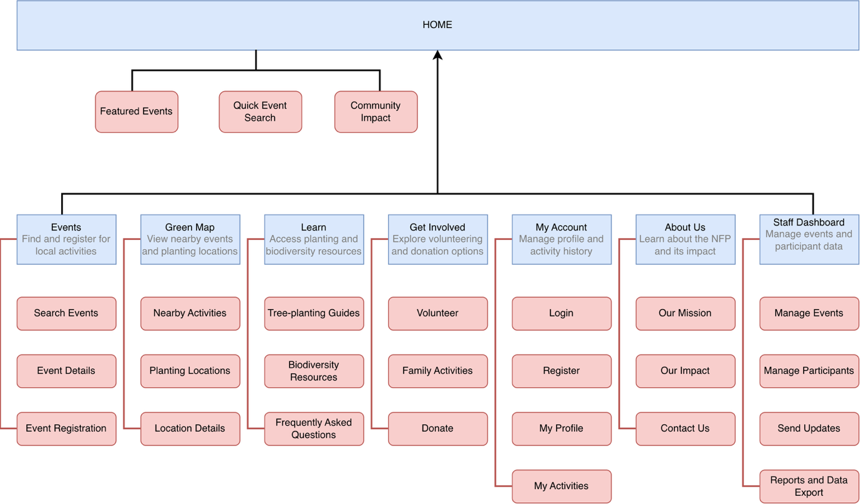

Section 3: User Personas
Persona 1: Mia Chen - Young Volunteer
Age: 22 | Occupation: University student and part-time cafe worker | Location: Clayton, Melbourne | Digital skills: High | Preferred device: Mobile phone
"I want to help the environment, but I need an easy way to find activities that fit my schedule."
Background: Mia is a university student living in Clayton. She is interested in climate action and wants practical experience. She has not joined a tree-planting activity before and normally uses her phone to search for events and public transport.
Goals and needs: Mia wants to find activities near her home or university. She prefers weekend events because of classes and part-time work. She needs clear details about time, location, transport, equipment and experience level. She also wants to record her volunteer activities.
Pain points: Activity information is spread across different websites and social media. Some pages do not explain what volunteers need to bring. Long registration forms are frustrating when Mia cannot first check whether an event suits beginners.
Usage scenario: Mia enters her postcode and filters for weekend, beginner-friendly activities. She checks nearby events on a map, reads the transport and equipment details, then registers. The completed event later appears in her participation history.
How the application helps: The application gives Mia a simple mobile-friendly search, useful filters, clear event information, online registration and a personal volunteer history.
Persona 2: Sarah Thompson - Parent and Community Resident
Age: 38 | Occupation: Primary school teacher | Location: Footscray, Melbourne | Family: Two children, aged 7 and 10 | Digital skills: Medium | Preferred device: Mobile phone and laptop
"I want my children to spend more time outdoors, but I need to know that an activity is safe and suitable for the whole family."
Background: Sarah is a primary school teacher in Footscray with two children. She wants them to learn about native plants and biodiversity through weekend outdoor activities.
Goals and needs: Sarah needs nearby family activities with clear age, duration, safety, toilet, transport and equipment details. She wants one registration for the whole family.
Pain points: Many websites do not clearly state whether children can participate, and details are spread across several pages. Sarah may register before discovering an event is unsuitable. Repeating family contact details is also inconvenient.
Usage scenario: Sarah filters by location, weekend and family-friendly status. She compares events, checks age requirements and views the map. She registers herself and both children in one form and receives a reminder.
How the application helps: The application provides family-friendly filters, clear safety and accessibility information, simple family registration, map directions and event reminders.
Persona 3: David Nguyen - NFP Staff Member
Age: 42 | Occupation: Community Program Coordinator | Location: Richmond, Melbourne | Digital skills: Medium to high | Preferred device: Laptop
"I need one place to publish events and manage volunteers because using spreadsheets and emails takes too much time."
Background: David works for a small environmental NFP in Melbourne. He organises planting activities, biodiversity workshops and volunteer programs. With limited staff, he also manages event promotion, registrations and participant communication using spreadsheets, email and online forms.
Goals and needs: David needs to publish event dates, locations, capacity and equipment details. He wants a searchable participant table, current registration numbers, data export and a simple way to notify volunteers about changes.
Pain points: Information is stored across several tools. Different spreadsheets and manual emails create duplicates and make participant numbers difficult to confirm. Reporting volunteer attendance and planted trees also takes extra time.
Usage scenario: David creates an event with its location, capacity and family information. He monitors registrations in the dashboard, exports the participant list and sends an update. After the activity, he records attendance and trees planted.
How the application helps: The application provides role-based access, event management, searchable participant tables, email updates, data export and an impact dashboard.

Section 4: Wireframes/Low-fidelity prototype
BR C.1: Authentication

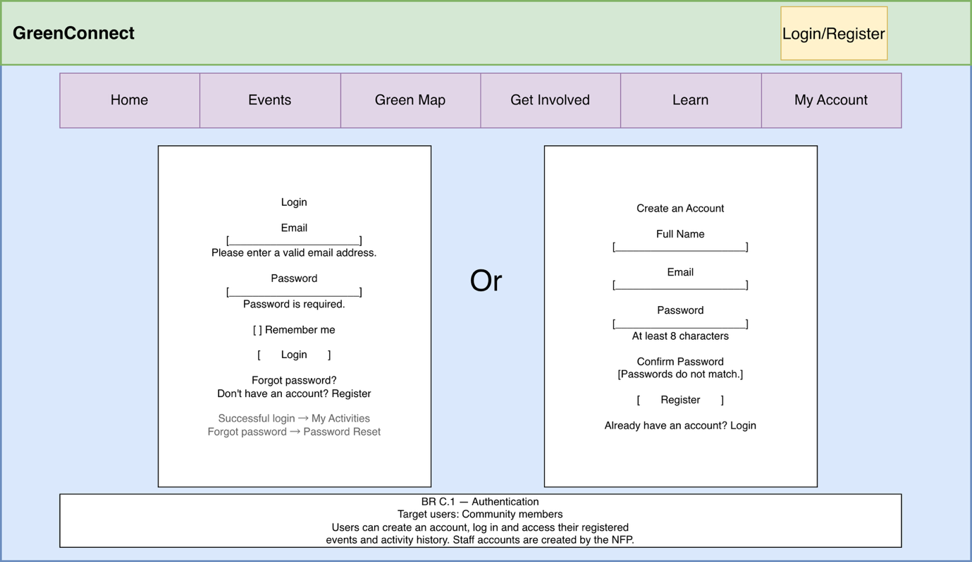
BR E.2: Geo Location
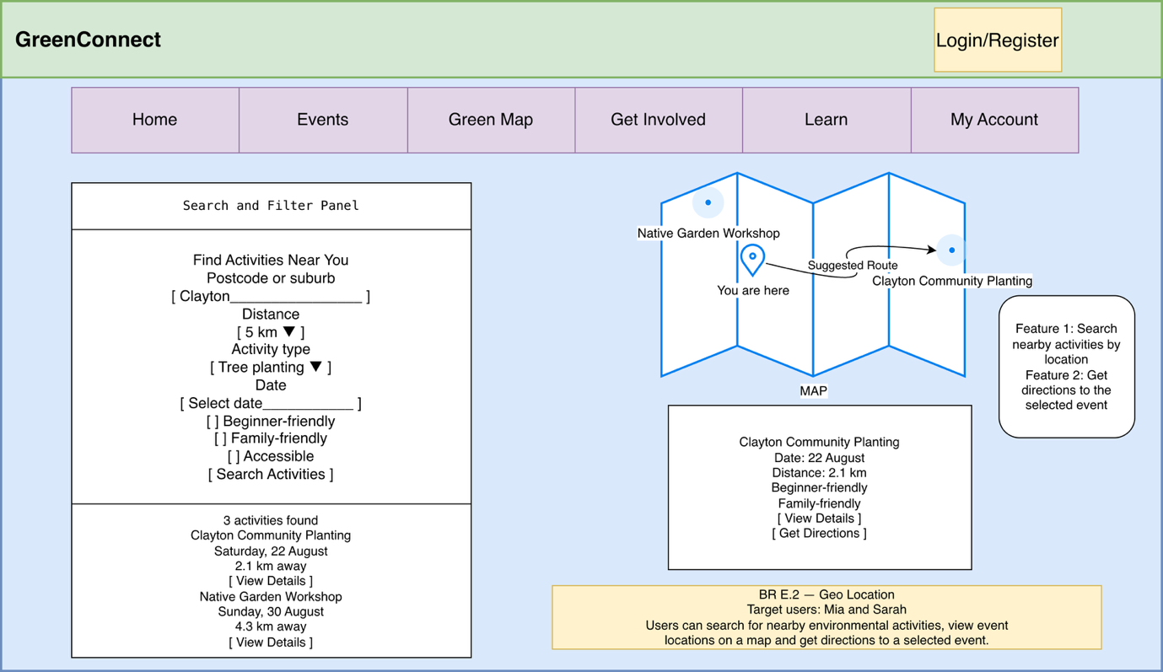

BR D.3: Event Table and Participant Table
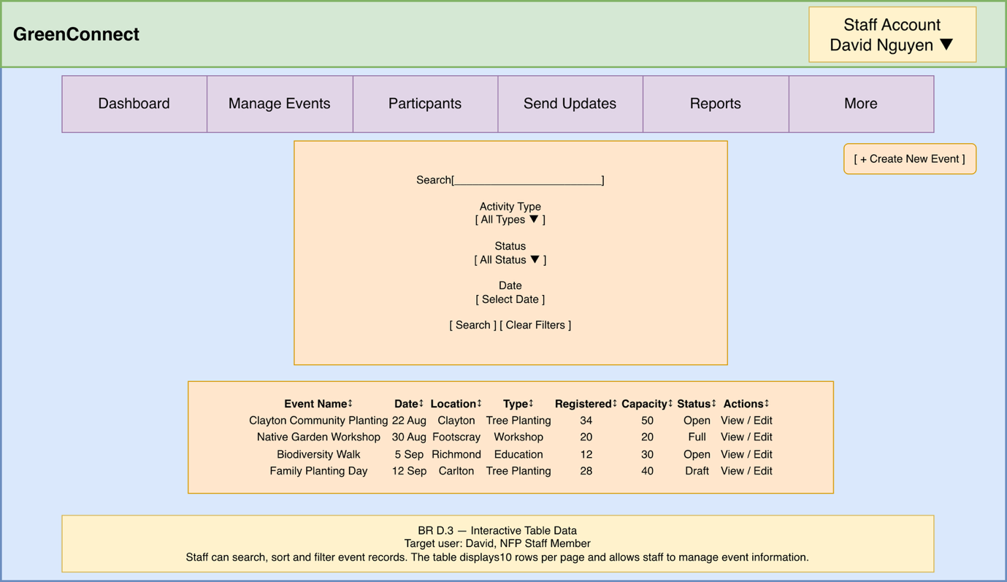
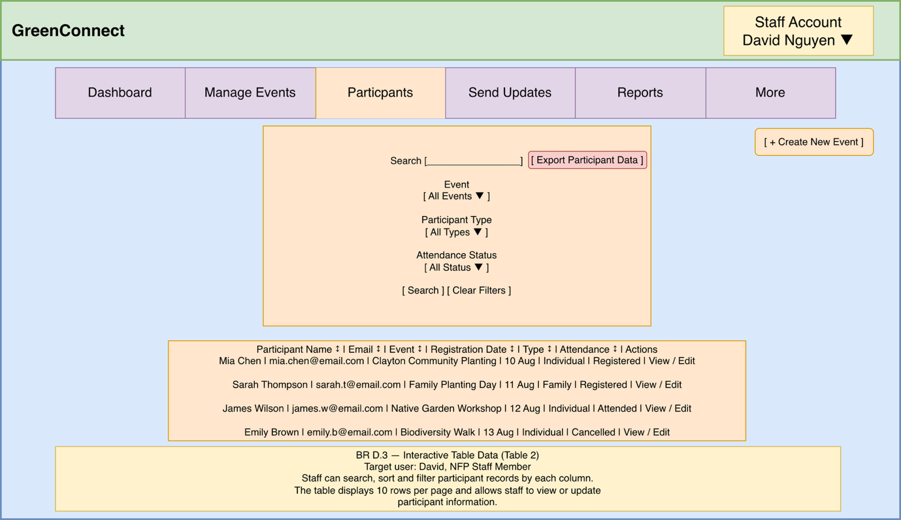

Declaration: Additional Help
Any tools that you used (including Gen AI or existing code reuse) must be declared here.

Note: GenAI is not allowed for coding purposes in any assignment,

However, you may use GenAI for brainstorming, problem solving and learning. You need to declare all such uses here. One row per help used. More details on how to acknowledge the use of Gen AI can be found here.

Name | Description
ChatGPT | I used ChatGPT to help me understand the assignment requirements, brainstorm the website structure, and improve the English wording in my executive summary and user personas. It also gave me feedback on my sitemap and wireframe ideas. I reviewed the content, made the final decisions, and created the diagrams myself.
diagrams.net | I used diagrams.net to create the sitemap and low-fidelity wireframes for the proposed website.

