## Vancouver Explorer - Web Design Proposal

Assignment 1

Comp 4711 Intro to Internet Software Development

Instructor: James L. Parry

Team: Bromance

Members: Clement Lo, William Huang

# Introduction

In this digital age, a website frequently serves as a business or organization’s front entrance.

A great Vancouver travel guide catch people’s attractions without an awesome website that leads tourists into Vancouver.

On the website, we will be focusing on the user-friendly interface and using eat, play, and sleep as major categories.

## About Us

Web Design requires great ideas and unmistakable skills for web developers. That’s why our team has gathered developers with the most innovative design ideas and over 2 years of experience in the IT field. We can’t wait to apply our knowledge, skills, and experience on this web project.

## Our Team & Members

Bromance / Team Name, For BCIT COMP4711 Web Assignment

Clemens Lo / Senior Partner, Website Designer + Project Executor

William Huang / User Interface Designer + Web Developer

# Project Details

In order to achieve the goals of the web development project with no compromise, the ideas of the website have been taken into pieces:

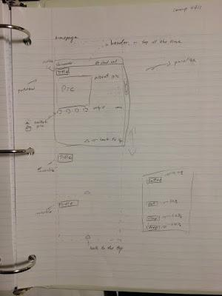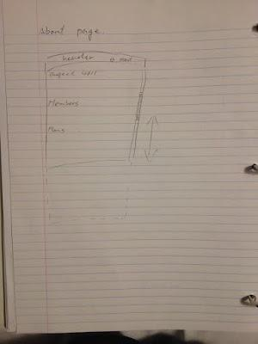

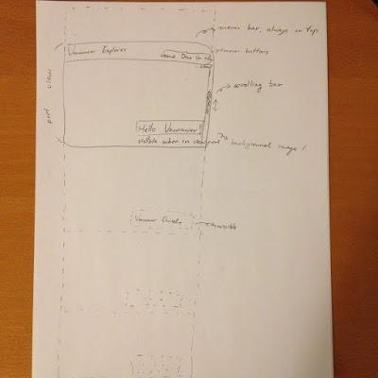

## Planning

The entire project will be based on the CodeIgniter as our application development framework which is built upon PHP. It is using MVC approach that helps us develop project much faster and more efficient. We will also be using HTML5, CSS, and JavaScript just like other modern websites.

## Concept Design

Sketches and page mock-ups are made to reflect the general appearance and feel of the website. Parallax design will be using through each pages of the website. It is the way to be more simple, beautiful, visible when browsing a web page.

## The Title

Our website - Vancouver Explorer is for the people who would like to know more about Vancouver or first time visit Vancouver. Through our website, people can start planning their everyday schedule in this lovely city immediately by just a glance. The whole website are separated into five different views - Home, Dine, Go, Stay, and About. The Home page is where the website starts, it shows the latest information about Vancouver such local news and weather. Dine page displays iconic foods of Vancouver and links that lead to the famous restaurants. Go page brings the most exciting entertainment and the best place in town. Stay page finds hotels for you and your body to relax. The last page is About, the showcase about the developers and website maps. The views are from the perspective of people who are browsing the pages. Our goal is to make the website easy-to-see and easy-to-use. We will keep testing and making changes on the page information until we fulfill the goal.