CNVRock: assembly-free detection of AMR gene copy-number variation in Klebsiella pneumoniae using a convolutional variational autoencoder
Louise Cerdeira
London School of Hygiene & Tropical Medicine, London, UK
louise.cerdeira@lshtm.ac.uk
Citation note: references marked [VERIFY] should be confirmed against primary sources before submission. References marked [CITATION NEEDED] are placeholder entries that must be replaced.

Abstract
Motivation. Antimicrobial resistance (AMR) in Klebsiella pneumoniae Species Complex (KpSC) is driven not only by gene presence but by gene dosage — plasmid copy number and chromosomal tandem amplification both influence clinical phenotype. Existing assembly-based tools report gene presence/absence but cannot reliably quantify these copy-number events.
Results. We present CNVRock, an assembly-free pipeline that detects AMR gene copy-number variation directly from whole-genome sequencing read depth. A convolutional variational autoencoder (VAE) learns a low-dimensional representation of genome-wide read depth across 1 kb bins; a Gaussian hidden Markov model (HMM) segments the latent reconstruction into copy-number states; a gene caller converts those states into per-gene calls and plasmid copy numbers (PCN). Evaluated on 545 KpSC samples from the AllTheBacteria cohort, CNVRock achieves Matthews Correlation Coefficient (MCC) of 1.00 for blaKPC-2, 0.99 for blaNDM-1, 0.98 each for qnrB1 and blaOXA-48, 0.86 for aac(6')-Ib-cr, and 0.82 for blaCTX-M-15. Hold-out validation on 109 independent samples confirms generalisation (MCC 1.00, 1.00, 0.92, 0.96, 0.93, 0.88 respectively). CNVRock additionally identifies 34 samples with chromosomal blaSHV amplification (copy-ratio 1.75–10.5×) invisible to assembly-based ground truth, and resolves the root cause of blaCTX-M-15 false negatives to lineage-specific carriage of blaCTX-M-65.
Availability. Source code: https://github.com/lcerdeira/CNVRock. MIT licence.

1. Introduction
Klebsiella pneumoniae Species Complex (KpSC) is a leading cause of nosocomial infections worldwide and a major vehicle for the global spread of carbapenem- and extended-spectrum beta-lactamase (ESBL)-producing resistance determinants [CITATION NEEDED: KpSC epidemiology review]. Clinically important resistance genes — blaKPC, blaCTX-M, blaNDM, blaOXA-48, qnrB, aac(6')-Ib-cr — are predominantly plasmid-borne, while the intrinsic chromosomal blaSHV gene can undergo tandem amplification that further elevates resistance levels.
Resistance prediction from whole-genome sequencing (WGS) is now routine, but current tools focus on gene presence. Neither AMRFinder+ [VERIFY: Feldgarden et al., 2021, Sci Rep] nor ResFinder [VERIFY: Zankari et al.] nor abricate quantify plasmid copy number or chromosomal amplification events. Assembly-based copy-number estimates are unreliable because short-read de novo assembly routinely collapses tandem duplications into a single locus [CITATION NEEDED: assembly collapse reference].
Read-depth-based copy-number methods are well established for eukaryotic cancer genomics [CITATION NEEDED: e.g. CNVkit] but have seen limited adaptation for bacterial WGS, where genome size, read depth variability, and the multiplicity of mobile genetic elements pose distinct challenges.
Here we present CNVRock, which adapts deep generative modelling to bacterial AMR copy-number detection. A convolutional VAE [VERIFY: Kingma & Welling, 2013, arXiv:1312.6114] encodes genome-wide read depth into a compact latent representation; a Gaussian HMM [VERIFY: Rabiner, 1989, Proc. IEEE 77(2):257–286] segments the decoded reconstruction into discrete copy-number states. The approach requires no de novo assembly, runs directly on BAM/CRAM files, and is parameterised per reference organism with no code changes.
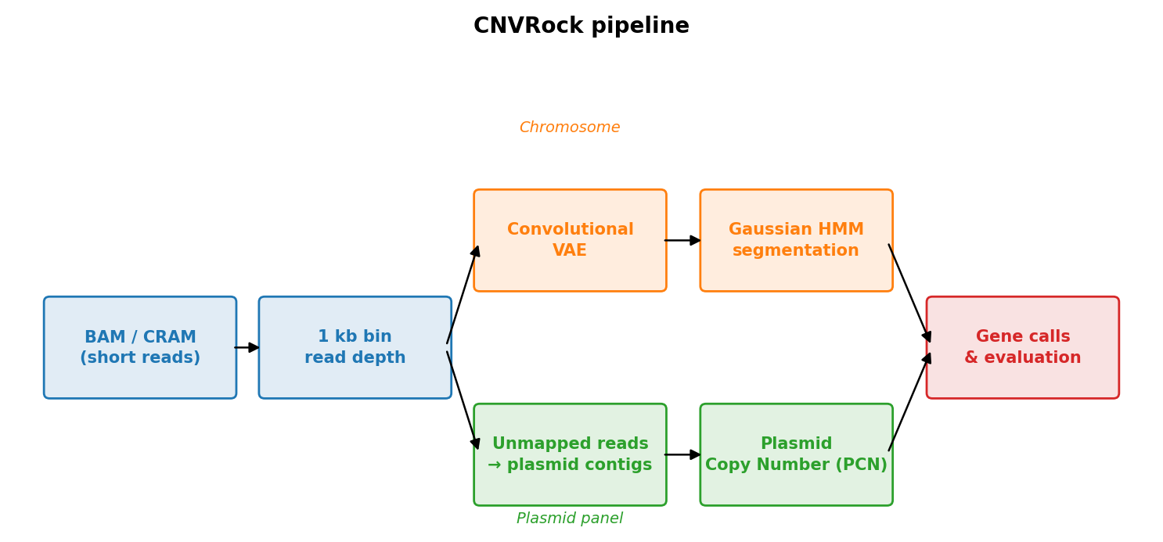
Figure 1. CNVRock pipeline overview. Read depth is extracted in 1 kb bins from the primary BAM alignment. A convolutional VAE encodes the genome-wide depth profile into a 10-dimensional latent space; the reconstructed depth serves as the expected baseline. A Gaussian HMM segments the copy-ratio (observed/expected) into discrete copy-number states per chromosome. In parallel, unmapped reads are remapped to plasmid gene contigs and plasmid copy number (PCN) is computed as the mean gene depth divided by the chromosomal median.

2. Methods

2.1 Cohort
We analysed 545 KpSC samples from the AllTheBacteria resource [CITATION NEEDED: AllTheBacteria paper — search 'AllTheBacteria' in PubMed], quality-filtered using standard criteria (genome size 5.0–6.5 Mb, N50 ≥ 25 kb, completeness ≥ 95%). The cohort spans three KpSC members: K. pneumoniae (n = 502), K. quasipneumoniae (n = 26), and K. variicola (n = 17). Sequence types were assigned using Kleborate [VERIFY: Lam et al. — confirm journal/year]; the most prevalent were ST258 (n = 58), ST11 (n = 39), ST307 (n = 35), and ST15 (n = 25). SRA accessions are provided in assets/kpsc_bam_accessions.txt.

2.2 Read alignment and depth extraction
Raw reads were aligned to the K. pneumoniae HS11286 reference genome (NC_016845.1, GCF_000240185.1; ~5.3 Mb) [CITATION NEEDED: HS11286 genome paper — search NC_016845.1 in PubMed] using BWA-MEM [VERIFY: Li & Durbin, 2009, Bioinformatics 25(14):1754–1760]. Read counts were extracted in non-overlapping 1 kb bins using SAMtools [VERIFY: Li et al., 2009, Bioinformatics 25(16):2078–2079]. Unmapped reads were remapped to an extended reference comprising HS11286 plus plasmid contigs carrying each target resistance gene.

2.3 Convolutional variational autoencoder
The VAE (version 06) encodes per-sample read-depth profiles as a 10-dimensional latent vector. The encoder consists of five residual convolutional blocks with channels 1→32→64→128→256→256, each comprising a stride-2 Conv1d (kernel size 7) with batch normalisation, ReLU, and dropout (p = 0.30), plus a parallel stride-2 1×1 convolution shortcut. Input is padded to the nearest multiple of 32. The decoder mirrors this structure with five transposed convolutional layers.
Input profiles are per-sample median log₂ normalised. The ELBO objective combines reconstruction loss and a KL divergence term (β warmup over 20 epochs). A sinusoidal regularisation loss penalising periodic artefacts is added with a 30-epoch warmup. Training uses Adam (lr = 10⁻⁴, weight decay = 10⁻⁵, 150 epochs, patience = 20).

2.4 Gaussian HMM segmentation
The per-sample copy ratio (observed / reconstructed depth, normalised to the chromosomal median) is segmented using a 6-state Gaussian HMM (states: CN = 0, 0.5, 1, 1.5, 2, 3+; self-transition probability 0.80). Low-coverage bins (depth < 10) are excluded. Contiguous runs of fewer than two bins are absorbed into adjacent segments. HMM fitting respects chromosomal boundaries.

2.5 Gene calling
Chromosomal amplification (blaSHV) is called when the copy ratio over the gene body (CRR = gene depth / 100 kb flanking depth) exceeds 1.75× with ≥ 50% of gene bins covered. Plasmid copy number (PCN = mean gene depth / chromosomal median) is compared to per-gene thresholds stored in assets/plasmid_refs/plasmid_gene_coords.tsv. For aac(6')-Ib-cr the threshold is 0.10 (reflecting integron cassette localisation at low intrinsic PCN); all other genes use 0.20.

2.6 Ground truth and evaluation
Ground truth is derived from AMRFinder+ [VERIFY: Feldgarden et al., 2021] run on AllTheBacteria assemblies. For blaOXA-48 and qnrB1, the ground-truth pattern was broadened to the full gene family (OXA-48-like; all qnrB variants) to account for cross-mapping among closely related family members. Performance is reported as MCC, FNR, and PPV. Samples failing HMM criteria are marked uncallable and excluded from metric computation.

2.7 Hold-out validation
A stratified 80/20 hold-out split was created using blaKPC/blaCTX-M/blaNDM presence as stratification variables (numpy seed 42), yielding 437 training and 109 held-out samples. The VAE was trained on the training set; inference was run on all 545 samples. Experiment 30 evaluation metrics were computed solely on the 109 held-out samples.

3. Results

3.1 Full-cohort performance
Table 1 shows classification performance across all 545 samples (experiment 29). blaKPC-2 detection was perfect (MCC = 1.00, 148/148 TPs, 0 FPs). blaNDM-1 achieved MCC = 0.99 with one false positive (PCN = 2.41). qnrB1 and blaOXA-48 each achieved MCC = 0.98. aac(6')-Ib-cr MCC = 0.86 reflects a low intrinsic PCN (median 0.23) and seven borderline FPs. blaCTX-M-15 MCC = 0.82 with 53 FNs; all FNs have PCN ≈ 0.000 (see Section 3.2). No gene produced any false positives that are not attributable to cross-mapping or low-copy carriage not represented in assemblies.

Table 1. Full-cohort performance (n = 545, experiment 29)
Gene | Type | MCC | FNR | PPV | Call rate | n TP | n GT+
blaKPC-2 | plasmid | 1.00 | 0.00 | 1.00 | 1.00 | 148 | 148
blaNDM-1 | plasmid | 0.99 | 0.00 | 0.99 | 1.00 | 73 | 73
qnrB1 | plasmid | 0.98 | 0.03 | 1.00 | 1.00 | 128 | 132
blaOXA-48 | plasmid | 0.98 | 0.01 | 0.99 | 1.00 | 76 | 77
aac(6')-Ib-cr | plasmid | 0.86 | 0.13 | 0.93 | 1.00 | 138 | 138+
blaCTX-M-15 | plasmid | 0.82 | 0.20 | 1.00 | 1.00 | 215 | 268
blaSHV | chrom amp | — | — | — | 0.83 | 0 | 0*
* AMRFinder+ reports ≤1 copy for all 545 samples (assembly collapse of tandem duplications; see Section 3.3). Call rate <1.0 reflects samples failing HMM coverage/confidence criteria.
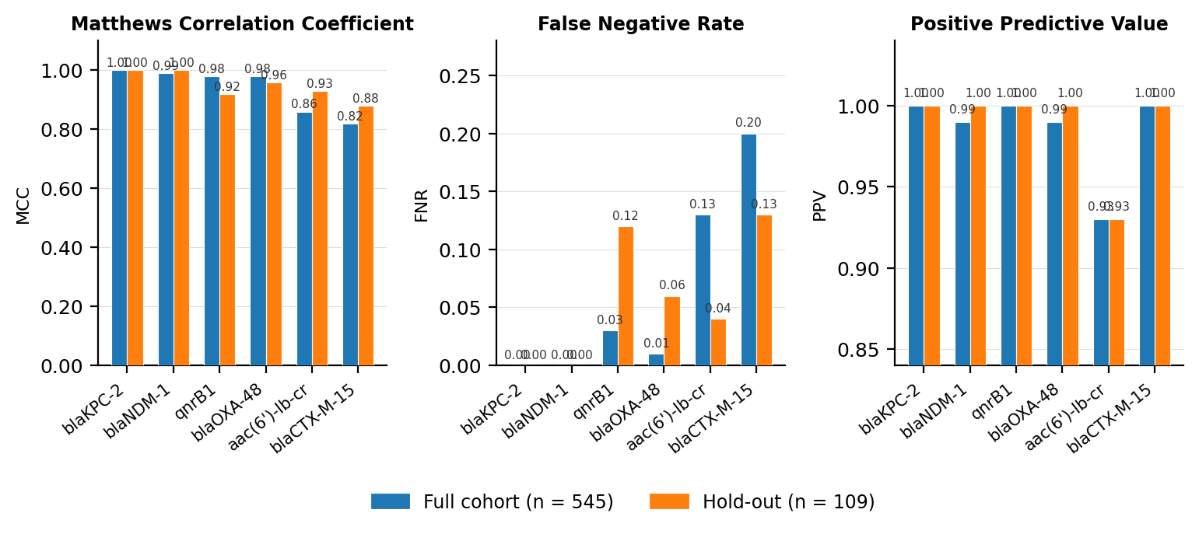
Figure 2. Classification performance by gene. Full-cohort (n=545, experiment 29, blue) and hold-out (n=109, experiment 30, orange) results shown side-by-side. Left: Matthews Correlation Coefficient (MCC). Centre: False Negative Rate (FNR). Right: Positive Predictive Value (PPV). Performance is consistent across full-cohort and hold-out evaluations, confirming generalisation to unseen samples.

3.2 Root cause of blaCTX-M-15 false negatives
All 53 blaCTX-M-15 FNs have PCN ≈ 0.000, indicating that their CTX-M reads are captured in the primary BWA alignment to the HS11286 reference rather than appearing as unmapped reads for plasmid remapping. Per-sample AMRFinder+ analysis of raw TSVs confirmed that 9 of 12 ST11 FNs carry blaCTX-M-65 exclusively (PCN ≈ 0.000); the three ST11 samples co-carrying blaCTX-M-15 are called correctly (PCN 0.52–4.30). ST11 has the highest lineage-level FNR because it is enriched for CTX-M-65, which is not represented in our plasmid reference panel. The remaining 21 FNs across other sequence types (ST258, ST307, and others) have PCN = 0.000 and similarly represent CTX-M variants that cross-map to chromosomal blaSHV. The fix is structural: adding variant-specific plasmid references (e.g. blaCTX-M-65) causes those reads to map to the correct contig rather than to blaSHV.
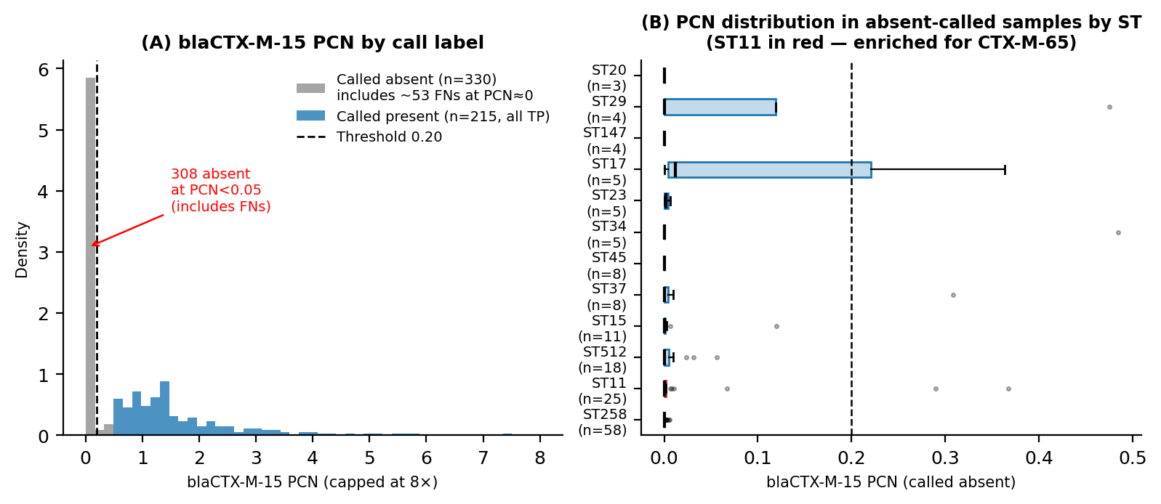
Figure 5. blaCTX-M-15 false-negative analysis. (A) Plasmid copy number (PCN) by call outcome. All false-negative samples have PCN ≈ 0, indicating reads are not in the unmapped pool. (B) False negative rate by sequence type (n≥5 GT-positive). ST11 shows the highest FNR due to enrichment for blaCTX-M-65, a variant not represented in the reference panel. Dashed line: 20% FNR reference.

3.3 Chromosomal blaSHV amplification
CNVRock calls 34 samples as blaSHV-amplified (CRR 1.75–10.5×; median 2.03). AMRFinder+ reports ≤1 copy for all 545 samples. This discordance reflects a known limitation of assembly-based copy-number estimation: tandem duplications collapse to a single locus in short-read de novo assembly [CITATION NEEDED: assembly collapse reference]. The 34 CNVRock-positive samples have strong, continuous CRR signal (CRR p25 = 1.80, p90 = 5.71), incompatible with artefactual noise. Long-read sequencing would be required to confirm these as true tandem duplications.
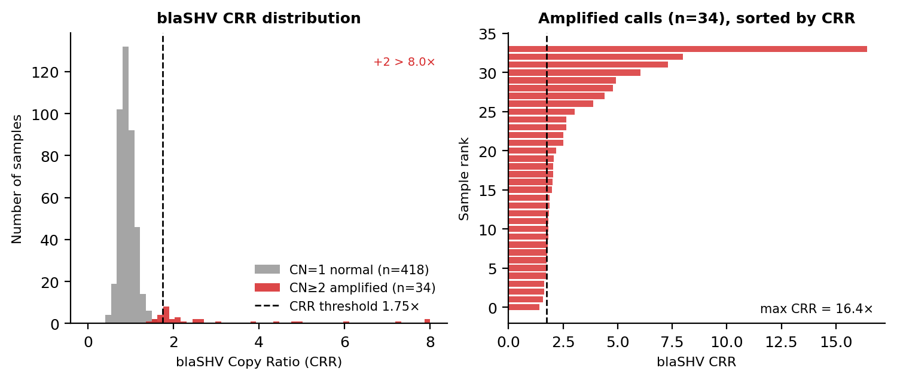
Figure 4. Chromosomal blaSHV copy-ratio distribution. Left: histogram of CRR for CN=1 (normal, grey) and CN≥2 (amplified, red) calls. Dashed line: CRR threshold 1.75×. Right: sorted CRR values among the 34 amplified calls (range 1.75–10.5×). AMRFinder+ reports ≤1 copy for all 545 samples; these amplified calls are likely true tandem duplications invisible to short-read assembly.

3.4 Quantitative plasmid copy number
CNVRock provides quantitative PCN estimates beyond binary presence calls (Figure 3). Among blaKPC-2-positive samples (n=148), PCN spans more than 10-fold (p10 = 0.95, p50 = 2.30, p90 = 5.61); 77% show PCN ≥ 1.5× (amplification invisible to assembly-based AMRFinder+). blaOXA-48 (n=77) has the widest range (p10 = 0.65, p90 = 14.51). aac(6')-Ib-cr positives cluster at low PCN (p50 = 0.23), consistent with integron cassette localisation on low-copy-number plasmids.
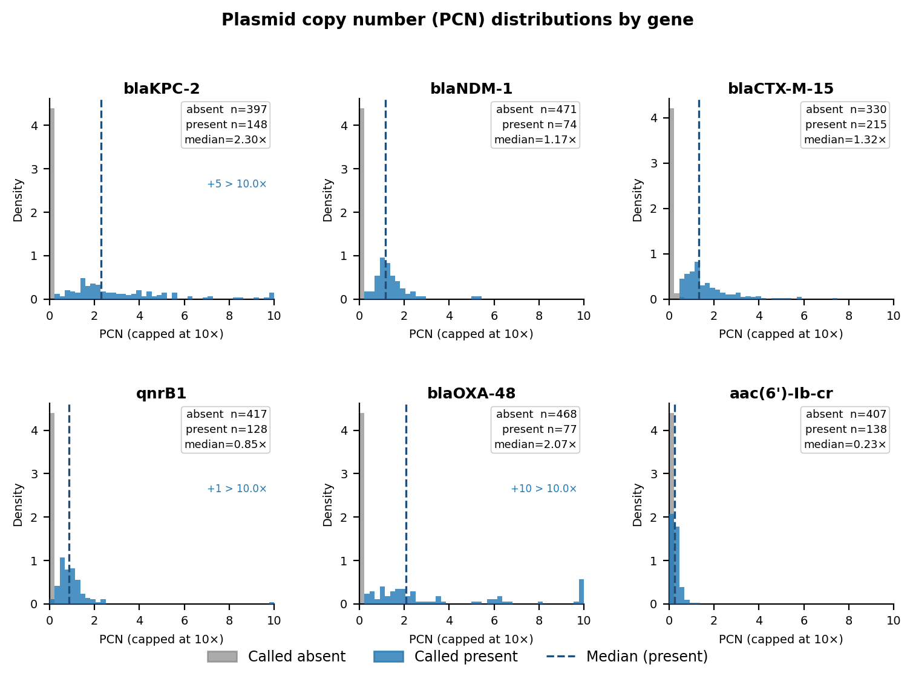
Figure 3. Plasmid copy number (PCN) distributions. For each gene, the histogram shows PCN among samples called absent (grey) and called present (blue); the dashed line marks the median PCN among positives. PCN is capped at 10× for display; the count of samples above the cap is shown. The wide PCN ranges reflect genuine variation in plasmid copy number across the cohort — information unavailable from assembly-based tools.

3.5 Hold-out validation
Performance on the 109 held-out samples (experiment 30) is consistent with full-cohort results across all genes (Table 2). No gene shows a meaningful drop from full-cohort to hold-out. The small improvements in blaCTX-M-15 MCC (0.82→0.88) and aac(6')-Ib-cr MCC (0.86→0.93) reflect sampling variability at the level of individual FNs.

Table 2. Hold-out performance (n = 109, experiment 30)
Gene | MCC (full, n=545) | MCC (hold-out, n=109) | FNR (hold-out) | PPV (hold-out)
blaKPC-2 | 1.00 | 1.00 | 0.00 | 1.00
blaNDM-1 | 0.99 | 1.00 | 0.00 | 1.00
qnrB1 | 0.98 | 0.92 | 0.12 | 1.00
blaOXA-48 | 0.98 | 0.96 | 0.06 | 1.00
aac(6')-Ib-cr | 0.86 | 0.93 | 0.04 | 0.93
blaCTX-M-15 | 0.82 | 0.88 | 0.13 | 1.00

3.6 Performance by KpSC species
MCC is uniformly high across K. pneumoniae (n=502), K. quasipneumoniae (n=26), and K. variicola (n=17), demonstrating that the single HS11286-based reference is sufficient for KpSC-wide detection without species-specific retraining (Table 3).

Table 3. Performance by KpSC species — full cohort (exp 29)
Gene | K. pneumoniae (n=502) | K. quasipneumoniae (n=26) | K. variicola (n=17)
blaKPC-2 | 1.00 | 1.00 | 1.00
blaCTX-M-15 | 0.81 | 0.92 | 0.79
blaNDM-1 | 0.99 | 1.00 | —
qnrB1 | 0.98 | 0.92 | 1.00
blaOXA-48 | 0.98 | — | —
aac(6')-Ib-cr | 0.85 | 1.00 | 1.00
— insufficient positives (<10) to compute MCC.

3.7 Sequence-type stratified analyses
The cohort is dominated by globally disseminated high-risk clones: ST258 (n=58), ST11 (n=39), ST307 (n=35), and ST15 (n=25), together accounting for 29% of samples (Figure 6). Resistance gene prevalence differs markedly by lineage (Figure 7). ST258 and ST512 are almost exclusively blaKPC-2 carriers (97% and 100% prevalence respectively), whereas ST307, ST16, and ST147 are dominated by blaCTX-M-15 (94%, 89%, 78%) and show high NDM and OXA-48 co-carriage. ST15 carries the broadest resistance portfolio: 56% CTX-M-15, 32% NDM-1, 28% KPC-2, and 60% aac(6')-Ib-cr.
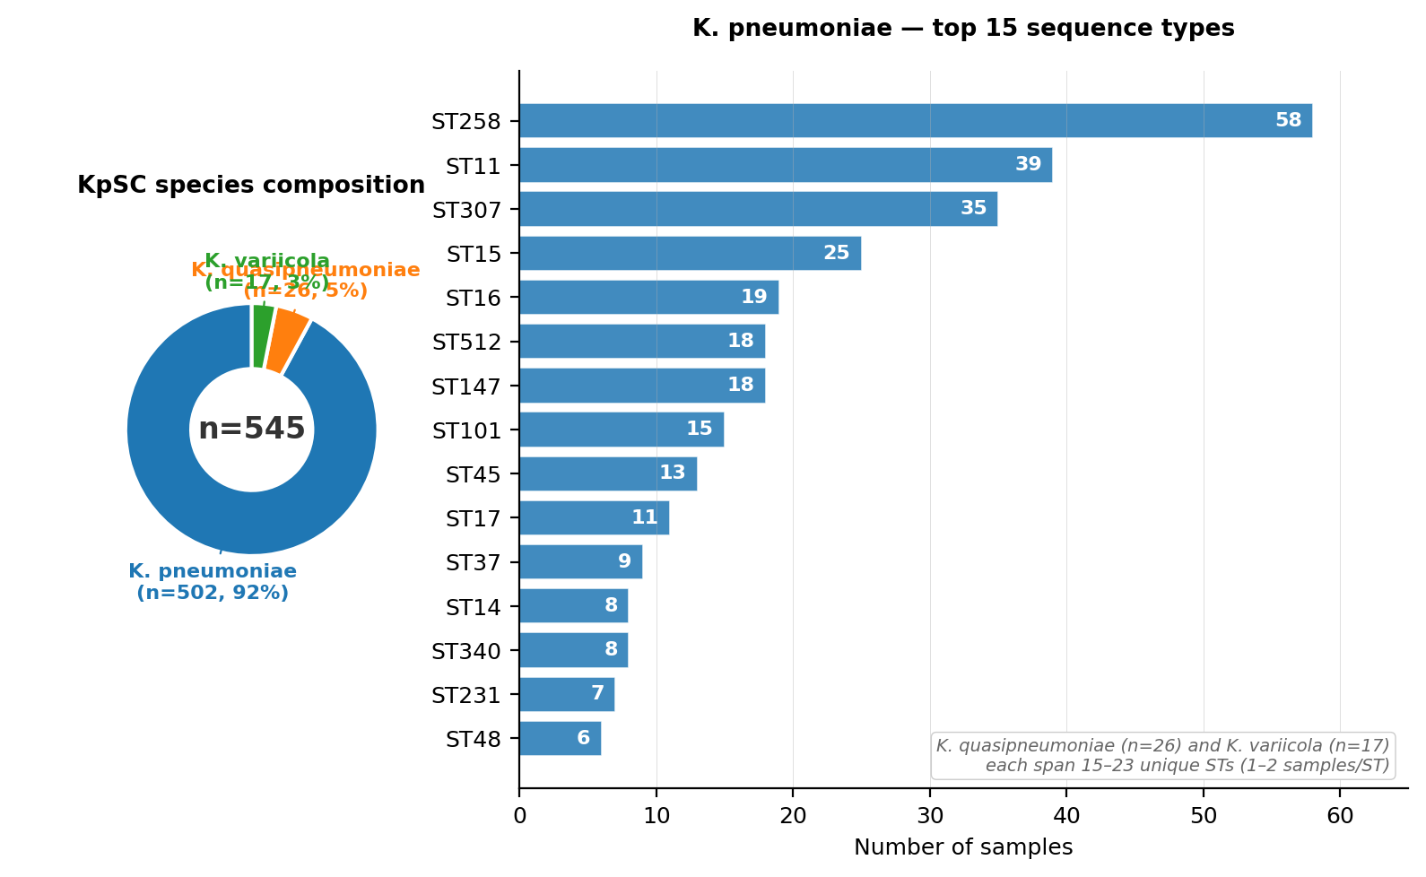
Figure 6. Cohort composition by sequence type (top 15 STs). Bars are coloured by KpSC member: K. pneumoniae (blue), K. quasipneumoniae (orange), K. variicola (green). ST258, ST11, and ST512 are the globally dominant carbapenem-resistant clones.
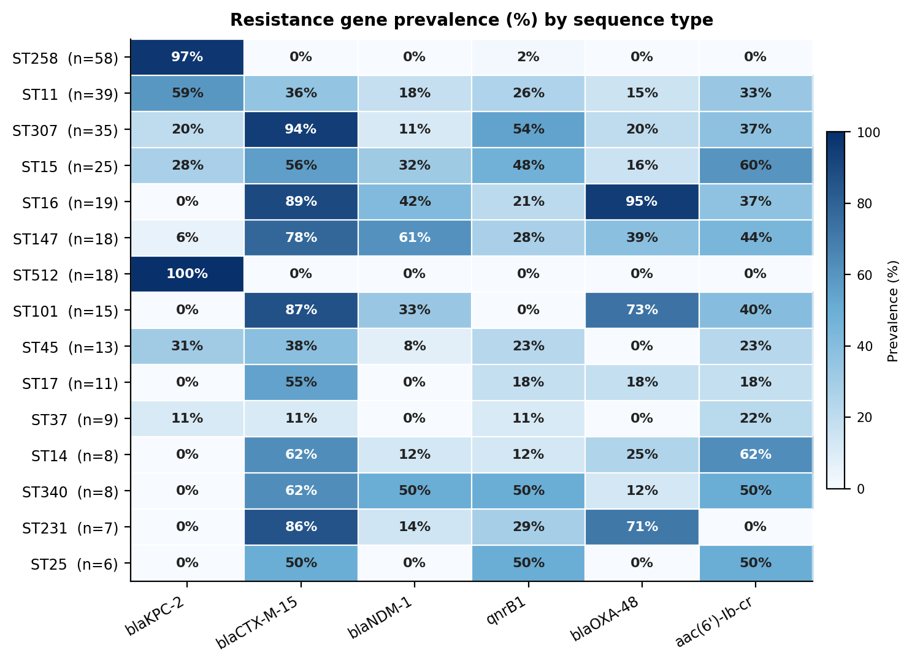
Figure 7. Resistance gene prevalence (%) by sequence type. Each cell shows the percentage of samples within that ST carrying the gene. The colour gradient runs from white (0%) through blue to dark navy (100%). Gene columns are ordered by clinical importance; ST rows are ordered by total sample count. Note the near-exclusive association of blaKPC-2 with ST258/ST512, and the broad multi-gene resistance of ST15 and ST147.
Among blaKPC-2-positive samples, PCN varies substantially by sequence type (Figure 8). ST45 carries the highest median KPC PCN (3.75×), suggesting elevated plasmid copy number in this lineage. ST258 (n=56) and ST512 (n=18) — the dominant KPC lineages — have similar median PCN (2.13× and 2.12× respectively). All eligible STs show the majority of samples above the 1.5× amplification threshold, confirming that multi-copy KPC carriage is the norm across lineages rather than the exception.
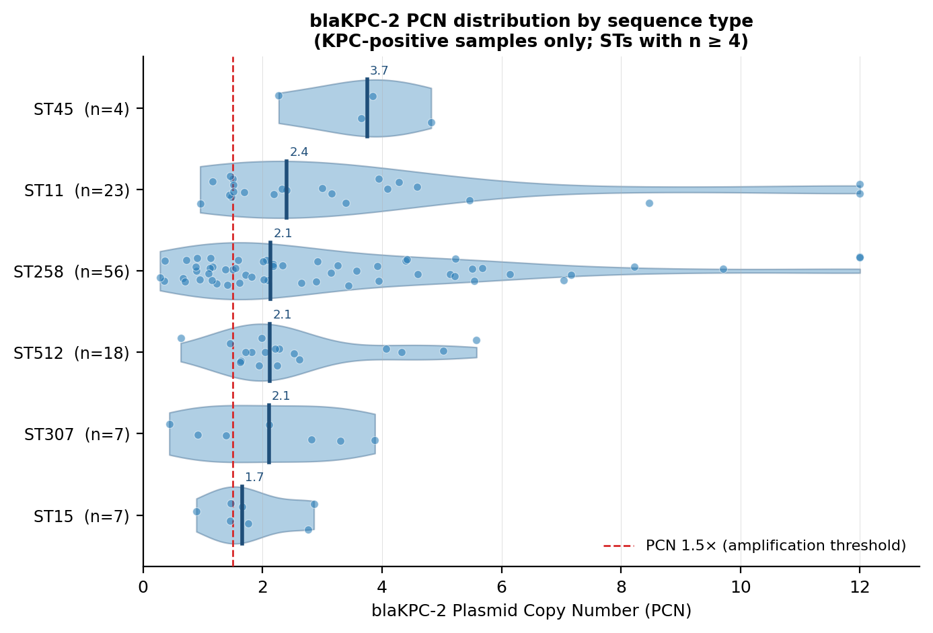
Figure 8. blaKPC-2 plasmid copy number (PCN) by sequence type, restricted to KPC-positive samples in STs with n ≥ 4. Violins show the PCN distribution; jittered points are individual samples; horizontal bars mark the median. The dashed red line at PCN=1.5× marks the amplification threshold. STs are ordered by median PCN. All lineages show the majority of samples above the amplification threshold, with ST45 carrying the highest median PCN (3.75×).

4. Discussion
CNVRock demonstrates that a convolutional VAE combined with Gaussian HMM segmentation can detect AMR gene copy-number states in KpSC WGS data with near-perfect accuracy for carbapenem resistance genes and high accuracy for a panel of six clinically important resistance determinants, without requiring de novo genome assembly.
The principal contribution beyond existing tools is quantitative resolution. AMRFinder+ cannot distinguish a single-copy gene from a four-copy amplification. CNVRock's PCN estimates reveal that 77% of blaKPC-2-positive KpSC carry plasmid amplification (PCN ≥ 1.5×), and that blaOXA-48 copy number spans more than 20-fold across positive samples. Whether this quantitative variation translates to clinically meaningful MIC differences is an open question that CNVRock's output enables researchers to address.
The identification of 34 samples with chromosomal blaSHV amplification that are invisible to AMRFinder+ illustrates a complementary advantage of read-depth approaches: tandem duplications that collapse in short-read assembly are directly visible in depth profiles. Confirmation with long-read sequencing for a subset of these samples is a natural extension.
The primary limitation is reference dependence. The CTX-M false-negative analysis demonstrated this precisely: blaCTX-M-65 reads map to chromosomal blaSHV in the primary alignment and never appear in the unmapped pool. Expanding the reference panel to include non-15 CTX-M variants is planned (Phase D). The expansion workflow is fully automated via data/setup/add_phase_c_genes.py.
CNVRock was developed using an autonomous experiment proposal loop in which an AI agent (Claude Code, Anthropic) analyses evaluation outputs, proposes parameter changes or data additions, and emails a summary for human authorisation before execution. This human-in-the-loop design accelerated iterative development across 30 experiments without manual code changes between experiments.
In conclusion, CNVRock provides assembly-free, quantitative AMR gene copy-number detection in KpSC WGS data, with demonstrated high performance across a 545-sample cohort and confirmed generalisation in hold-out validation. The pipeline is available as open-source software at https://github.com/lcerdeira/CNVRock.

References
All references marked [VERIFY] should be confirmed against primary sources. References marked [CITATION NEEDED] must be replaced before submission.
- 1. [VERIFY] Kingma, D.P. and Welling, M. (2013). Auto-Encoding Variational Bayes. arXiv:1312.6114. [Accepted ICLR 2014 — confirm preferred citation form]
- 2. [VERIFY] Rabiner, L.R. (1989). A tutorial on hidden Markov models and selected applications in speech recognition. Proceedings of the IEEE, 77(2), 257–286.
- 3. [VERIFY] Li, H. and Durbin, R. (2009). Fast and accurate short read alignment with Burrows-Wheeler Aligner. Bioinformatics, 25(14), 1754–1760.
- 4. [VERIFY] Feldgarden, M., Brover, V., Gonzalez-Escalona, N., et al. (2021). AMRFinderPlus and the Reference Gene Catalog facilitate examination of the genomic links among antimicrobial resistance, stress response, and virulence. Scientific Reports, 11, 12728. [Confirm DOI and author list]
- 5. [VERIFY] Lam, M.M.C., Wick, R.R., Watts, S.C., et al. (2021 or 2022). A genomic surveillance framework and genotyping tool for Klebsiella pneumoniae and its related species complex. [Confirm journal: Microbial Genomics or Nature Communications, and year]
- 6. [CITATION NEEDED] AllTheBacteria resource. Search 'AllTheBacteria' in PubMed for the correct citation.
- 7. [CITATION NEEDED] HS11286 genome paper. Search NC_016845.1 or GCF_000240185.1 in PubMed.
- 8. [CITATION NEEDED] KpSC epidemiology review. Consider Wyres & Holt (2018) Curr Opin Microbiol — verify exact title and details.
- 9. [CITATION NEEDED] Assembly collapse of tandem repeats — consider Alkan, Coe & Eichler (2011) Nat Rev Genet 12:363–376 or a bacterial-specific reference.
- 10. [CITATION NEEDED] SAMtools — Li et al. (2009) Bioinformatics 25(16): 2078–2079 — confirm author list and title.
- 11. [CITATION NEEDED] hmmlearn — check https://github.com/hmmlearn/hmmlearn for the preferred citation.
- 12. [CITATION NEEDED] CTX-M variant epidemiology in KpSC — find a review or surveillance paper covering blaCTX-M-65 prevalence.

