**Generalized Multi-Reservoir Analyses using Probabilistic Streamflow Forecasts (GRAPS)**

**GRAPS Interface Documentation**

**Contents**

**Table of Figures** 2

**Introduction** 3

**Features of GRAPS Interface** 3

**Using the GRAPS Interface** 4

**Interface Layout** 4

**General Setup** 4

**Building Reservoir Networks** 6

**Watersheds** 7

**Reservoirs** 8

**Users** 10

**Junctions** 13

**Inter-basin Transfers** 13

**Sinks** 14

**Links** 14

**Saving and Reopening Network Files** 15

**Exporting Input Files for Model-Run** 15

**Printing Network Graphics** 15

**Future Work** 15

**References** 16

**TVA Examples** 17

# **Table of Figures**

Figure 1 - GRAPS GUI tool bar descriptions 4

Figure 2 - General Setup Dialog (User Description tab) 5

Figure 3 - General Setup Dialog (Forecast tab) 5

Figure 4 - TVA Downstream Reservoir Example 6

Figure 5 - Watershed Dialog 7

Figure 6 - Reservoir Dialog (Reservoir Description tab) 8

Figure 7 - Reservoir Dialog (Evaporation / Storage Relationship tab) 9

Figure 8 - Resevoir Dialog (Operational Information tab) 9

Figure 9 - Reservoir Dialog (Spillway / Outlets tab) 10

Figure 10 - User Dialog (User Description tab) 11

Figure 11 - User Dialog (User Demand tab) 11

Figure 12 - User Dialog (Restriction Compensation tab) 12

Figure 13 - User Dialog (Hydropower tab) 12

Figure 14 - Junction Dialog 13

Figure 15 - Inter-basin Transfer Dialog 14

Figure 16 - Sink Dialog 14

Figure 17 - Link Dialog (a) Identification tab; (b) Discharge tab 15

# **Introduction**

Previously, the input files for the Multi-Objective Reservoir Analyses using Probabilistic Streamflow Forecasts (GRAPS) model were manually created. In addition to this process being meticulous and error-prone, there also was not a way to visualize the network cascade or to easily interact with different parameters associated with the network. This graphical user interface enables GRAPS users to create reservoir networks with intuitive keystrokes and mouse movements. Network files can be saved and opened for editing later, the interface graphics can be exported as a PDF or directly printed, and all input files required to run GRAPS can be exported with the correct information and formatting.

# **Features of GRAPS Interface**

Reservoir networks are created by placing blocks that correspond to different network nodes (reservoirs, watersheds, junctions, etc.) on the graphics window and then creating links between those blocks. Each network node and link have a unique dialog that stores user-input associated with that node or link. Saving and opening network files and printing network graphics follow a process similar to other desktop applications and exporting input files only requires the user to specify a directory to place the files.

**System Requirements**

This interface was developed using Python 3.7 and PyQt5. It should be able to run on any Windows, MAC, or Linux operating system as long as the user has a version of Python 3.7 installed as well as PyQt5.

**A Note on Units**

The user of this interface is responsible for ensuring the units of the values entered correspond with each other (e.g. if storage is provided in acre-feet, inflow should be provided in acre-feet per time step and evaporation depths should be provided in feet). GRAPS makes no assumptions about the units except that they are consistent (i.e. it will not fail if you provide values in mismatched units unless they fall outside the realm of possibility). However, to assist users in setting the model up the dimensions have been provided for each quantity that is to be provided. The dimensions used are *M* for mass, *L* for length, and *T* for time. Combinations of these dimensions will be used to indicate specific types of information to be entered (e.g. *L* for elevation, *L3* for volumes, *L3/T* for volumetric flowrates, etc…).

# **Using the GRAPS Interface**

## **Interface Layout**

The GRAPS GUI is displayed as a desktop application (Figure 1). A drop-down menu bar is situated at the top of screen and the tool-bar (which the user will interact with the most) directly below it. As indicated in Figure 1, the tool-bar contains buttons for selecting modeling blocks and links as well as generic buttons to create a new file, open an existing file, save the current file, and print the current file. The rectangular button is used to center the screen based on the network that has been drawn and the “Export” button is used to create the input file for GRAPS to run based on the information entered by the user.

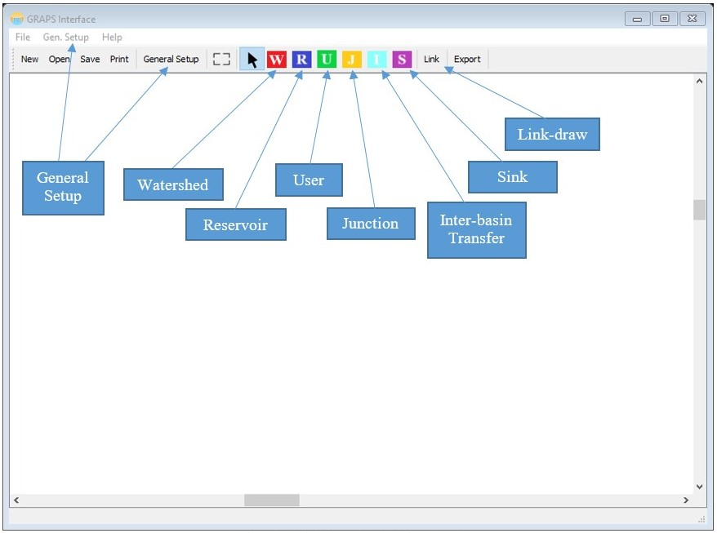

Figure 1 - GRAPS GUI tool bar descriptions

## **General Setup**

GRAPS requires basic setup information to adequately model the desired scenario. These parameters are entered in the general setup dialog, which is depicted in Figure 2 and Figure 3. This dialog can be accessed either through the “Gen. Setup” menu in the Menu Bar or via the “General Setup” tool bar button. The “General Setup” dialog requires the following information if the type of simulation is to be “Zero Flow”: number of time steps, number of restriction levels, and the type of simulation desired. If “Climatology” is selected as the simulation type then the “Number of years” is also required.

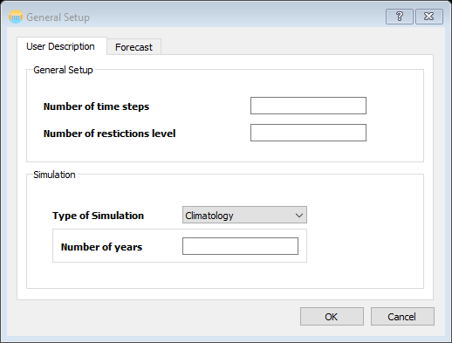

Figure 2 - General Setup Dialog (User Description tab)

If the selected simulation type is “Forecast”, the number of ensembles is required as well as extra information in the “Forecast” tab. If the “Adaptive Forecasts” button in the “Forecast” tab is selected, the number of years of simulations for the forecasts and the values for those forecasts are required in the “Adaptive Forecasts” table.

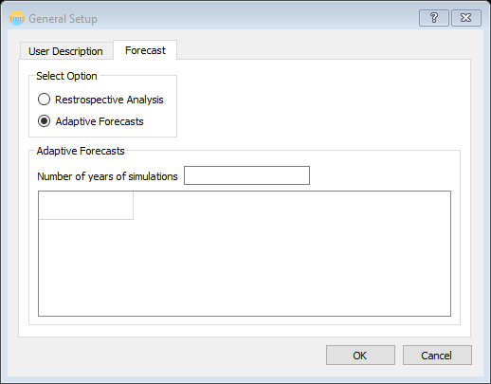

Figure 3 - General Setup Dialog (Forecast tab)

|  |  |  |
| --- | --- | --- |
| Table 1 - General Setup Variable Information | | |
| **Variable/Field** | **LB** | **UB** |
| Number of time steps | 1 | User Defined |
| Number of Restriction Levels | 1 | User Defined |
| **Simulation- Forecast** | |
| Number of Years | 1 | User Defined |
| Number of Ensembles | 1 | User Defined |
| Adaptive Forecasts –  Number of years of simulation | 1 | Number of years |

## **Building Reservoir Networks**

There are six network nodes to be used when creating reservoir networks (Watershed, Reservoir, Inter-basin Transfer, User, Junction, and Sink) as well as Links/Flow connectors. To begin creating networks in GRAPS, first complete the General Setup dialog and then click the toolbar icon corresponding to the name of the first network node you intend to create e.g. the red block with a white “W” for a watershed. To use the mouse without placing nodes, click the mouse pointer tool bar button. An example of some of the downstream main-stem reservoirs in the Tennessee Valley Authority’s (TVA) reservoir network is show in Figure 4 to illustrate a possible network configuration.

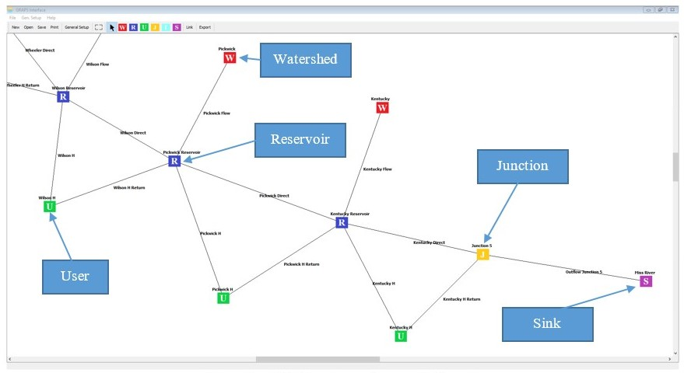

Figure 4 - TVA Downstream Reservoir Example

To open the dialog for a node, the node can be double-clicked, or if it is selected with a single click, hitting “Return/Enter” key on the keyboard. Table 2 shows valid and invalid node connection. Though the software should not allow invalid connections, it is best to keep in mind what is valid and what is not.

|  |  |  |  |  |  |  |  |
| --- | --- | --- | --- | --- | --- | --- | --- |
| Table 2 - Connectivity Flow Table | | | | | | | |
|  |  | **Connect From** | | | | | |
| **Connect To** | **System Blocks** | **Watershed** | **Inter-basin**  **Transfer** | **Reservoir** | **Junction Node** | **User** | **Sink** |
| **Watershed** | Invalid | Invalid | Invalid | Invalid | Invalid | Invalid |
| **Inter-basin**  **Transfer** | Invalid | Invalid | Invalid | Invalid | Invalid | Invalid |
| **Reservoir** | **Valid** | **Valid** | **Valid** | **Valid** | **Valid** | Invalid |
| **Junction Node** | **Valid** | **Valid** | **Valid** | **Valid** | **Valid** | Invalid |
| **User** | Invalid | Invalid | **Valid** | **Valid** | Invalid | Invalid |
| **Sink** | **Valid** | **Valid** | **Valid** | **Valid** | **Valid** | Invalid |

### **Watersheds**

Watersheds provide a description of natural inflows to reservoirs. An example of the watershed dialog is show in Figure 5. The information required in the “Watershed” dialog is the “Watershed Name”, “Drainage Area”, and the user must select a file containing observed inflows. The file must be space delimited (i.e. values separated by white space or tabs) and each line in the file represents one ensemble member and there should be the same number of values as the number of time steps specified in general setup. If you have not specified the number of ensembles to be used, the number is assumed one; therefore, the inflow file should only contain one line of values. For example, if you have specified 5 ensemble members and the number of modeled time steps is 6, your inflow files should look similar to this:

10 12 13 15 17 15

12 11 12 16 13 14

13 11 12 13 16 12

11 13 15 15 15 11

10 15 14 17 13 13

In the above text box, each line represents an ensemble member and each value in each line represents natural inflow into a watershed for a given time step.

|  |  |  |  |  |
| --- | --- | --- | --- | --- |
|  | Table 3 - Watershed Variable Information | | | |
| **Variable/Field** | | **Dimension** | **LB** | **UB** |
| Drainage Area | | L2 | 0.1 | User Defined |
| Inflows | | L3 | 0 | User Defined |

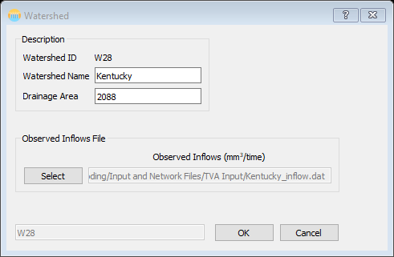

Figure 5 - Watershed Dialog

### **Reservoirs**

The information input into the “Reservoir” dialog is essential to effectively running GRAPS. There are four tabs that require user input: “Reservoir Description”, “Evaporation / Storage Relationships”, “Operational Information”, and “Spillway / Outlets”. Each of these tabs is shown below along with a description of what information is required.

*Reservoir Description*

Basic information regarding the reservoir. The most important information for GRAPS are the last 5 fields: min. and max. elevation, min. and max. storage, and current storage.

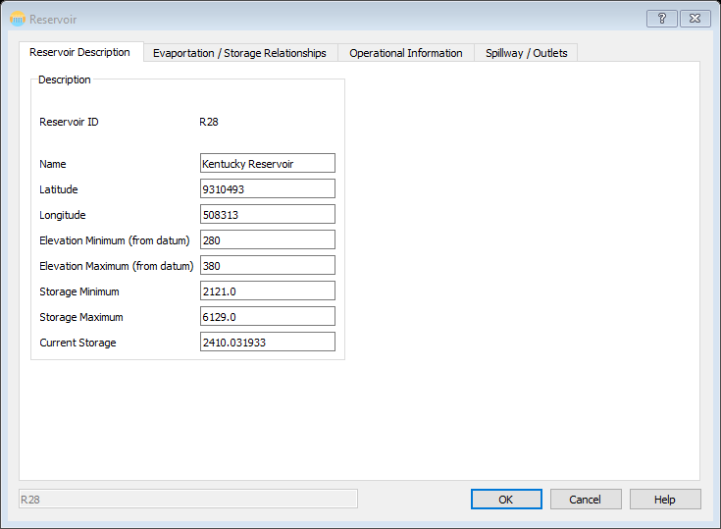

Figure 6 - Reservoir Dialog (Reservoir Description tab)

*Reservoir-Evaporation / Storage Relationships*

This tab (Figure 7) requires the user input information regarding the lake evaporation depth (in either a table or selecting a file) and the storage relationship coefficients. When simulating over longer periods, it can be easier to use data files rather than manual entry. When “Table” is selected, a table will appear to enter information and when “Input File” is selected, a field to select a file will appear. The below equations (Eqn. 1 - Eqn. 3)**Error! Reference source not found.** explain how the coefficients and the evaporation depths will be used in the model. In the below equations, ${\overline{S}}_{t, t-1}$  is the average storage between the current and previous time steps, $α, β, and γ$ are the coefficients that are requested (they exist separately for each relationship type), and *E* represents the evaporation depth. All of these quantities are calculated for each reservoir for each time step and ensemble member.

|  |  |  |
| --- | --- | --- |
| **Elevation-Storage Relationship** |  | Eqn. 1 |
| **Area-Storage Relationship** |  | Eqn. 2 |
| **Evaporation Calculation** |  | Eqn. 3 |

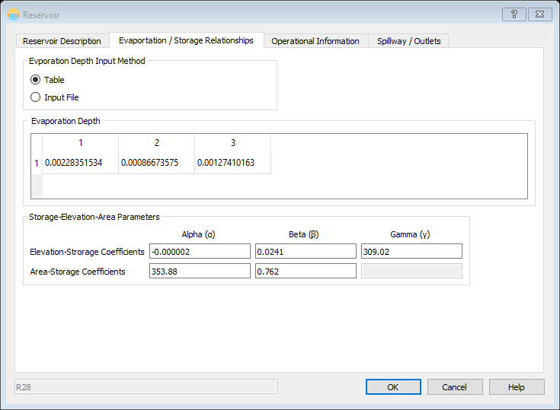

Figure 7 - Reservoir Dialog (Evaporation / Storage Relationship tab)

*Reservoir-Operational Information*

In the “Operational Information” tab (Figure 8) users are required to enter the “Target Storage”, “Storage Probability”, and “Target Restriction Levels Probability” for each restriction level. They are also required to specify a method of entry for the “Rule Curve;” either manual entry of values into a table or selecting a data file. As with the “Evaporation” tab, it is suggested to use the data file input method for long term simulations. Rule curves are not required, but they provide a method for the user to impose realistic, time-varying storage constraints.

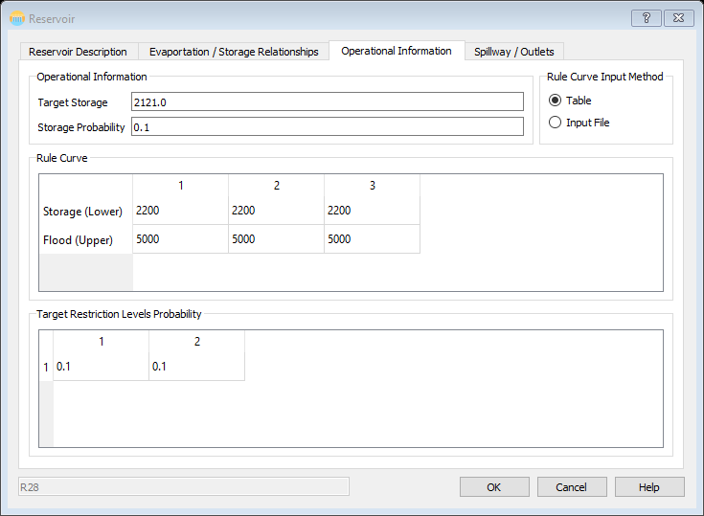

Figure 8 - Resevoir Dialog (Operational Information tab)

*Reservoir-Spillway/Outlets*

The “Spillway/Outlets” tab (Figure 9) requires the user enter the “Number of Spillways” and the type, crest level, and maximum discharge for each spillway as well as the “Number of Outlets” and the elevation, cross-sectional area, and maximum and minimum loss coefficients for each outlet. For the “Spillway Type” enter 0 for a controlled spillway or 1 for an uncontrolled spillway.

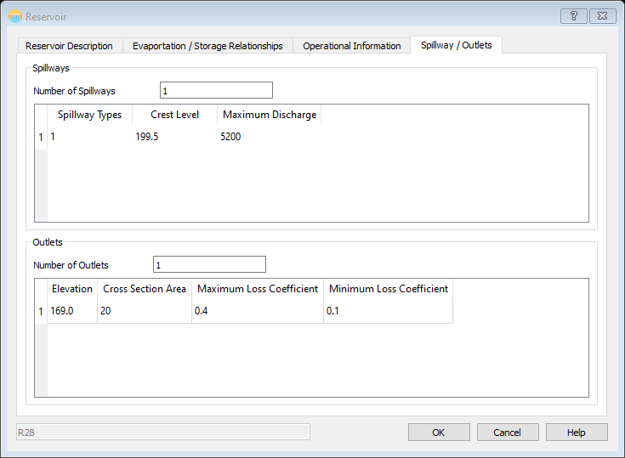

Figure 9 - Reservoir Dialog (Spillway / Outlets tab)

|  |  |  |  |
| --- | --- | --- | --- |
| Table 4 - Reservoir Dialog Variable Information | | | |
| **Variable/Field** | **Dimension** | **LB** | **UB** |
| **Reservoir Description** | | | |
| Elevation Minimum | L | 0 | User Defined |
| Elevation Maximum | L | Elevation Minimum +1 | User Defined |
| Storage Minimum | L3 | 0 | User Defined |
| Storage Maximum | L3 | Storage Minimum | User Defined |
| Current Storage | L3 | Storage Minimum | Storage Maximum |
| Evaporation | L | 0 | User Defined |
| **Operation Information** | | | |
| Target Storage | L3 | Storage Minimum | Storage Maximum |
| Storage Probability |  | 0 | 1 |
| Rule Curve | L3 | Storage Minimum | Storage Maximum |
| Target Restriction Level Probability |  | 0 | 1 |
| **Spillway Information** | | | |
| Spillway Type |  |  |  |
| Crest Level | L | Elevation Minimum | Elevation Maximum |
| Discharge | L3/T | 0 | User Defined |
| **Outlet Information** | | | |
| Elevation | L | Elevation Minimum | Elevation Maximum |
| Cross Sectional Area | L2 | 0 | User Defined |
| Minimum Loss Coeff. |  | 0 | 1 |
| Maximum Loss Coefficient |  | Minimum loss coefficient | 1 |

### **Users**

The user block is representative of the different types of users that are present in a reservoir network. The user type is selected in the “User” dialog window. If the “User Type” is “Hydropower” the “Hydropower” tab in the “User” description needs to be completed.

*User-User Description*  
The “User Description” tab (Figure 10) requires the following input: “User Name”, “User Type” (from the drop down box), “Minimum” and “Maximum Release”, “Tariff” amount, “Penalty” amount, “Reliability”, “Contract Restriction Volume”, and the “Penalty Compensation.”

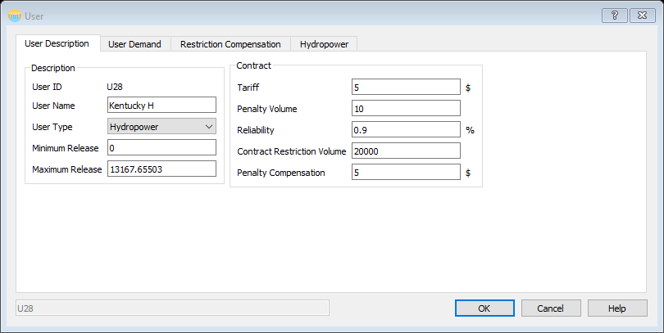

Figure 10 - User Dialog (User Description tab)

*User-User Demand*

Again, there is the option to enter the information required in this tab or to select a data file with the information. For larger data sets, it is ideal to use the data file entry method. The information required is the per time step demand for the user. If the model is being run in a simulation mode, these become the releases for that user. If the model is being optimized, these become the starting points for the optimization engine.

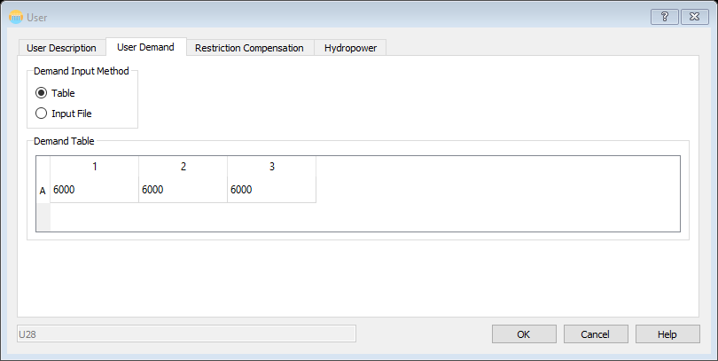

Figure 11 - User Dialog (User Demand tab)

*User-Restriction Compensation*

The information required in the “Restriction Compensation” tab is the restriction compensation and fraction for each restriction level.

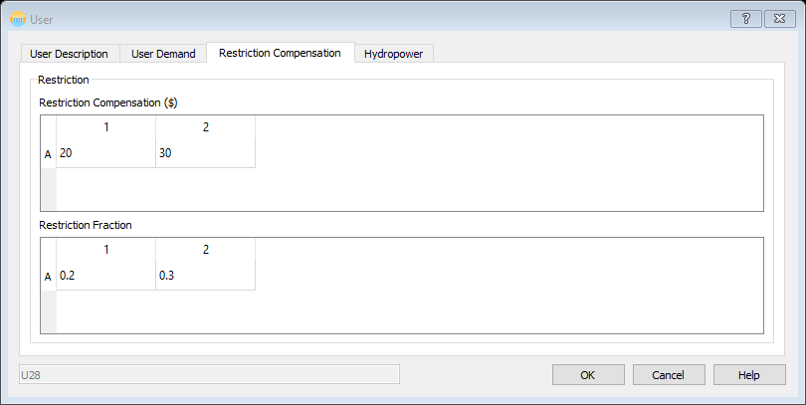

Figure 12 - User Dialog (Restriction Compensation tab)

*User-Hydropower (Conditional, “User Type”)*

If the “User Type” is “Hydropower” the “Hydropower” tab becomes required information. The user should specify the “Number of Turbines” and the “Maximum Discharge”, “Installed Capacity”, “Turbine Efficiency”, two energy coefficients, and the “Unit Rate Energy” for each turbine. The “Turbine Tail Elevation” is also required for each time step.

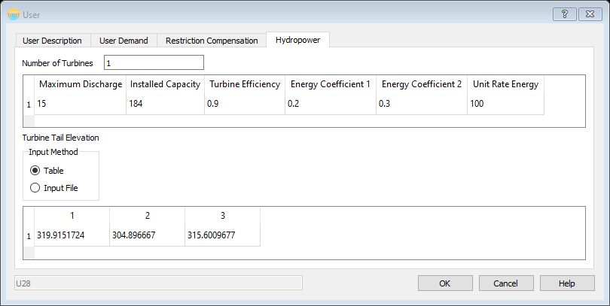

Figure 13 - User Dialog (Hydropower tab)

|  |  |  |  |  |
| --- | --- | --- | --- | --- |
| Table 5 - User Dialog Variable Information | | | | |
| **Variable/Field** | **Dimension** | **LB** | | **UB** |
| Minimum Release | L3 | 0 | | User Defined |
| Maximum Release | L3 | Min. | | User Defined |
| Tariff | Currency | 0 | | User Defined |
| Penalty | Currency | 0 | | User Defined |
| Failure Probability  (Or Reliability) |  | 0 | | 100 |
| Contract Restriction Volume | L3 | 0 | | Minimum Release |
| Demand Fraction |  | 0 | | 1 |
| Restriction Compensation | Currency |  | |  |
| Restriction Fraction |  | 0 | | 1 |
| Penalty Compensation | Currency | 0 | | User Defined |
| **Hydropower** | | | | |
| Maximum Discharge | L3/T | | 0 | User Defined |
| Installed Capacity | Energy Rate | | 0 | User Defined |
| Generator Efficiency |  | | 0 | 1 |
| Energy Coefficients |  | | 0 | 1 |
| Unit Rate Energy |  | | 0 | User Defined |
| Turbine Tail Elevation | L | | 0 | User Defined |

### **Junctions**

Junctions represent a connection between network branches or nodes that have no storage. The only requirement for the “Junction” dialog is the name of the junction.

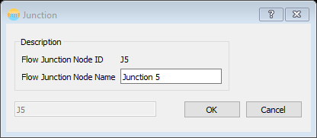

Figure 14 - Junction Dialog

### **Inter-basin Transfers**

Flows from neighboring basins that could be diverted into the reservoir or a junction. The requirements of the Inter-basin Transfer dialog is the name of the node, the drainage area, and an average flow for each time step. The average flow can either be entered manually in a table or imported with a data file.

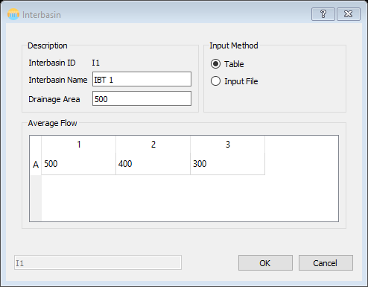

Figure 15 - Inter-basin Transfer Dialog

|  |  |  |  |
| --- | --- | --- | --- |
| Table 6 - Inter-basin Transfer Variable Information | | | |
| **Variable/Field** | **Dimension** | **LB** | **UB** |
| Drainage Area | L2 | 0.1 | User Defined |
| Average Flow | L3/T | 0 | User Defined |

### **Sinks**

Sinks should always be the last node in a network and there should never be more than one. If you desire to have multiple sinks, you can use junction nodes and then tie all the junctions to a single sink. Sinks represent a natural drainage entity such as a large river, sea, or ocean. The required information for the Sink Dialog is the name of the sink and the maximum storage.

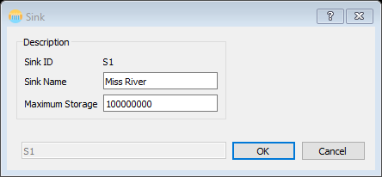

Figure 16 - Sink Dialog

|  |  |  |  |
| --- | --- | --- | --- |
| Table 7 - Sink Variable Information | | | |
| **Variable/Field** | **Dimension** | **LB** | **UB** |
| Maximum Storage | L3 | 0.1 | User Defined |

### **Links**

Links are what provides the network connectivity. The “Link” dialog is opened by clicking on the link name and hitting the “Return/Enter” key on the keyboard or double clicking the link name. Each link dialog contains two tabs: “Identification” and “Discharge.” The only requirement on the “Identification” tab is the “Link Name;” the rest of the information will auto-populate. On the “Discharge” tab, the user is required to enter the minimum and maximum discharge, the loss factor, and to specify if it is a return flow or not. If it is a return flow, the number of lags must be specified as well as the values associated with them.

|  |  |
| --- | --- |
| (a) | (b) |
| Figure 17 - Link Dialog (a) Identification tab; (b) Discharge tab | |

## **Saving and Reopening Network Files**

GRAPS GUI files should always be saved with a `.graps` extension. When you first save a file that will be the default file type. The interface leverages Python’s `pickle` library to serialize the network information. This results in a simple IO mechanism for the interface.

To open a previously saved network, a user can use either the “Open” toolbar icon or the “Open” menu item in the “File” menu in the menu bar. Either option will open a file dialog requiring the user to select what file they wish to open.

The “New” toolbar command will clear the network and all previously set parameters from the current network.

## **Exporting Input Files for Model-Run**

To export the data files needed to run GRAPS, the user must click the “Export” toolbar command. This will prompt the user to select a directory for which to save the files in. There are multiple files that will be created and they will have the names that are required for the model to find them. If you are exporting to a folder with these files already in it, the existing files will be overwritten without warning.

## **Printing Network Graphics**

To print an image of the network open in the interface open the “File” menu in the menu bar and click the “Print” menu item. This will open a traditional print dialog that will allow the user to print the extents of the network to any of the printers available on their machine.

# **Future Work**

While this interface makes new network formulation quicker and simpler, it is not complete. Future additions are integration with the GRAPS model to create a stand-alone modeling package and possible integration with an energy modeling software to allow for more in depth analysis of water management decisions.

# **References**

This document is an adaptation of the “GRAPS Software Documentation” – Dr. Sankar Arumugam. It is meant to be an extension of that document and to provide information regarding the interface and not the GRAPS model.

# **TVA Examples**

*Full cascade (top to bottom)*

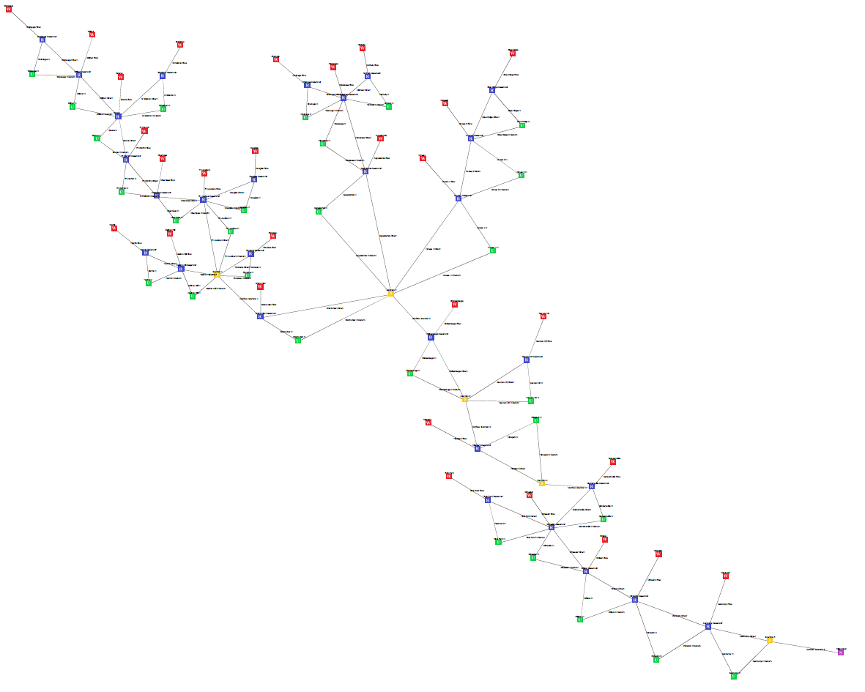

*Partial Cascade (top part of network)*

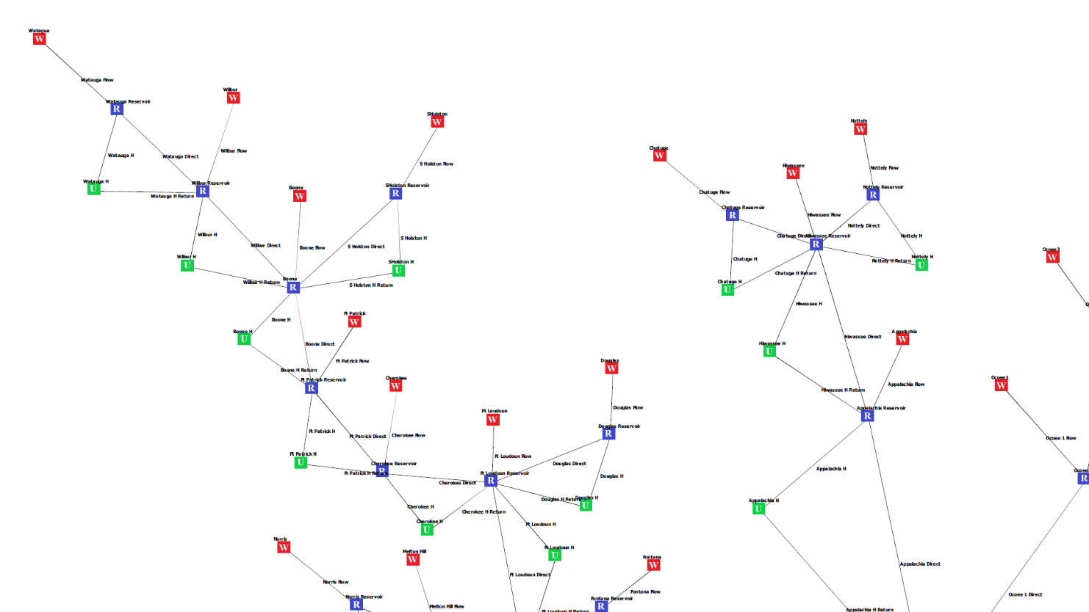

*Partial Cascade (zoomed in to better show network details)*

