Zone Algeciras

Vopak Algeciras + CLH Algeciras Storage --> demand centre for fuel oil (bunkering demand)

Vopak Algeciras: The terminal is now operated by EVOS (Royal Vopak's hydrocarbon terminal in Algeciras was sold to First State Investments in 2020 and is now operated as Evos Algeciras Evos Algeciras)

Product break down:

Imports mainly

- FO (bunkering)
- Diesel (Maybe maritime diesel)
- Gasoil
- Dirty Feedstock
- Slurry
- Gasoline

Classification: Bunkering

Gibraltar Santa Roque Refinery -->

Owned by MOEVE (former CEPSA), Capacity: Processes 240,000 barrels of crude oil per day (equivalent to 12 million tonnes per year).

Imports mainly:

- Jet

Exports mainly:

- Gasoline
- Gasoil
- Naphtha
- Diesel
- FO

Classification: Refinery

Zone Bilbao

Petronor: Located in Muskiz (Close to bilbao), Biscay, is the largest industrial consumer of hydrogen in northern Spain. Capacity to process 12 million tonnes per year. Owned by repsol (85.98%) and Kutzabank (14.02%).

Bilbao Oil Facilities: Owned by TEPSA, 3 jetties, has storage, blending, and is connected to petronor via pipeline. Storage capacity: 322 cbm in 79 tanks.

Import mainly:

- Diesel
- Jet
- Blending comp

Export mainly:

- Gasoline
- Dirty Feedstocks
- Naphtha
- FO
- Kerosene

Classification: Refinery (petronor)+ bilbao oil facilities (port actually doing the import/export work).

Bilbaina de Alquitranes: focuses its industrial activity in the distillation of coal tar from the coke batteries of Europe’s main steel groups. Mainly imports resids.

Zone Barcelona

Vopak terquimsa Barcelona -> ( Sold in sep-2025 to Tradebe TPS barcelona)

Barcelona 32F & 32G (Meroil) --> 45 tanks, 1 million cbm.

Barcelona 32A --> owned by Decal.

Barcelona 33B --> owned by Terquimsa

Barcelona 32C --> owned by Tepsa.

Barcelona 32D --> owned by Tepsa.

Barcelona 32E --> owned by Relisa.

ATP Terminals Barcelona -> owned by exolum, it provides jet for El prat international airport

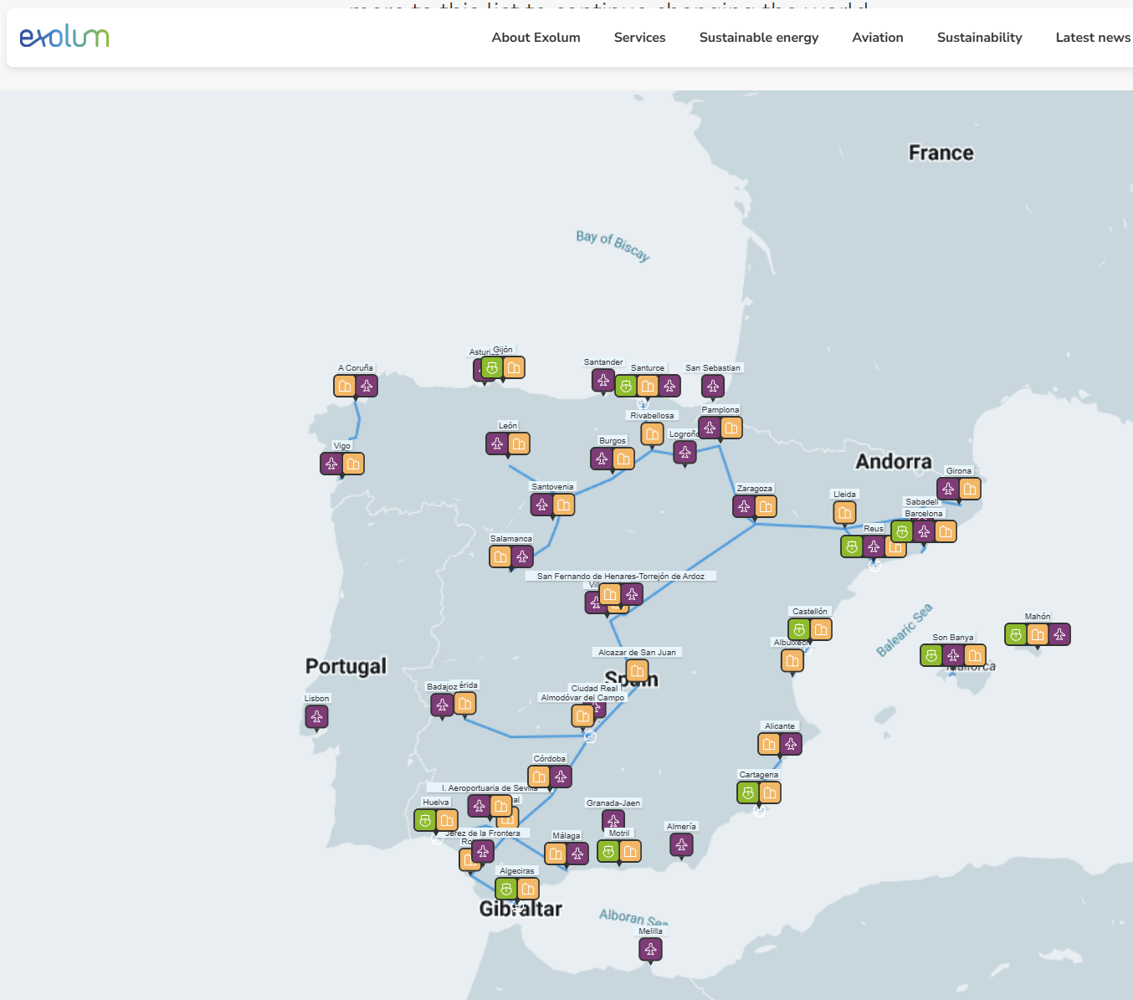

Ergansa + Cargill --> Agri imports (has only imported gasoil cargo twice in 10 years, not a demand center)

Zone Castellon

BP Castellon Refinery: Owned by BP, they produce and export:

- gasoline
- Diesel
- jet fuel

UBE Castellon: No trade

Masol Iberia Castellon: Biofuel operator, doesn't trade, no classification.

Zone Tarragona

Euroenergo: Storage of petroleum products and biofuels, 331.000 cbm distributed in 18 tanks. 3 berths connected through pipelines between themselves and with Terminal storage. independent

ASESA: Oil refining specialized in asphalt production. (50% owned by Moeve - formally cepsa)

TEPSA Tarragona: 128,500 cbm, 63 tanks. Storage, mixing & Blending.

Vopka Terquimsa Tarragona: Mainly blending components, use to create gasoline.

Tarragona refinery: Owned by repsol, it mainly imports naphatha from Cartagena refinery (also owned by repsol) and exports all range of products. It's a refinery + petchem operation, with the production of ethylene, propelyne, and other oleofins. It additionally, has a LPG storage and treatment site.

Import :

- Naphtha

Exports:

- Fuel oil
- Gasoline

Less important:

- Gasoil/diesel
- jet

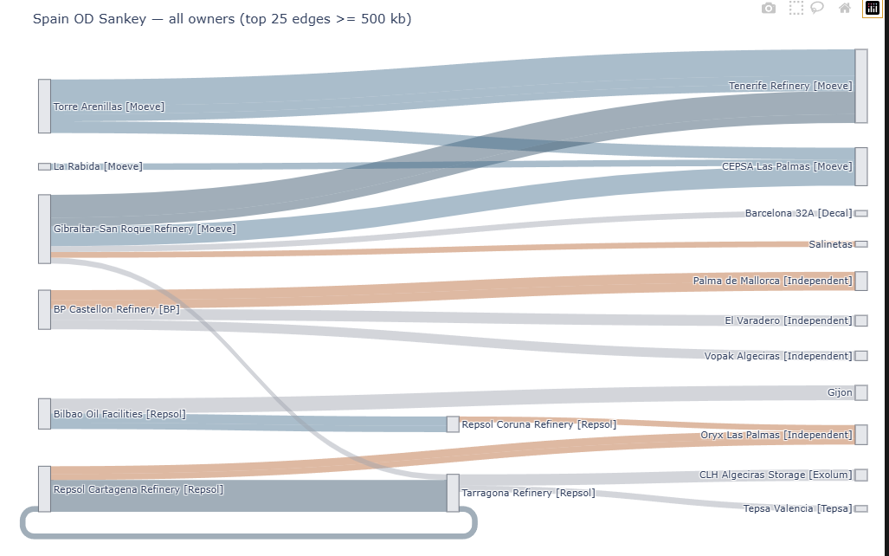

Zone Valencia

Only one terminal in this area

Tepsa Valencia:

Mainly and import - consumption center of:

- Gasoil/Diesel
- Fuel oil (bunkering?)

Zone Cartagena

Masol Iberia Cartagena: Biofuel storage company. Not a recurrent importer of refined products (0 trades)

Timab Cartagena: Phosphates producer. It's not a recurrent importer of refined products.

ICL Funetes Fertilizantes: Fertilizer producer, not a recurrent importer/exporter of refined products.

Repsol Cartagena Refinery: Owned by repsol, 220 kbd processing capacity.

Zone Carboneras

Muelle de Ribera I: Only two lumpy trade records, one import, one export. The location used to house a carbon powered thermal plant, it's been decomissioned (google 2025). Moreover, a Holcim cement plant also sit next to the power plant, the imports might have been one offs for one of this industries.

Zone Motril

El varadero: Storage site that houses liquid bulk and petrolum products logistics, real name is DBA Motril Port, owned by Hafesa group. 106,527 cbm, 10 tanks.

Imports:

- Diesel
- Gasoline
- Jetfuel

Zone Malaga

Malaga ODT: Storage site, Lumpy import/exports, not a real demand/supply center, couldn't find the owner. Probably served by pipe (look at exolum map)

Zone Cadiz

Olivia Petroleum Terminal: Storage site, lumpy imports/exports. Owned by olivia energy group, the site has a storage capcity of 67.000 cbm.

Cadiz: Storage site, it mainly import/exports asphalt/bitumen products. There seem to be two different storage sites, with one being owned by Puma energia espana, 66.6 cbm and another site with an unknow owner.

Rota Base: US naval base, they have imported mainly jet fuel.

Cadiz Oil Storage: Storage site, no berth connected to it, it has only one trade record, not a supply/demand center.

Zone Huelva

Decal Huelva: Owned by Decal Depositi, it's an storage site with 72 tanks, and total capacity of 733,000 cbm. It can store, gasoline, gasoil, fuel oil, vegetable oil, biodiese, fertilizer and more. It handles the product reception, blending, among other services.

Lipsa Huelva: No import/exports, Vegetable oil refinery.

BioOils: Owned by La rabida refinery, it's a biodiesel plan. It doesn’t import/export any refined products.

Repsol Huelva: Seems to be missclassified, couldn't find any trades in the data base or online information.

Atlantic Copper Huelva: it only imported 16 kb of blending components in 2019. Not a demand/supply center. It's a metallurgic complex, refines cooper. Also, obtains, sulfuric acid, precious metals and iron silicate.

Torre Arenillas: Seems to be a misclassification as the import

Zone Vigo

Alpenor: Lumpy imports, seem like the don't use much this terminal, as there's a pipeline connection from coruna to vigo (see exolum -previously CLH- map)

Zone Vilagarcia

No trade in this zone

Zone Coruna

ODC: no liquid products trades. Not an important port/facility as of the time of review. July 2026

Repsol Coruna Refinery: 120 kbd processing capacity.

Zone Ferrol

Forestal do Atlantico: Chemical producer, it also redistributes fuel oil. It has mainly traded FO, and seems to be a demand centre for that product.

Ferrol port: there's a biodiesel (Masoil Iberia) and residue treatment operation in the outer/external port. It not a recurrent importer/exporter and it's trade has been lumpy and focused on gasoil.

Zone San Cibrao

Alcoa San Ciprian: Aluminum smelter operation, lumpy trade, no real demand center.

Zone Aviles

Austuriana del Zinc: Zinc smelter, owned by Glencore. Lumpy trade. Mainly imports dirty products, either for industral process or for electric generation.

Aviles: Port that handles the imports of dirty products for the zinc smelter

Valliniello: right bank quay of the port usually handles dry bulks, cruice ships, and miscellaneous goods.

Zone Gijon

Gijon: port and storage site. 162,505 cbm. It mainly imports road fuels. The storage facility is owned by Exolum (former CLH).

Zone Santander

Chane Santander: Storage site, total capacity 86,000 cbm in 47 tanks. It offer heating and filtering services.

Used to be an exporter of blending comp, but since 2022 it hasn’t exported regularly. Instead, it has imported fuel oils (dirty products rather than bunker oil).

Zone Palma

Palma De Mallorca: A demand center. It's a port+storage site. Exolum has presence there. It mainly imports road fuels and jet.

Zone "Canary Islands"

Lanzarote

Arrecife: Storage site for the whole island, owned by Disa Group, it manage marine fuel bunkering logistics, as such, the main imports are fuel oil. It also imports road fuels but less important that bunkering.

Fuerteventura

Puerto del Rosario: Storage site, apparently using a decommission thermal power plant site. It imports products on a need basis, data doesn’t look recurrent.

Gran Canaria (Free trade zone)

Oryx Las Palmas: Storage site with over 220,000 cbm, 13 tanks and pipeline infrastructure. It also provide blending, re-export and bunkering services. It's owned by Oryx energy, an independent energy provider in Africa.

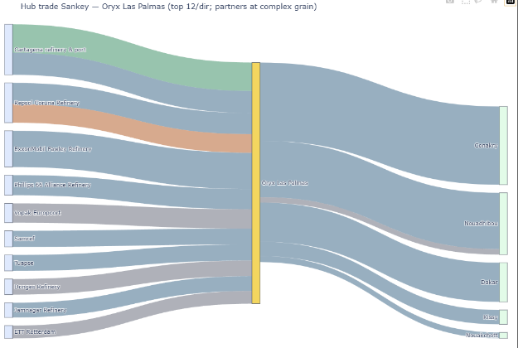

Export mainly Gasoil to west Africa.

Imports
- Gasoil
- Fuel Oil ( Bunker oil)
- Jet

Exports
- Gasoil
- Fuel Oil

Canarios Gran Canaria: Storage facility with 100,000 cbm, it services include reception, storage and into-ship supply of marine gasoil, storage and handling of jet fuel, logistic operations involving tanker trucks for the distribution of gasoline and road diesel.

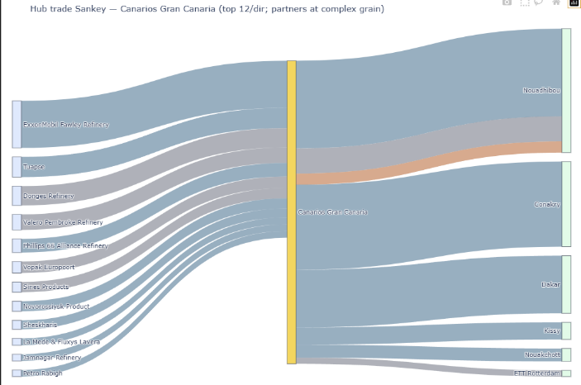

CEPSA Las Palmas: Bulk fuel storage and maritime bunkering facility. It's supplied by CEPSA's refinery network.

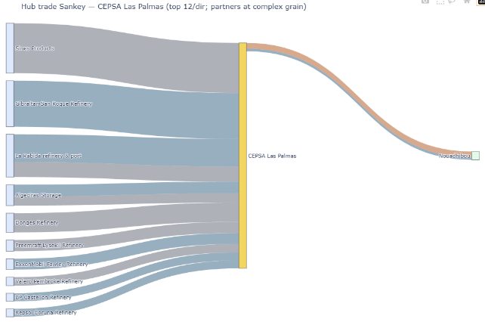

Salinetas: Independent storage site, seems to be owned by Group Disa (it's got facilities in every island) .

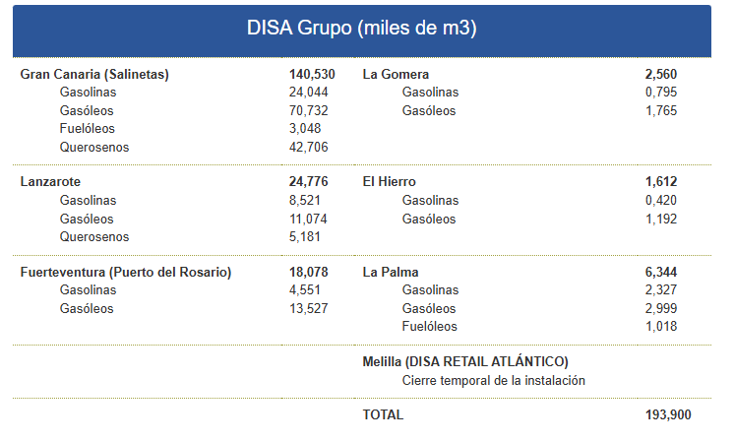

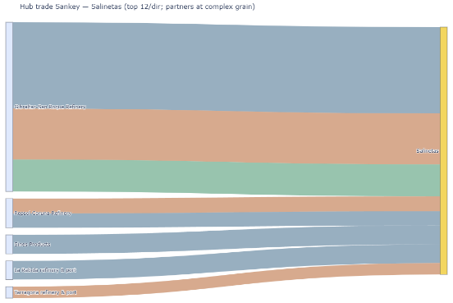

Asfaltos Arigana: A company that imports, stores, and distributes asphalt bitumen.

Tenerife

Tenerife Refinery: Owned by moeve, was decommissioned in 2025. Moeve announced in 2022, that the dismantling of the refinery was linked to the start-up of a new storage and distribution park in the port of Granadilla (same island -there's a power plant in that port).

Santa Cruz de Tenerife: It's mainly imported Gasoil, probably related to bunkering operation service offered at that port. The storage site has imported mainly Gasoil from Moeve, seems like it's integrated to the decommissioned refinery.



La gomera

San Sebastian de la gomera: Couldn’t find the owner but seems like Group Disa has some operation there -Storage Site. It mainly imports gasoil (most like marine gasoil, for motorboats, and gasoline for inland use).

La Palma

Santa Cruz de La Palma: Couldn’t find the owner but seems like Group Disa has some operation there -Storage Site. It mainly imports gasoil (most like marine gasoil, for motorboats, some FO for bunkering and gasoline for inland use).

El Hierro

Puerto de la Estaca: Couldn’t find the owner but seems like Group Disa has some operation there -Storage Site. It mainly imports gasoil (most like marine gasoil, for motorboats, and some gasoline).

