Demand
Add table to the consumption and petchem tabs, to calculate the change in monthly demand, look at this template:
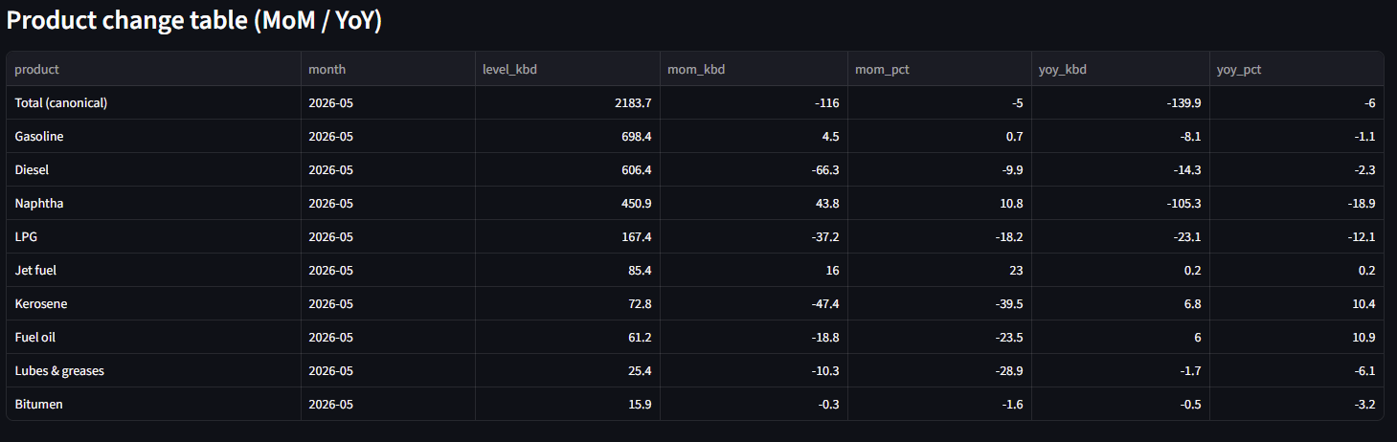

Products output and stocks:
Let’s also add a table I have the below template. Please complement it with ideas you have. I was thinking adding a line with implied demand something like if how much the demand change given that the build in inventories wasn’t equal to the increase in production (or maybe and increase in exports).
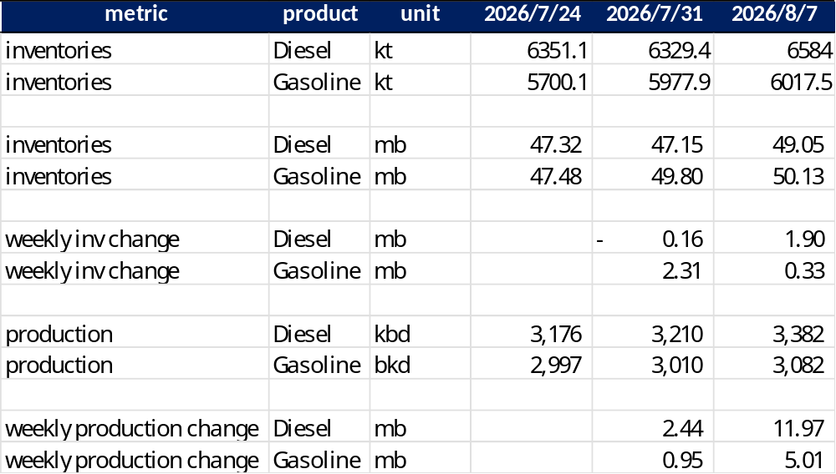

Sci export plans for month
Wonder if this information can be found in the API, how ca we use it to track the balance of the market?
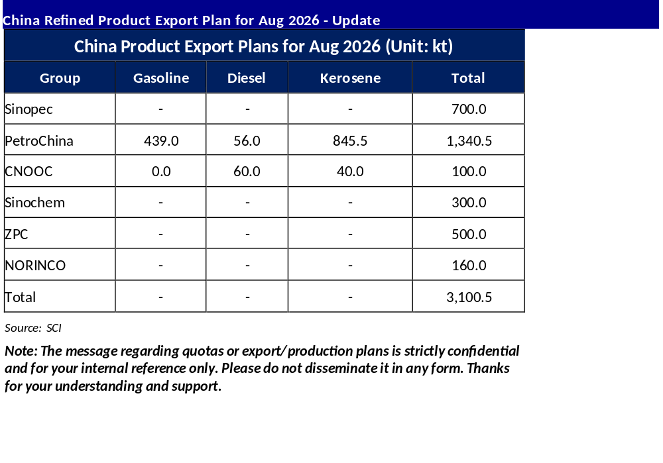
Additionally, reviewing this graph the title says YTD exports at 19,116 kt, while the last datapoint in the graph to the left, has a cumulative value of 16,135 kt, what’s the difference about?

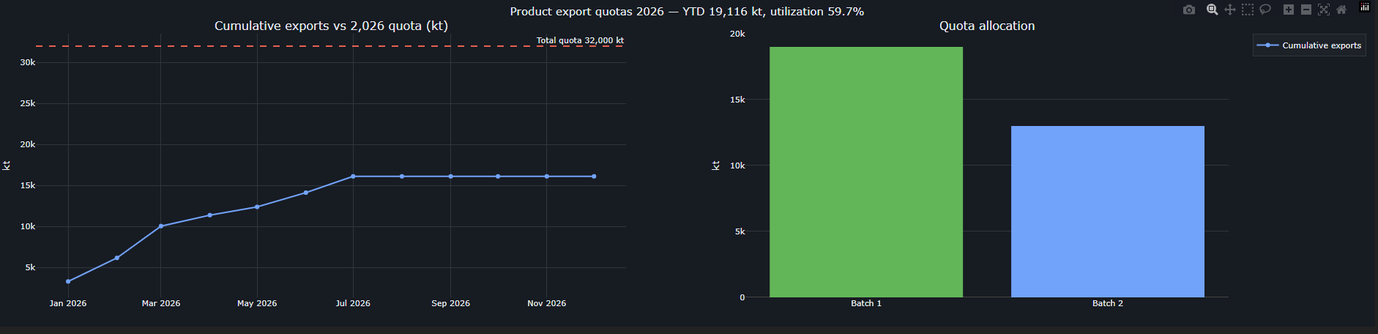

Future ideas:
- Electric vehicles stats (and impact on demand, maybe?)
- Crude
  - Imports (foreign crude shipping) and quotas – tracking blends and where they are coming from how much they are managing to import, what routes they using, what fleet is bringing the crude, and many more questions that can be answered, maybe?
  - Processing by oil grade – no idea what insights we can get from here but worth a look.
- More analytics and insights but will review after this improvement It’s complete - phase 2.

