This graph for Yanbu but might decide for the more organized graph of ras Laffan (see bellow).

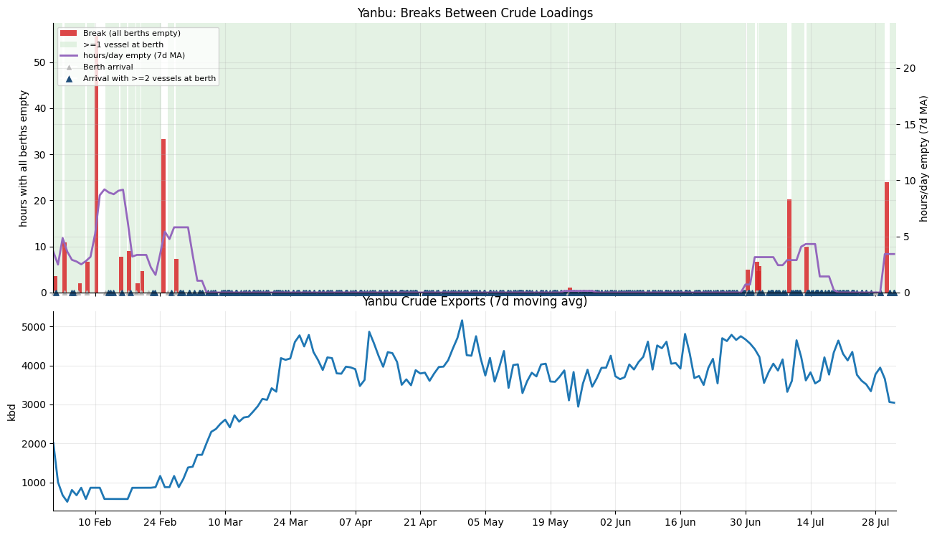

Raslaffan sample (not in scope of report)
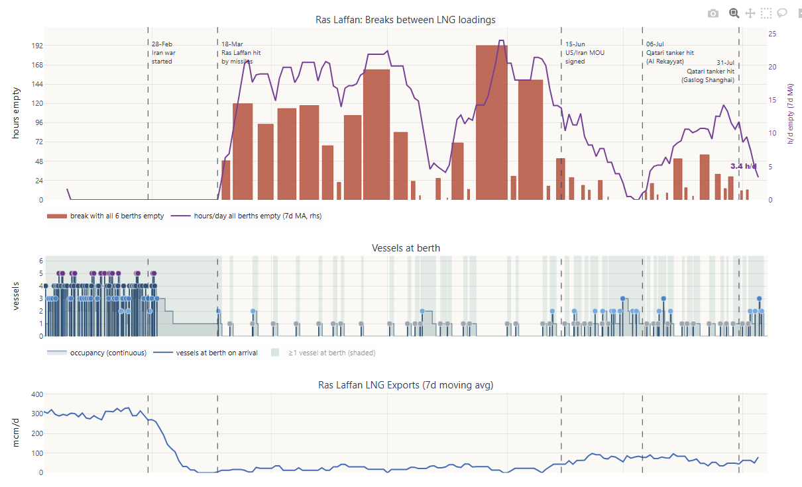

Table (Fomat and contents undecided just compied for placeholder, open to better formatting)

vessel_name | vessel_imo | vessel_type | installation_name | start | end | closest_ancestor_group | cargo_origin_barrels_split_by_product | is_sts | is_reexport | multiple_forecasted_zones
416 | Niban | 9484716 | VLCC | Muajjiz | 2026-07-25 | 2026-07-27 00:00:00 | Crude/Co | 2000002 | False | False | NaN
417 | Amzan | 9693745 | VLCC | Muajjiz | 2026-07-25 | 2026-07-27 00:00:00 | Crude/Co | 2141428 | False | False | NaN

Last available Satellite image in Copernicus (is there and endpoint to request dates available in the api?)
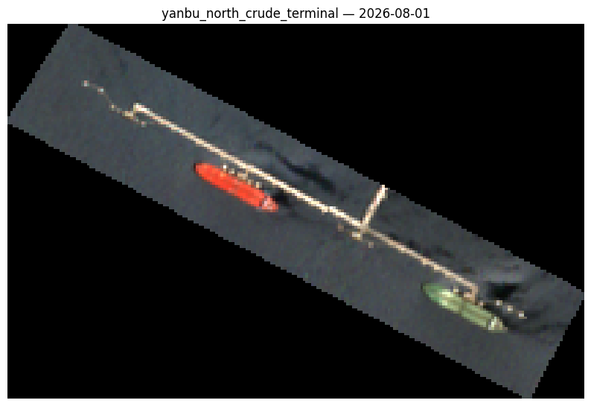

CPC (Format pretty much the same, the only change is that I’m adding the debug plots as it helps visualize the number of vessels in spms – this plot only works for spms have in mind if new terminals need to be added in the future)

Graph

Table of last 2 and 2 forward dates of loadings for terminal

