Programming Assignment #1

CS 8750: Artificial Intelligence II

Adil A. Al-Azzawi  
Chanmann Lim  
Fernando Torre

February 20, 2015

# Introduction

The ability to detect persons who have been drinking alcohol has been an ongoing struggle since the inception of alcoholic drinks themselves. Despite advances in the 20th century, it is yet to be seen for an application to be able to deduce drunkenness from data alone. In this assignment, we attempt to construct Bayesian networks that can achieve this goal.

There are 5 random variables:

* Pd: drink or not. Domain {+, -}
* Xb: breathing rate. Domain {H, M, L}
* Xh: heart rate. Domain {H, M, L}
* Xt: skin temperature. Domain {H, M, L}
* Xa: ambulation status. Domain {Fast, Slow, Stationary}

Pd is our target variable, which we will attempt to derive under different combinations of the other four variables.

To test the soundness of the networks, we will test 10 queries, in which we try to determine Pd from a given set of evidences.

1. Xb=H, Xh=H, Xt=H, Xa=Stationary
2. Xb=H, Xh=M, Xt=M, Xa=Fast
3. Xb=H, Xh=M, Xt=L, Xa=Slow
4. Xb=M, Xh=M, Xt=M
5. Xb=M, Xh=L, Xt=M
6. Xb=H, Xt=L, Xa=Slow
7. Xb=L, Xt=L, Xa=Fast
8. Xb=L, Xt=M
9. Xb=L, Xt=H
10. Xb=M

Contents

Introduction 1

BN#1 3

Formula derivations 3

Pseudocode 5

Matlab code 5

Query execution results 5

SamIam implementation 5

BN#2 5

Formula derivations 5

Queries 4-5 6

Queries 6-7 6

Pseudocode 8

Matlab code 8

Query execution results 8

SamIam implementation 8

Conclusions 8

# BN#1

We start our exploration with a naïve Bayesian network, flowing from Pd as the root cause, to Xb, Xh, and Xt as the effects.

## Formula derivations

### Queries 1-5

To answer the first three queries with this network, we must calculate $P(Pd=+)$ for given evidences Xb, Xh, Xt with known values which we’ll call A, B, and C respectively

$$P\left(Pd=+ | Xb=A,Xh=B,Xt=C\right)=\frac{P\left(Xb=A,Xh=B,Xt=C | Pd=+\right)P\left(Pd=+\right)}{P\left(Xb=A,Xh=B,Xt=C\right)}$$

Notice that Xb, Xh, Xt are independent given Pd, but are not when Pd is unknown. Therefore we can expand $P\left(Xb=A,Xh=B,Xt=C\right)$ into

$$P\left(Xb=A,Xh=B,Xt=C\right)=P\left(Xb=A,Xh=B,Xt=C|Pd=+\right)P\left(Pd=+\right)+P\left(Xb=A,Xh=B,Xt=C|Pd=-\right)P\left(Pd=-\right)=\left(P\left(Xb=A | Pd=+\right)P\left(Xh=B | Pd=+\right)P\left(Xt=C | Pd=+\right)\right)P\left(Pd=+\right)+\left(P\left(Xb=A | Pd=-\right)P\left(Xh=B | Pd=-\right)P\left(Xt=C | Pd=-\right)\right)P\left(Pd=-\right)$$

Finally,

$$P\left(Pd=+ | Xb=A,Xh=B,Xt=C\right)=\frac{\left(P\left(Xb=A | Pd=+\right)P\left(Xh=B | Pd=+\right)P\left(Xt=C | Pd=+\right)\right)P\left(Pd=+\right)}{\left(P\left(Xb=A | Pd=+\right)P\left(Xh=B | Pd=+\right)P\left(Xt=C | Pd=+\right)\right)P\left(Pd=+\right)+\left(P\left(Xb=A | Pd=-\right)P\left(Xh=B | Pd=-\right)P\left(Xt=C | Pd=-\right)\right)P\left(Pd=-\right)}$$

### Queries 6-9

In the next four queries, two nodes of the Bayesian network are known. For this derivation, well use A and B to denote the respective variable holding the query value. Thus, for query 6, $P(B)$ shall represent $P(Xt=L)$, while for query 8 it shall represent $P(Xh=M)$. We apply the same steps as in the previous derivation.

$$P\left(Pd=+ | A,B\right)=\frac{P\left(A,B | Pd=+\right)P\left(Pd=+\right)}{P\left(A,B\right)}=\frac{P\left(A,B | Pd=+\right)P\left(Pd=+\right)}{P\left(A,B | Pd=+\right)P\left(Pd=+\right)+P\left(A,B | Pd=-\right)P\left(Pd=-\right)}=\frac{\left(P\left(A | Pd=+\right)P\left(B | Pd=+\right)\right)P\left(Pd=+\right)}{\left(P\left(A | Pd=+\right)P\left(B | Pd=+\right)\right)P\left(Pd=+\right)+\left(P\left(A | Pd=-\right)P\left(B | Pd=-\right)\right)P\left(Pd=-\right)}$$

### Query 10

The last query is comparatively straightforward:

$$P\left(Pd=+ | Xb=M\right)=\frac{P\left(Xb=M | Pd=+\right)P\left(Px=+\right)}{P\left(Xb=M\right)}=\frac{P\left(Xb=M | Pd=+\right)P\left(Px=+\right)}{P\left(Xb=M | Pd=+\right)P\left(Px=+\right)+P\left(Xb=M | Pd=-\right)P\left(Px=-\right)}$$

## Pseudocode

For the implementation of this network, we will use…

## Matlab code

What follows is the actual code put into matlab to run this network

## Query execution results

## SamIam implementation

The Bayesian Network 1 graph constructed using SamIam to answer query number 4 : $P\left(Pd= + | Xb=M,Xh=M,Xt=M\right)$

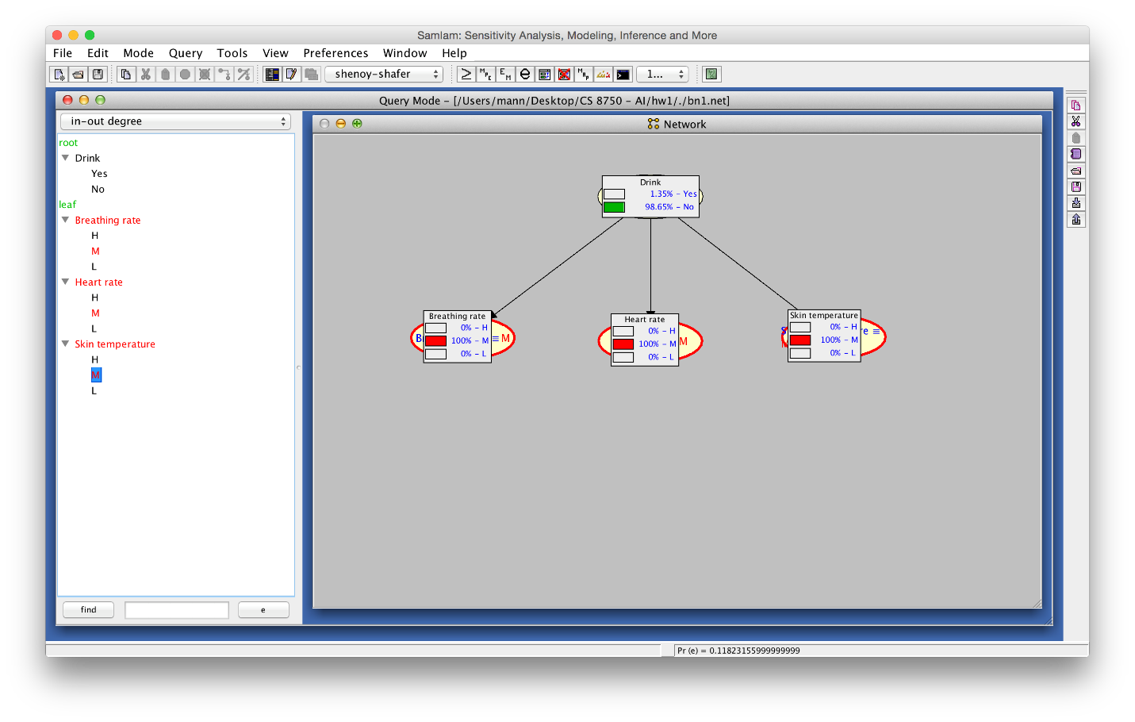

The results of running the query using junction tree algorithm Shenoy-Shafer: $P\left(Pd= + | Xb=M,Xh=M,Xt=M\right)=1.35\%$

# BN#2

We build a second Bayesian network that considers Xa. Xa is posited as an alternative cause for Xb, Xh, and Xt. It is hoped that if Xa can explain away Xb, Xh and Xt better than Pd, Pd will be use as the explanation less often.

## Formula derivations

### Queries 1-3

To answer the first three queries with this network, we must calculate $P(Pd=+)$ for Xa, Xb, Xh, X with known values. In the interest of legibility, we will denote $Pd=+$ as A, $Pd=-$ as $¬A$, $Xa=y_{1}$ (Where $y_{i}$ is the desired value for the query) as $B$, $Xb=y_{2}$ as $C$, $Xh=y_{3}$ as $D$, and $Xt=4$ as $E$. Thus, in each of the three queries, we are seeking

$$P\left(Pd=+ | Xa=y_{1},Xb=y_{2},Xh=y_{3}, Xt=4\right)=P\left(A | B,C,D,E\right)=\frac{P\left(A,B,C,D,E\right)}{P\left(B,C,D,E\right)}=\frac{P\left(C,D,E | A,B\right) P\left(A,B\right)}{P\left(C,D,E | B\right)P\left(B\right)}=\frac{P\left(C,D,E | A,B\right) P\left(A,B\right)}{\left[P\left(C,D,E | B,A\right)P\left(A\right)+P\left(C,D,E | B,¬A\right)P\left(¬A\right)\right]P(B)}=\frac{\left(P\left(C | A,B\right)P\left(D | A,B\right)P\left(E | A,B\right)\right)P\left(A\right)P\left(B\right)}{\left[\left(P\left(C | B,A\right)P\left(D | B,A\right)P\left(E | B,A\right)\right)P\left(A\right)+\left(P\left(C | B,¬A\right)P\left(D | B,¬A\right)P\left(E | B,¬A\right)\right)P\left(¬A\right)\right]P\left(B\right)}=\frac{\left(P\left(C | A,B\right)P\left(D | A,B\right)P\left(E | A,B\right)\right)P\left(A\right)}{\left(P\left(C | B,A\right)P\left(D | B,A\right)P\left(E | B,A\right)\right)P\left(A\right)+\left(P\left(C | B,¬A\right)P\left(D | B,¬A\right)P\left(E | B,¬A\right)\right)P\left(¬A\right)}$$

## Queries 4-5

We use the same procedure and notation as to derive the previous expression, however, we add the following: $B_{f}$ to denote $Xb=\text{fast}$, $B_{sw}$ to denote $Xb=\text{slow}$, and $B_{st}$ to denote $Xb=\text{stationary}$. We therefore have:

$$P\left(Pd=+ | Xb=y_{2},Xh=y_{3}, Xt=y_{4}\right)=P\left(A | C,D,E\right)=\frac{P\left(A,C,D,E\right)}{P\left(C,D,E\right)}=\frac{P\left(C,D,E | A\right)P\left(A\right)}{P\left(C,D,E | A\right)P\left(A\right)+P\left(C,D,E | ¬A\right)P\left(¬A\right)}$$

We derive separately $P\left(C,D,E | A\right)$ and $P\left(C,D,E | ¬A\right)$ and later plug them into the expression

$$P\left(C,D,E | A\right)= P\left(C,D,E | A,B_{f}\right)P\left(B_{f}\right)+P\left(C,D,E | A,B_{sw}\right)P\left(B_{sw}\right)+P\left(C,D,E | A,B_{st}\right)P\left(B_{sw}\right)=\sum_{i∈\left\{f,sw,st\right\}}{P\left(C,D,E | A,B_{i}\right)P\left(B_{i}\right)}=\sum_{i∈\left\{f,sw,st\right\}}{\left(P\left(C | A,B_{i}\right)P\left(D | A,B_{i}\right)P\left(E | A,B_{i}\right)\right)P\left(B_{i}\right)}=\sum_{i∈\left\{f,sw,st\right\}}{\prod_{j∈\{A,D,E\}}{P\left(j | A,B_{i}\right)}}P\left(B_{i}\right)$$

$$P\left(C,D,E | ¬A\right)= P\left(C,D,E | ¬A,B_{f}\right)P\left(B_{f}\right)+P\left(C,D,E | ¬A,B_{sw}\right)P\left(B_{sw}\right)+P\left(C,D,E | ¬A,B_{st}\right)P\left(B_{sw}\right)=\sum_{i∈\left\{f,sw,st\right\}}{P\left(C,D,E | ¬A,B_{i}\right)}=\sum_{i∈\left\{f,sw,st\right\}}{\left(P\left(C | ¬A,B_{i}\right)P\left(D | ¬A,B_{i}\right)P\left(E | ¬A,B_{i}\right)\right)P\left(B_{i}\right)}=\sum_{i∈\left\{f,sw,st\right\}}{\prod_{j∈\{A,D,E\}}{P\left(j | ¬A,B_{i}\right)}}P\left(B_{i}\right)$$

Finally,

$$P\left(A | C,D,E\right)=\frac{\left(\sum_{i∈\left\{f,sw,st\right\}}{\prod_{j∈\{A,D,E\}}{P\left(j | A,B_{i}\right)}}P\left(B_{i}\right)\right)P\left(A\right)}{\left(\sum_{i∈\left\{f,sw,st\right\}}{\prod_{j∈\{A,D,E\}}{P\left(j | A,B_{i}\right)}}P\left(B_{i}\right)\right)P\left(A\right)+\left(\sum_{i∈\left\{f,sw,st\right\}}{\prod_{j∈\{A,D,E\}}{P\left(j | ¬A,B_{i}\right)}}P\left(B_{i}\right)\right)P\left(¬A\right)}$$

## Queries 6-7

We use the same procedure and notation as before.

$$P\left(Pd=+ | Xa=y_{1},Xb=y_{2}, Xt=4\right)=P\left(A | B,C,E\right)=\frac{P\left(A,B,C,E\right)}{P\left(B,C,E\right)}=\frac{P\left(C,E | A,B\right)P\left(A,B\right)}{P\left(C,E | B\right)P\left(B\right)}=\frac{P\left(C,E | A,B\right)P\left(A,B\right)}{\left[P\left(C,E | B,A\right)P\left(A\right)+P\left(C,E | B,¬A\right)P\left(¬A\right)\right]P\left(B\right)}=\frac{\left(P\left(C | A,B\right)P\left(E | A,B\right)\right)P\left(A\right)P\left(B\right)}{\left[\left(P\left(C | B,A\right)P\left(E | B,A\right)\right)P\left(A\right)+\left(P\left(C | B,¬A\right)P\left(E | B,¬A\right)\right)P\left(¬A\right)\right]P\left(B\right)}$$

### Queries 8-9

Once again we use the same notation

$$P\left(Pd=+ | Xb=y_{2},Xh=y_{3}\right)=\frac{P\left(A,C,D\right)}{P\left(C,D\right)}=\frac{P\left(A,C,D,B_{f}\right)+P\left(A,C,D,B_{sw}\right)+P\left(A,C,D,B_{st}\right)}{P\left(C,D\right)}$$

Let us expand $P\left(C,D\right)$ separately

$$P\left(C,D\right) \\ =P\left(C,D,A,B_{f}\right)+P\left(C,D,A,B_{sw}\right)+P\left(C,D,A,B_{st}\right) \\ +P\left(C,D,¬A,B_{f}\right)+P\left(C,D,¬A,B_{sw}\right)+P\left(C,D,¬A,B_{st}\right) \\ = P\left(C,D | A,B_{f}\right)P\left(A,B_{f}\right)+P\left(C,D | A,B_{sw}\right)P\left(A,B_{sw}\right)+P\left(C,D | A,B_{st}\right) \\ +P\left(C,D | ¬A,B_{f}\right)P\left(¬A,B_{f}\right)+P\left(C,D | ¬A,B_{sw}\right)P\left(¬A,B_{sw}\right)+P\left(C,D | ¬A,B_{st}\right)P\left(¬A,B_{st}\right) \\ =\sum_{i∈\left\{f,sw,st\right\} }{\left(P\left(C,D | A,B_{i}\right)P\left(A,B_{i}\right)+P\left(C,D | ¬A,B_{i}\right)P\left(¬A,B_{i}\right)\right)}=\sum_{i∈\left\{f,sw,st\right\} }{\sum_{j∈\left\{A,¬A\right\} }{P\left(C,D | j,B_{i}\right)P\left(j,B_{i}\right)}}=\sum_{i∈\left\{f,sw,st\right\} }{\sum_{j∈\left\{A,¬A\right\} }{\left(P\left(C | j,B_{i}\right)P\left(D | j,B_{i}\right)\right)P(j)P\left(B_{i}\right)}}$$

We note that

$$P\left(C,D,A,B_{f}\right)+P\left(C,D,A,B_{sw}\right)+P\left(C,D,A,B_{st}\right)=\sum_{i∈\left\{f,sw,st\right\} }{P\left(C,D | A,B_{i}\right)P\left(A,B_{i}\right)}=\sum_{i∈\left\{f,sw,st\right\} }{\left(P\left(C | A,B_{i}\right)P\left(D | A,B_{i}\right)\right)P(A)P\left(B_{i}\right)}$$

Therefore

$$\frac{P\left(A,C,D\right)}{P\left(C,D\right)}=\frac{\sum_{i∈\left\{f,sw,st\right\} }{\left(P\left(C | A,B_{i}\right)P\left(D | A,B_{i}\right)\right)P(A)P\left(B_{i}\right)}}{\sum_{i∈\left\{f,sw,st\right\} }{\sum_{j∈\left\{A,¬A\right\} }{\left(P\left(C | j,B_{i}\right)P\left(D | j,B_{i}\right)\right)P(j)P\left(B_{i}\right)}}}$$

### Query 10

Once more, the same notation is used.

$$P\left(A | C\right)=\frac{P\left(A,C\right)}{P\left(C\right)}=\frac{P\left(A,C,B_{f}\right)+P\left(A,C,B_{sw}\right)+P\left(A,C,B_{st}\right)}{P\left(C\right)}$$

We calculate $P(C)$ separately

$$P\left(C\right)=P\left(C,A,B_{f}\right)+P\left(C,A,B_{sw}\right)+P\left(C,A,B_{st}\right)+P\left(C,¬A,B_{f}\right)+P\left(C,¬A,B_{sw}\right)+P\left(C,¬A,B_{st}\right)=P\left(C | A,B_{f}\right)P\left(A\right)P\left(B_{f}\right)+P\left(C | A,B_{sw}\right)P\left(A\right)P\left(B_{sw}\right)+P\left(C | A,B_{st}\right)P\left(A\right)P\left(S_{sw}\right)+P\left(C | ¬A,B_{f}\right)P\left(¬A\right)P\left(B_{f}\right)+P\left(C|¬A,B_{sw}\right)P\left(¬A\right)P\left(B_{sw}\right)+P\left(C | ¬A,B_{st}\right)P\left(¬A\right)P\left(B_{st}\right)=\sum_{i∈\left\{f,sw,st\right\} }{\left(P\left(C | A,B_{i}\right)P\left(A\right)P\left(B_{i}\right)+P\left(C | ¬A,B_{i}\right)P\left(¬A\right)P\left(B_{i}\right)\right)}$$

Therefore:

$$P\left(A | C\right)=\frac{P\left(C | A,B_{f}\right)P\left(A\right)P\left(B_{f}\right)+P\left(C | A,B_{sw}\right)P\left(A\right)P\left(B_{sw}\right)+P\left(C | A,B_{st}\right)P\left(A\right)P\left(S_{sw}\right)}{\sum_{i∈\left\{f,sw,st\right\} }{\left(P\left(C | A,B_{i}\right)P\left(A\right)P\left(B_{i}\right)+P\left(C | ¬A,B_{i}\right)P\left(¬A\right)P\left(B_{i}\right)\right)}}$$

## Pseudocode

For the implementation of this network, we will use…

## Matlab code

What follows is the actual code put into matlab to run this network

## Query execution results

## SamIam implementation

The Bayesian Network 1 graph constructed using SamIam to answer query number 7 : $P\left(Pd= + | Xa=Fast, Xb=L,Xt=L\right)$

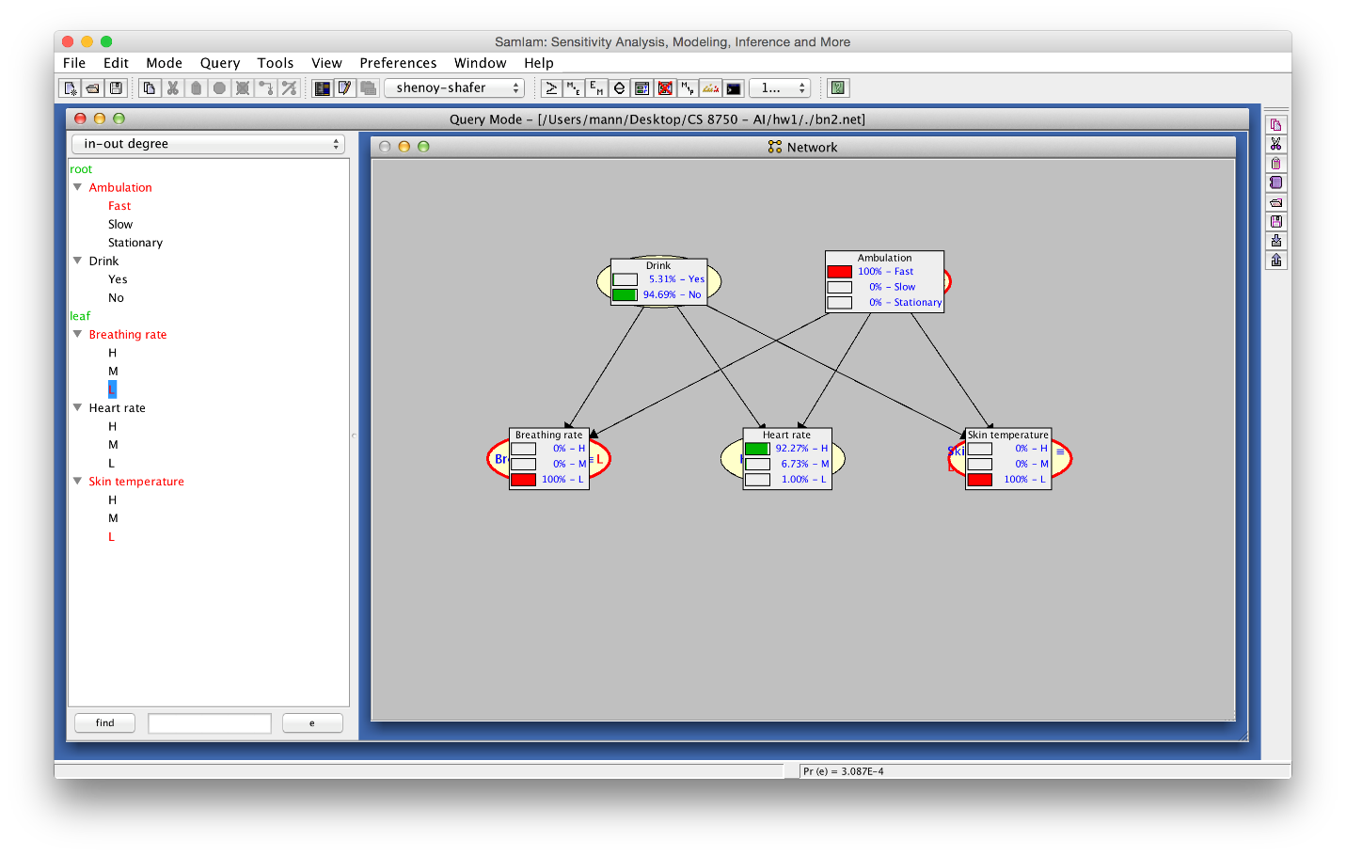

The results of running the query using junction tree algorithm Shenoy-Shafer: $P\left(Pd= + | Xa=Fast, Xb=L,Xt=L\right)=5.31\%$

# Conclusions

When comparing the same queries in both networks, we observe that Pr decreases in the second network. This is expected to be because of the introduction of an alternate casue to explain away Xb Xh and Xt. The new probabilities are more in line with the prior probabilities of Pd, suggesting a more accurate model