1. Find C1 and C2 and n0 to show that 5x2 + 4x -8320 is Θ(n2)

Solution:

For n0 = 1, c1 ~= -8311, but it should be positive

X intercept = 40.39, must be greater than that!

let’s round up to n0 = 50 🡪F(50) = 4380, but when we divide by x2

Now:

Need a bigger n0 = 8230

for n>n0

C1 <= 0.00036057692

Now:

$$5+\frac{4}{x}≤c2$$

$$5+\frac{4}{8320}≤c2$$

5.00048076923 <= C2

One Solution:

**N0 = 8230**

**C1 <= 0.00036057692**

**C2 >= 5.00048076923**

1. An algorithm can process 512 items in 2 seconds

6144/514 = 12 🡪 12t

* 1. Time for 6144 items if algorithm is is Θ(n2)

2*122 = 288 s

* 1. Time for 6144 items if algorithm is is Θ(n)

2*12 = 24 s

* 1. Time for 6144 items if algorithm is is Θ(n3)

2*123 = 3456 s

* 1. Time for 6144 items if algorithm is is Θ(2n)

2*212 = 213 s

* 1. Time for 6144 items if algorithm is is Θ(n1/2)

2*sqrt(12) = 6.928 s

1. Write a program – See Attached Program

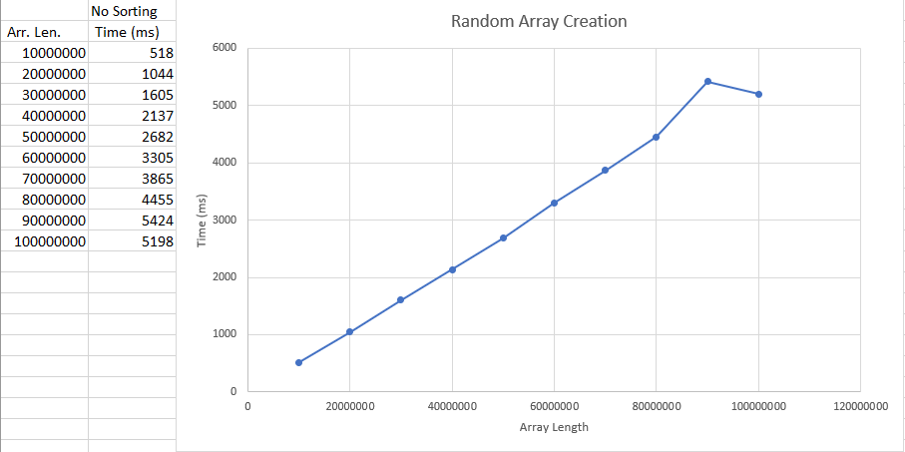

This is an O(n) algorithm whose completion time y (milliseconds) can be predicted by:

y = 0.00005626485*x - 71.26667, where x is the length of the array

To solve for items generated in 3 days, we must solve for X where Y = 3days

1000ms/s*60s/m*60m/hr*24hr/d*3d = 259200000ms

259200000 = 0.00005626485*x - 71.26667

**X = 4,606,785,199,759 numbers**

1. Insertion Sort - See Attached Program

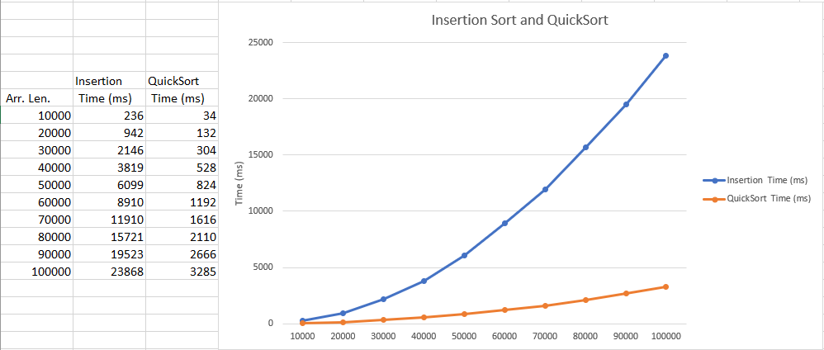

This is an O(n2) algorithm whose completion time y (milliseconds) can be predicted by:

y = -234.4 + 0.01334788*x + 0.000002290303*x2, where x is the length of the array

To solve for items generated in 3 days, we must solve for X where Y = 3days

3 days = 1000ms/s*60s/m*60m/hr*24hr/d*3d = 259200000ms

259200000 = -234.4 + 0.01334788*x + 0.000002290303*x2

**X = 10,635,362 numbers**

1. QuickSort - See Attached Program



This is a O(n*log(n)) algorithm. A 3 day approximation is harder to predict via a regression extrapolation.

We need to model a function f(n) = C*n*log(n)

Solving for c for y=23868, x=100000… C =

23868 = C * 100000* log2(100000)

C = 0.01436996787

We can get a rough estimate for the array length by solving for x:

259200000ms = 0.01436996787*x*log(x)

**X = 876,000,000 numbers**

1. Given the table, fill in the bounds you can

Highlighted 🡪Given in Assignment

|  |  |  |  |  |  |  |  |  |
| --- | --- | --- | --- | --- | --- | --- | --- | --- |
| 🡨 | Problem | 🡪 | 🡨 | Algorithm | 🡪 | 🡨 | Solution | 🡪 |
| Best | Average | Worst | Best | Average | Worst | Best | Average | Worst |
|  |  |  |  | Ω(n) | O(n) |  | Ω(n) | O(n) |
| Ω(n) |  |  | Θ(n2) |  |  | Ω(n2) | O(n2) |  |
| Ω(n2) | Θ(n2) |  | Ω(n2) | Θ(n2) |  |  | Ω(n2) |  |