TodoListManager

Apply in Delete mode with no selections
Apply in Delete mode with one selection – ansr ‘No’
Apply in Delete mode with more than one selection

Select four consecutive lists (for deletion), activate each one.
If necessary, create them first.
Deselect all
Go to delete all 4 lists.
Verify a delete from Vector message for each list.

After a list has been deleted, (Do not make any other tree selection) add one with a new name. Verify that the list appears with the new name and not one of the ones just deleted.

Tree-select a list for the first time, note the delay. Then use the list manager to deselect. View a different list. Use the manager to reselect the list, then tree-select it and verify that it has less of a delay.

Select a list and make a minor change. Then do a ‘Save As’ to a different name. Verify that the tree node text has changed to the new name. Go to the list manager and select the original name. Select that list and verify that it is identical to the new name except that it does not have that minor change.

DayNotes

- Go to a fresh day – no existing data.
- Enter on consecutive lines: a, b, c, d, e, f, g.
- Verify that each line becomes ‘initialized’ after a character is typed. Look for a time entry and a default icon, and each time text is entered, the line below becomes visible. See example:

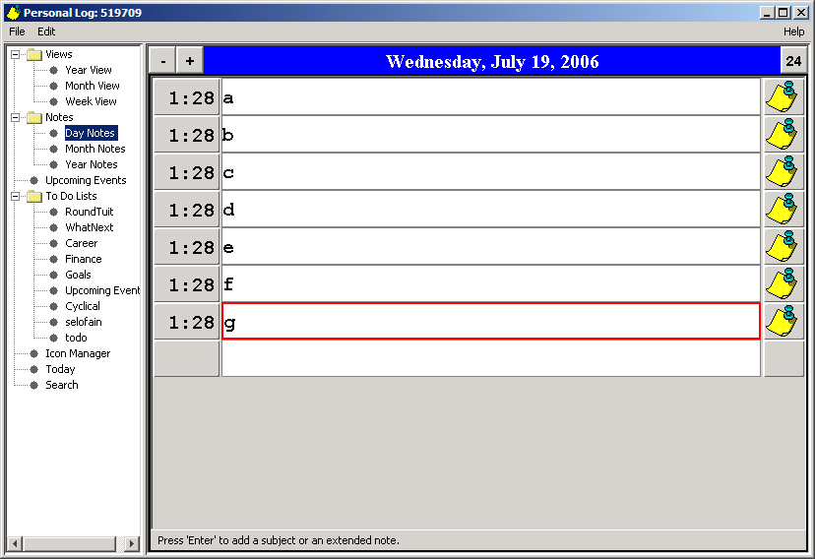

- Highlight the ‘b’ line, press ‘Enter’ and verify that the Extended Note dialog appears. Verify that the subject line reads ‘Day Note’. Enter “Test 1” in the main text area (not the subject area), then size the dialog to fit its height exactly, with minimum width (text still shows) then close.

- Highlight the ‘c’ line, enter “This is it.”, choose a non-default subject from the drop-down list, then close. Verify both the ‘b’ and ‘c’ are colored blue, to indicate that there is additional text.

- Go back to the ‘b’ line extended dialog and verify its size is how it was left in step 4.

- Open the ‘d’ line and choose a non-default subject, different from the one chosen in step 5 above. Close the dialog with no extended text. Now move the mouse cursor over the ‘c’ and ‘d’ lines and verify tool tip text that displays the subjects. A default subject does not set a tool tip.
- Click the default icon on the ‘c’ line, verify an icon-chooser interface pops up and you can select a different icon for the note. Click ‘Set Icon’ to close the dialog and set the icon.

- Right-click one of the other, default icons and verify a popup menu with the choices ‘Set As Default’ and ‘Reset Icon’ are disabled.

- Now right-click the icon you set on the ‘c’ line and verify that all four menu choices are active, and that the ‘Show on Month’ choice has a checkmark.

- Cycle ahead to the next ‘blank’ day by clicking on the ‘+’. Verify there is a single empty line. Enter text for the first two lines, (a, b). Go back to the earlier day by clicking on the ‘-‘.

- Right-click the icon on the ‘c’ line, select ‘Set As Default’ from the popup menu. Verify that every other icon changes to this one. Verify the same for the icons on the other day from the previous step. Quit the application.

- Start the application, verify it starts on the Day View, current day. Go to the ‘test’ day and verify that the new default icon is was set correctly.

Upcoming Events

1

Dates, Time and Duration
Open the interface and add 16 new event entries. This can be done quickly via a single digit entry hexadecimal value (0-f). Then make the following Date and Time entries (the values you choose may be anything that the interface allows):
- Nothing, for now.
- End Time.
- End Date.
- End Date and End Time
- Start Time
- Start Time and End Time
- Start Time and End Date
- Start Time, End Date, and End Time
- Start Date
- Start Date and End Time
- Start Date and End Date
- Start Date, End Date, and End Time
- Start Date and Start Time
- Start Date, Start Time, and End Time
- Start Date, Start Time, and End Date
- All

- Verify that an entry that is obviously in the past will color its panel in a light red shade and an entry that is obviously in the future will color its panel in a light green shade. If the determination cannot be made then the panel background color should remain unchanged.
- Verify also that the interface will not allow an Event Start prior to the Event End.
- Verify that entries 5, a, b, e, and f (and no others) reflect a Duration.
- On entry 5, verify that the Duration value is less than 1440 and the units are in minutes.
- On entry a, verify that the Duration is accurate and that the units are in days or weeks.
- On entry f, verify that the Duration is accurate to the minute. Make adjustments to any time or date field, as needed.

Recurrence
When testing ‘first thru last’ of the specific days, be sure to include the cases where (the fourth == last) and (the fourth != last). Test both the fourth and the last descriptions in these two cases.

