Software Design Document
for
Battleship
Version 1.0
Prepared by Max Hesser-Knoll, Lucas Cheek, and Nick Segler
UAF CS 372
February 20, 2016
Table of Contents
Table of Contents ii
Revision History ii
1. Introduction 1
2. System Architecture 1
2.1 Application Architecture 1
2.2 System Overview 1
2.3 System Diagram 1
2.4 Assumptions and Dependencies 1
3. System Design 2
3.1 Design Overview 2
3.2 System Components 2
4. Testing Strategy 3
4.1 Development Testing 3
4.2 Post Development Testing 3
5. Appendix 4
5.1 Glossary 4
5.2 References 4

Revision History
Date | Version | Version
Feb 20, 2016 | 1.0 | Rough draft for submission.

Introduction
The purpose of this document is to provide an outline of the design of the Battleship software package, also simply called Battleship. This outline will be used as a blueprint for the actual implementation Battleship. This document is intended to be used by parties designing and implementing the Battleship.

System Architecture

Application Architecture
The application architecture for Battleship will be similar to that of an event-processing architecture. Like an event-processing architecture Battleship will detect and interpret interface events as commands and then provide rapid feedback that the command has been accomplished.

System Overview
The Battleship software package has a modular system design. The primary modules are core game module, a graphical user interface (GUI) module, and a networking module. The core game module will contain the game logic and allow two players to play against each on a single computer using a command line interface. The GUI module will allow the players to play using a GUI rather than a CLI. The networking module will allow two users to play a game against each other from two different computers over a network connection.
Battleship will be implemented using C++, the Cinder graphical library, and a yet unspecified networking library.
The advantage of the modular system is that new modules may be added or an existing module can be interchanged with an upgraded module in order to expand the functionality of the program, such as though the incorporation different IO modules to provide varying interfaces for the Battleship software.

System Diagram
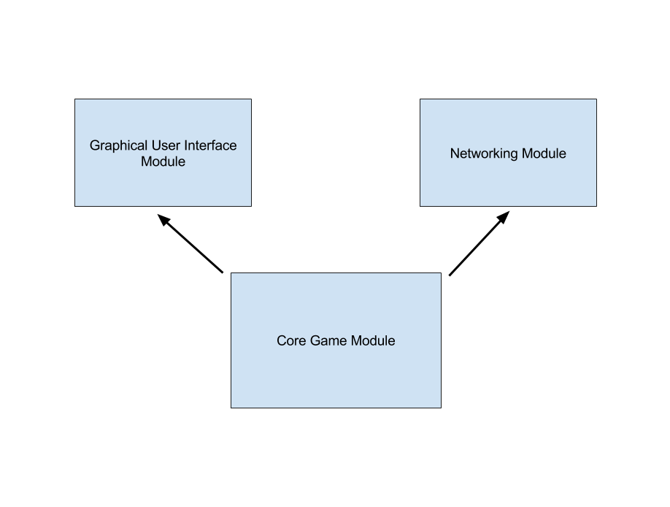
Figure 2.3.1

Assumptions and Dependencies
The Battleship software package is intended to run on a modern x86 Windows, Linux, and Mac OS computers. For each module used, the system(s) must have at least the minimal necessary resources to run the modules.
Elements of the design of Battleship addressed in this document are subject to change during implementation if sufficient cause is provided.
This version of Battleship is only intended for personal use.

System Design

Design Overview
This section outlines the basic structure and functionality of the primary Battleship modules. See Section 2.2 for a high level overview of how the modules work together to form the complete Battleship software package. The functionality outlined for each module in this section is targeted toward satisfying the requirements in the software requirements document for Battleship.

System Components

Core Game Module
The core game module allows two players to play against each on a single computer using a command line interface. The command line interface displays game prompts and status to a terminal window using ASCII text output. It receives commands from the user in the form of text commands entered into the command line. The entire game of Battleship can be played using the interface.

Graphical User Interface Module
The graphical user interface (GUI) module allows the players to play using a GUI rather than a CLI. The GUI supports mouse input and will display critical information about the game to the user including but not limited to player turn status, game board state, and whether a shot hits.

Networking Module
The networking module allows two users to play a game against each other from two different computers over a network connection. The network module will establish a network connection between the two machines and allow Battleship gameplay across the network connection. Both of the computers must have the core game module and the networking module installed for this functionality. In addition, the computers must be able to establish a network connection with each other.

Testing Strategy

Development Testing
The testing of the system will begin while the system is under development. The basic principles of test driven development will be used at every level of development. Each module, and every component of each module, will be developed concurrently with its testing package. Once each element of a module passes its tests the module can be assembled and tested. The tests that are generated during development can be retained to prevent regression and potentially recycled as elements of other tests.

Post Development Testing
Once the initial development is complete, the post development testing can begin. The post development testing consists of two parts, Basic Functionality Testing and Stress Testing.

Basic Functionality Testing
The purpose of the basic functionality testing is to confirm that the entire system functions properly under normal usage. The testing will mimic the actions of an average user which makes automation of some aspects of the test impractical due to the difficulty of automating a user’s interaction with the system’s user interface. The basic functionality testing strategy can confirm that the development produced a functioning, usable product.

Stress Testing
The purpose of the stress testing to subject the system to unusual datasets in an attempt to determine its limitations or bugs that were not encountered under the normal usage testing in the basic functionality testing stage. Automation can be applied during this stage of testing in order to push the program to its limits. In some cases, automation may require the circumvention of the user interface. Stress testing can facilitate the location of obscure bugs and helps to determine the performance and usage guidelines for the system as a whole.

Appendix

Glossary

Placeholder: This is a placeholder for future glossary entries.

References
This document uses the IEEE 1016-1998 template as outlined in the following document as a guide:
"Software Design Description." Wikipedia, Web. 20 Nov 2011. <http://en.wikipedia.org/wiki/Software_Design_Description>.
The following site provided additional formatting information:
Appleton, Brad. "A Software Design Specification Template." . N.p., n.d. Web. 20 Nov 2011. <http://www.cmcrossroads.com/bradapp/docs/sdd.html>.

