User Manual
for
Battleship
Version 1.0
Prepared by Max Hesser-Knoll, Lucas Cheek, and Nick Segler
UAF CS 372
March 10, 2016
Table of Contents
Table of Contents ii
Revision History ii
1. Introduction 1
2. Instructions 1
2.1 Core Game Module 1
2.2 Graphical User Interface Module 2
3. Appendix 2
3.1 References 2

Revision History
Date | Version | Version
March 10, 2016 | 1.0 | Rough draft for submission.

Introduction
The purpose of this document is to serve as an instruction manual on how to use the Battleship software package as an end user. It will guide you through how run and use the core game module and the graphical user interface (GUI) module in the Battleship software package.

Instructions

Core Game Module
The following instructions will explain how to run and play Battleship using the core game module using a command line interface. The core game module can be run independently of the graphical user interface module. The core game module supports two human players playing a game of Battleship against each other on a single computer using a command line interface.
- Download the source files from the following GitHub repository by cloning the repo or downloading a zip file containing the source files by clicking “Download Zip”:
URL: https://github.com/lcheek3/CS372-Project-1
- Build the files battleship_core.h and battleship_game_loop.cpp using a compiler or IDE of your choice.
- Run the executable that was output in Step 2. This will run the core game module and start a command line interface game of battleship in your system’s default console program or within your IDE’s console if it has one.
- The game begins by allowing the first player to optionally set his or her name and then place his or her ships on the game board. After each ship is places, the program outputs an ASCII representation of the player’s placed ships to the console.
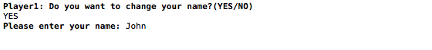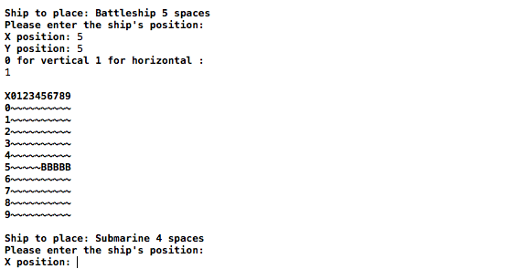
- Once the first player has placed all of his or her ships, this process is repeated for the second player.
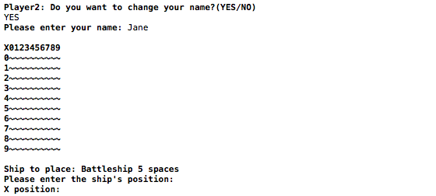

- After both players have placed all of their ships, the players begin to take turns firing at each other’s ships.
  - The first player is prompted to enter the coordinates he wishes to fire at on his opponent’s board. After entering the coordinates, the first player is informed whether the shot hit an enemy ship. The first player is then prompted to give the computer the the second player. 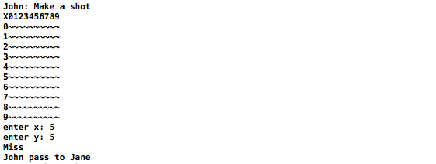
  - The second player is then able to enter the coordinates he wishes to fire at on his opponent’s board. After entering the coordinates to fire at, he or she is informed whether the shot hit an enemy ship. 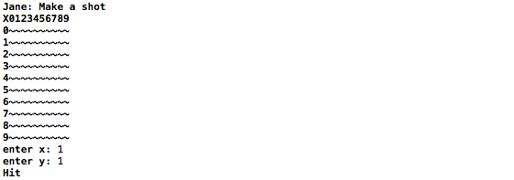
- The process in Step 5 continues until a player’s ships have all been destroyed, i.e. all coordinates his or her ships occupy have been hit by the opposing player. The player whose ships are all destroyed first loses, and the opposing player is the winner. Once a player has won, the program displays to the console which player has won.
- The game may be closed by closing the console window or stopping execution in the IDE that it is running in.

Graphical User Interface Module

Appendix

References
The following site provided formatting information:
Appleton, Brad. "A Software Design Specification Template." . N.p., n.d. Web. 20 Nov 2011. <http://www.cmcrossroads.com/bradapp/docs/sdd.html>.

